A Narendiran

PES1UG19CS001

A Sec

LAB 4 Consensus Algorithm using Raft

Task 1

1a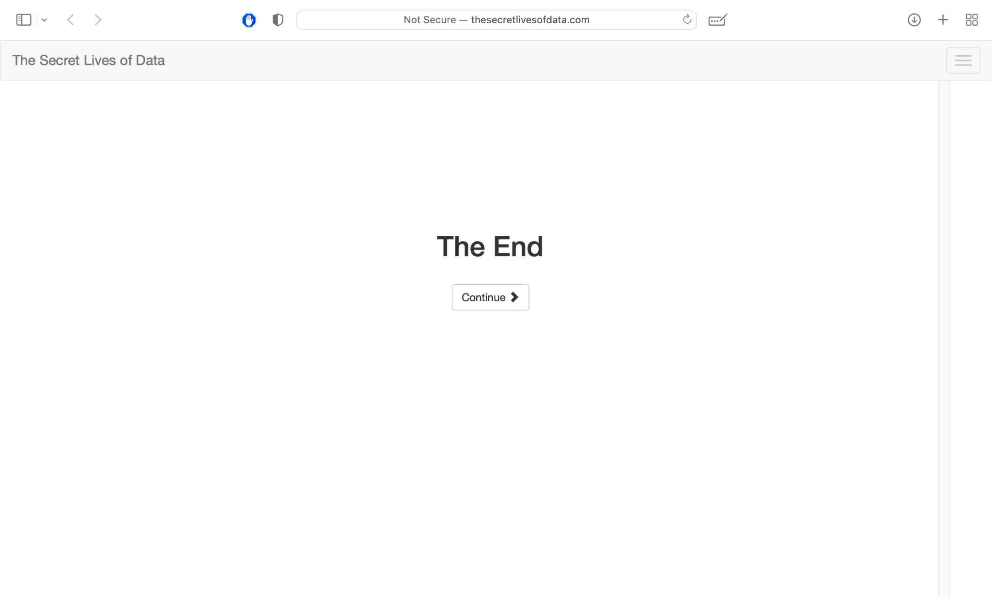

1b

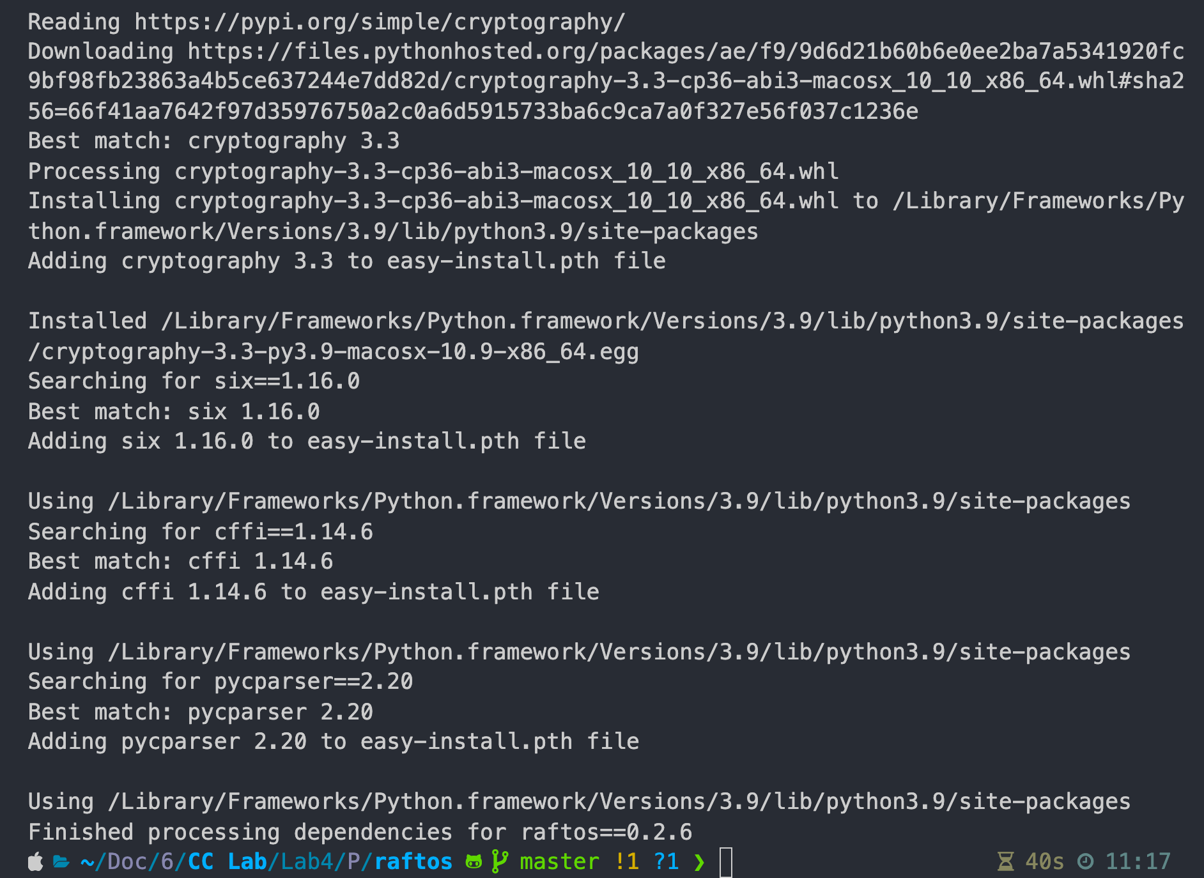

Task 2

2a

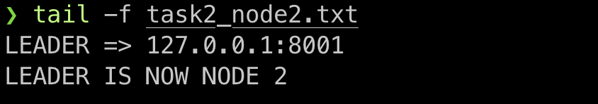

2b

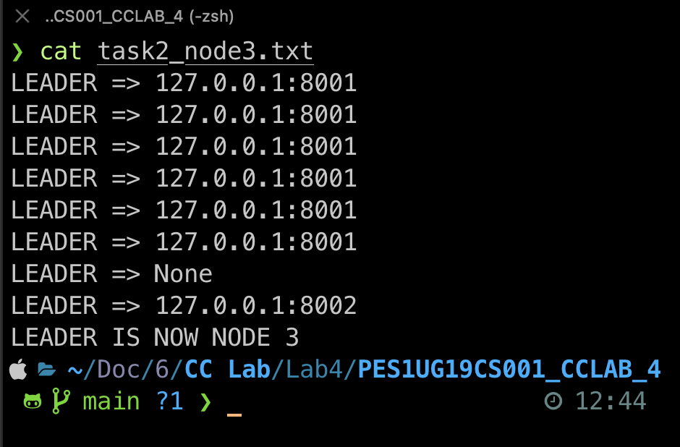

2c

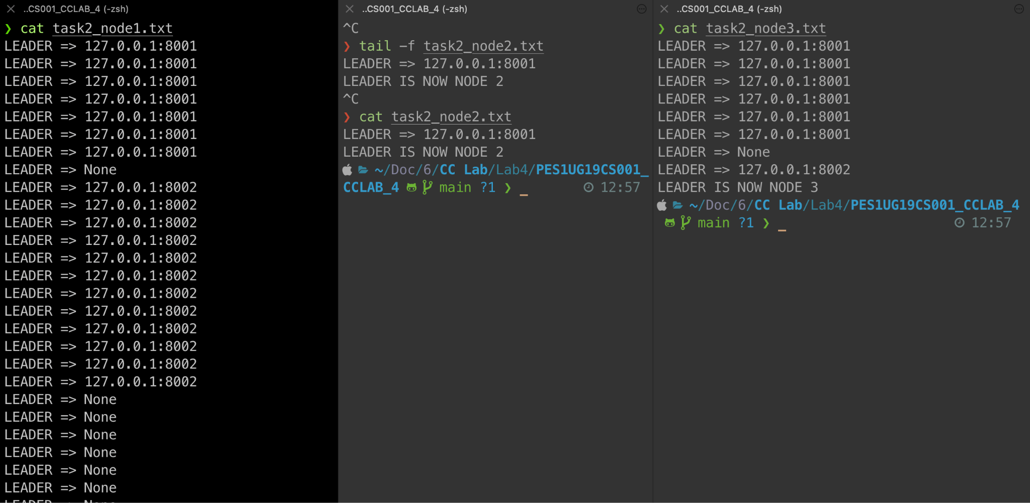

Task 3

3a

log



State machine



Storage



3b

