**Product Design**

|  |  |
| --- | --- |
| **Team-** | **Team 09 Jalees Jahanzaib , Mayank Goyal , Naren RJ Akash , Meena** |

# **Design Overview**

## **Architectural design**

The Circular Dichroism divided into the following parts:

* Introduction: Text introduction to the whole lab
* Experiments: 10 Experiments, each having the following parts
  + Objective: Text explaining the objective of the experiment
  + Procedure: Text explaining the procedure of the experiment
  + Tutorial: Interactive tutorial for performing an experiment
  + Experiment: Interactive experiment (currently in Java and PHP)
  + Observations: Text explaining observations noted
  + Assessment: Quiz for evaluating learning
  + References: External links for further learning
* Target audience: Text explaining user profiles
* Courses Aligned: Text explaining courses for which it is useful
* Pre-requisites: Text explaining pre-requisites

## **System interfaces**

### **User Interface**

* + - User opens the website and reads the overall introduction
    - User opens the Prerequisites tab and checks that the requirements are satisfied
    - User opens and reads the Objective of the experiment
    - User familiarizes himself with Procedure of the experiment
    - The user watches the Tutorial demo to see how it is performed
    - The user performs the Experiment
    - User understands Observations
    - User takes the Quiz to assess learning
    - User refers to the References for further learning

### APIs

*Not applicable*

## Model

This is not quite applicable to our project as we are only required to translate experiments. Just as modules and APIs were not applicable, similarly models are not applicable either.

# **Sequence Diagram(s)**

UC-01 to UC-10: Experiments

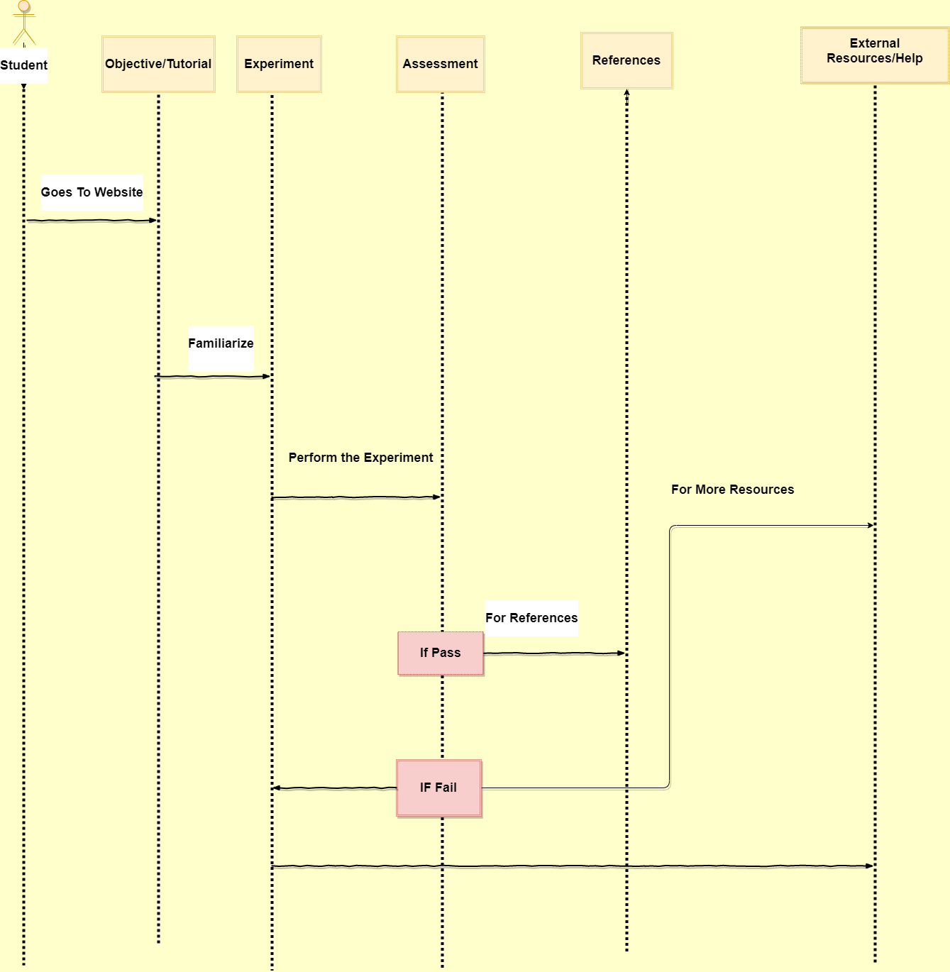

# **Design Rationale**

1. **Trying to run the Experiments:**
2. **Setting up a Virtual Machine on Ubuntu 14 provided to run experiments.(It didn’t work since the Java plugin is old and only runs on old OS)**
3. **Using Firefox 5.0 (Surprising it Worked after a few T weeks)**
4. * + The experiments are designed using Vlabs color scheme.
     + As the experiments and the content already follow a format that all of the Vlabs projects must follow, we chose to also keep with the same themes.
     + We tried using Jsmol for making Molecules for making molecules in Experiment 3 (It didn’t work properly)
     + Used 3dmol for making molecules in Experiment 3
     + Using Bootstrap 4 for UI