horizontal line

Report

**Team-09**

|  |  |
| --- | --- |
| **Project Number** | 43 |
| **Project Title** | Porting Circular Dichroism Spectroscopy Virtual Lab to  Javascript |
| **Team Members** | P.Meena Raja Sree  Jalees Jahanzaib  Naren Akash R J  Mayank Goyal |
| **Client** | Mrs. Padmapriya Raman  Virtual Labs |

**About VLabs:-**

|  |  |
| --- | --- |
|  | * Virtual Labs is an initiative of MHRD, Govt.   of India to provide remote experimentation  facilities to those who do not have access  to good lab facilities.This project consists  of over 100 virtual labs with more than  1500 web-enabled experiments which are  designed for remote operation. |

**Brief Problem Statement:-**

The experiments and activities (Exp. 01 to Exp. 10) in the lab given to us are created through embedded SWF files and also depend on Jmol Java applet.The browsers do not natively support Flash and we had to download the Flash plugin. SEO and accessibility of data from the SWF file also posed a variety of problems. In today’s scenario, HTML, CSS and JavaScript combination is the most-widely used web tool. So, this project focuses on porting the Circular Dichroism Spectroscopy lab from Flash to JavaScript.

**Users Profile:-**

The primary target audiences are students and faculty members of science and engineering colleges who do not have access to good lab facilities. Highly motivated high-school students, researchers from various educational institutes, and different educational institutes may use the resources available for learning, teaching and collaborating. A great majority of the audience are assumed to be computer-literates.

**Usage Model:-**

The lab consisting of simulation-based experiments does not need additional infrastructure for conducting experiments at user premises. A computer/mobile phone with internet connectivity is enough for accessing the labs.

**System requirements:-**

1. 3Dmol.js library developed at the University of Pittsburgh, UGA for molecular visualization and interaction.
2. The website is written in HTML5, CSS and JavaScript and hence, the usage of web-browsers supporting them is recommended.

**User Interface:-**

* Users will open the website and read the overall introduction.
* Users will open the Prerequisites tab and check that the requirements are satisfied.
* Users will open and read the Objective of the experiment.
* Users will familiarize himself with Procedure of the experiment.
* Users will watch the Tutorial demo (if needed) to see how it is performed.
* Users will perform the Experiment.
* Users will understand the Observations.
* Users will take the Quiz to assess learning.
* Users will refer to the References for further learning (if needed).

**Sequence Diagram : -**

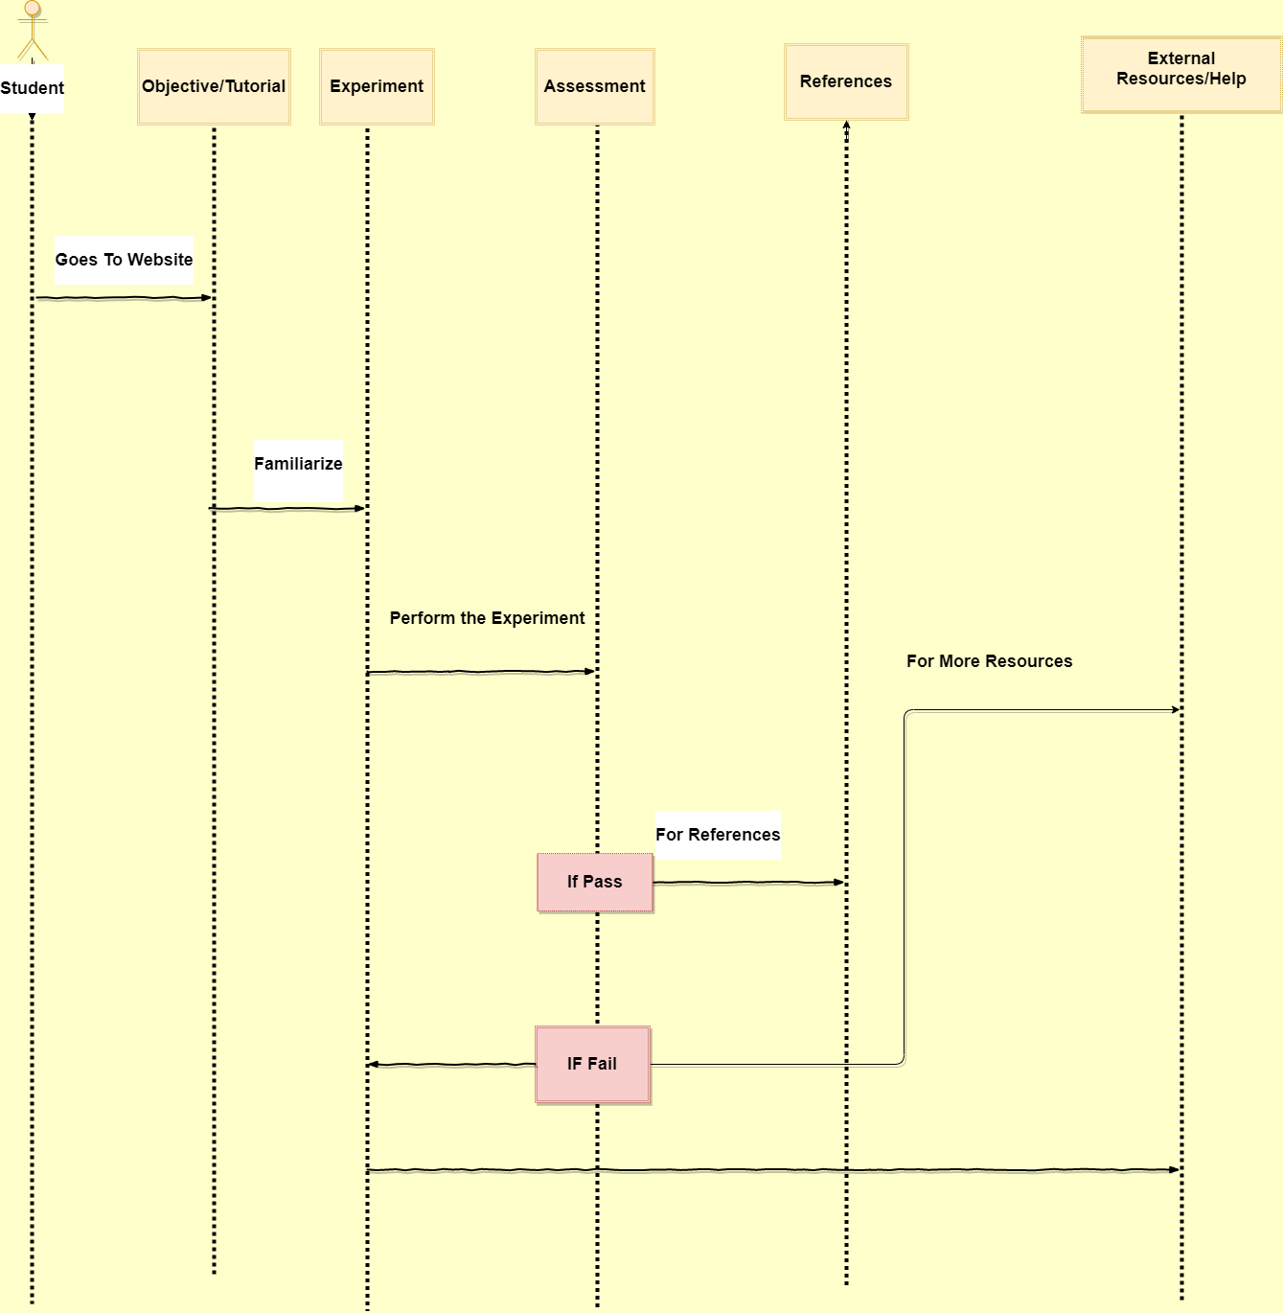

**Challenges : -**

1. Initially , Experiments didn’t work i.e., not even able to view what is there since the Java plugin is old.
2. Most of the experiments will work only on old OS (say Ubuntu 14).
3. Experiments started to Work after a few weeks after installing Virtual box and opening them using firefox (Version 5.0) in ubuntu 14.
4. Finding an open JS library to design molecules for experiment-3 is a big issue.
5. After finding libraries some of them didn’t work (like Jsmol) properly.So, used 3dmol for making molecules.
6. Understanding enough about the experiments .
7. Understanding terminology of experiments.
8. Creating an experiment by understanding whole content which is under construction (exp4).
9. Getting resources to simulate experiments for which content is not available(exp10).
10. Identifying ways about how to code animated experiments using JS.
11. Simulating animated experiments using JS.
12. Constructing Graphs,Quizzes using JS.

**Approach:-**

Commonly carried out steps to accomplish each experiment are:

* Study about the activity and performing the existing Flash-based experiment.
* lf the simulation is not-working, learn about the working from the manual provided for the experiment.
* Analyze the existing code for dependencies (esp. Flash, Jmol applet).
* Code the experiment using the new tools identified.

**UML State-Diagram:-**

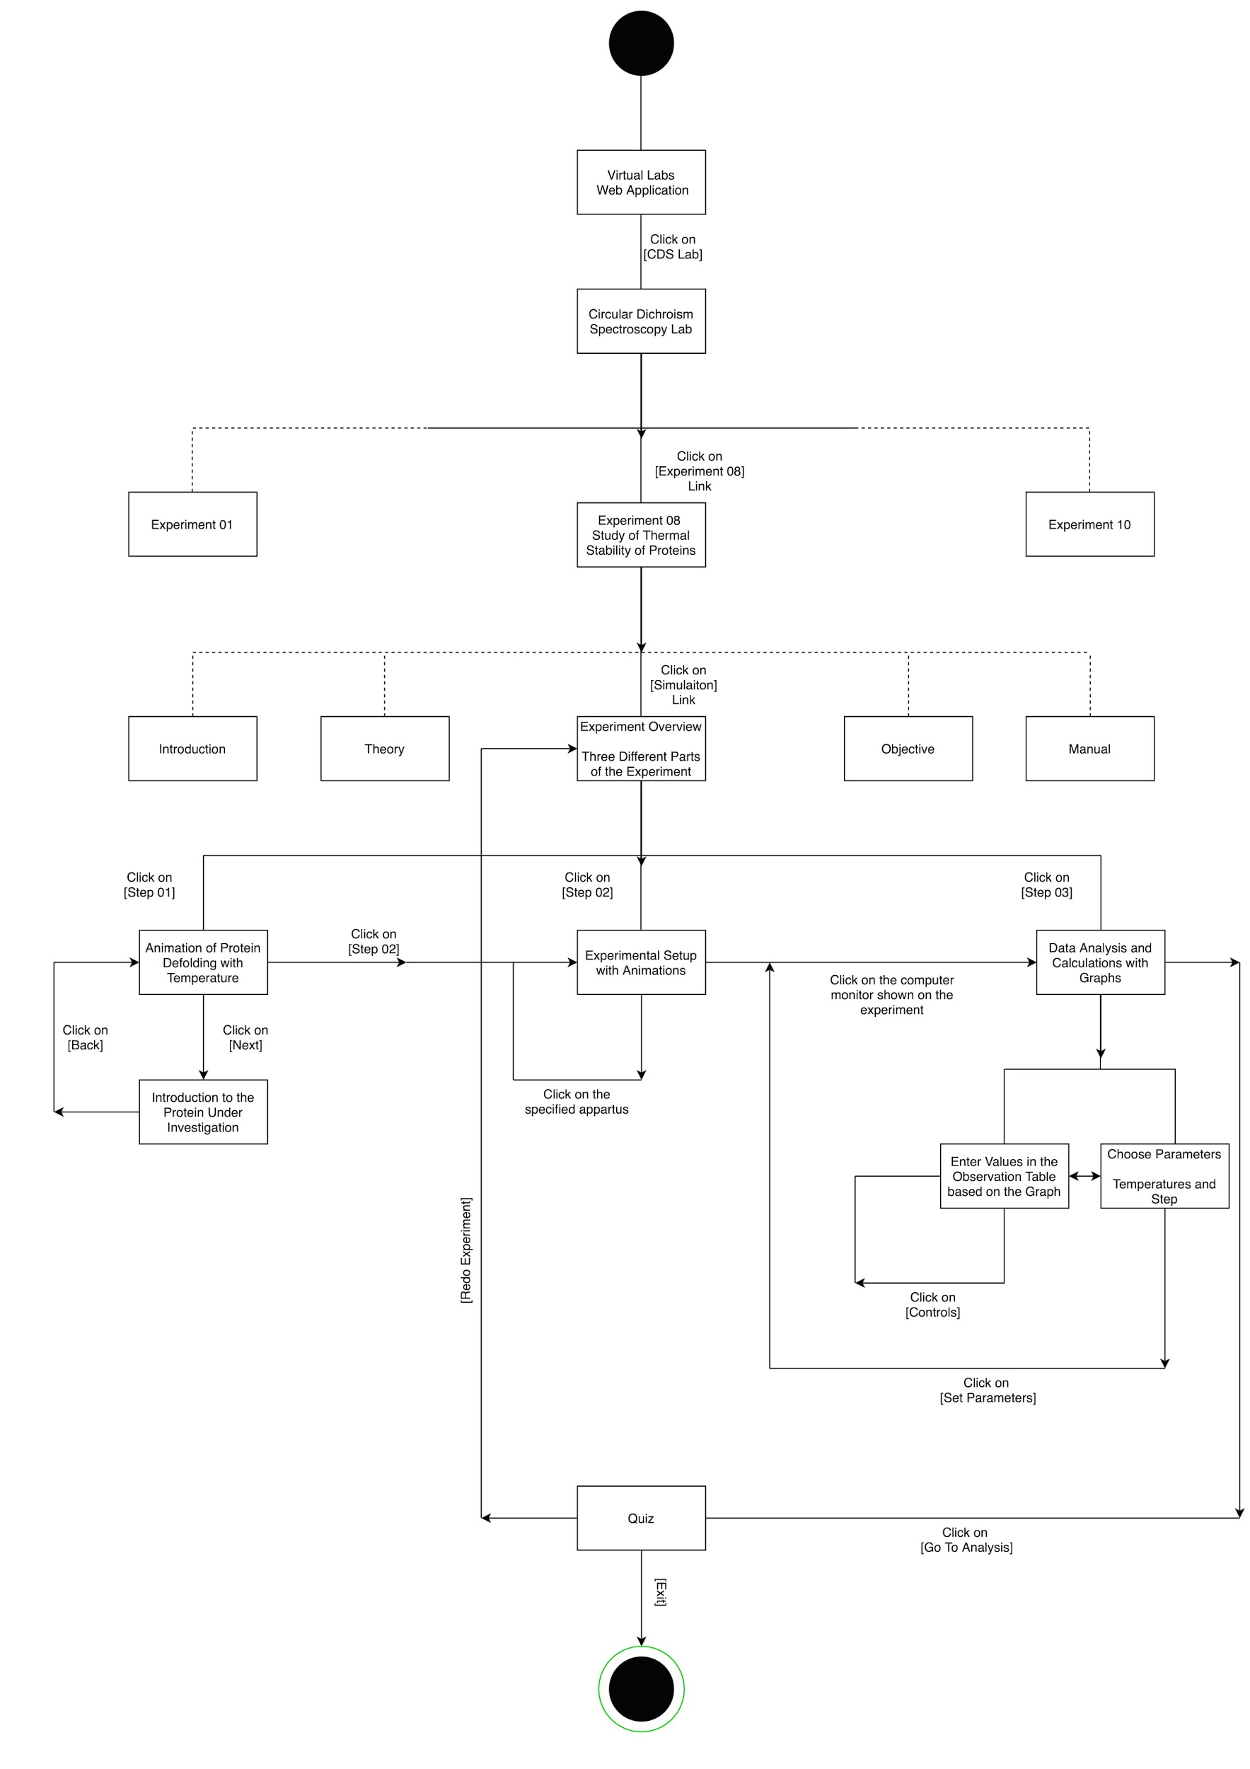

**Final Product:-**

All the experiments are designed using Vlabs colorscheme.As the experiments and the content already follow a format that all of the Vlabs projects must follow, we chose to also keep with the same themes,Using Bootstrap 4 for UI.

All the experiments will be fully JavaScript based.No installations(older version OS etc..,),plug-ins (flash,Java-Dependent),are needed to perform the experiments.Users can directly perform experiments without any difficulty as they are fully ported using JavaScript.

**Learning From the Project : -**

**Good :**

* Exploring different libraries in JS and using them.
* Learning how to perform projects in the real world.
* Meeting with client , TA’s(Mentors).
* Updating progress to them.
* Having daily goals,weekly goals.
* Setting milestones.
* Paving way towards completion of project.
* Coordination with the team.
* Team meetings.
* Dividing work among us.
* Mutual Helping.
* Executing what we have planned and reaching milestones on-time.

**Bad :**

* We didn’t have a chance to explore other coding languages, as our project is about Vlabs, and completely based on JS.