Software Requirements Specification (SRS) Document

**Porting ¹Circular Dichroism Spectroscopy¹ Virtual Lab to JavaScript**

Jalees Jahanzaib1 Mayank Goyal1 P Meena Raja Sree1 Naren Akash R J1

1lnternational lnstitute of lnformation Technology, Hyderabad

# Brief Problem Statement

Virtual Labs, an initiative of MHRD, Government off lndia has more than 1500 web-enabled experiments which are designed for remote operation. ln this project, our focus is on porting the ‘Circular Dichroism Spectroscopy' lab experiment codes from Flash and Java-dependent to JavaScript. The experiments and activities (Exp. 01 to Exp. 10) are created through embedded SWF files and also depend on Jmol Java applet.

# System requirements

sDmol.js library developed at the University of Pittsburgh, UGA for molecular visualization and interaction. The website is written in HTML5, CGGs and JavaGcript and hence, the usage of web-browsers supporting them is recommended.

# Users profile

The primary target audiences are students and faculty members of science and engineering colleges who do not have access to good lab facilities. Highly motivated high-school students, researchers from various educational institutes, and different educational institutes may use the resources available for learning, teaching and collaborating. A great majority of the audience are assumed to be computer-literates.

**Feature Requirements (described using use cases)**

|  |  |  |  |
| --- | --- | --- | --- |
| **S.No.** | **User Case**  **Name** | **Description** | **Release** |
| 01. | Experiment 01  Simulation | Porting the experiment from Flash, Jmol, Java  applet dependency to JavaScript | R2 |
| 02. | Experiment 02  Simulation | Porting the experiment from Flash, Jmol, Java  applet dependency to JavaScript | R1 |
| 03. | Experiment 03  Simulation | Porting the experiment from Flash, Jmol, Java  applet dependency to JavaScript | R1 |
| 04. | Experiment 04  Simulation | Porting the experiment from Flash, Jmol, Java  applet dependency to JavaScript | R2 |
| 05. | Experiment 05  Simulation | Porting the experiment from Flash, Jmol, Java  applet dependency to JavaScript | R2 |
| 06. | Experiment 06  Simulation | Porting the experiment from Flash, Jmol, Java  applet dependency to JavaScript | R2 |
| 07. | Experiment 07  Simulation | Porting the experiment from Flash, Jmol, Java  applet dependency to JavaScript | R1 |
| 08. | Experiment 08  Simulation | Porting the experiment from Flash, Jmol, Java  applet dependency to JavaScript | R1 |
| 09. | Experiment 09  Simulation | Porting the experiment from Flash, Jmol, Java  applet dependency to JavaScript | R1 |
| 10. | Experiment 10  Simulation | Porting the experiment from Flash, Jmol, Java  applet dependency to JavaScript | R2 |

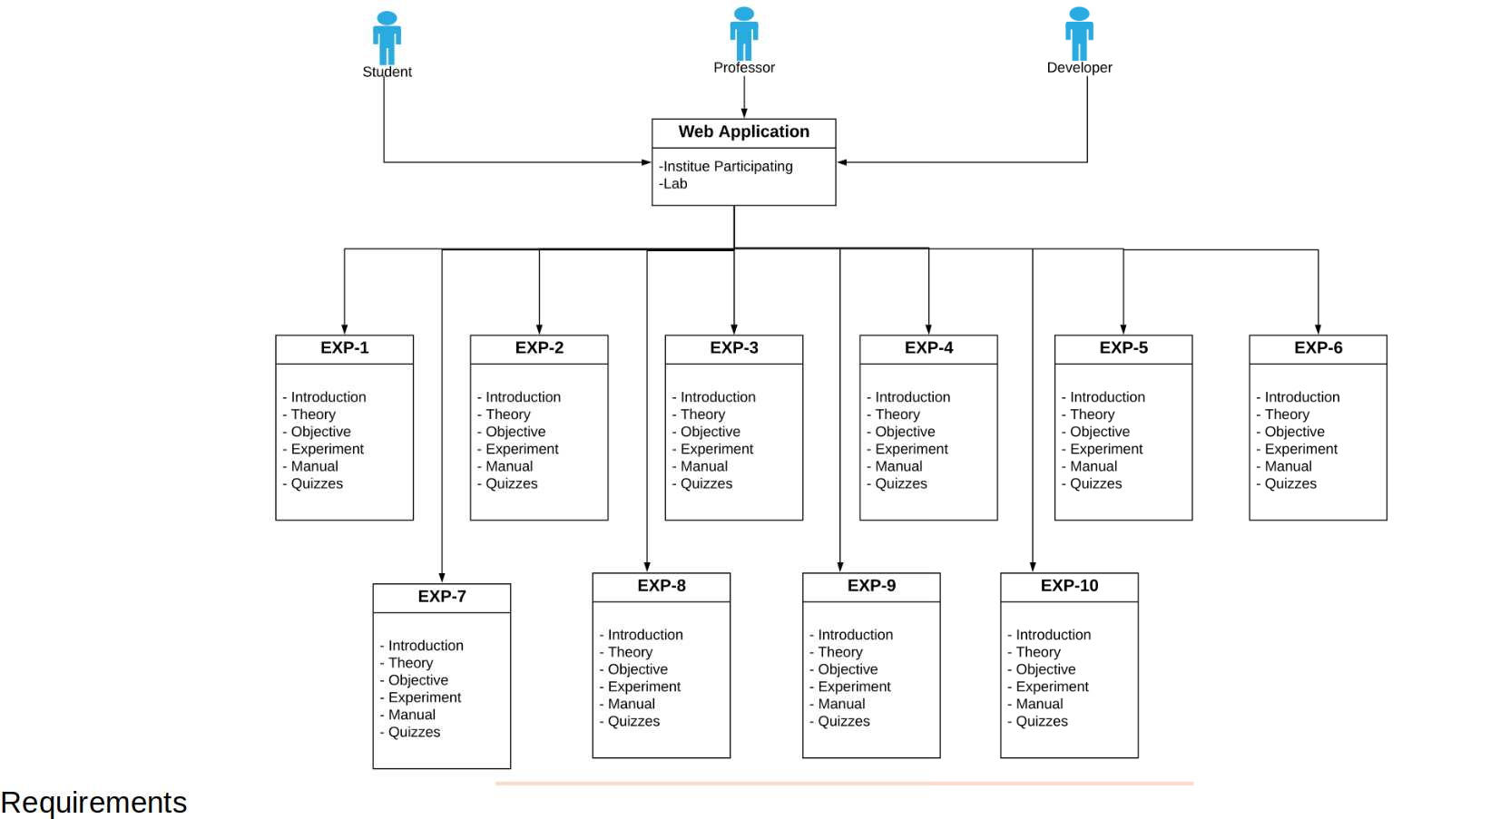**Use Case Diagram**

**Use Case Description**

|  |  |
| --- | --- |
| **Use Case Number:** | UC-01 |
| **Use Case Name:** | Experiment 01 Simulation |
| **Overview:** | Web experiment to determine the specific rotation of a sugar using a  polarimeter. |
| **Actors:** | Mayank Goyal and Jalees Jahanzaib |
| **Pre condition:** | Requires Adobe Flash plugin support |
| **Flow:** | Main (success) Flow:   1. Study about the activity by simulating the existing Flash-based experiment. 2. Analyze the existing code for dependencies (esp. Flash, Jmol applet). 3. Code the experiment using the new tools identified. |
|  | Alternate Flows: lf the simulation is not-working, learn about the working from  the manual provided for the experiment. |
| **Post Condition:** | The experiment will be fully JavaScript based. |

|  |  |
| --- | --- |
| **Use Case Number:** | UC-02 |
| **Use Case Name:** | Experiment 02 Simulation |
| **Overview:** | Web-based laboratory experiment to to understand the effect of chiral substances on plane polarized light as a function of wavelength |
| **Actors:** | Naren Akash R J and P Meena Raja Sree |
| **Pre condition:** | Requires Adobe Flash plugin support |
| **Flow:** | Main (success) Flow:   1. Study about the activity by simulating the existing Flash-based experiment. 2. Analyze the existing code for dependencies (esp. Flash, Jmol applet). 3. Code the experiment using the new tools identified. |
|  | Alternate Flows: lf the simulation is not-working, learn about the working from the manual provided for the experiment. |
| **Post Condition:** | The experiment will be fully JavaScript based. |

|  |  |
| --- | --- |
| **Use Case Number:** | UC-03 |
| **Use Case**  **Name:** | Experiment 03 Simulation |
| **Overview:** | Simulate an experiment to To study the Optical Rotatory Dispersion (ORD) of some chiral substances. |
| **Actors:** | Mayank Goyal and P Meena Raja Sree |
| **Pre condition:** | Requires Adobe Flash plugin and Jmol Java applet support |
| **Flow:** | Main (success) Flow:   1. Study about the activity by simulating the existing Flash-based experiment. 2. Analyze the existing code for dependencies (esp. Flash, Jmol applet). 3. Code the experiment using the new tools identified. |
|  | Alternate Flows: lf the simulation is not-working, learn about the working from the manual provided for the experiment. |
| **Post Condition:** | The experiment will be fully JavaScript based. |

|  |  |
| --- | --- |
| **Use Case Number:** | UC-04 |
| **Use Case Name:** | Experiment 04 Simulation |
| **Overview:** | Simulation of an experiment to To study the Circular Dichroism of some substances with chiral chromophores. |
| **Actors:** | Naren Akash R J and Jalees Jahanzaib |
| **Pre condition:** | The experiment is non-existent |
| **Flow:** | Main (success) Flow:   1. Study about the activity by simulating the existing Flash-based experiment. 2. Analyze the existing code for dependencies (esp. Flash, Jmol applet). 3. Code the experiment using the new tools identified. |
|  | Alternate Flows: lf the simulation is not-working, learn about the working from the manual provided for the experiment. |
| **Post Condition:** | The experiment will be fully JavaScript based. |

|  |  |
| --- | --- |
| **Use Case Number:** | UC-05 |
| **Use Case Name:** | Experiment 05 Simulation |
| **Overview:** | Web-based simulation of an experiment to To Study the operational details of a CD spectrometer. |
| **Actors:** | P Meena Raja Sree and Jalees Jahanzaib |
| **Pre condition:** | Requires Adobe Flash plugin support |
| **Flow:** | Main (success) Flow:   1. Study about the activity by simulating the existing Flash-based experiment. 2. Analyze the existing code for dependencies (esp. Flash, Jmol applet). 3. Code the experiment using the new tools identified. |
|  | Alternate Flows: lf the simulation is not-working, learn about the working from the manual provided for the experiment. |
| **Post Condition:** | The experiment will be fully JavaScript based. |

|  |  |
| --- | --- |
| **Use Case Number:** | UC-06 |
| **Use Case Name:** | Experiment 06 Simulation |
| **Overview:** | Simulation of an experiment to Study the effect of Secondary Structure elements on CD spectrum of proteins.. |
| **Actors:** | Mayank Goyal and Naren Akash R J |
| **Pre condition:** | Requires Adobe Flash plugin support |
| **Flow:** | Main (success) Flow:   1. Study about the activity by simulating the existing Flash-based experiment. 2. Analyze the existing code for dependencies (esp. Flash, Jmol applet). 3. Code the experiment using the new tools identified. |
|  | Alternate Flows: lf the simulation is not-working, learn about the working from the manual provided for the experiment. |
| **Post Condition:** | The experiment will be fully JavaScript based. |

|  |  |
| --- | --- |
| **Use Case Number:** | UC-07 |
| **Use Case Name:** | Experiment 07 Simulation |
| **Overview:** | Simulation of an experiment to deconvolute the CD spectrum of a given protein solution and to classify it in terms of its secondary structure elements. |
| **Actors:** | Jalees Jahanzaib and P Meena Raja Sree |
| **Pre condition:** | Requires Adobe Flash plugin support |
| **Flow:** | Main (success) Flow:   1. Study about the activity by simulating the existing Flash-based experiment. 2. Analyze the existing code for dependencies (esp. Flash, Jmol applet). 3. Code the experiment using the new tools identified. |
|  | Alternate Flows: lf the simulation is not-working, learn about the working from the manual provided for the experiment. |
| **Post Condition:** | The experiment will be fully JavaScript based. |

|  |  |
| --- | --- |
| **Use Case Number:** | UC-08 |
| **Use Case Name:** | Experiment 08 Simulation |
| **Overview:** | Simulation of an experiment to study the thermal stability of proteins. |
| **Actors:** | Naren Akash R J and Mayank Goyal |
| **Pre condition:** | Requires Adobe Flash plugin support |
| **Flow:** | Main (success) Flow:   1. Study about the activity by simulating the existing Flash-based experiment. 2. Analyze the existing code for dependencies (esp. Flash, Jmol applet). 3. Code the experiment using the new tools identified. |
|  | Alternate Flows: lf the simulation is not-working, learn about the working from the manual provided for the experiment. |
| **Post Condition:** | The experiment will be fully JavaScript based. |

|  |  |
| --- | --- |
| **Use Case Number:** | UC-09 |
| **Use Case Name:** | Experiment 09 Simulation |
| **Overview:** | Web-based simulation of an experiment to study the effect of chemical denaturants on protein stability. |
| **Actors:** | Naren Akash R J and Jalees Jahanzaib |
| **Pre condition:** | Requires Adobe Flash plugin support |
| **Flow:** | Main (success) Flow:   1. Study about the activity by simulating the existing Flash-based experiment. 2. Analyze the existing code for dependencies (esp. Flash, Jmol applet). 3. Code the experiment using the new tools identified. |
|  | Alternate Flows: lf the simulation is not-working, learn about the working from the manual provided for the experiment. |
| **Post Condition:** | The experiment will be fully JavaScript based. |

|  |  |
| --- | --- |
| **Use Case Number:** | UC-10 |
| **Use Case Name:** | Experiment 10 Simulation |
| **Overview:** | Simulation of an experiment to study the comparison between protein unfolding and protein aggregation in the presence of chemical denaturing agents. |
| **Actors:** | P Meena Raja Sree and Mayank Goyal |
| **Pre condition:** | Requires Adobe Flash plugin support |
| **Flow:** | Main (success) Flow:   1. Study about the activity by simulating the existing Flash-based experiment. 2. Analyze the existing code for dependencies (esp. Flash, Jmol applet). 3. Code the experiment using the new tools identified. |
|  | Alternate Flows: lf the simulation is not-working, learn about the working from the manual provided for the experiment. |
| **Post Condition:** | The experiment will be fully JavaScript based. |