09/06/2024
Environment: pdcocp4stg02_mbp_az_6d
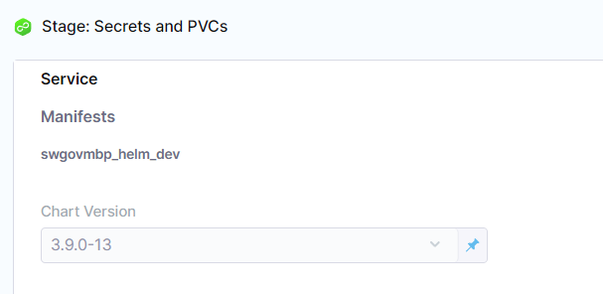
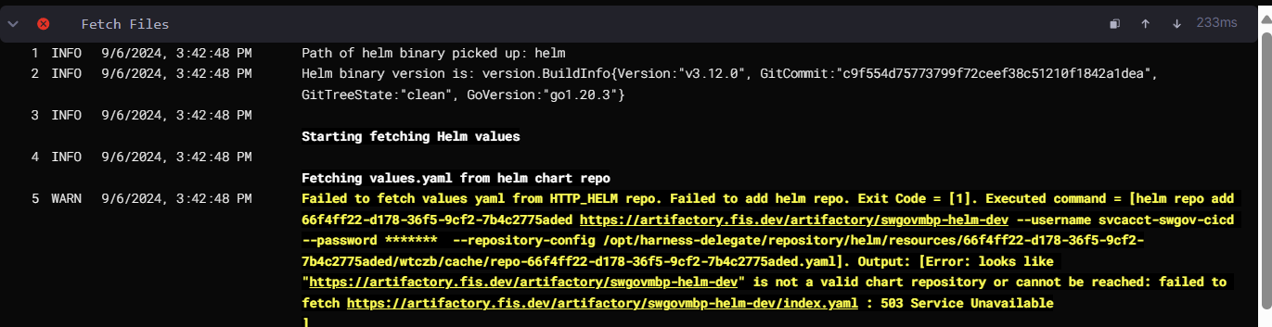

09/05/2024
Environment: pdcocp4stg01_mbp_cax_uat
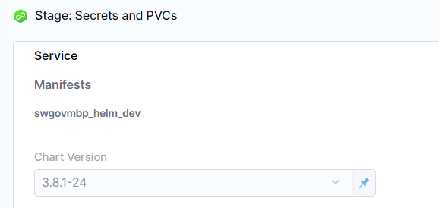
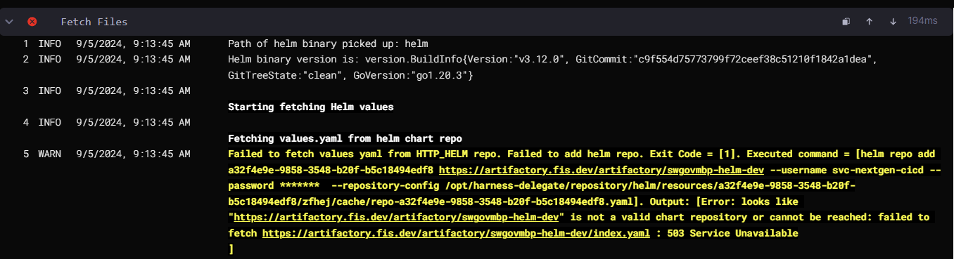

Environment: useast2mbp1_mbp_amx_qa
