Jenkins Node Setup

CM Questionnaire
Get the following details to configure Jenkins node:
- Dev team needs to provide FIS Dev segment server details(IP/Host Name)
- If the server is a Windows machine:
a. Dev team needs to provide a project-specific service account and Machine should have JDK and GIT installed
b. It should be in the administrator group.
c. Service Account should have RDC access(RDC creates a user profile )
If the server is a Linux machine:
1. "jenkins" user needs to be created.
- Admin access to CM resource(Who is working on the request) to configure Jenkins slave.
- One/Two hours of Palnview bucket.
- Install Java-1.8, latest version of GitBash, Git LFS client software.
- Jira, Bitbucket & Jenkins project details.

Windows Node Creation:
Windows Server: vwmazaligne-cli.fisdev.local
Request Number: CMSUPPORT-58580
JIRA Project: https://spdissues.fnis.com/projects/AGN/
Create a new node:
Login to the windows machine and create Jenkins_Workspace.
Login to Jenkins → Manage Jenkins → Manage Nodes → New Node
Copy the configuration from existing node "WBLD05"
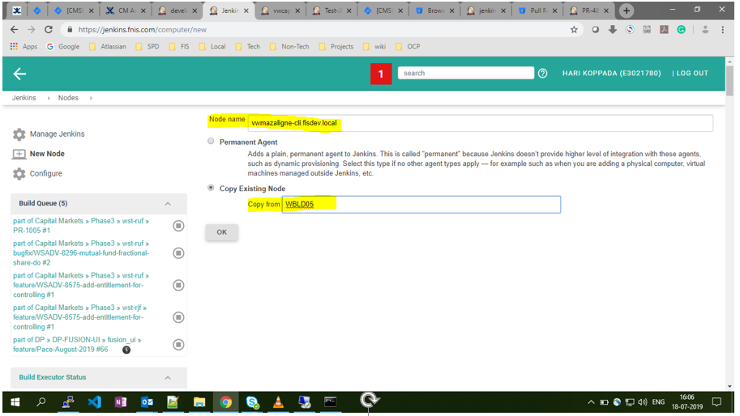

Configure the Node:
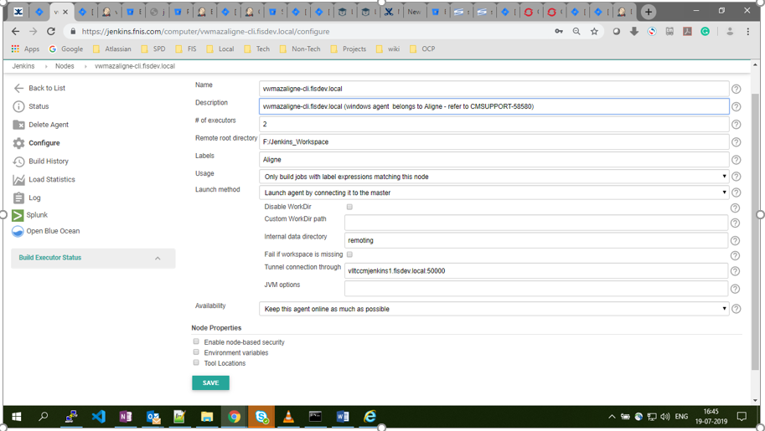
Details:
Name: vwmazaligne-cli.fisdev.local
Description: windows agent belongs to Aligne - refer to CMSUPPORT-58580
# of executors: 2
Remote root directory: F:/jenkins_workspace(Depends on server drives)
Labels: JIRA project name/Key
Usage: Only Build jobs
Launch method: Launch agent by connecting it to the master
Tunnel connection through: vlltccmjenkins1.fisdev.local:50000
Availability: Keep this agent online as much as possible
Connect agent to Jenkins one of these ways:
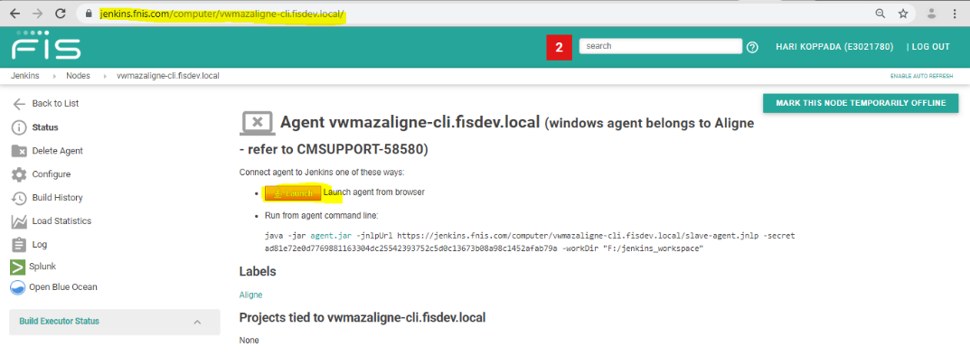
Launch agent from browser
Access the agent URL(https://jenkins.fnis.com/computer/vwmazaligne-cli.fisdev.local/ ) from the node through RDC click on Launch to download the slave-agent.jnlp file.
Copy slave-agent.jnlp file to Jenkins_Workspace → Open cmd(as admin) change to Jenkins_Workspace folder → run the below command
javaws.exe -verbose F:\jenkins_workspace\slave-agent.jnlp
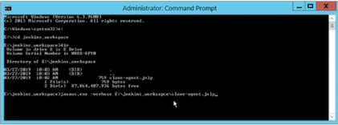

Or to copy files from your downloads to vm
$ xcopy jenkins-agent.jnlp \\vwmazvalutec.fisdev.local\F$
This command establishes jnlp:
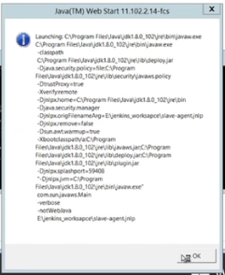

Lanches the applet:
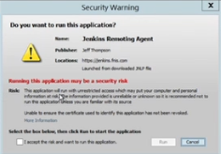

Establish the connectivity to master
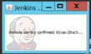
Wait for a while to create the applet as a service
Go to File → Install as a service → OK
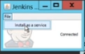 → 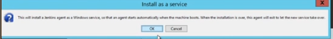

Verify whether Jenkins agent added to Services or not
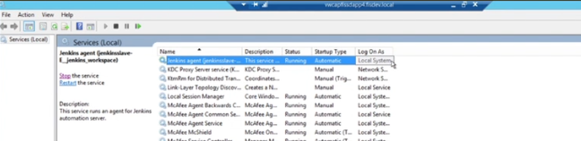
Add Service account user to service:
Right Click on Jenkins agent → Log On Tab → The Account →
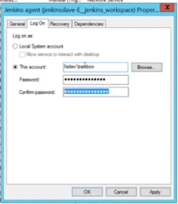
The Account is fisdev/SA which is given by Dev team.
OK → Restart the service.
Jenkins slave is available now(check it from Jenkins URL)
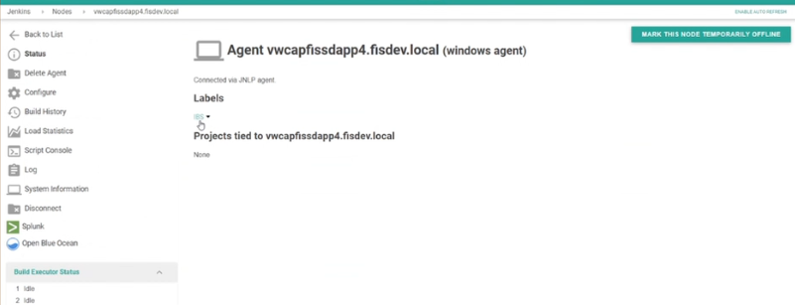

Create a test pipeline and test the connectivity:
Example Jenkins plan: https://jenkins.fnis.com/job/Configuration-Management/job/Research/job/Test-JNLP-windows-client/configure
Pipeline code:
node('IBS'){
echo "Test the JNLP Windows agent connectivity"
bat "dir && cd E:/jenkins_workspace && dir"
bat "git --version && git lfs version"
}
**********************************************************************************

Unix Jenkins Node Creation:
Login to Jenkins server: vlltccmjenkins1.fisdev.local → switch to Jenkins user → copy id_rsa.pub key
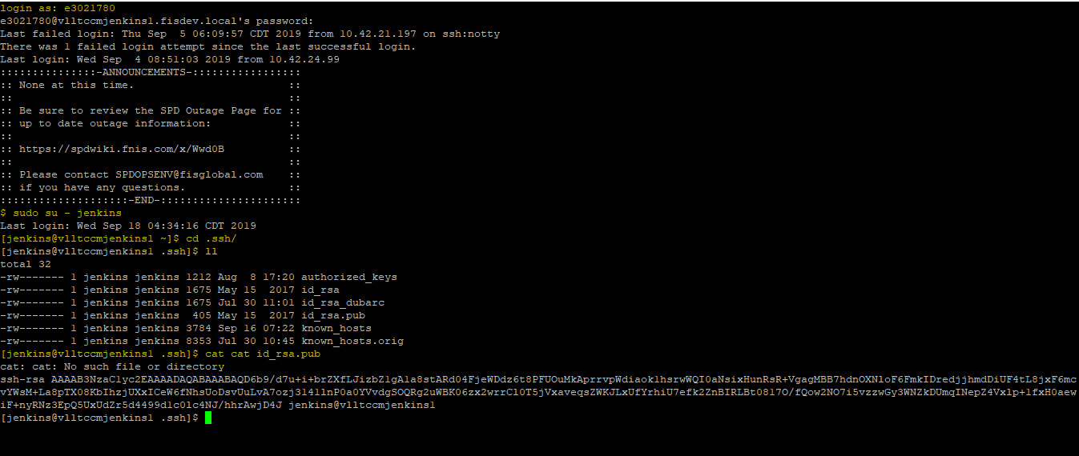

Method-1: (it's useful when you can switch to service account )
Log in to Client Linux server(10.7.76.42) via Putty → switch to the service account given by Dev team. (Jenkins/other service accounts)
"jenkins" user ID creation is a mandatory step to proceed further, some exceptional cases we configure with the user's custom service account like below
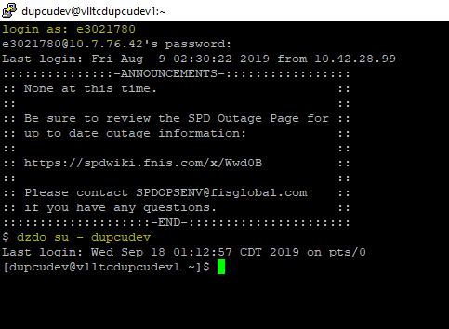
If .ssh folder is not available in service account home directory, create .ssh directory.
Create authorized_keys and paste the public key copied from Jenkins server
Change the .ssh folder privileges to 700
switch to Jenkins server and try ssh connectivity to the Client-server → We can log in without a password.
ssh -i id_rsa dupcudev@vlltcdupcudev1.fisdev.local
If jenkins user already available
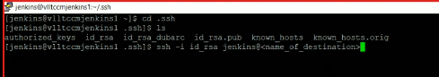

Method-2
If unable to login without password with Method 1 process:
Generate ssh keys on the client machine(ssh-keygen -t rsa)
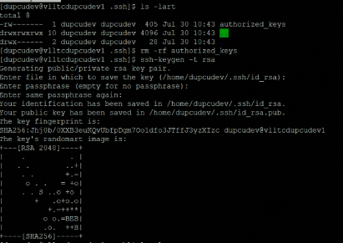
Create authorized_keys and copy id_rsa public key to authorized_keys file.
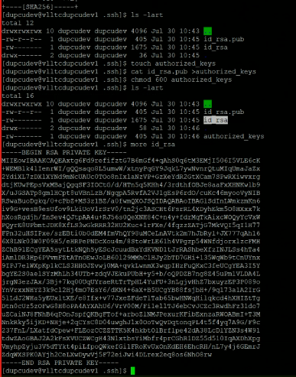
Switch to Jenkins server and create id_rsa_dubrc file(id_rsa file with client name) and paste the above key and change the permission to 600 → Login with ssh again.
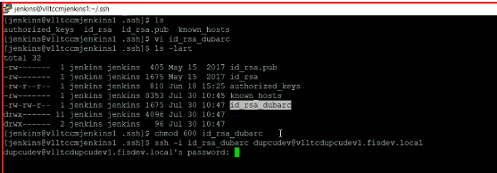

or ssh-copy-id -i id_rsa.pub jenkins@vlmazcrfusion01.fisdev.local
Method 3:
ssh-copy will copy the Jenkins user id_rsa.pub key to the client Linux machine
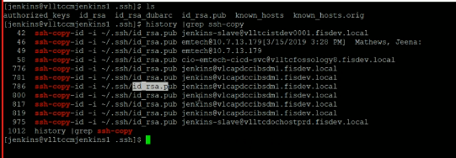
example: ssh-copy-id -i id_rsa.pub jenkins@vlmazjenkinsc2p.fisdev.local
we can use when we have Jenkins user password only
Create a node in Jenkins:
Once Jenkins to client Linux server connectivity established, Login to Jenkins → Manage Jenkins → Manage Nodes → New Node(use "packer node" as a reference for Linux node configuration)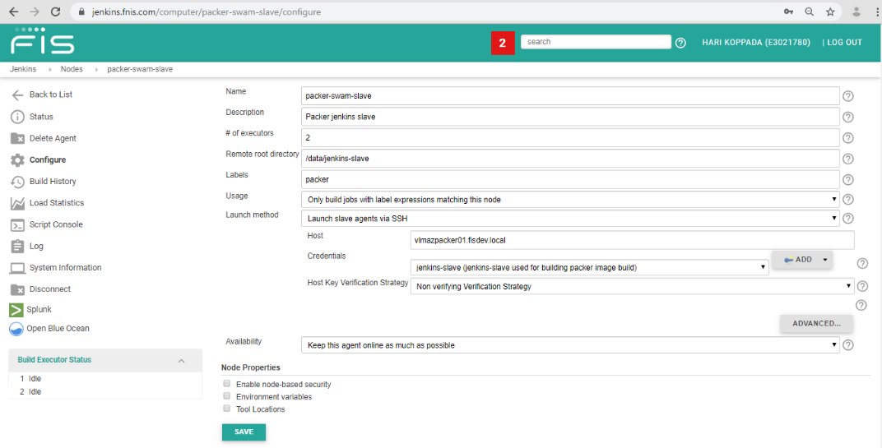
If Dev team provides different user than "jenkins", CM Team needs to add new Jenkins credentials
if user is jenkins use " jenkins (jenkins ID used for ssh connectivity to standalone vm's)" credentails, no need to create new ids.
Login to Jenkins → Manage Jenkins → Configure Credentials → Credentials → System → Global credentials (unrestricted) → Add Credentials → Kind: SSH User Name And Private Key.
Private key: From client Linux server - /home/user_home/.ssh/id_rsa key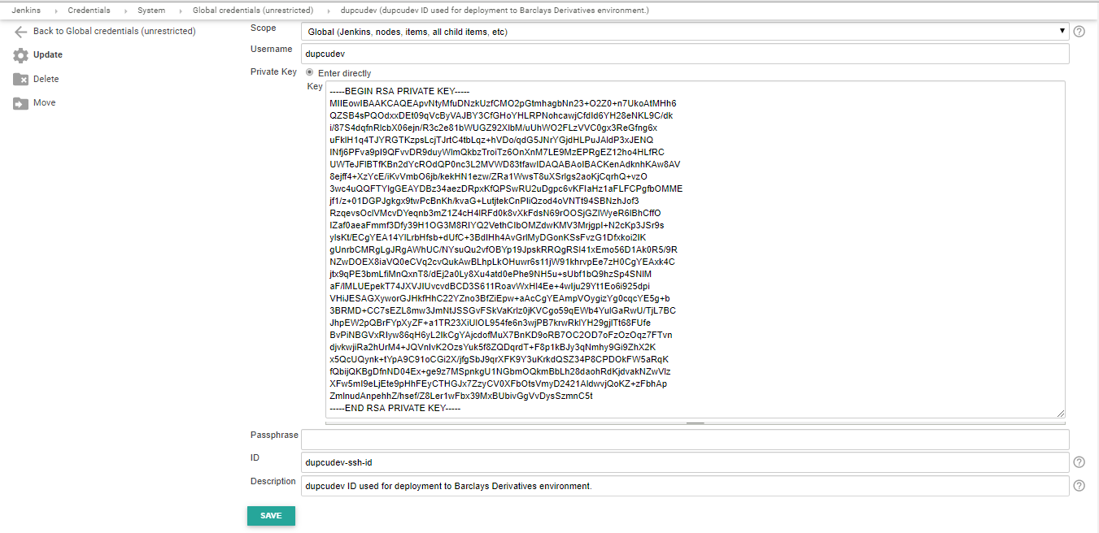

If the user is "jenkins", no need to create new Jenkins credentials. use existing credentials
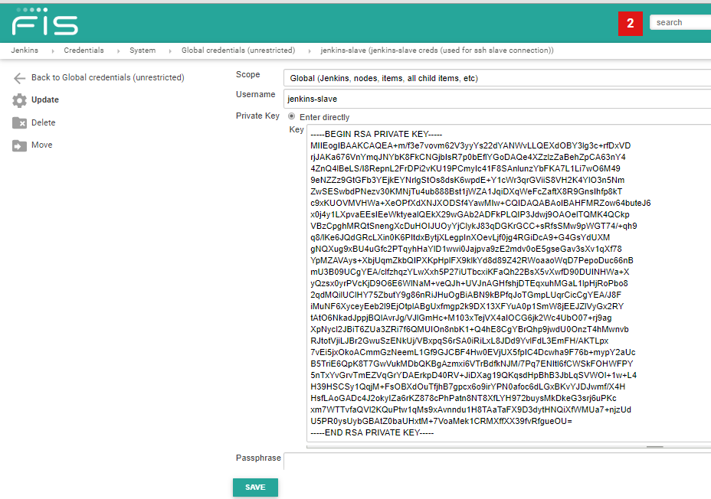

Node Creation:
Login to Jenkins → Manage Jenkins → New Node
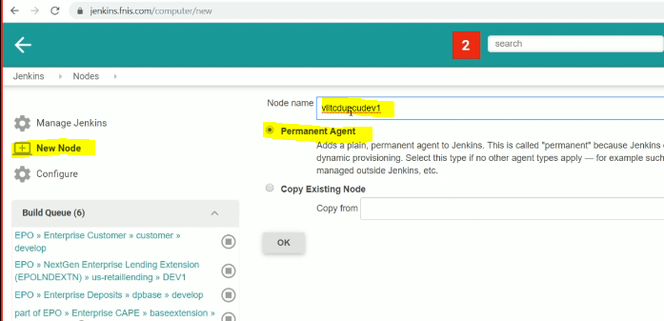
Update the configuration: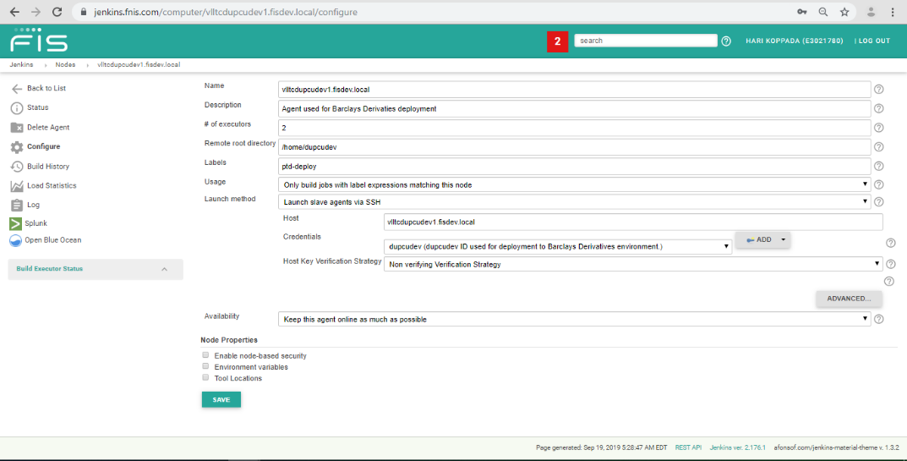

Select the node from Jenkins portal and check the logs
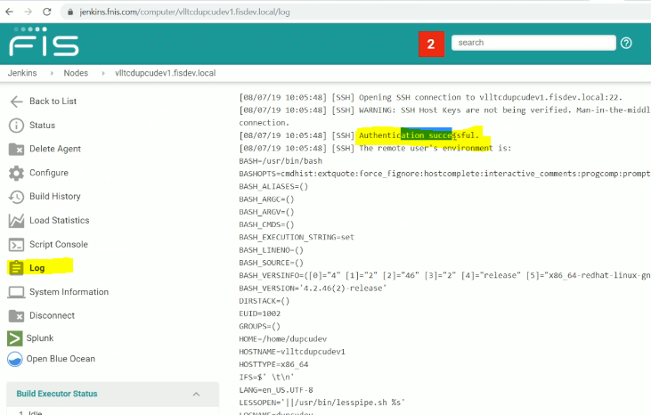

Create a test pipeline in the project and update the jenknsfile script
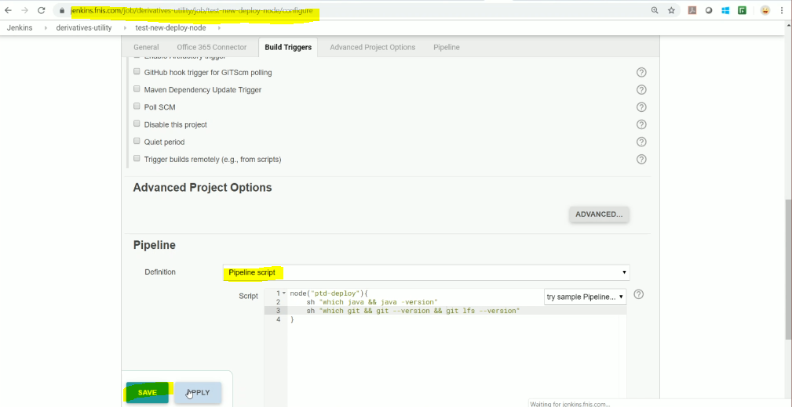

If the server is facing any issues while fetching the path, update the path in Jenkins node configuration
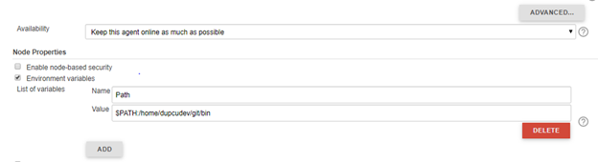

Client Software Installation:
If git is not available follow the steps
login into client machine and access
wget http://vlcmartifact.fisdev.local:8082/artifactory/fis-cd-local/utilities/git/2.22.0/git-2.22.0.tar.gz
If unable to download the file
Update .bash_profile file with proxy details.
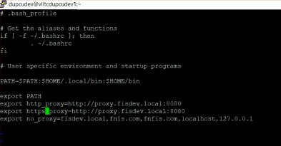
untar the git file tar zxf git2.22.0.tar.gz
cd to git directory
check the git version in it "./git --version"
update the git path in .bash_profile file
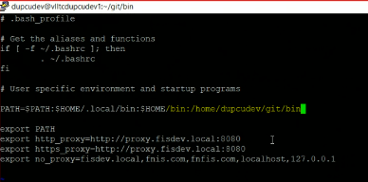
check git version
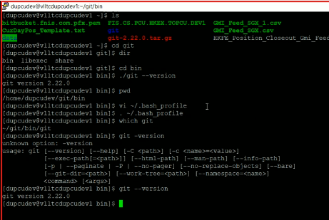
Notes:
-> Megha handling all windows RDP access from ops team.
-> password change policy should be changed to 90 days so Dev team changes the password for every 90 days.
-> Permissions: 700 for ssh folder and 600 for authorized keys
→ SNOW Request: Technology Service Catalog -> Global Development Operations (FISDEV) -> FISDEV Support Requests -> General Inquiry Request
If project specific Service account is not availabel for windows server, Dev team need to create a project-specific service account from SNOW portal https://atyourserviceportal.service-now.com
the service account needs to be created under fisdev.local domain.
→ Jenkins slave - service account should be in fisdev.local

