**Pod Status Alerts**

Alert Name : Pod CrashLoopBackOff

PromQL : count(kube_pod_container_status_waiting_reason{reason="CrashLoopBackOff", namespace="nab"} == 1) by (pod)

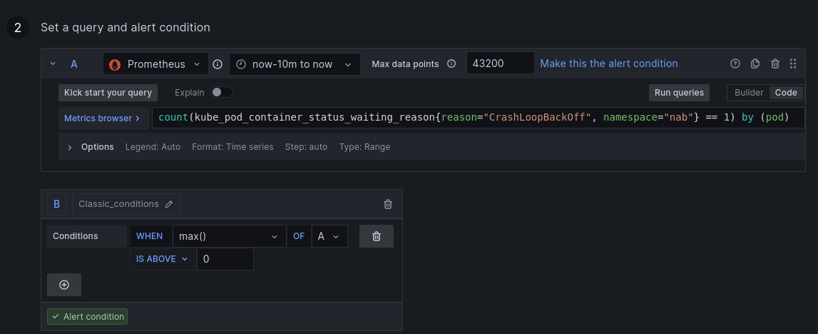

Alert Name : Pod ImagePullBackOff

PromQL : count(kube_pod_container_status_waiting_reason{reason="ImagePullBackOff", namespace="nab"} == 1) by (pod)

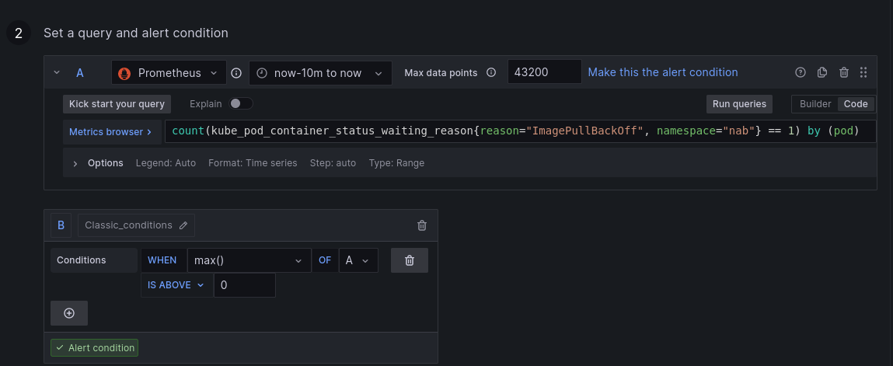

Alert Name : Pod Pending

PromQL : count(kube_pod_status_phase{ phase="Pending", namespace="nab"} == 1) by (pod)

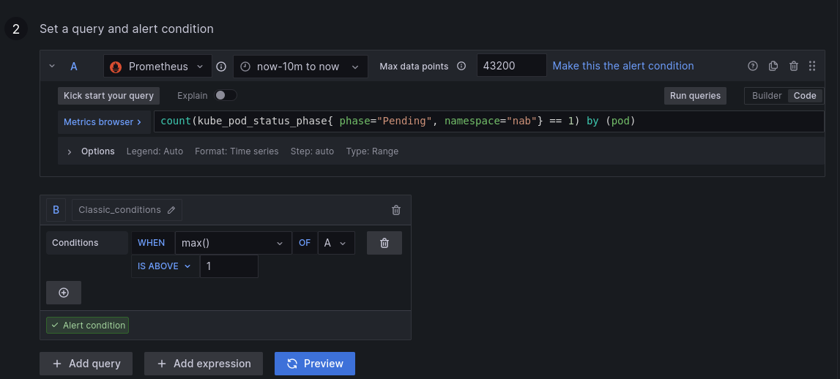

Alert Name : Pod Failed

PromQL : count(kube_pod_status_phase{ phase="Failed", namespace="nab"} == 1) by (pod)

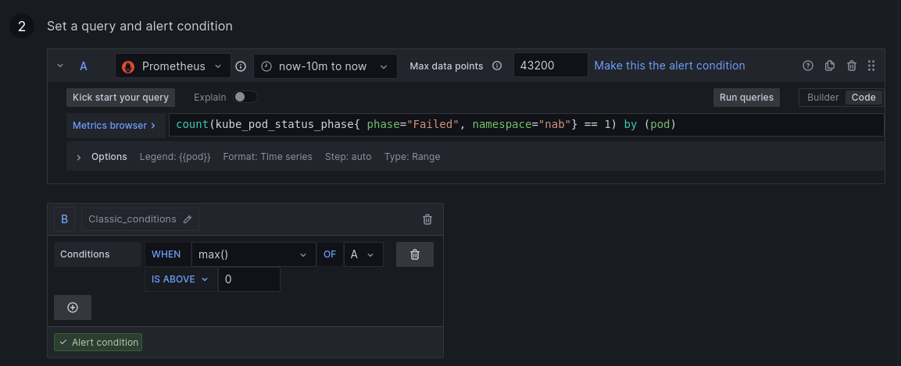

Alert Name : Pod Restart

PromQL : count(kube_pod_status_phase{ phase="Restart"} == 1) by (pod)

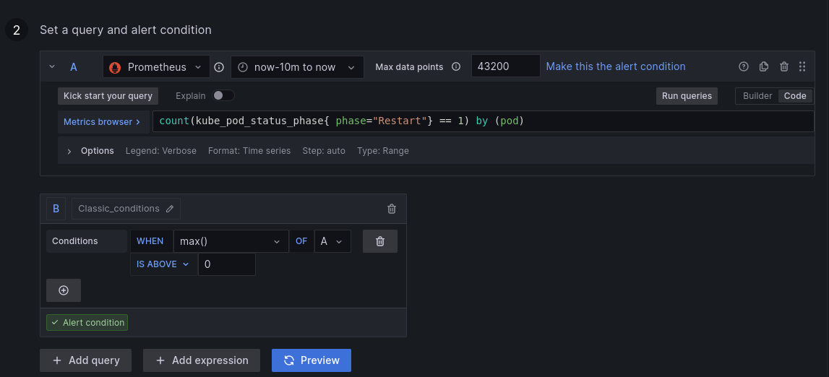

**Node Resources Alerts (EKS & Mysql Server)**

Alert Name : Node CPU Alert

PromQL : 100 - (avg(irate(node_cpu_seconds_total{mode="idle"}[30m])) * 100)

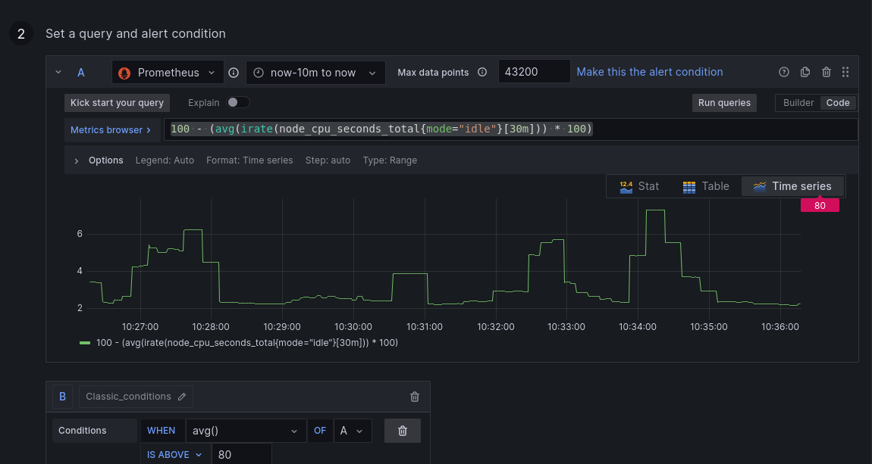

Alert Name : Node Memory Alert

PromQL : (node_memory_MemFree_bytes / node_memory_MemTotal_bytes) * 100

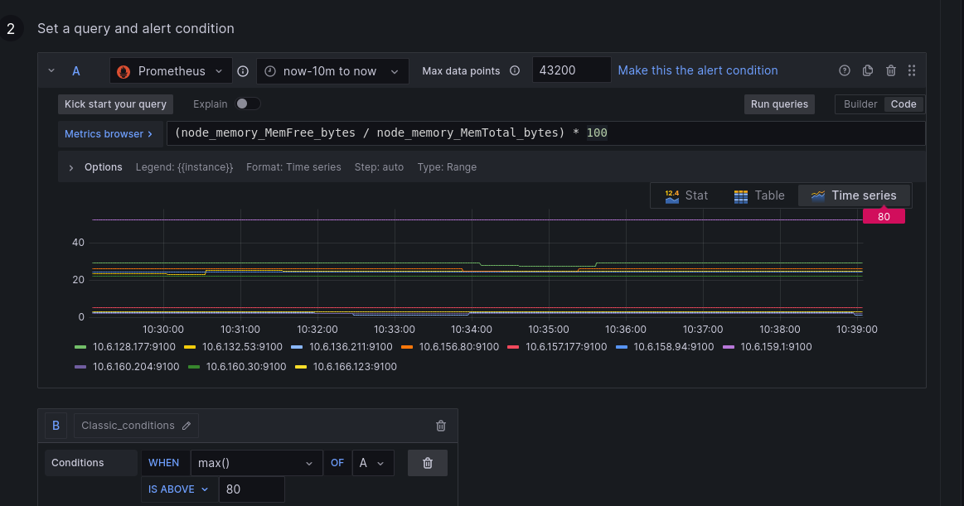

Alert Name : Node Disk Usage Alert

PromQL : 100 - (100 * ((node_filesystem_avail_bytes{mountpoint="/",fstype!="rootfs"} ) / (node_filesystem_size_bytes{mountpoint="/",fstype!="rootfs"})

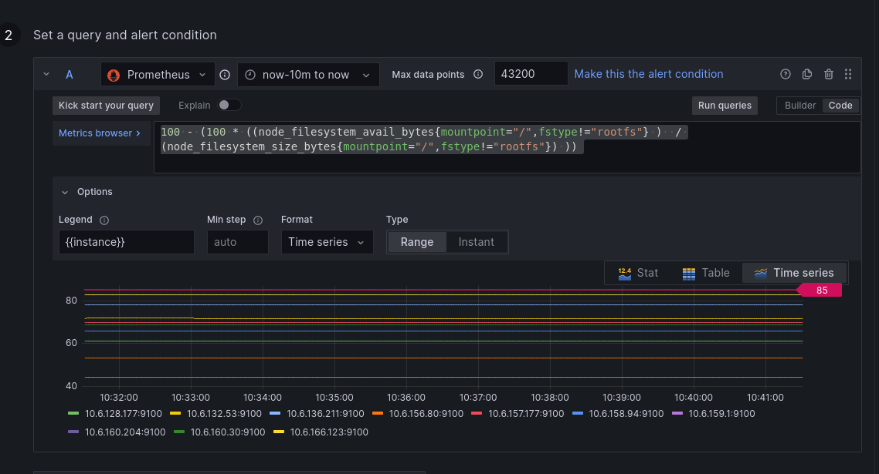

**MySql Connections and Threads Connected Alerts (mysql exporter)**

Alert Name : Mysql connections alert

PromQL : sum(mysql_global_status_max_used_connections{job=~"mysql_exporter", instance=~"10\\.6\\.132\\.191:9104"})

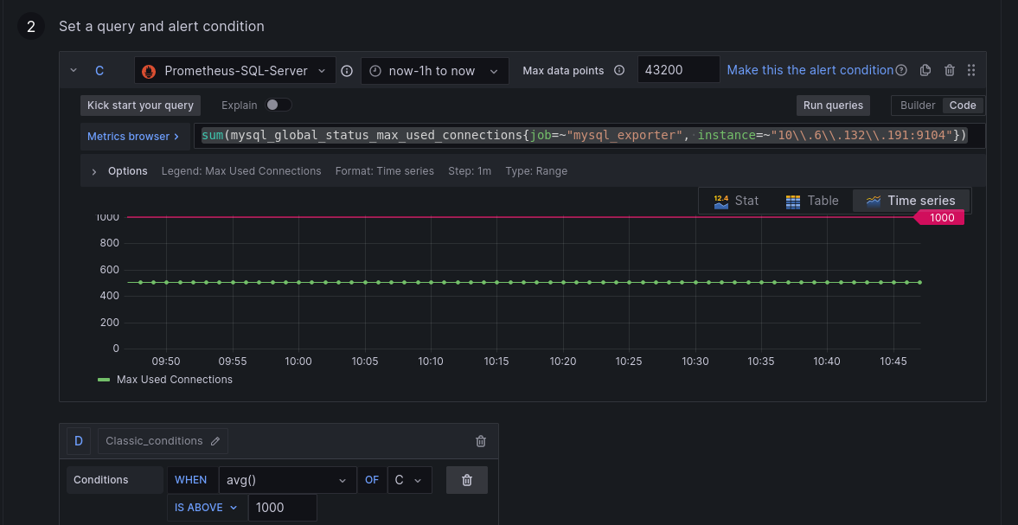

Alert Name : Mysql threads connected alert

PromQL : sum(max_over_time(mysql_global_status_threads_connected{job=~"mysql_exporter", instance=~"10\\.6\\.132\\.191:9104"}[15s]))

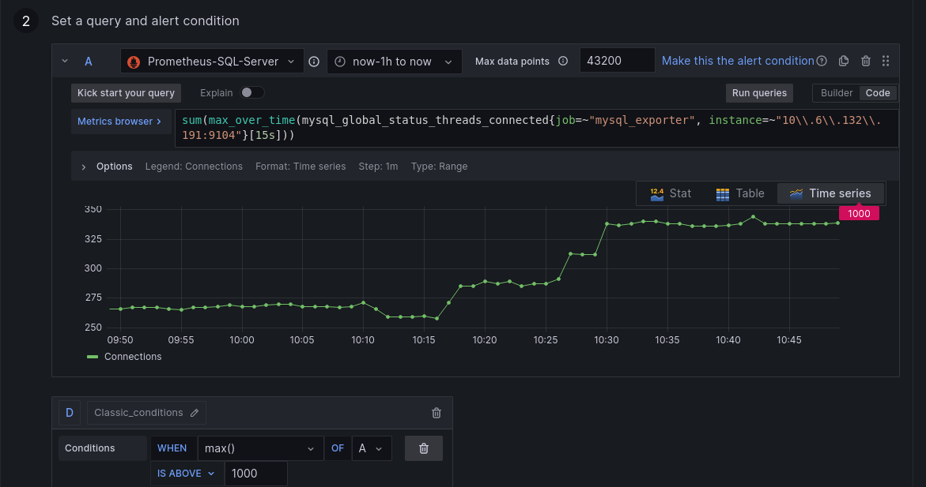

**Template and annotations**

**Template :**

| {{ define "alert_severity_prefix_emoji" -}}  {{- if ne .Status "firing" -}}  :white_check_mark:  {{- else if eq .CommonLabels.severity "critical" -}}  :red_circle:  {{- else if eq .CommonLabels.severity "warning" -}}  :warning:  {{- end -}}  {{- end -}}  {{ define "slack1" }}  {{- range .Alerts -}}  *Alert*: {{ .Labels.alertname }}  Status: {{ if eq .Status "firing" }}ALERT{{ else }}RESOLVED{{ end }}  Severity: {{ .Labels.severity }}  Description: {{ .Annotations.description }}  {{ end }}  {{ end }} |
| --- |

**Annotations (description)**

| {{ with $values }}  {{ range $k, $v := . }}  Instance: {{$v.Labels.instance}}  Current Value: {{ $v }}  {{ end }}  {{ end }} |
| --- |