**KEYCLOAK SETUP**

**Steps to install keycloak on amazon linux ec2 server(standalone mode)**

**Pre-requisite-**

* Sudo yum update
* wget <https://github.com/keycloak/keycloak/releases/download/21.0.1/keycloak-21.0.1.tar.gz>
* tar -zxf /tmp/keycloak-21.0.1.tar.gz

Move the keycloak directory inside /opt folder-

* mv keycloak-21.0.1 /opt
* cd /opt/keycloak-21.0.1

You will see folder structure like this-

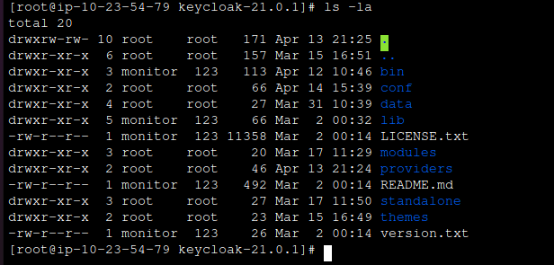

Now, **Install JDBC driver for MYSQL-**

* sudo wget https://dev.mysql.com/get/Downloads/Connector-J/mysql-connector-java-8.0.22.tar.gz
* sudo tar xzf mysql-connector-java-8.0.22.tar.gz

**Install java 11JDK**

* sudo yum install java-11-openjdk
* sudo amazon-linux-extras install java-openjdk11
* java -version

Once this is done-

* **Cd <keycloak-installation-directory>**/modules/com/mysql/main
* Vi module.xml

<?xml version='1.0' encoding='UTF-8'?>

<module xmlns="urn:jboss:module:1.1" name="com.mysql">

<resources>

<resource-root path="mysql-connector-java-8.0.22.jar"/>

</resources>

<dependencies>

<module name="javax.api"/>

<module name="javax.transaction.api"/>

</dependencies>

</module>

**Before starting the keycloak, to open the keycloak in UI and to login make sure to make keycloak user and password.**

* export KEYCLOAK_ADMIN= <keycloak_username>
* export KEYCLOAK_ADMIN_PASSWORD=<keyclaok_passowrd>

Now, start the keycloak in dev mode-

* Cd /opt/keycloak-21.0.1/
* /opt/keycloak-21.0.1/bin/kc.sh start-dev

**NOTE- To open keycloak in browser <IP>:8080**

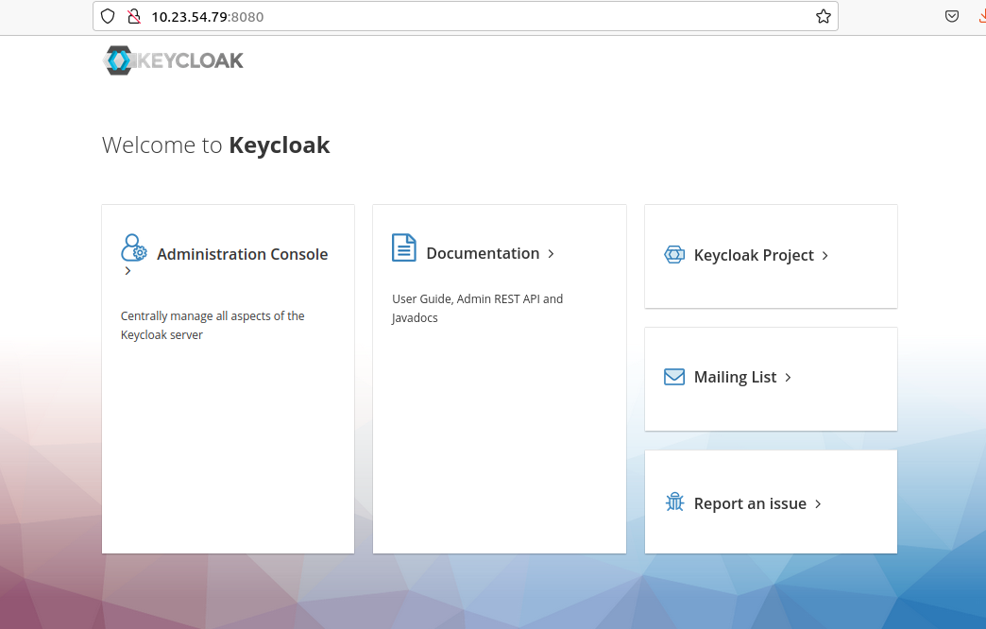

**Go to the administration console and login with keycloak user and password which you have made initially.**

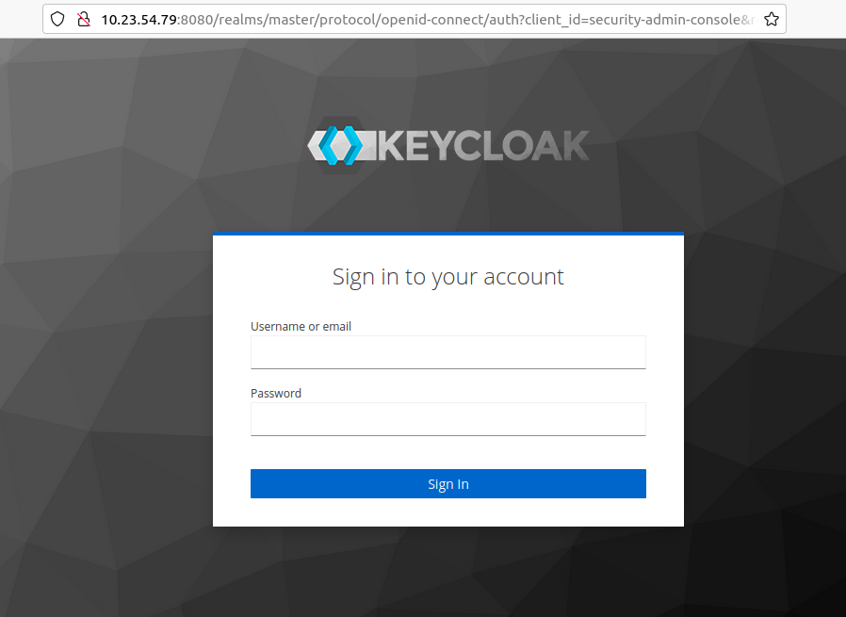

**Once you logged in you will see the following console-**

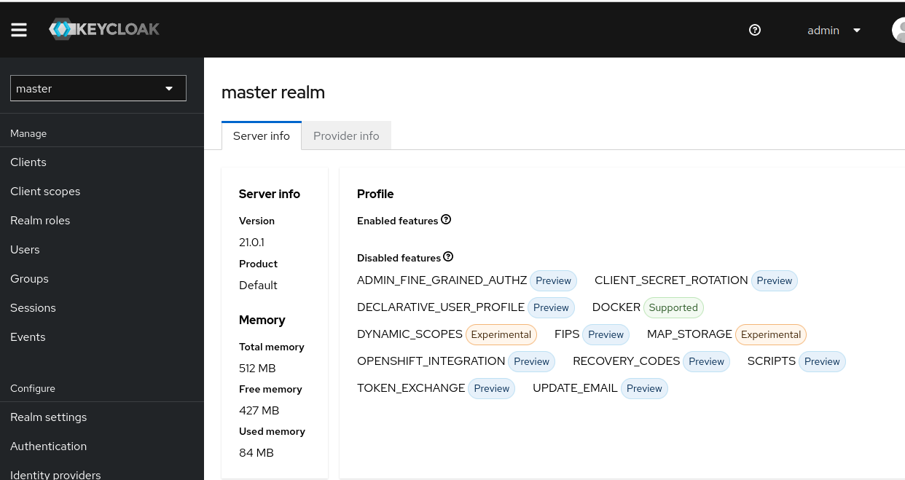

**Configure database to keycloak-**

Create keycloak database and keycloak database user in your database.

* Cd /opt/keycloak-21.0.1/conf
* Vi keycloak.conf

Edit the following configuration to the keycloak.conf-

Db, db-username, db-passowrd, db-url

Save and exit.

Restart keycloak.

For creating start/stop script for keycloak.

Go to

Cd /usr/local/bin/

Vim script.sh

#!/bin/bash

case $1 in

start)

echo "starting service"

cd /opt/keycloak-21.0.1/bin/

bash kc.sh start-dev

;;

For creating keycloak service-

Cd /etc/systemd/system/

Vim keycloak.service

[Unit]

Description=KeyCloak

[Service]

Restart=always

ExecStart=/usr/bin/bash /opt/keycloak-21.0.1/bin/kc.sh start-dev

ExecReload=/usr/bin/bash /opt/keycloak-21.0.1/bin/kc.sh start-dev

StartLimitBurst=10

StartLimitInterval=120

RemainAfterExit=yes

[Install]

WantedBy=multi-user.target

Save and exit

systemctl daemon-reload

systemctl status keycloak.service

systemctl start keycloak.service

