**Flash Boot Loader**

* **Boot Loader** controls initial operation after reset
* **Boot Loader** also provides means to accomplish programming Flash memory
  + initial programming of blank device
  + erasure
  + re-programming of previously programmed device
  + Programming of Flash Memory by application program in running system.

**Features**

* **In-System Programming (ISP) –** programming/reprogramming the on-chip flash memory, using boot loader software and a serial port.
* **In Application Programming(IAP) –** programming is done by erase and writing on the on-chip flash memory directly by end-user application code

**Description**

* Flash boot loader code is executed every time powered on or on reset.
  + This loader can execute
    - ISP command handler
    - user application code
* After reset, Logic 0 to P0.14 pin causes external hardware request to start the ISP command handler
* After reset, Logic 1 to P0.14 pin causes no external hardware request resulting in searching of valid user program.
  + If valid user program is found, then the execution control is transferred to it.
  + Else Auto-Baud routine is invoked.

**Note:** *Generally, P0.14 pin is high impedance after reset, so should be maintained at particular logic to get the flash boot loader to load into particular State.*

**Memory Map after any reset**

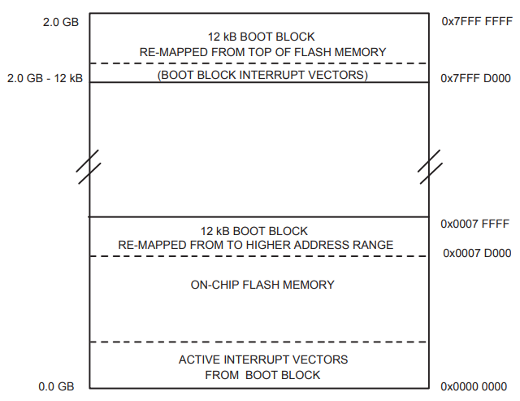

* The boot block is 12kB and resides in top portion of the **on-chip** **flash memory** (@ 0x0007 D000 to 0x0007 FFFF).
* the entire boot block is also mapped to the top of the **on-chip memory**(**on-chip RAM**) space(@ 0x7FFF D000 to 0x7FFF FFFF)
* The flash boot loader runs from this **on-chip** **flash memory.**
* But, the ISP and IAP uses **on-chip RAM**.
* The interrupt vectors residing in the boot block of the on-chip memory also becomes active after reset (64 bytes starting @ 0x0000 0000).

**Criterion for valid user code:**

* The reserved ARM interrupt vector location (0x0000 0014) should contain 2’s complement of check-sum of remaining interrupt vectors.
* The boot loader code checksums the interrupt vectors in sector 0 of the flash.
  + If signature matches, then the execution control is transferred to user code by loading the program counter with 0x0000 0000. So the user flash reset vector (0x0000 0000) should contain a jumpy instruction to the entry point of the user application code.
  + If signature doesn’t match, the auto-baud routine synchronizes with the host via serial port 0 with 8 data bits, 1 stop bit and no parity.
    - The host should send ‘?’(0x3F) as synchronization character.
    - The auto-baud routine measure bit time and programs the baud rate generator of serial port
    - Now, the device sends “Synchronized<CR><LF>” to host.
    - And the host responds by sending “Synchronized<CR><LF>”.
    - Next, then device sends “OK <CR><LF>”.
    - Now, the host respond by sending the crystal frequency greater than or equal to 10MHz like “10000<CR><LF>”.
    - Now, the device responds by “OK <CR><LF>”.
    - Now, the devices invokes the ISP command handler.
    - For one ISP session, “Unlock” command is required before any commands and operation.