QM 640 Capstone
Exploratory Data Analysis Findings
NOAA Storm Events, FEMA/NFIP Flood Claims, and Census ACS County-Year Data
This document summarizes the Phase 2 exploratory analysis generated by 02_EDA.ipynb. The results are intended for the Interim Report and provide descriptive evidence for RQ1–RQ4. Baseline machine-learning results are exploratory, not final tuned model estimates.

1. Dataset Overview
Metric | Value
Rows | 903
Columns | 40
Minimum year | 2000
Maximum year | 2023
Unique counties | 50
Missing values | 0
Duplicate county-year keys | 0
The cleaned dataset contains one observation per county-year and passed the missing-value and duplicate-key checks. This supports reproducible EDA and baseline modeling.
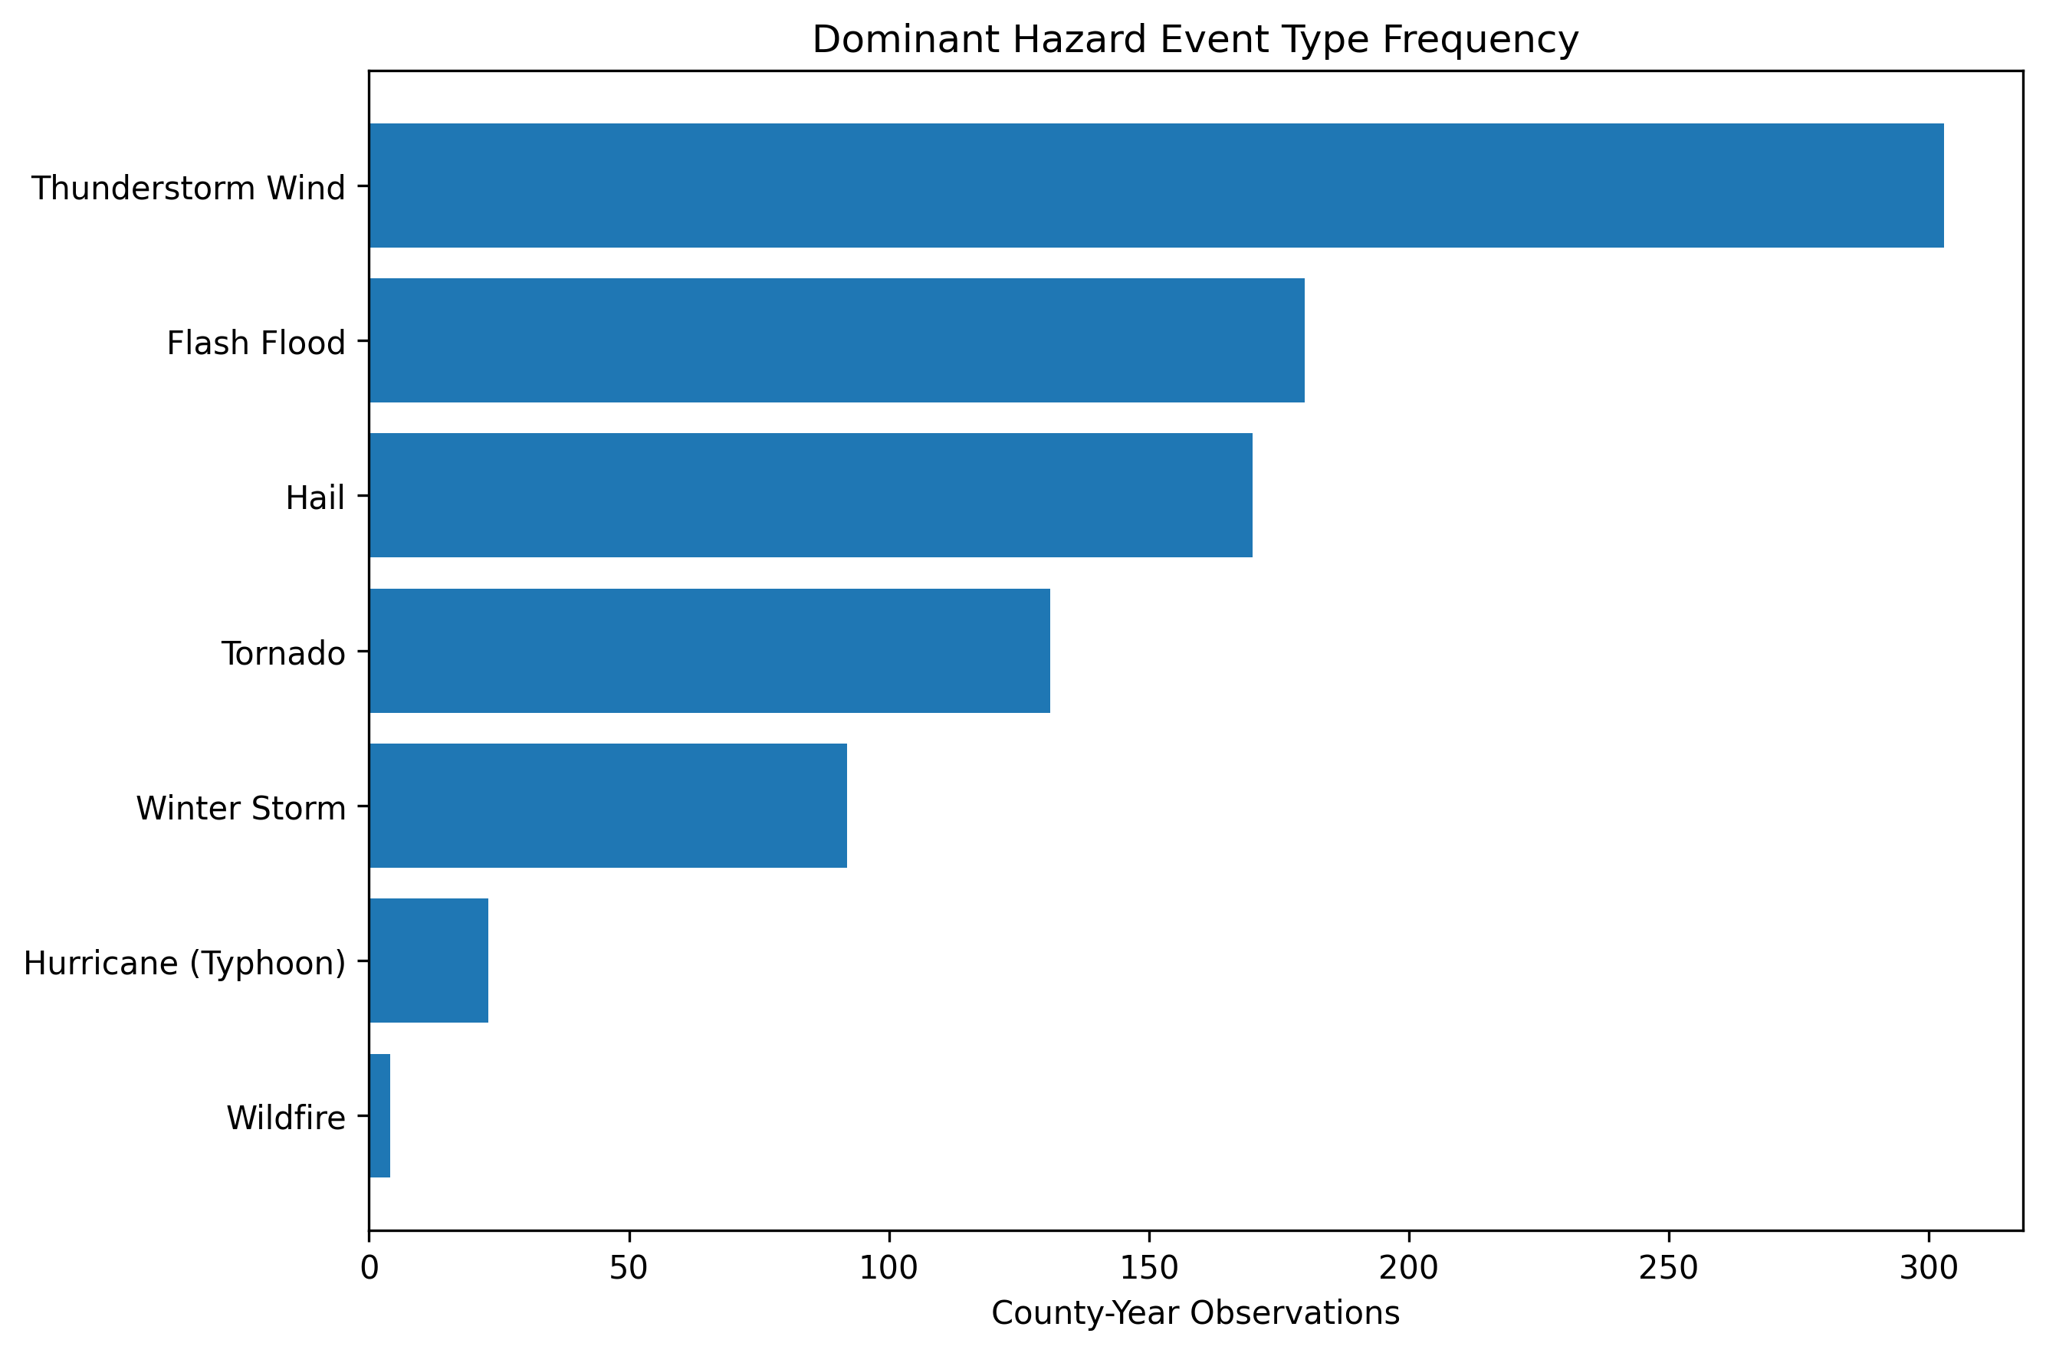
Figure 1. Dominant hazard event-type frequency.

2. Hazard and Severity Patterns
Hazard-intensity and financial-loss variables are right-skewed and contain extreme observations. These observations were retained because tail events are central to catastrophe-risk analysis.
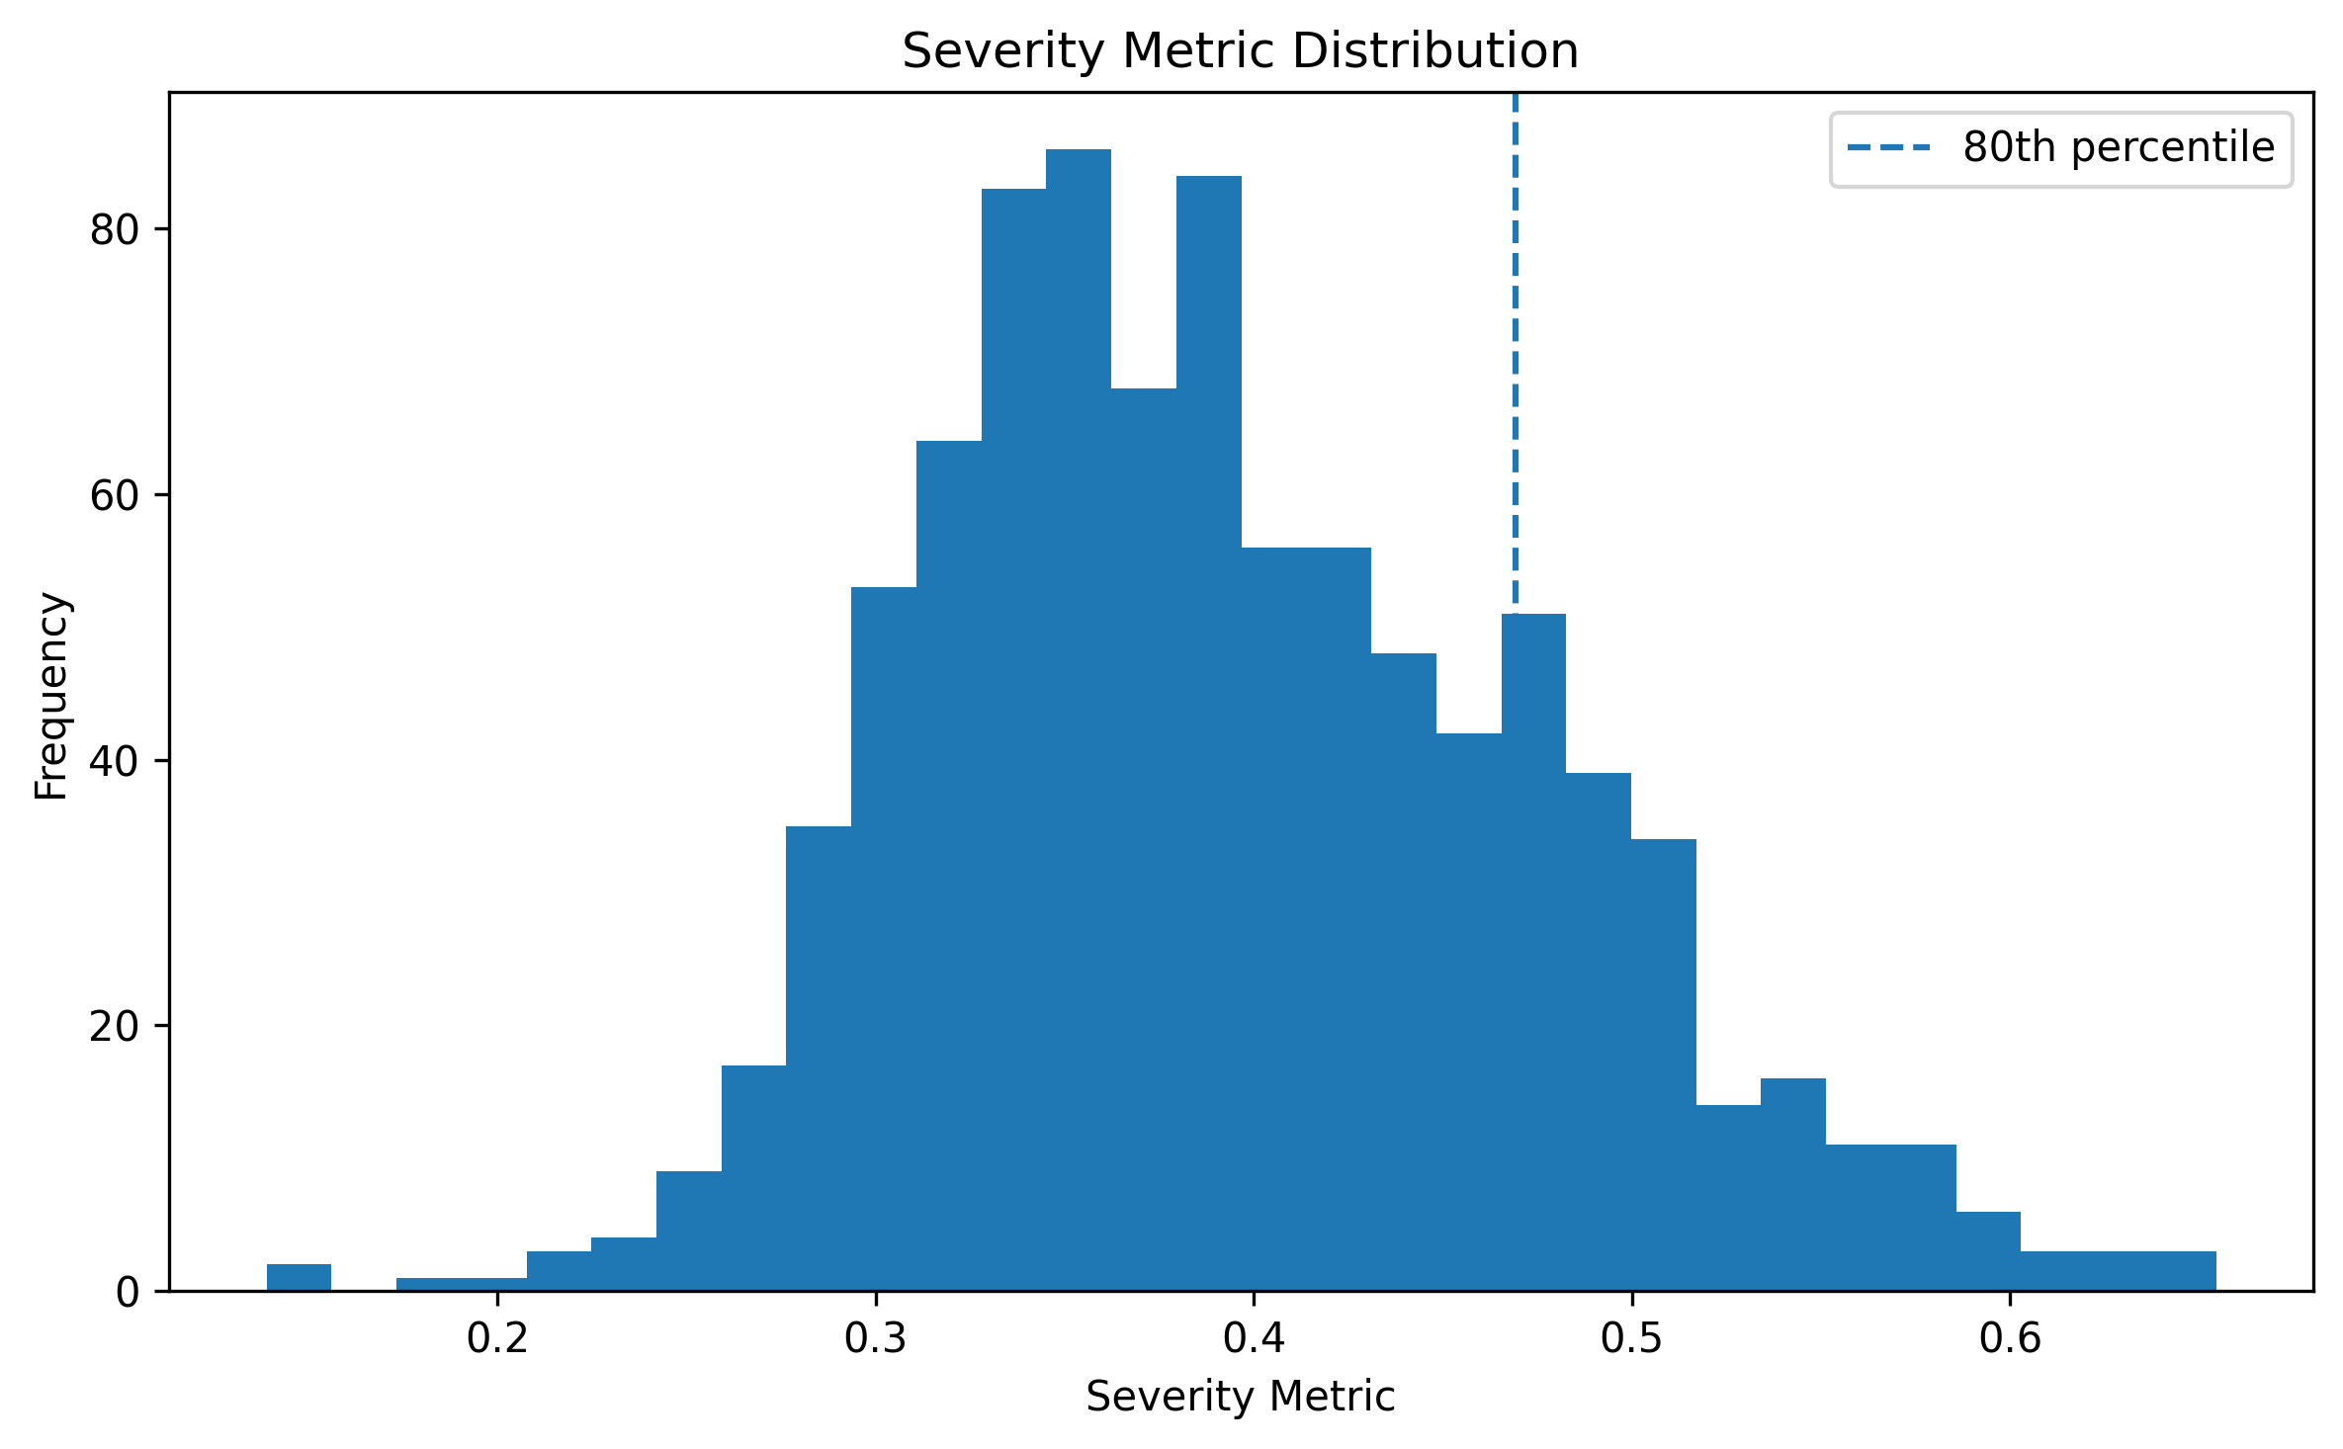
Figure 2. Severity metric distribution and the 80th-percentile high-severity threshold.
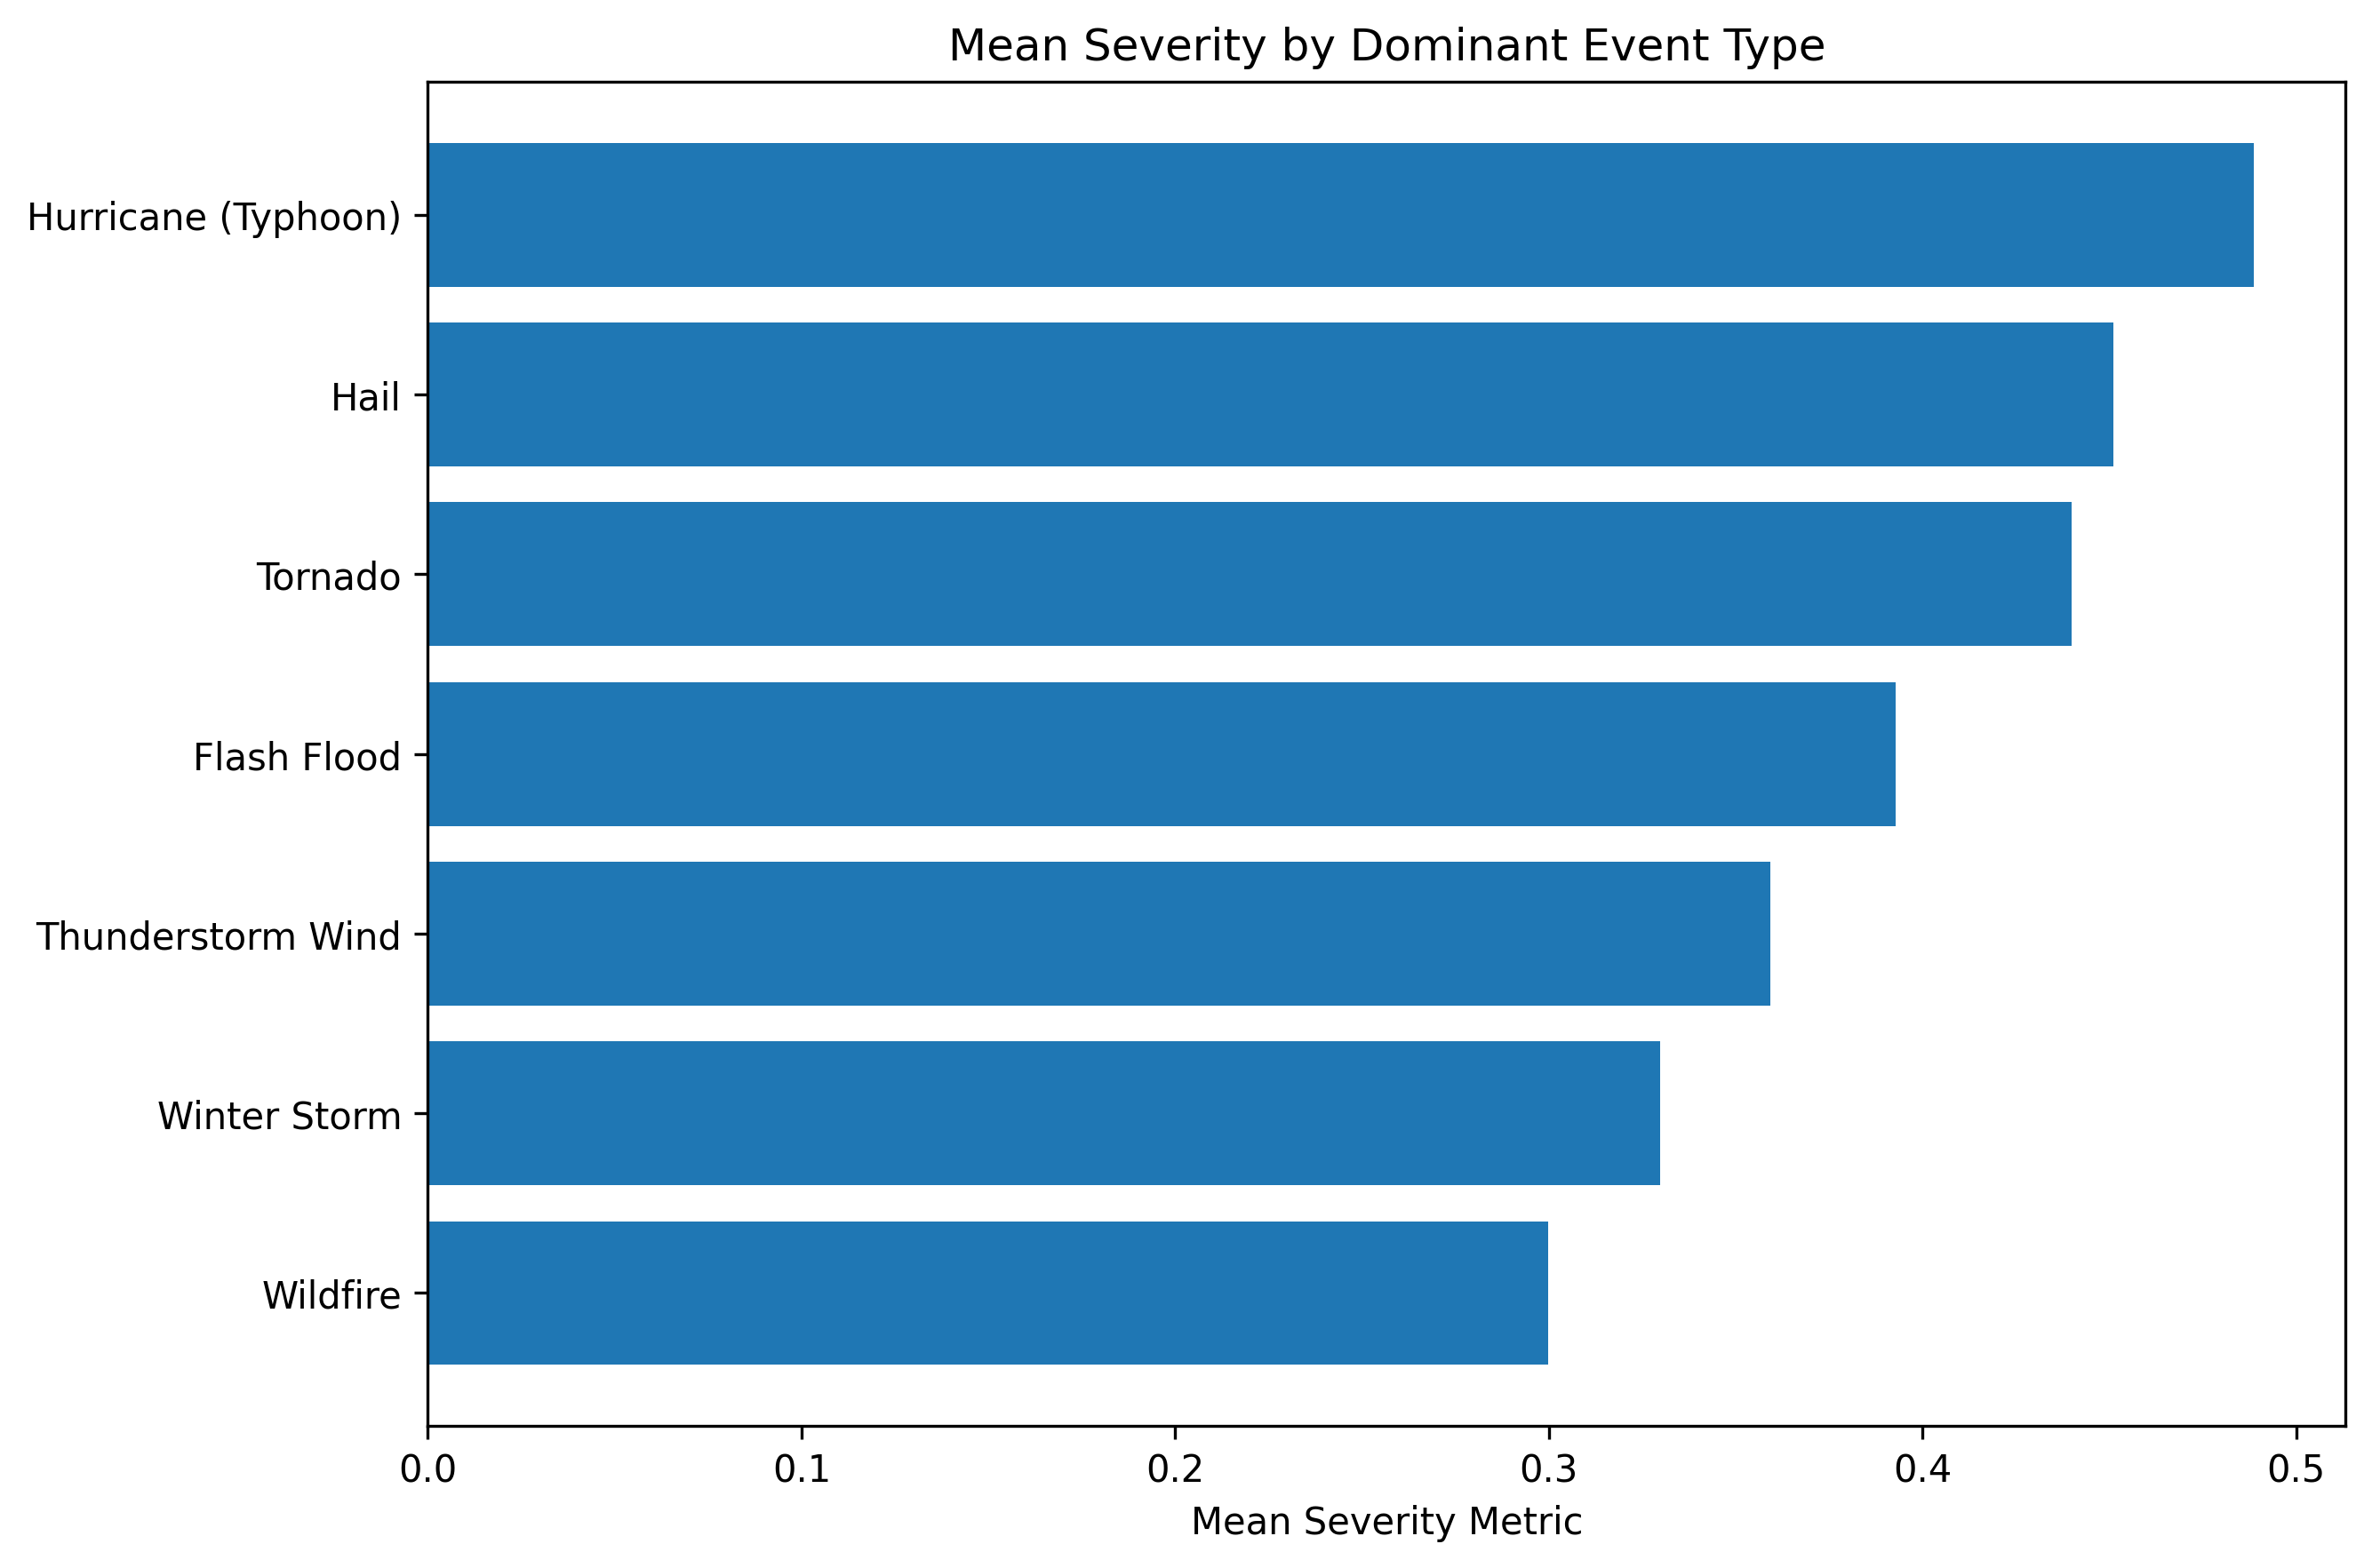
Figure 3. Mean severity by dominant event type.
In the supplied data, Hurricane (Typhoon) has the highest mean severity (0.489) among dominant event types. This is a descriptive comparison and does not by itself establish a causal effect.
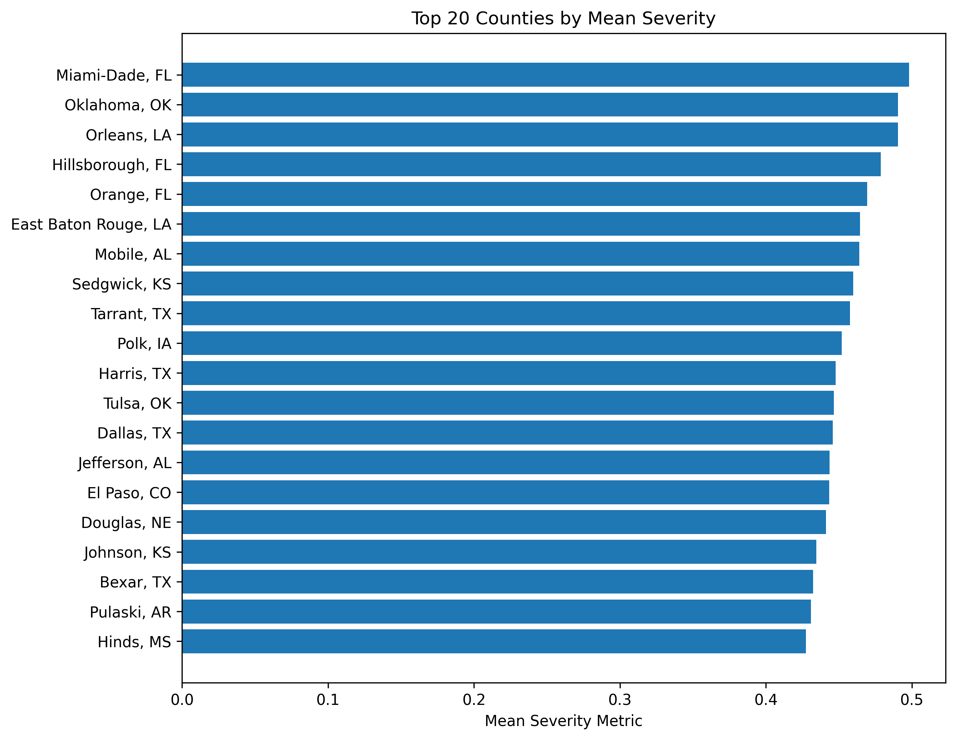
Figure 4. Top 20 counties by mean severity.
Miami-Dade, FL has the highest mean severity (0.498) in the supplied sample. County rankings should be interpreted within the scope and coverage of the provided data.

3. Socioeconomic and Correlation Analysis
Income, population density, housing age, vacancy, homeownership, and older-housing share vary substantially across the observed county-years. Because RQ2 concerns moderation, weak or moderate direct correlations do not rule out meaningful interaction effects.
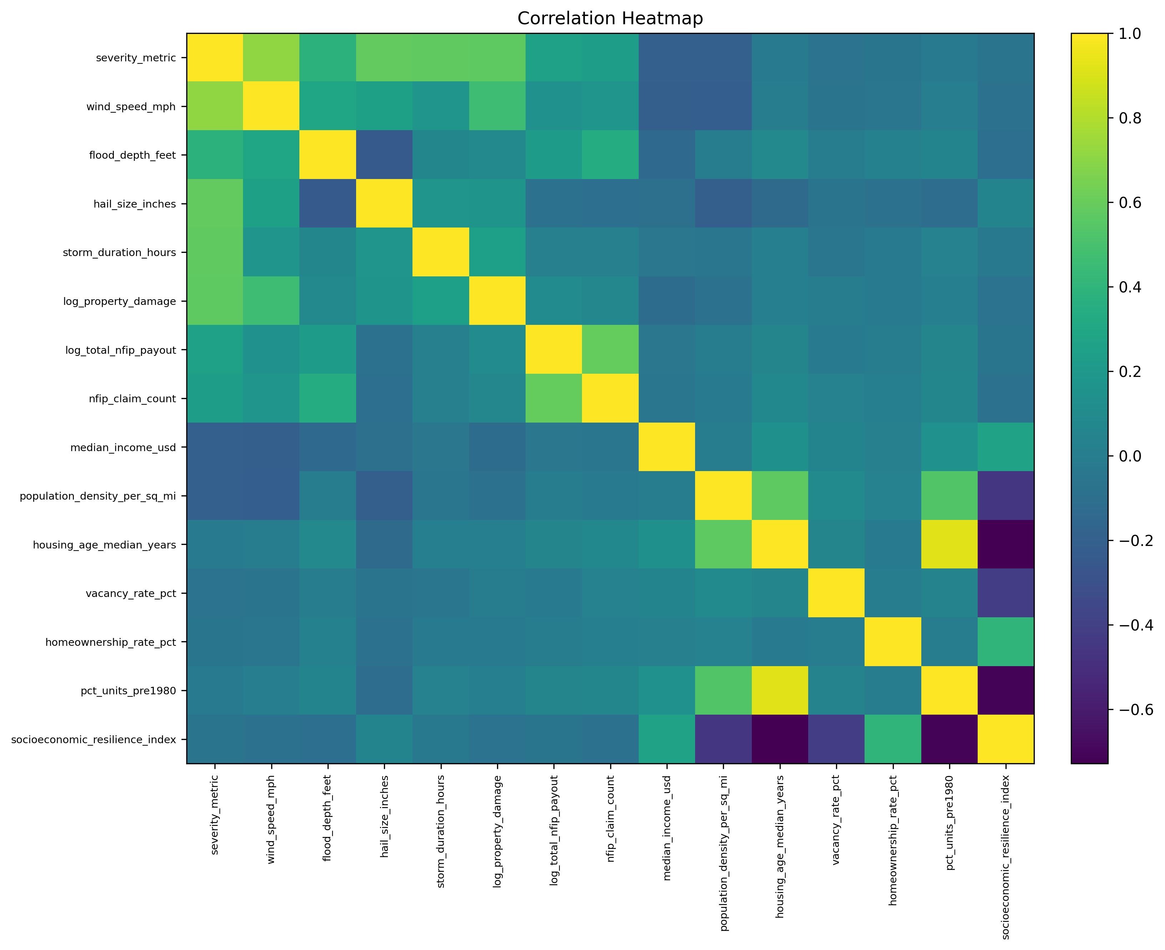
Figure 5. Correlation matrix for selected hazard, loss, and socioeconomic variables.
Among the plotted bivariate relationships, wind_speed_mph shows the largest absolute Pearson association with severity (r=0.710, R²=0.504). The severity metric contains hazard and loss components, so these relationships should be assessed with sensitivity analyses.

4. Annual Trend Analysis
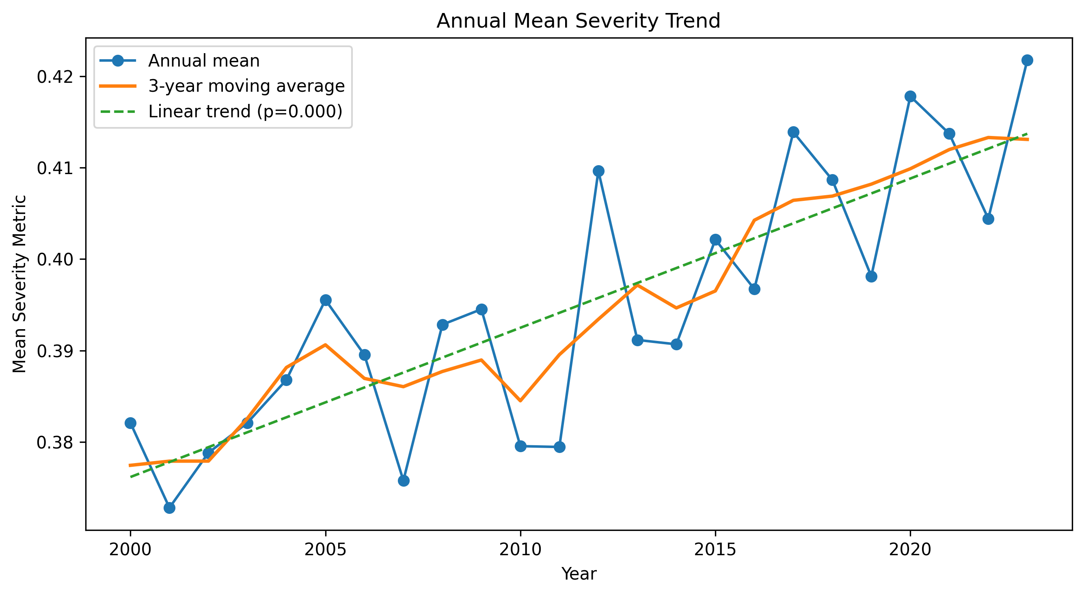
Figure 6. Annual mean severity, three-year moving average, and exploratory linear trend.
The exploratory annual mean-severity slope is 0.001632 per year (p=0.000). This is preliminary evidence only. The final RQ4 analysis should apply the planned Mann-Kendall and ARIMA methods before making a formal trend conclusion.

5. Baseline Machine-Learning Preparation
The high-severity target uses the 80th percentile of the continuous severity metric. A stratified train-test split and a class-balanced Random Forest were used as an exploratory baseline to test whether the available predictors contain classification signal.
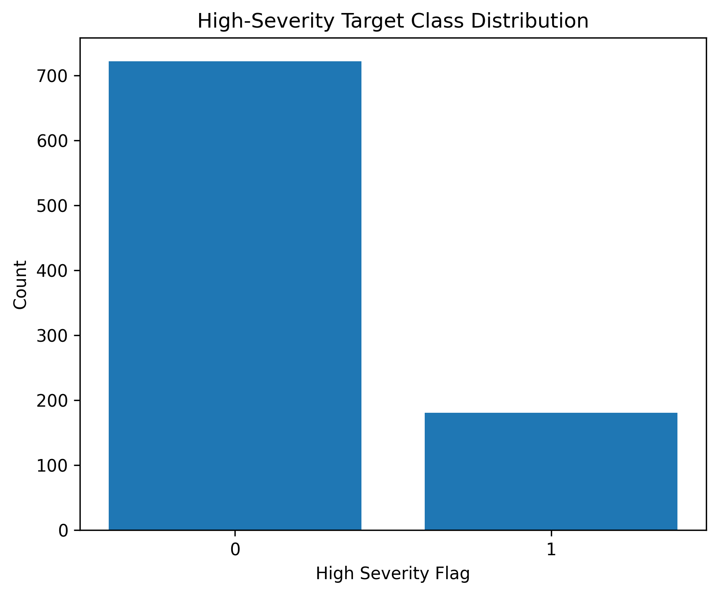
Figure 7. High-severity target-class distribution.
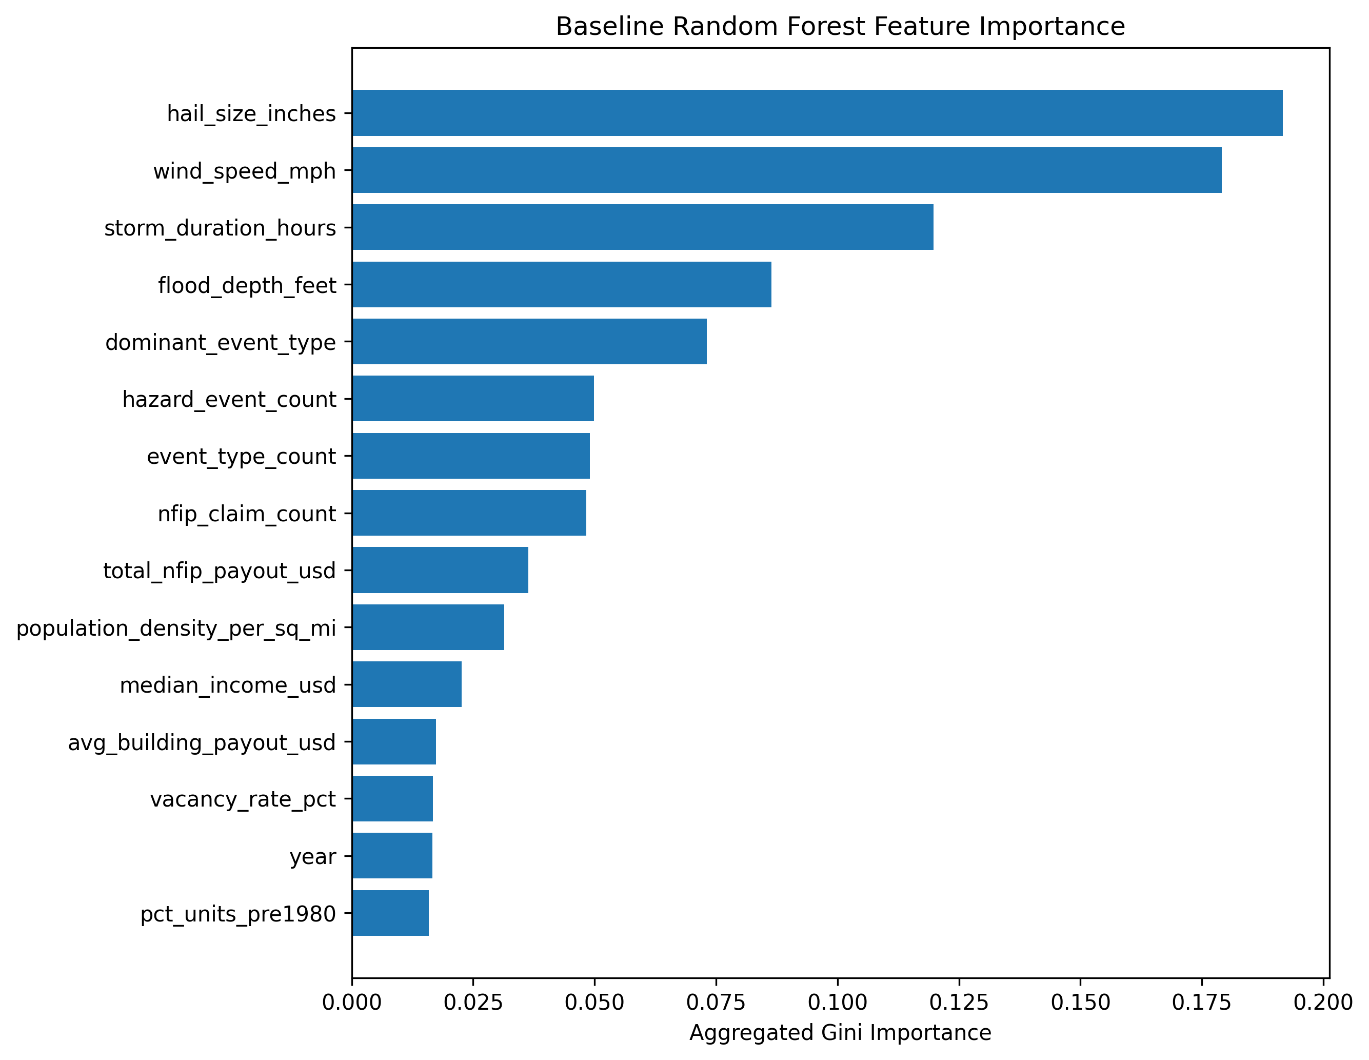
Figure 8. Aggregated baseline Random Forest feature importance.
The baseline model achieved accuracy=0.925, precision=0.833, recall=0.778, F1=0.805, and ROC-AUC=0.979. The highest aggregated feature importance was hail_size_inches (0.192). These values are not final model estimates because cross-validation, tuning, calibration, and comparison with alternative algorithms remain for Phase 4.

6. EDA Findings for the Interim Report
Dataset readiness: The integrated county-year dataset passed completeness and uniqueness checks.
Hazard distributions: Hazard and loss variables are right-skewed and contain meaningful extremes.
Severity: The 80th-percentile rule provides a transparent high-severity classification target.
Socioeconomic context: Socioeconomic variables vary substantially and should be tested through moderation models.
Correlations: Correlation and VIF tables provide diagnostics for later regression specification.
Trend analysis: Annual patterns are exploratory and require formal Mann-Kendall and ARIMA analysis.
Machine learning: The baseline model demonstrates predictive signal but is not a final tuned model.

7. Recommended Use in the Interim Report
Use the dataset overview and severity figures in the Data Description and EDA Results sections. Use the hazard-versus-severity plots and correlation diagnostics to motivate RQ1. Use the socioeconomic distributions and resilience discussion to motivate RQ2. Use the target balance and baseline Random Forest results as evidence of RQ3 feasibility, clearly labeling them as preliminary. Use the annual severity trend as descriptive context for RQ4 without claiming a confirmed time-series result.

