Objective Questions
- Does any table have missing values or duplicates? If yes how would you handle it ?
Ans-: Yes ,
- Tables with Missing Values:
Customer, Track, Employee, Invoice
- Tables without Missing Values:
Album, Artist, Genre, invoice_Line
- Duplicate Records:
- No true duplicates due to primary key constraints.
- Invoice_Line contains valid transactional repetitions.
- Methods to Handle Missing Values:
  - Replace NULL Values (Using COALESCE)
  - Replace NULL Values (Using IFNULL / ISNULL)
  - Update Table to Replace NULL Values
  - Delete Rows with NULL Values
  - Use CASE Statement
  - Handle NULL in Aggregations
  - Replace NULL with Average (Numeric Data)
- Methods to Handle Duplicate Values
- Using ROW_NUMBER()
- Select Only Unique Records
- Remove Duplicate Rows (Using DELETE + Subquery)
- Create a New Table Without Duplicates
- Use GROUP BY for Analysis
- Add Constraints to Prevent Duplicates

- Find the top-selling tracks and top artist in the USA and identify their most famous genres.
Ans- 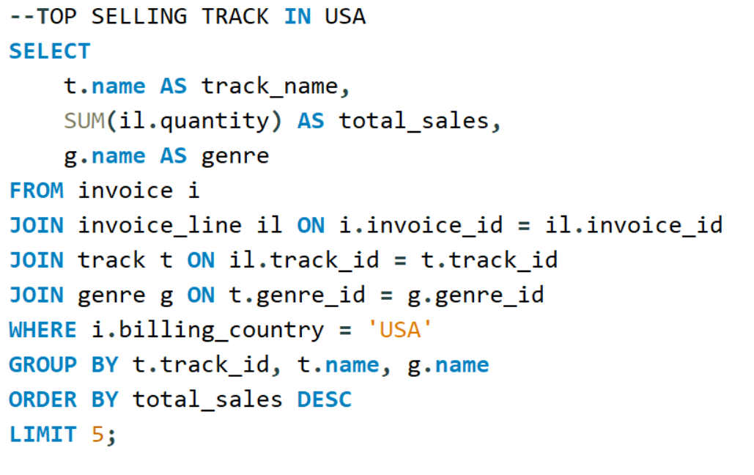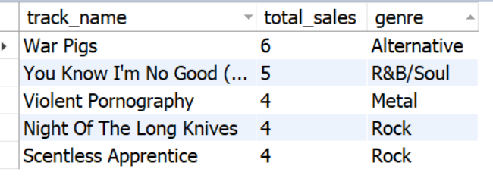
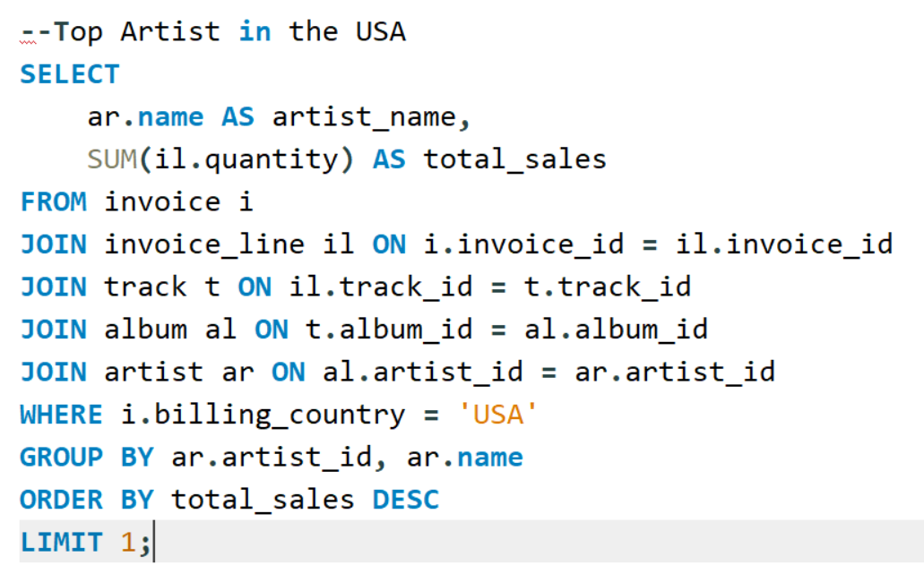
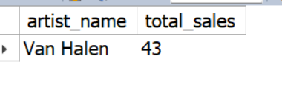
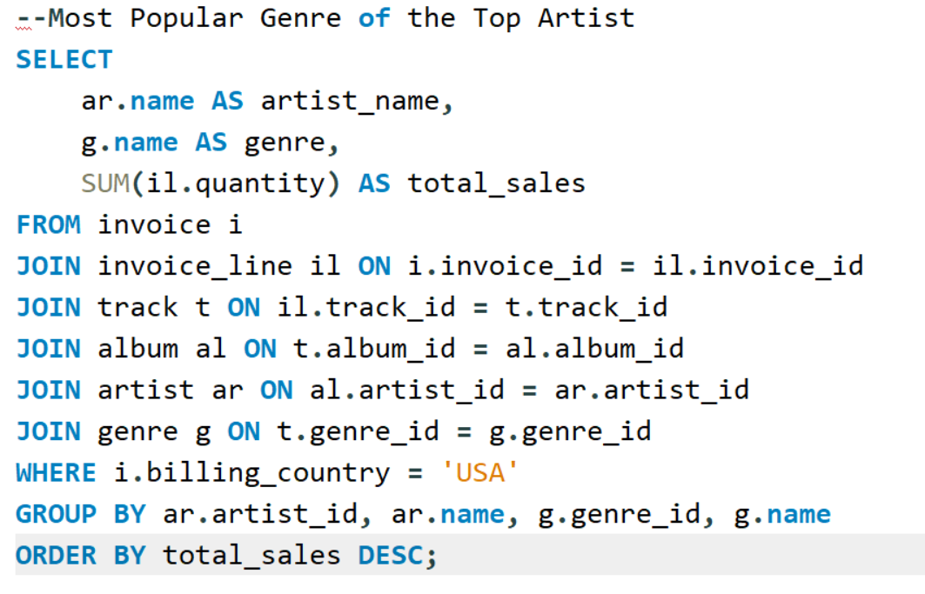
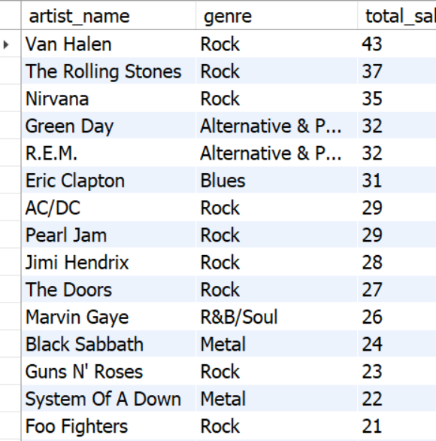

- What is the customer demographic breakdown (age, gender, location) of Chinook's customer base?
Ans- 1. Age & Gender Breakdown: - The Chinook dataset does NOT contain age
or gender columns in the customer table.
2. Location Breakdown: - We can analyse customer demographics based on:
- Country
- City
- State
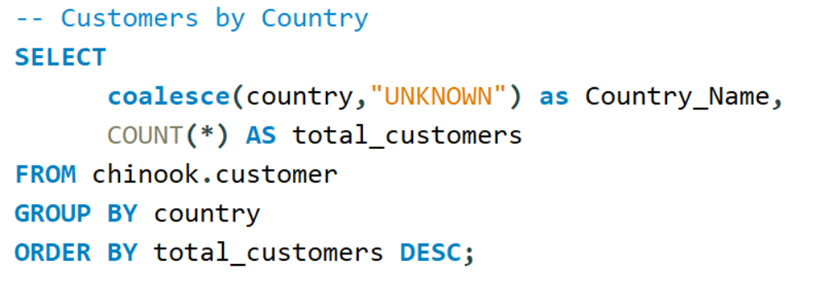
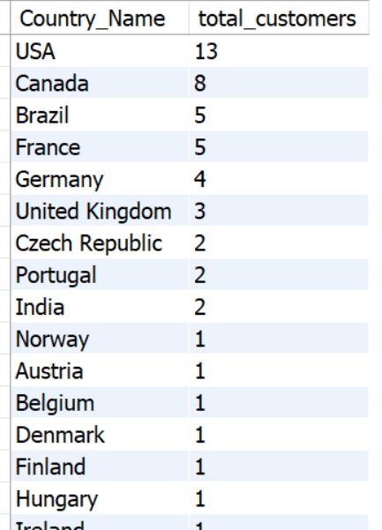
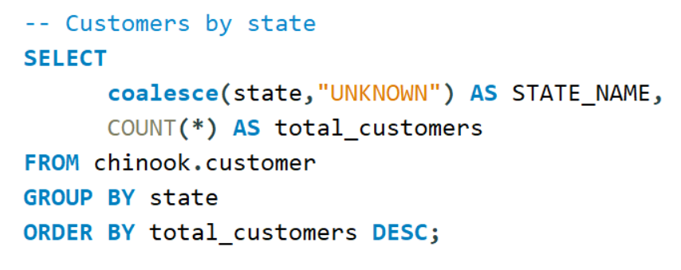
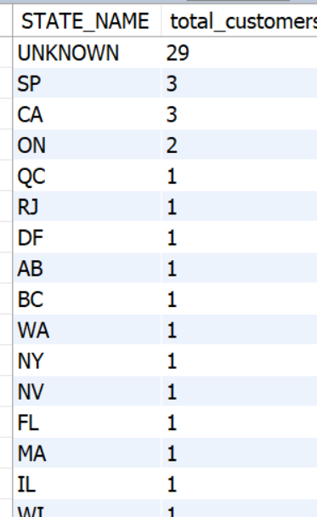
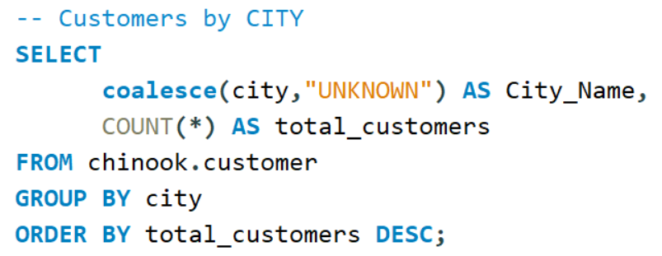
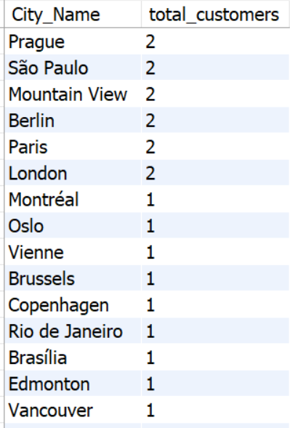
- Calculate the total revenue and number of invoices for each country, state, and city:
Ans- 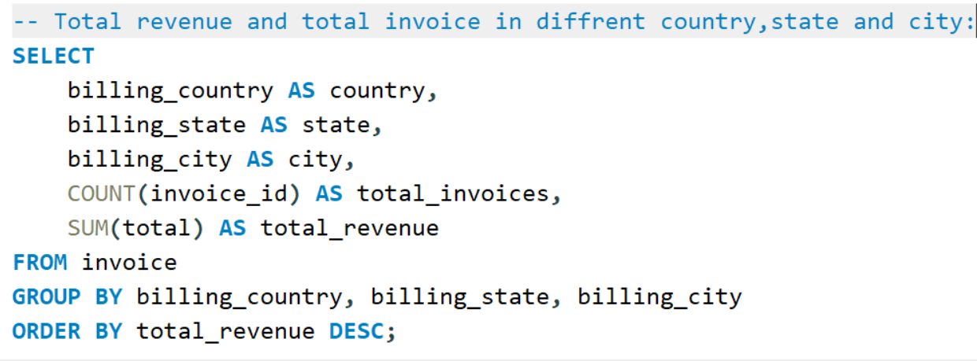
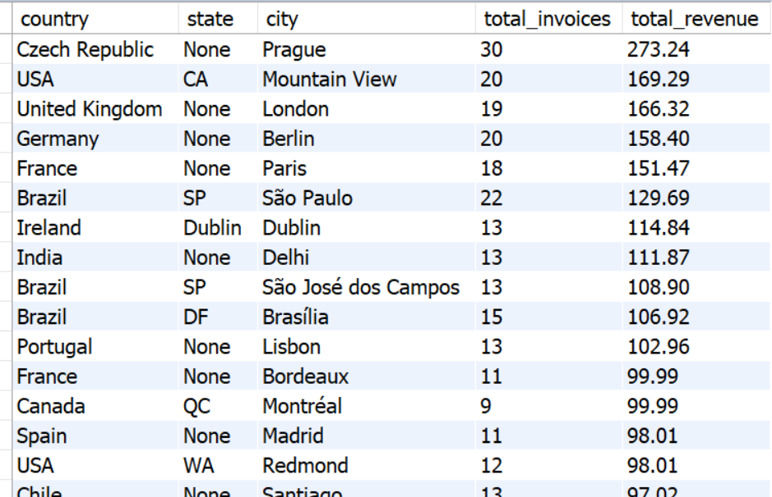

- Find the top 5 customers by total revenue in each country
Ans-
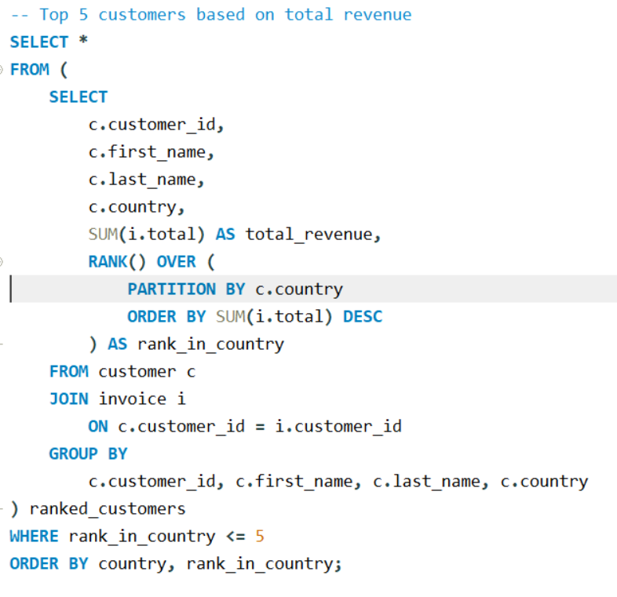
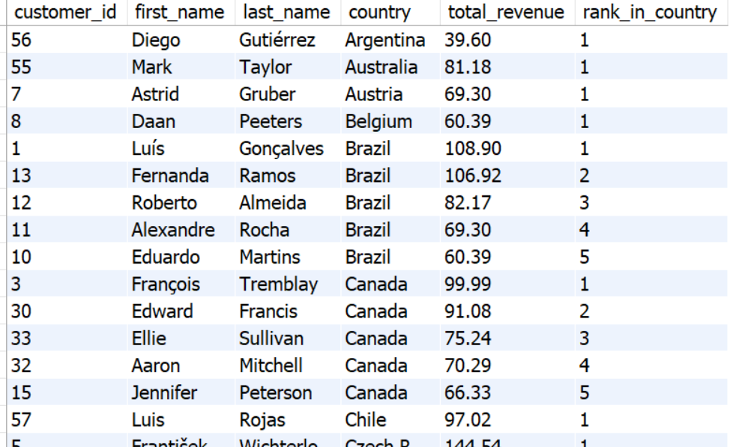
- Identify the top-selling track for each customer
Ans-
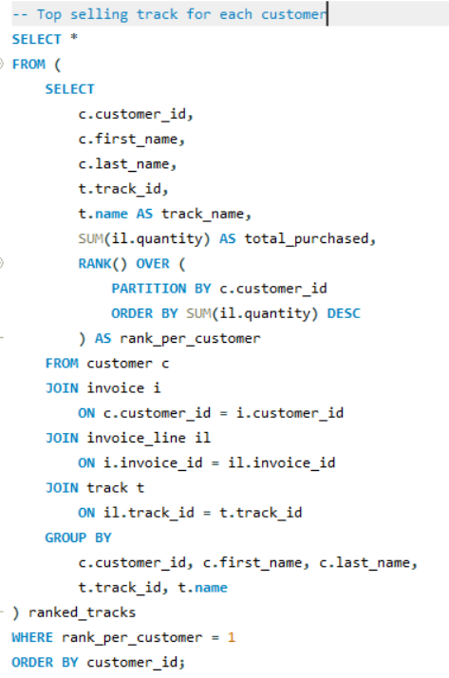
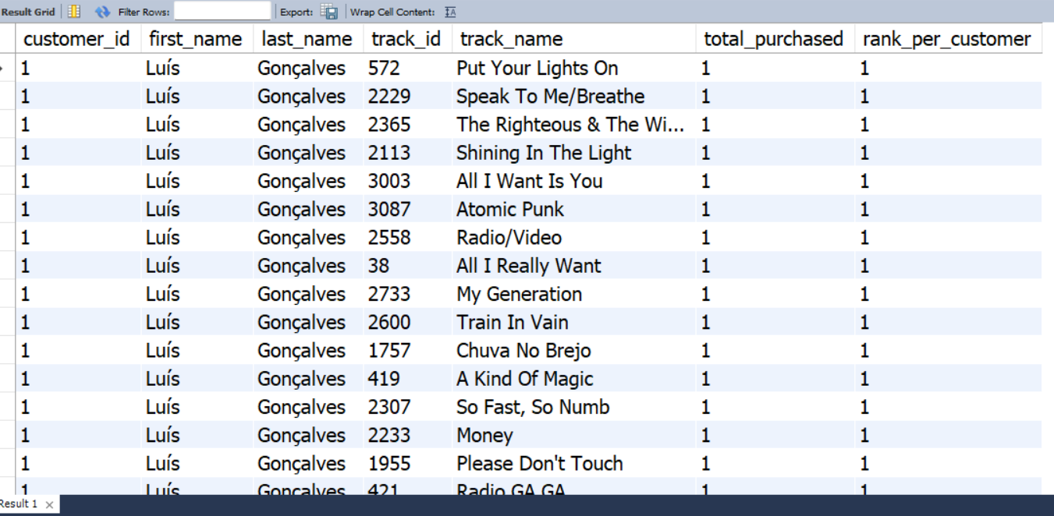

- Are there any patterns or trends in customer purchasing behavior (e.g., frequency of purchases, preferred payment methods, average order value)?
Ans-
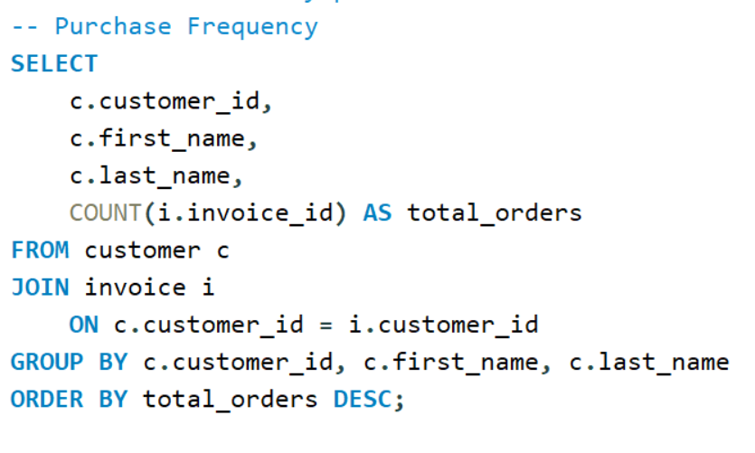
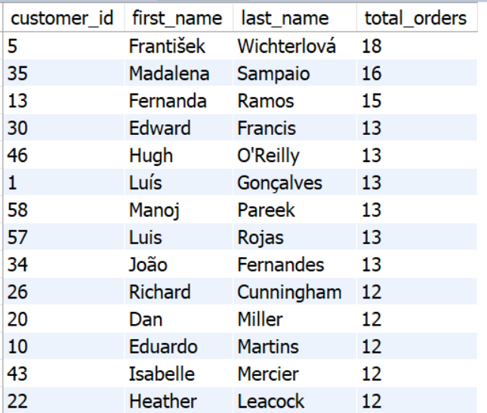
Insight
- Some customers purchase frequently (loyal customers)
- Others are one-time buyers
- Helps identify:
  - VIP customers
  - Retention opportunities

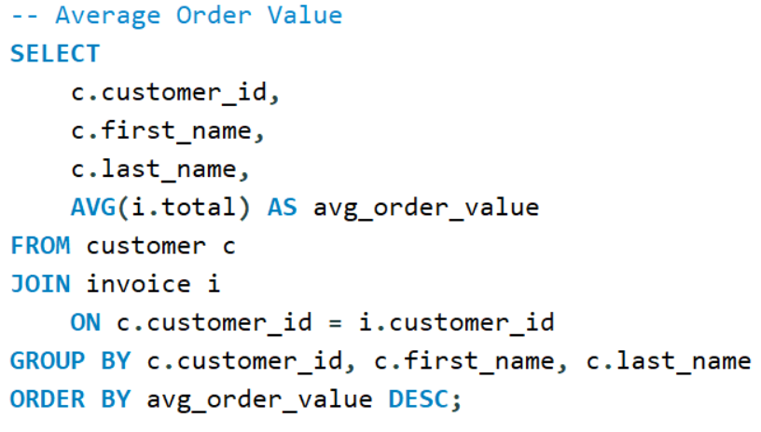
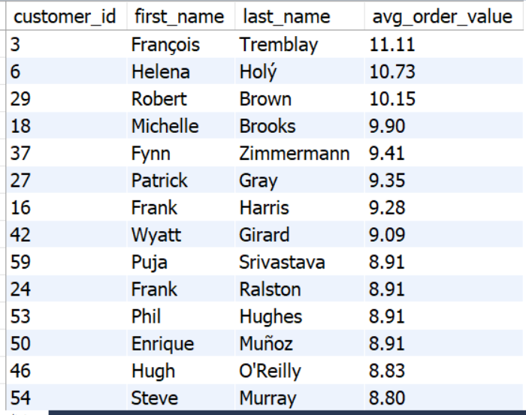
Insight
- Customers differ in spending behavior
  - Some buy frequently but low value
  - Some buy rarely but high value
- Useful for:
  - Customer segmentation
  - Targeted marketing
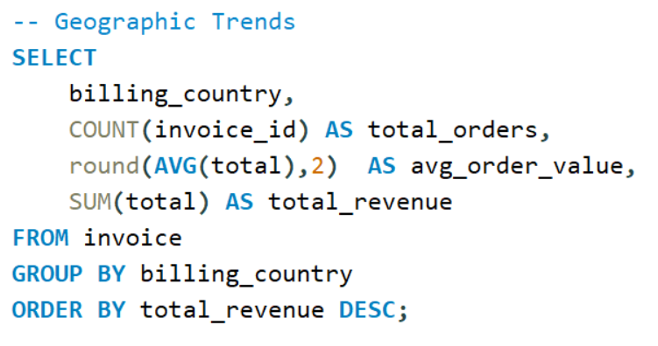
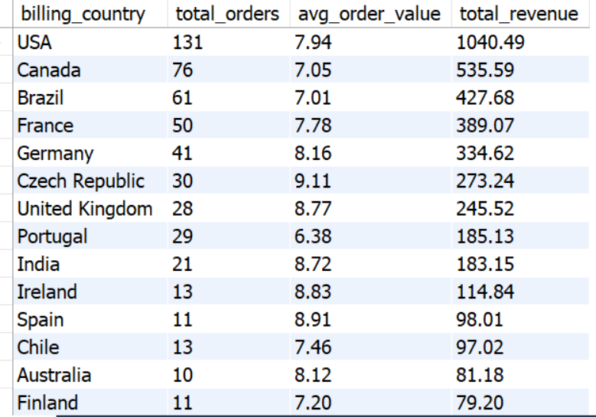
Insight
- Countries like USA, Canada, Brazil typically generate more revenue
- Some regions:
  - High volume, low value
  - Low volume, high value

- What is the customer churn rate?
Ans- Churn -: Customers who stopped purchasing in a given period.
We do not have any specific churn condition given in the data set so let us
Assume A customer is considered churned if they have not made a purchase in the last 6 months.
Churn based on inactivity: -
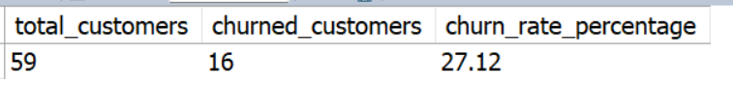
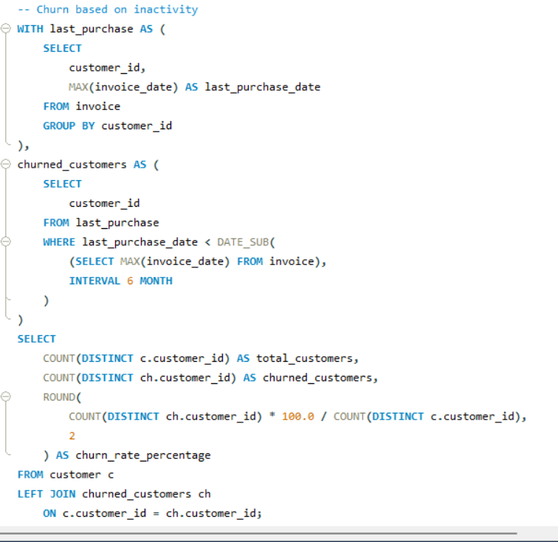
- Calculate the percentage of total sales contributed by each genre in the USA and identify the best-selling genres and artists.
Ans-
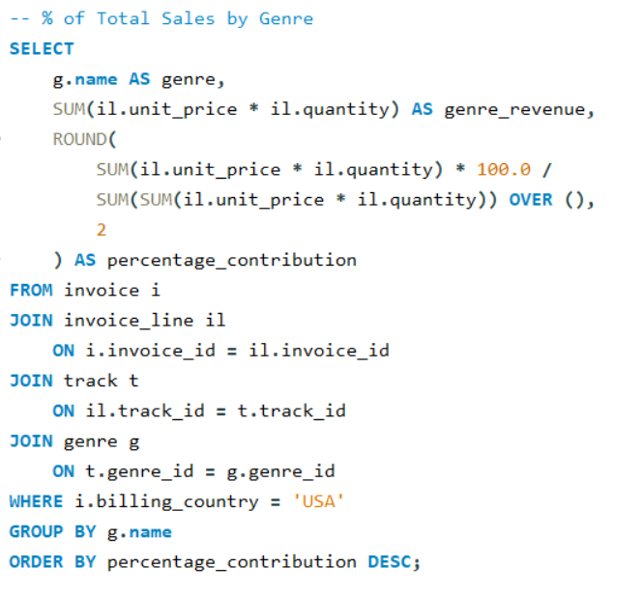
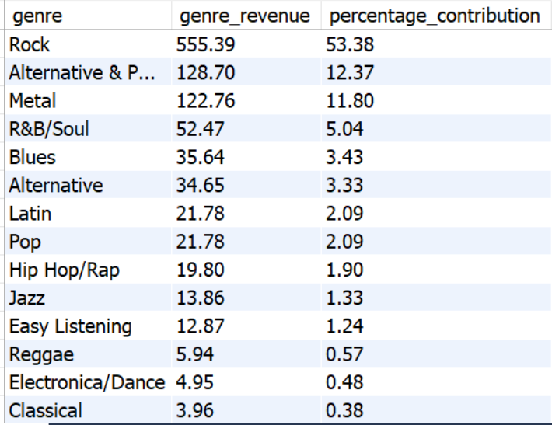
Top 5 genre in USA :-
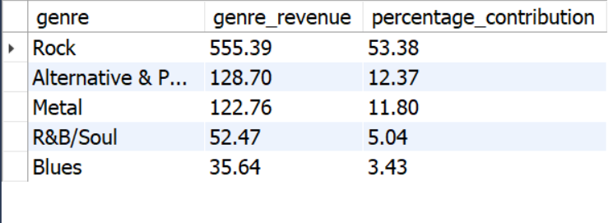
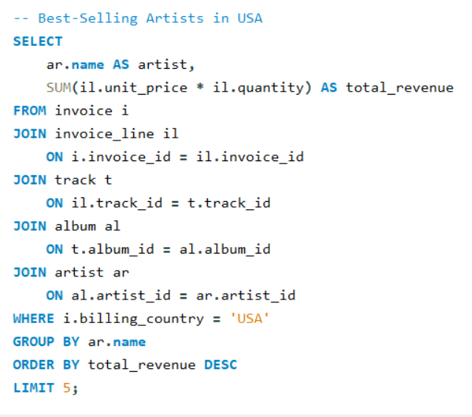
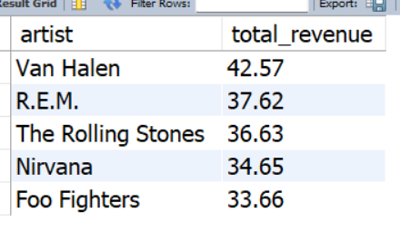

- Find customers who have purchased tracks from at least 3 different genres
Ans-
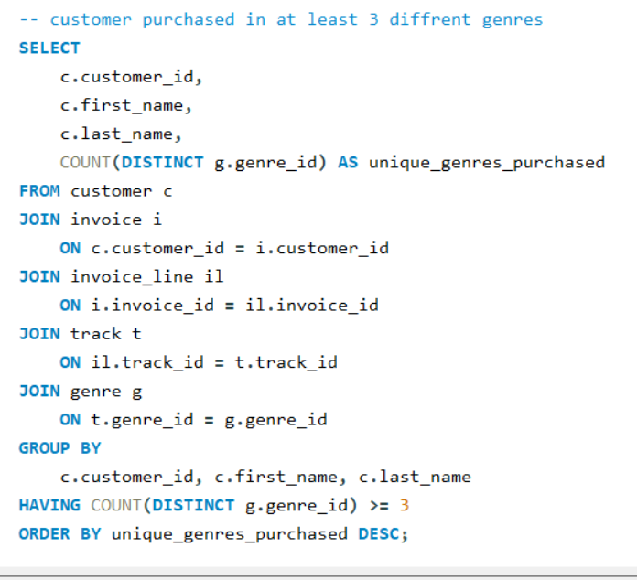
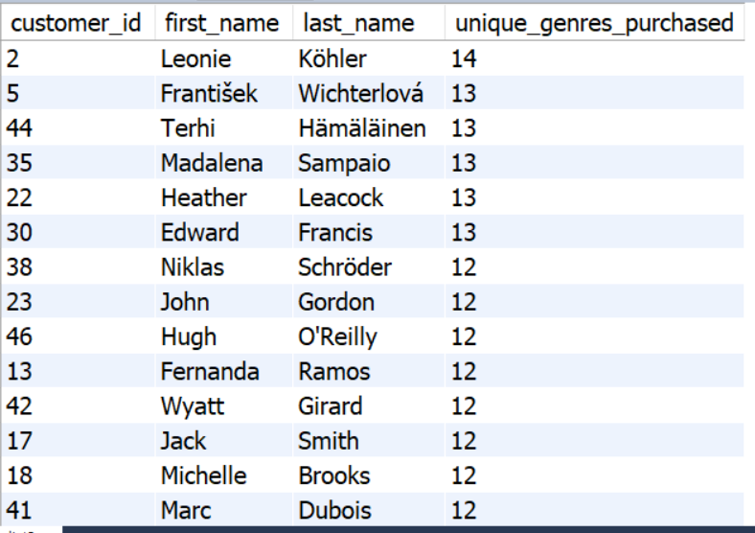
- Rank genres based on their sales performance in the USA
Ans-
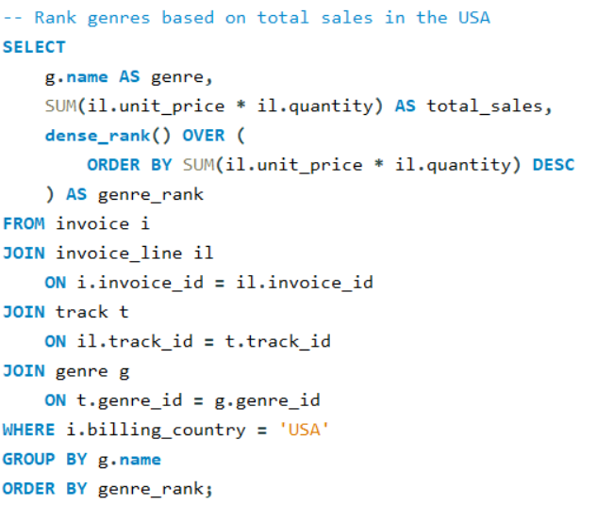
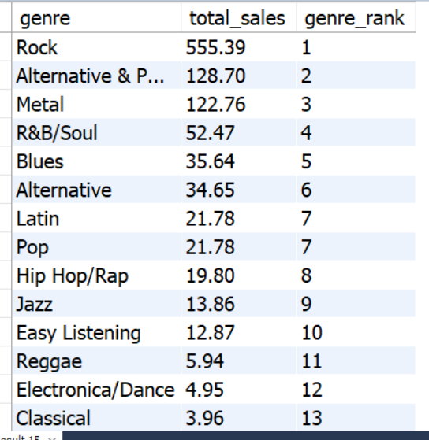

- Identify customers who have not made a purchase in the last 3 months
Ans-
