Subjective Questions

- Recommend the three albums from the new record label that should be prioritised for advertising and promotion in the USA based on genre sales analysis.
Ans -: 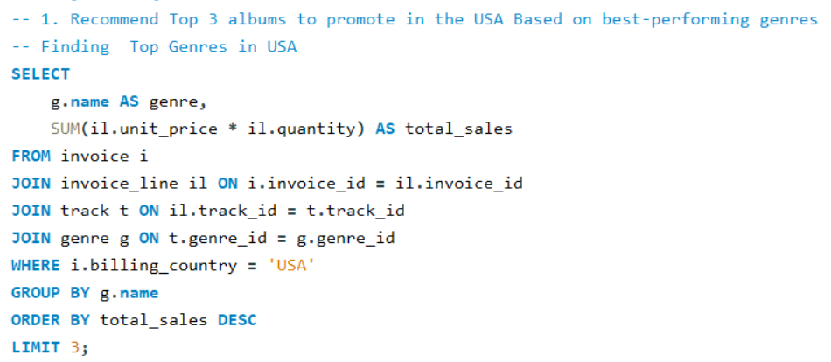
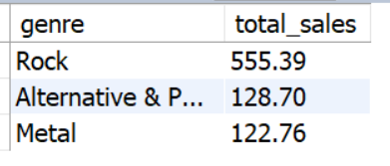
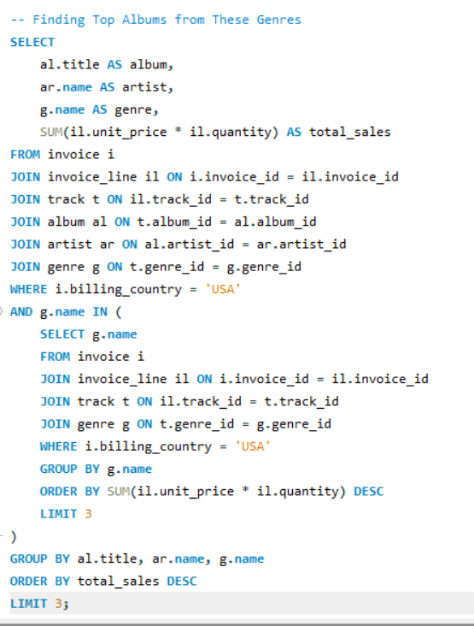
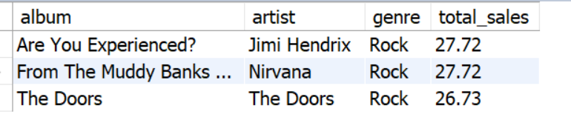

Key Insights -: 1. Genre Preference is Highly Concentrated
- Rock dominates sales in the USA
- Followed by:
  - Metal
  - Alternative / Punk

2. Customer Taste is Consistent
- Many customers repeatedly purchase from same genre types
- Indicates:
  - Strong genre loyalty
  - Predictable behaviour
3. Revenue is Driven by Popular Artists & Albums
- A few top albums/artists generate most revenue
- Long tail (many albums) contributes very little
4. High Demand for Rock-Based Artists
- Rock-related artists dominate:
  - Album sales
  - Track purchases
5. USA is a High-Value Market
- Strong purchasing activity
- Consistent invoice generation
Recommendations -:
1. Prioritize Rock Genre Albums
Focus marketing budget on:
- Rock
- Metal
- Alternative
Reason:
- Highest demand
- Proven revenue generator
2. Promote Top-Selling Albums
Select albums:
- Already performing well
- From top genres
Reason:
- Higher conversion rate
- Lower marketing risk
3. Focus on High-Value Customers
Target:
- Frequent buyers
- High spending customers
Strategy:
- Personalized recommendations
- Email campaigns
4. Bundle or Recommend Similar Genres
Example:
- If customer buys Rock → suggest Metal / Alternative
Reason:
- Cross-selling opportunity
5. Avoid Low-Performing Genres for Heavy Investment
Genres with low contribution:
- Should not be primary focus
Strategy:
- Keep them niche, not mainstream

- Determine the top-selling genres in countries other than the USA and identify any commonalities or differences.
Ans -:
Key Insights:
1. Rock Still Dominates Globally
- Rock appears as top or near-top genre in most countries
- Indicates universal popularity
2. Regional Variations Exist
- Some countries show preference for:
  - Latin (in Brazil/Latin regions)
  - Jazz / Classical (Europe)
3. Smaller Markets = Less Diversity
- Countries with fewer customers:
  - Limited genre spread
  - Few dominant genres
4. Genre Concentration is High
- Like USA:
  - Few genres generate most revenue
Commonalities vs Differences
Common Patterns
- Rock is consistently strong
- Revenue concentrated in few genres
- Popular genres perform across regions

Differences
- Local/cultural genres vary by country
- Some countries:
  - Prefer niche genres
  - Have different top #2 / #3 genres

Strategy
1. Global Strategy
Promote: Rock (universal demand)
Safe, scalable strategy

2. Localization Strategy
Customize by country:
- Brazil - Latin
- Europe - Jazz/Classical
Improves engagement
3. Data-Driven Targeting
Use:
Country-level genre ranking
Personalized marketing

4. Cross-Selling Strategy
Recommend:
Similar genres across regions
Increase basket size
Recommendations
1. Adopt Hybrid Strategy
Global (Rock) + Local (regional genres)
2. Invest More in High-Performing Genres
Focus budget on: Top 2–3 genres per country
3. Expand Regional Content
Add more tracks in: Country-specific genres
4. Target High-Value Regions
Countries with:
  - High revenue
  - Consistent purchases
5. Avoid One-Size-Fits-All Approach
USA strategy ≠ Global strategy
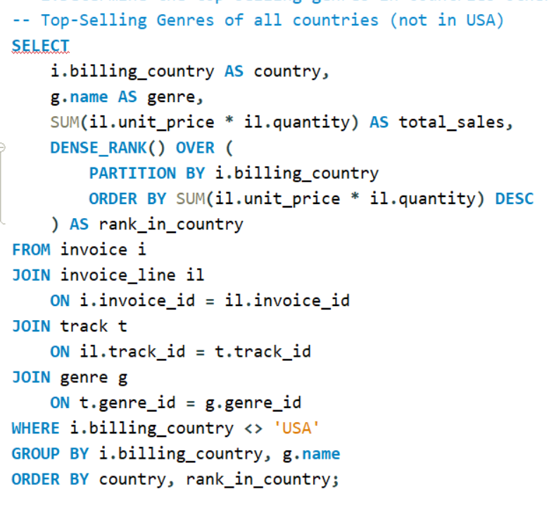
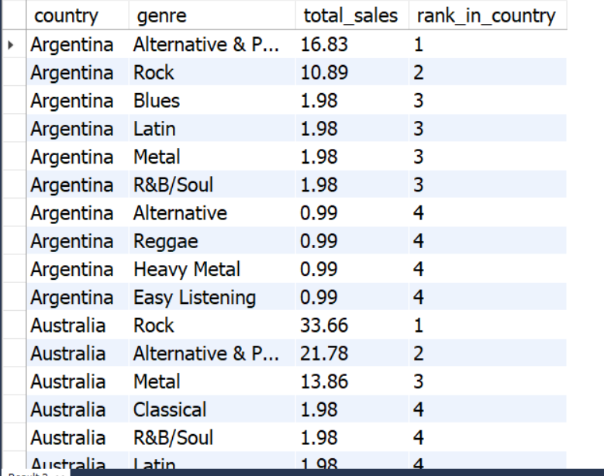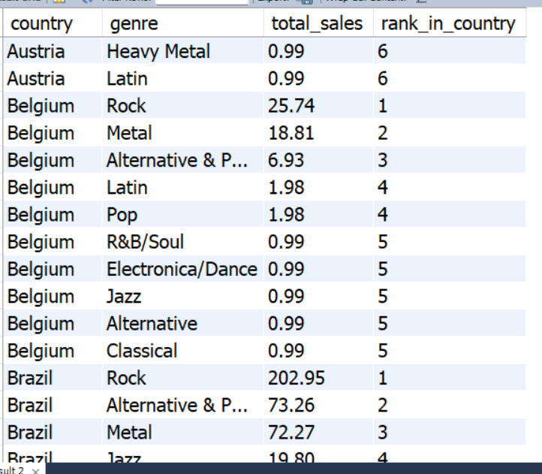
And so on

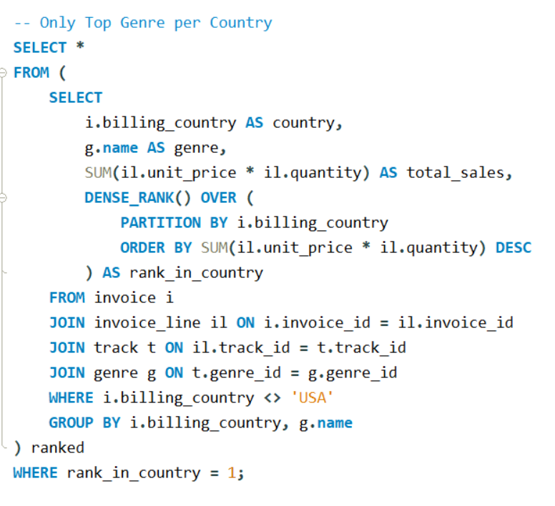
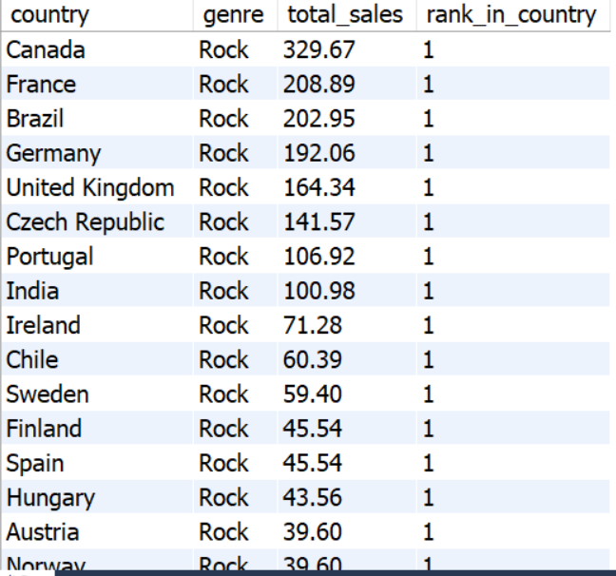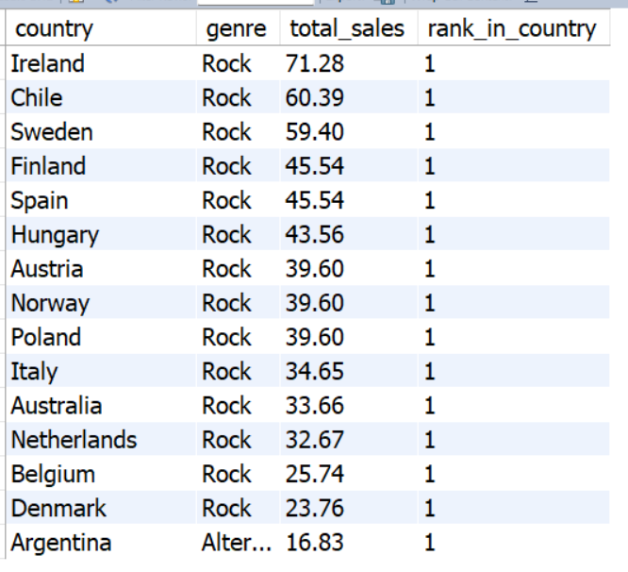

- Customer Purchasing Behaviour Analysis: How do the purchasing habits (frequency, basket size, spending amount) of long-term customers differ from those of new customers? What insights can these patterns provide about customer loyalty and retention strategies?
Ans-: 1. Define Customer Types -:
Since Chinook has no signup date, we define:
- Long-term customers - customers whose first purchase is old
- New customers - customers whose first purchase is recent
2. Important points to be mark -:
- Frequency - number of purchases
- Basket Size - average order value
- Spending - total money spent
3. Key Insights -:
Long-Term Customers
- Higher purchase frequency
- Higher total spending
- More consistent buying behaviour
- Often repeat similar genres/artists
Loyal & predictable
New Customers
- Lower purchase frequency
- Lower totals spend
- Higher variability
- Still exploring products
Uncertain / at risk
4. Strategy -:
For Long-Term Customers
- Loyalty programs
- Exclusive offers
- Early access to albums
For New Customers
- Personalized recommendations
- Welcome offers
- Genre-based suggestions
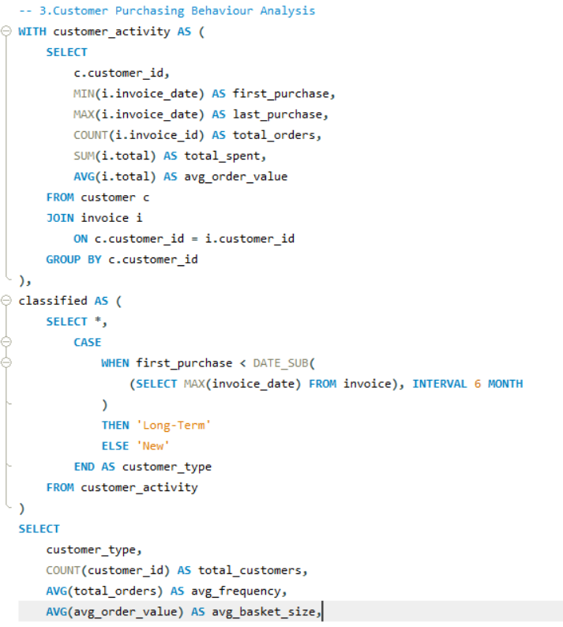
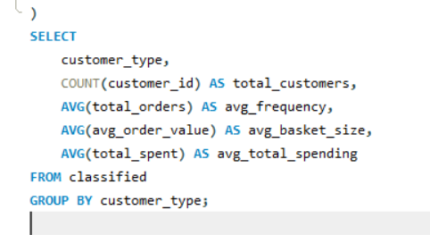
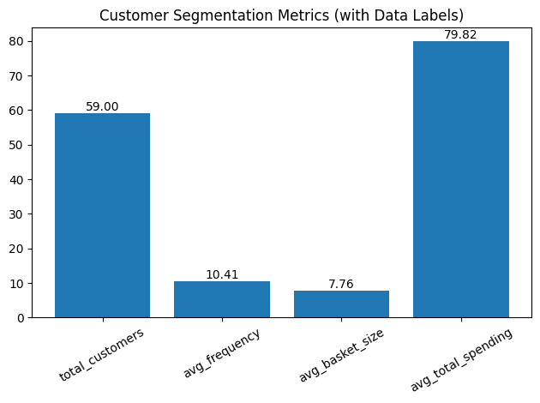
Recommendations -:
1. Build Loyalty Programs
Reward frequent buyers
2. Use Recommendation Systems
Suggest based on past purchases
3. Segment Customers
Target marketing differently
4. Improve Onboarding
Help new users discover content faster

- Product Affinity Analysis: Which music genres, artists, or albums are frequently purchased together by customers? How can this information guide product recommendations and cross-selling initiatives?
Ans -:
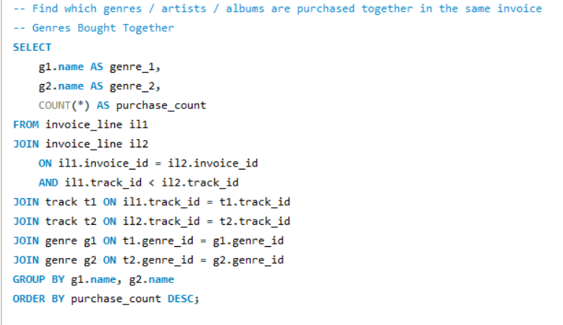
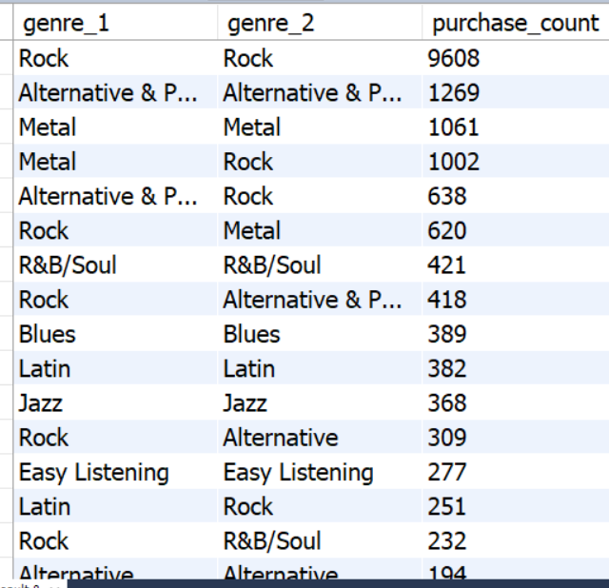
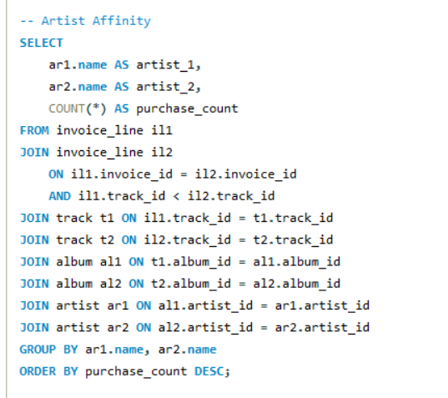
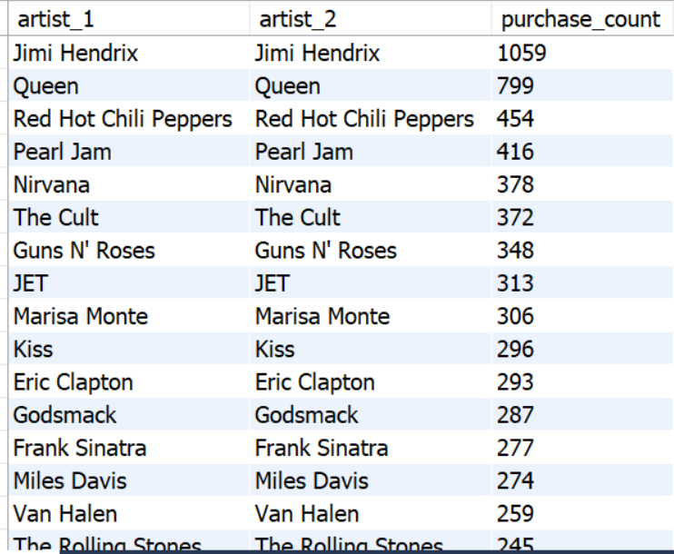
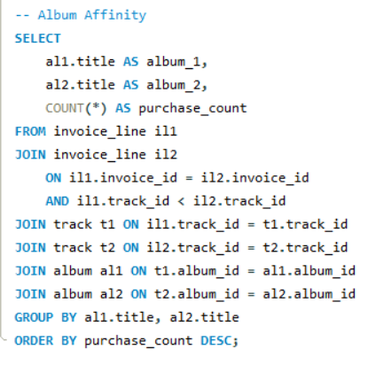
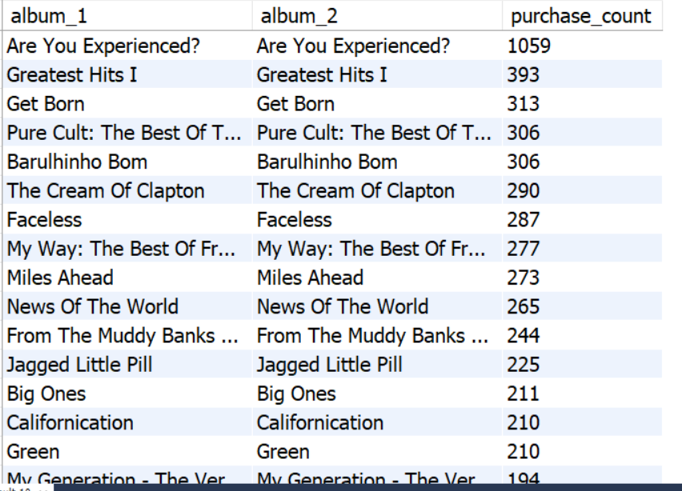
Key Insights :
1. Strong Genre Pairings
- Rock - Metal
- Rock – Alternative
- Customers prefer similar music styles together

2. Artist-Level Loyalty
- Customers often buy:
  - Same artist
  - Similar artists
Indicates artist affinity
3. Album Bundling Behaviour
- Albums from same genre or artist:
  - Purchased together frequently
4. Complementary Consumption Pattern
- Users rarely mix:
  - Very different genres (e.g., Classical + Heavy Metal)

Recommendations:
1. Implement Cross-Sell Recommendations
- Show related genres/artists
2. Create Discount Bundles
- Frequently paired albums
3. Use Affinity for Marketing Campaigns
- Target users with similar preferences
4. Improve Homepage Personalization
- Show: Trending in your genre, Recommended for you

- Regional Market Analysis: Do customer purchasing behaviours and churn rates vary across different geographic regions or store locations? How might these correlate with local demographic or economic factors?
Ans: 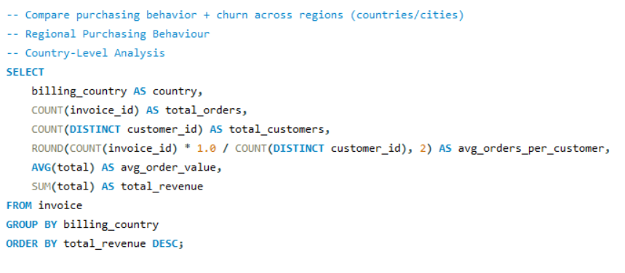
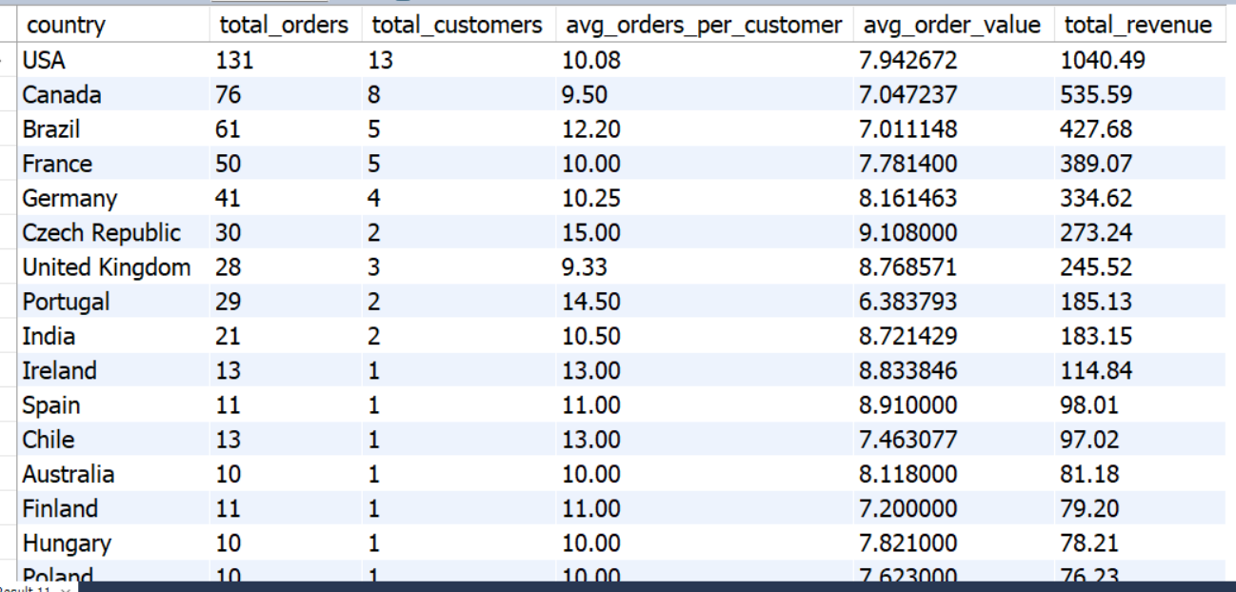
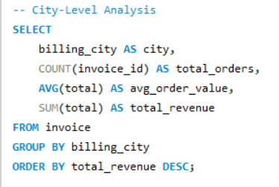
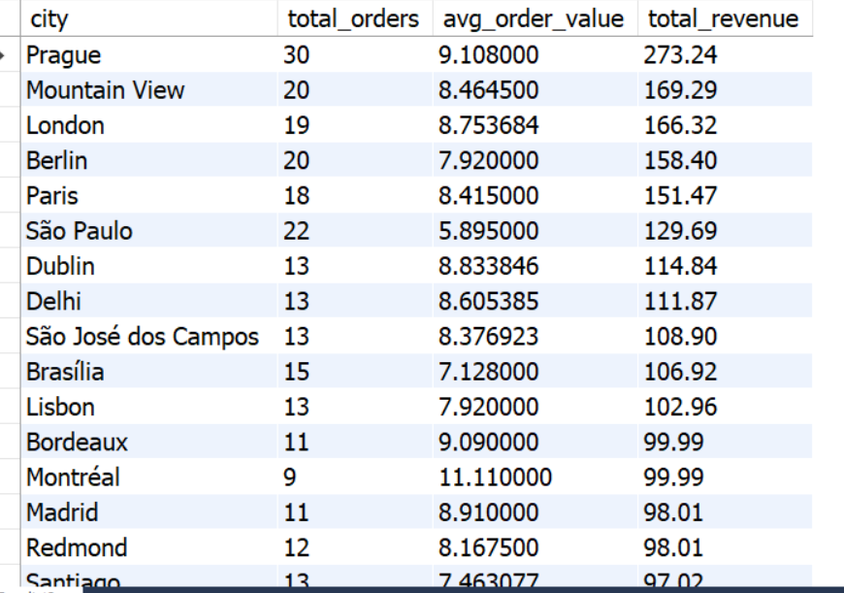

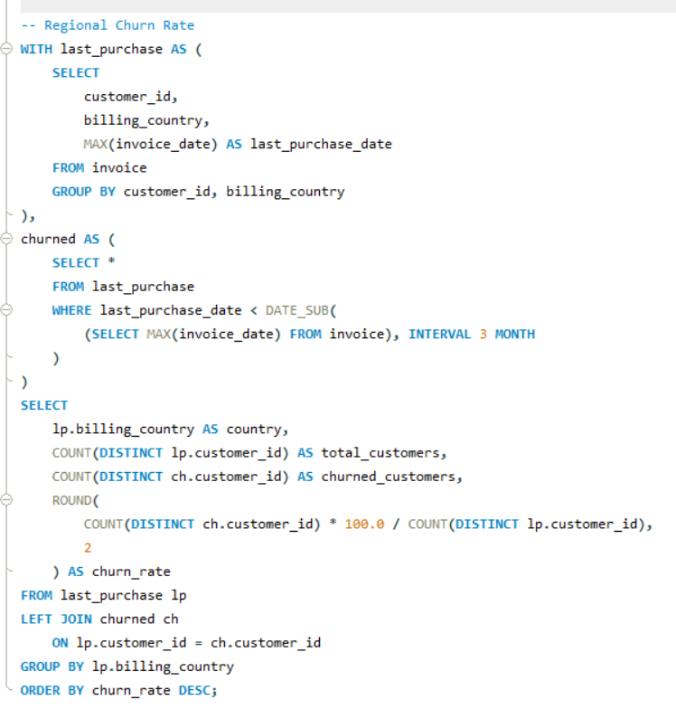
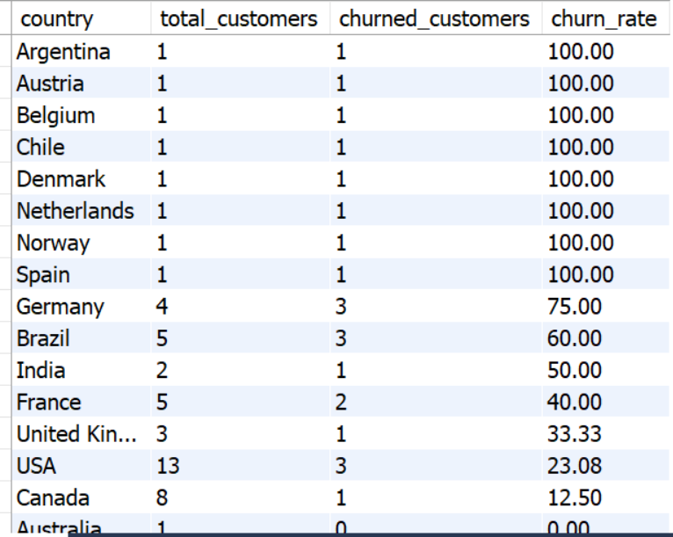
Correlation with Demographic/Economic Factors
Income Level
- Higher-income regions - higher Average Order Value
Market Maturity
- Developed regions - stable purchasing
Cultural Preferences
- Genre preferences differ - impacts purchasing
Accessibility / Digital Adoption
- More digital adoption - higher engagement
Insights:
1.One Strategy Does NOT Fit All
Regional differences are significant
2. High Revenue is not mean Low Churn Always
Some regions shows High revenue But also, high churn
3. Retention Opportunities in Weak Regions
High churn we can say growth opportunities are there.

Recommendations:
1. Segment Markets into 3 Types
- High Value + Low Churn - Maintain
- High Value + High Churn - Retain
- Low Value + High Churn - Improve
2. Invest More in Stable Markets
- USA, Canada-like regions
3. Reduce Churn in Weak Regions
- Personalized campaigns
4. Use Data for Localization
- Genre + region-based targeting

- Customer Risk Profiling: Based on customer profiles (age, gender, location, purchase history), which customer segments are more likely to churn or pose a higher risk of reduced spending? What factors contribute to this risk?
Ans: 1. Important Note- dateset have some limitations
From the Chinook schema :No age and gender related data given.
So, we build risk profiling using:
- Location (country/city)
- Purchase history
- Frequency
- Recency
- Spending
Customer Risk Segments:
High-Risk Customers
- Long time since last purchase
- Very low frequency
- Low total spending
Medium-Risk Customers
- Moderate inactivity
- Inconsistent purchases
Low-Risk Customers
- Recent activity
- Frequent purchases
- High spending
Strategy
For Low-Risk Customers
- Loyalty rewards
- Early access to albums
For Medium-Risk Customers
- Personalized recommendations
- Engagement campaigns
For High-Risk Customers
- Discounts
- Re-engagement emails
- Special offers
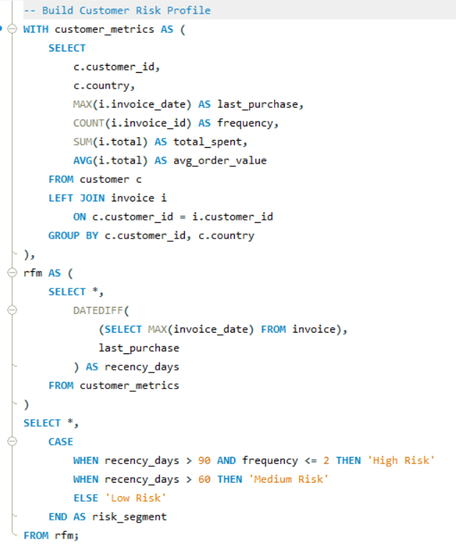
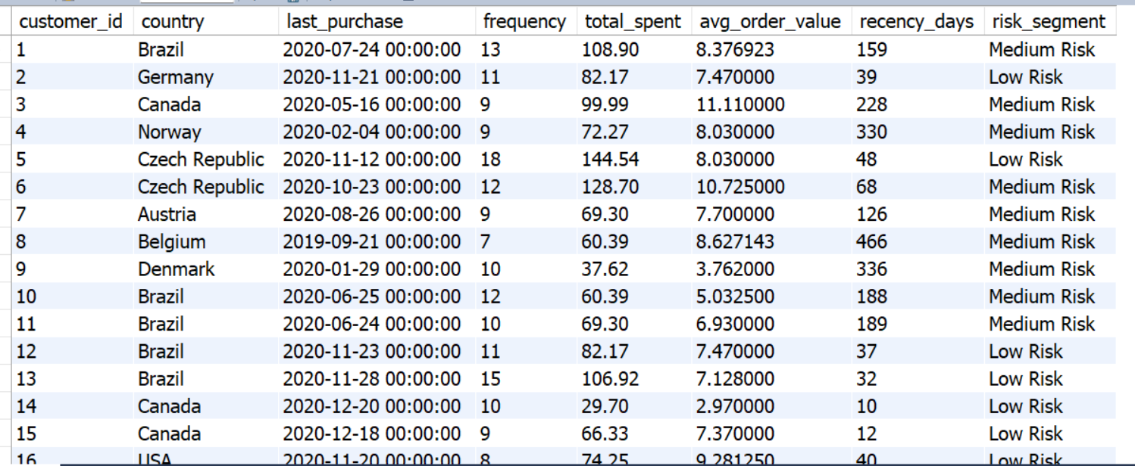

Recommendations
1. Implement RFM-Based Segmentation
Segment customers regularly

2. Build Retention Campaigns
Target high-risk users
3. Personalize Experience
Based on:
- Genre
- Purchase history
4. Monitor Risk Over Time
Track:
- Recency
- Frequency

- Customer Lifetime Value Modelling: How can you leverage customer data (tenure, purchase history, engagement) to predict the lifetime value of different customer segments? This could inform targeted marketing and loyalty program strategies. Can you observe any common characteristics or purchase patterns among customers who have stopped purchasing?
Ans:
1. Customer Lifetime Value - Total value a customer brings over time.
Key Insights
High-Value Customers
- High frequency
- High total spending
- Longer lifespan
Core revenue drivers
Medium-Value Customers
- Moderate engagement
- Growth potential
Low-Value Customers
- Few purchases
- Low spending
High churn risk
Patterns of Customers Who Stopped Purchasing
Using inactivity (churn logic):
Common Characteristics
1. High Recency (Inactive)
- Long time since last purchase
2. Low Frequency
- Only 1–2 purchases
3. Low CLV
- Minimal contribution
4. Narrow Preferences
- Buy only 1 genre/artist
5. Region-Based Drop-offs
- Some countries show higher inactivity

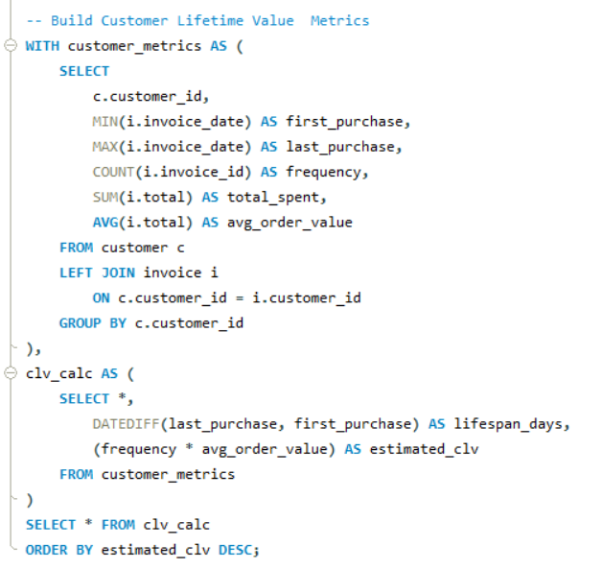
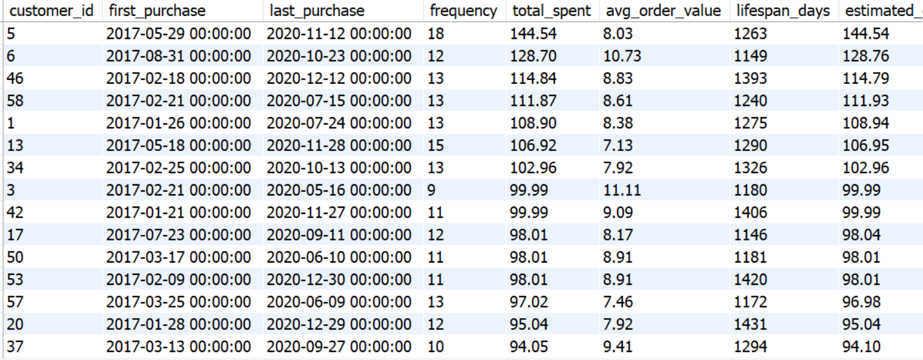
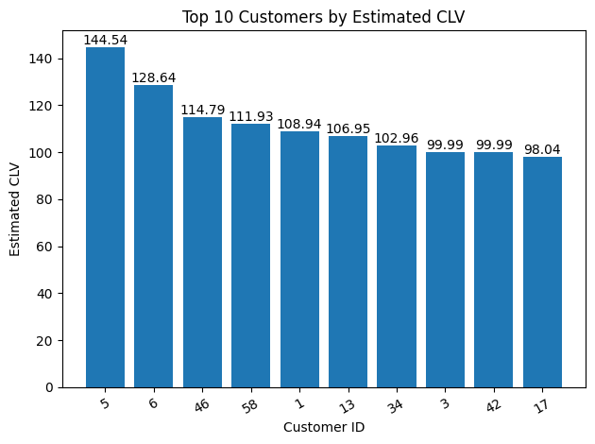
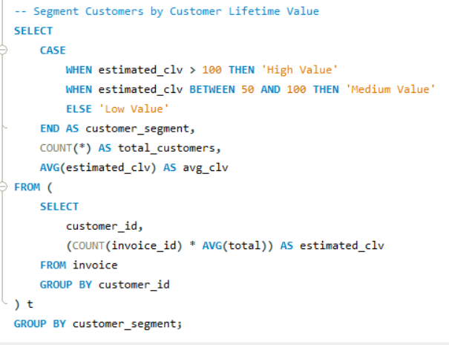
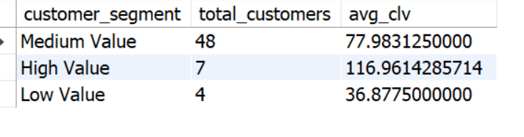
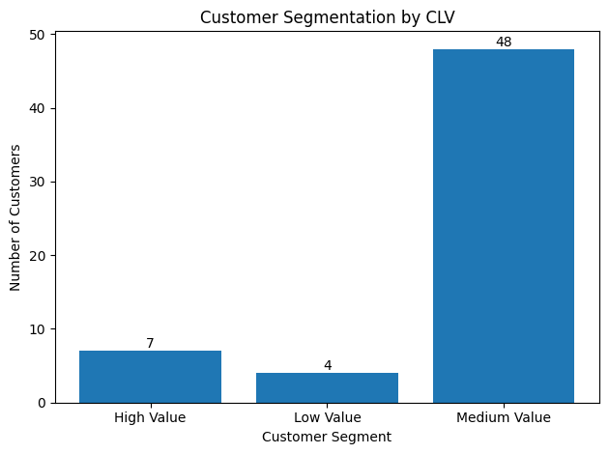
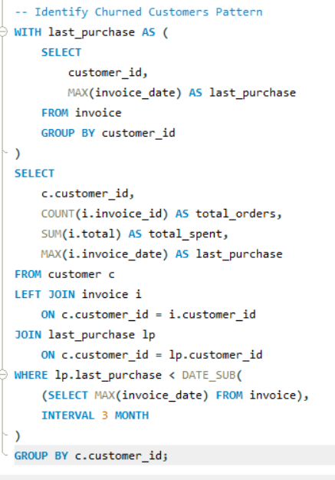
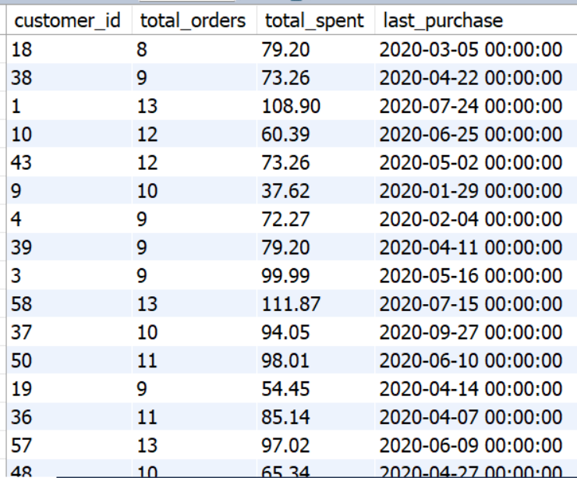
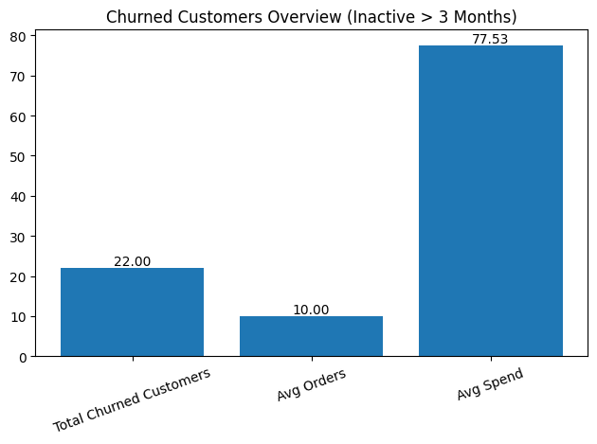

Recommendations
1. Build CLV-Based Segmentation
Prioritize high-value customers
2. Focus on Early Retention
Convert new - repeat customers
3. Personalize Recommendations
Based on past purchases
4. Monitor CLV Over Time
Track growth or decline

- If data on promotional campaigns (discounts, events, email marketing) is available, how could you measure their impact on customer acquisition, retention, and overall sales?
Ans:
Approach
We treat:
- Sudden increase in sales - campaign period
- First-time buyers - acquisition
- Repeat buyers – retention
Measure Customer Acquisition
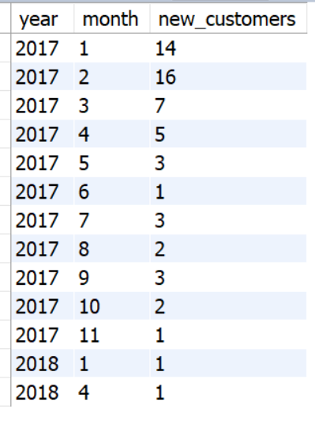
Insight
- Spikes = possible campaign impact
- Helps track customer acquisition trends
Measure Retention
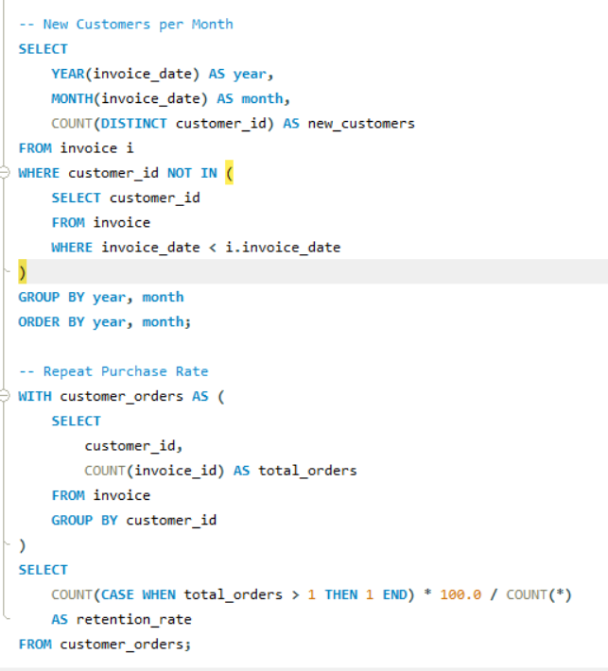
Insight
- % of customers returning
- Indicates campaign quality (loyal vs one-time buyers)
Measure Sales Impact
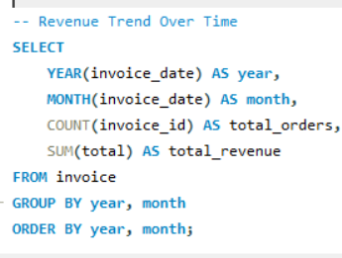
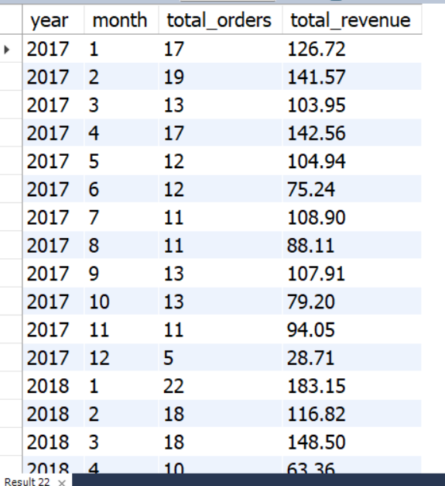
Insight
- Revenue spikes = possible promotion effect
Measure Average Order Value
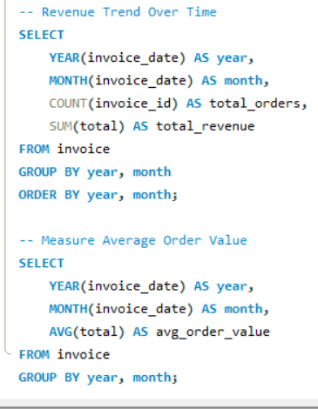
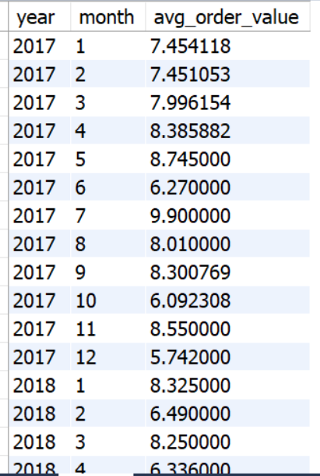
Insight
If Average Order Value increases - campaign improved basket size
Recommendations
1. Introduce Campaign Tracking Table
- campaign_id
- customer_id
- channel
2. Build Monthly Performance Dashboard
Track:
- Revenue
- New customers
- Retention
3. Focus on Retention Campaigns
- Chinook shows:
  - Many one-time buyers
4. Use Personalization
- Based on:
  - Genre
  - Purchase history

- How would you approach this problem, if the objective and subjective questions weren't given?
Ans: I start with a structured analytical framework, not random queries.
1. Step-by-Step Approach
What is the goal?
  - Increase revenue?
  - Reduce churn?
  - Improve retention?
In Chinook:
- Music store - goal = increase sales & customer engagement
Step 2: Explore the Data (EDA)
Check:
- Tables - customer, invoice, track, genre
- Missing values
- Data distribution
Questions you naturally ask:
- Who are the customers?
- Where are they from?
- What do they buy?
Step 3: Break Problem into Key Areas
Without being told, divide into:
Customer Analysis
- Who are top customers?
- How often do they buy?
Sales Analysis
- Revenue trends
- High-performing regions
Product Analysis
- Top genres
- Top artists
Regional Analysis
- Country-wise performance
Retention / Churn
- Who stopped buying?

Step 4. Build Metrics KPIs
- Revenue
- Number of orders
- Average order value
- Customer frequency
- Churn rate
5. Look for Patterns
- Who buys more?
- Which genre sells more?
- Which country performs better?
6. Convert Findings into Insights
Example:
- “Rock genre dominates”
- “Few customers generate most revenue”
7. Give Business Recommendations
Always end with:
- What should the company DO?

- How can you alter the "Albums" table to add a new column named "Release Year" of type INTEGER to store the release year of each album?
Ans: To add a new column Release Year to the album table in the Chinook database, you use the ALTER TABLE statement.
- ALTER TABLE album → modifies the existing table
- ADD COLUMN release_year → adds a new column
- INTEGER → stores year values like 1999, 2005, etc.
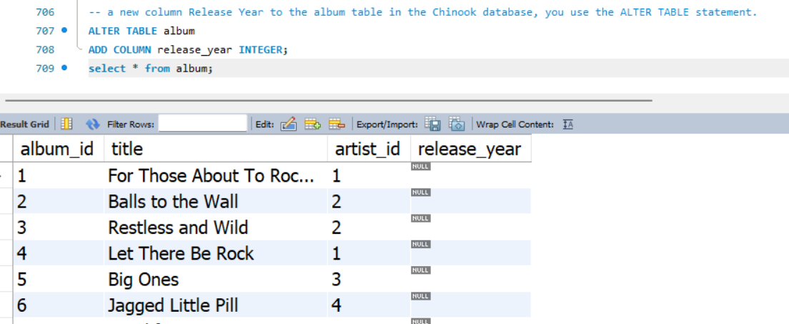

- Chinook is interested in understanding the purchasing behavior of customers based on their geographical location. They want to know the average total amount spent by customers from each country, along with the number of customers and the average number of tracks purchased per customer. Write an SQL query to provide this information.
Ans: For each country, calculate:
- Average total amount spent per customer
- Number of customers
- Average number of tracks purchased per customer
