BRACT’s
Vishwakarma Institute of Technology, Pune
Practical Implementation Sheet
Department: CSE-AI Semester: 5 Academic Year: 2026-27
Division: E Batch: 1 Practical No: 1
Roll no: 04 PRN No: 12412054 Name of Student: Narendra Ajit Patil
Subject Name : Deep Learning

Problem Statement : Assignment 1 - Install and configure TensorFlow/Keras in Google Colab. Perform data preprocessing, normalization, train-test split, and visualization on a sample dataset.

Algorithm :
1. Import the required libraries:
a.TensorFlow
b.Numpy
c.Matplotlib
2. Load the sample dataset ( MNIST) Keras.
3. Verify the dataset by checking the shape of the training and testing images and labels.
4. Preprocess the data by converting the image pixel values to the appropriate data type (float32).
5. Normalize the image pixel values to a suitable range
a.Mean Normalization
b.Normalization[-1,1]
c.Divide by 255
6. Split the dataset into training and testing sets.
7. Visualize the dataset by displaying sample images along with their corresponding labels.
8. Plot multiple sample images in a grid to understand the distribution and appearance of the handwritten digits.
9. Display the distribution of class labels using a histogram or bar chart (optional but recommended).
10. Verify that the preprocessing and normalization have been applied correctly.
11. End the program.

Code :
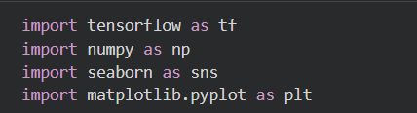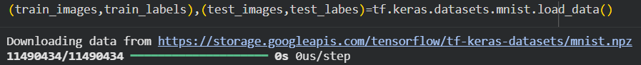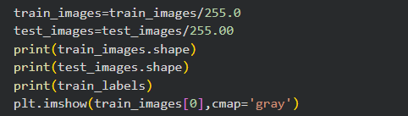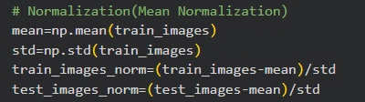
Output :