FUNCTIONAL REQUIREMENTS DOCUMENT
LinkedIn Job-Lead Capture & Outreach Management Module
An extension of the Personal Job Application Tracker
Prepared for: Narendra Gupta
Document Type: Functional Requirements Document (FRD)
Version 1.0 | Draft | 19 August 2026
Classification: Personal / Internal Use Only

Document Control
Version | Date | Author | Change Summary
0.1 | 19-Aug-2026 | N. Gupta / Claude (drafting) | Initial draft based on feasibility discussion
1.0 | 19-Aug-2026 | N. Gupta / Claude (drafting) | First complete FRD — scope, functional/non-functional requirements, data model, diagrams

Field | Detail
Project | Job Application Tracker — LinkedIn Ingestion Module
Owner / Sponsor | Narendra Gupta (personal-use system)
Related System | Existing Job Application Tracker (React, FastAPI, PostgreSQL, OpenAI)
Status | Draft — for review before Sprint 1 build

Table of Contents
1. Executive Summary
2. Purpose & Business Objective
3. Scope
4. Stakeholders & Users
5. System Architecture Overview
6. Functional Requirements
7. End-to-End Process Workflow
8. Data Model
9. Non-Functional Requirements
10. Assumptions
11. Dependencies
12. Risks & Constraints
13. Alternatives Considered
14. Success Metrics (KPIs)
15. Implementation Plan & Timeline
16. Recommendations & Next Steps
Appendix A — Glossary
Appendix B — Sample Field Mapping

1. Executive Summary
LinkedIn job alerts currently arrive as unstructured Gmail messages and are difficult to track, compare, or act on consistently. This module automates only the inbound data capture — reading LinkedIn job-alert emails and converting them into structured, queryable records — while keeping every outward-facing action (reviewing a listing, capturing a recruiter or referral contact, sending a message, following up) manual and AI-assisted rather than automated.
The distinction is deliberate. The job title, company, location, and apply link are static content LinkedIn puts in the email and can be parsed reliably with no risk. Recruiter and referral contact details, by contrast, are computed by LinkedIn per-viewer, per-session, only on the job page itself, and are not exposed to any third-party API — attempting to automate their capture would require scripted access to a logged-in LinkedIn session, which violates LinkedIn's User Agreement and risks account restriction. This FRD scopes automation strictly to the email side and treats contact capture as a fast, AI-assisted manual step.

Key Findings
Data Field | Automatable? | Rationale
Job title, company, location, tags, apply link | Yes — fully automated | Present in every alert email in a consistent HTML template
Full job description text | Partial — requires manual open | Not included in the alert email itself
Recruiter / hiring-team contact | No — manual capture only | Personalised, session-based rendering on LinkedIn's own page
Referral / alumni connections | No — manual capture only | Computed from the viewer's own network; cannot exist outside a logged-in session as the user

2. Purpose & Business Objective
To give the user a single place to see every LinkedIn job alert as a structured, actionable record — eliminating manual triage of alert emails — and to extend the existing job-application tracker with the outreach, referral-tracking, and follow-up-reminder capabilities needed to act on those leads consistently.
- Reduce time spent scanning and re-reading LinkedIn alert emails.
- Prevent promising leads and referral opportunities from being lost in the inbox.
- Standardise outreach and follow-up so no contact is missed or forgotten.
- Reuse the existing resume-JD matching and reach-out drafting already planned for the tracker.

3. Scope

3.1 In Scope
- Automated ingestion of LinkedIn job-alert emails via the Gmail API (read-only).
- Parsing and storage of title, company, location, remote flag, tags, posted date (relative), and canonical job link.
- Deduplication of repeat alerts for the same job posting.
- Lead management dashboard (list, filter, status tracking).
- Manual, AI-assisted capture of JD text and recruiter/referral contacts (user pastes; AI structures the fields).
- AI-drafted outreach messages (referral ask, cold outreach, follow-up) for manual review and manual sending.
- Follow-up reminder scheduling and status tracking, consistent with the existing tracker's reminder states.
- Message history per contact and per lead.

3.2 Out of Scope
- Any automated scraping, browser automation, or bot access to LinkedIn's website or logged-in session.
- Automated sending of messages/emails/LinkedIn DMs on the user's behalf.
- Use of LinkedIn's partner-gated Talent/Jobs APIs (not accessible for an individual, non-partner account).
- Multi-user/tenant support — this is a single-user personal system.

4. Stakeholders & Users
Stakeholder | Role | Interest
Narendra Gupta | Owner, sole end user | Uses the system daily to manage LinkedIn-sourced leads and outreach
Gmail (Google API) | Data source | Provides read-only access to alert emails via OAuth
LinkedIn | External platform (out of system control) | Source of alert emails and job postings; no integration beyond reading own inbox
OpenAI | AI service dependency | Structures pasted text and drafts outreach content

5. System Architecture Overview
The architecture separates automated components (navy/teal) from AI-assisted steps (gold) and manual, user-driven steps (green). Only the top two layers touch external systems without a human in the loop — and the only external system touched automatically is the user's own Gmail account.
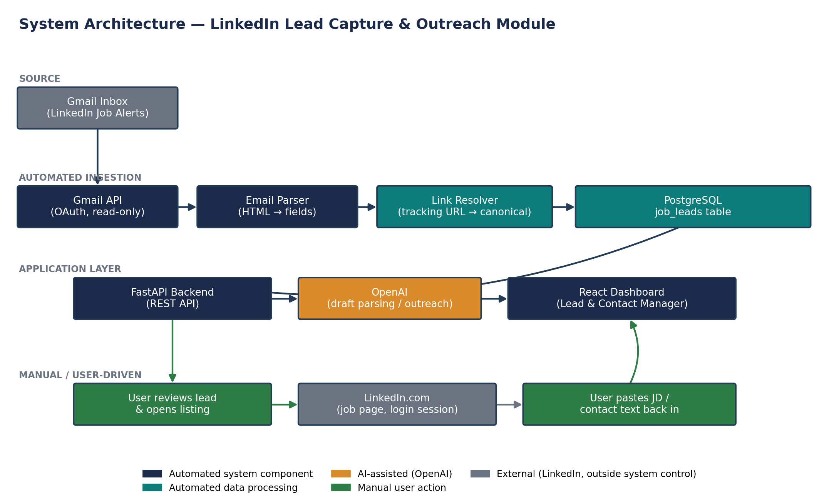
Figure 1 — System architecture: automated ingestion vs. manual/AI-assisted workflow

6. Functional Requirements
Priority follows MoSCoW (Must / Should / Could). Automation Level indicates whether the requirement is system-automated, AI-assisted, or manual by design.

6.1 Module 1 — Automated Email Ingestion
ID | Requirement | Priority | Automation
FR-1.1 | Connect to the user's Gmail account via OAuth 2.0 with read-only scope, restricted to LinkedIn alert sender/label. | Must | Automated
FR-1.2 | Detect new LinkedIn alert emails via scheduled poll or Gmail push notification. | Must | Automated
FR-1.3 | Parse the HTML body to extract title, company, location, remote flag, tags, and posted-relative text. | Must | Automated
FR-1.4 | Resolve the tracking redirect link to the canonical LinkedIn job URL and extract the job ID. | Must | Automated
FR-1.5 | Deduplicate leads by job ID + company across repeated alert emails. | Must | Automated
FR-1.6 | Write each parsed lead to job_leads with status “New” and a captured_at timestamp. | Must | Automated
FR-1.7 | Route parsing failures (e.g., template change) to an error queue instead of silently dropping the email. | Should | Automated

6.2 Module 2 — Lead Management Dashboard
ID | Requirement | Priority | Automation
FR-2.1 | List all leads with filter/sort by status, company, capture date, and tags. | Must | Manual (view)
FR-2.2 | Allow the user to change lead status: New / Reviewing / Applied / Discarded. | Must | Manual
FR-2.3 | Deep-link each lead to its canonical LinkedIn job URL for one-click manual review. | Must | Manual
FR-2.4 | Flag leads with no activity after a configurable number of days for cleanup review. | Could | Automated

6.3 Module 3 — Manual Contact & JD Capture (AI-Assisted)
ID | Requirement | Priority | Automation
FR-3.1 | Provide a free-text paste field on the lead detail page for JD text and hiring-team/referral text copied from LinkedIn. | Must | Manual
FR-3.2 | Use an LLM call to structure pasted hiring-team text into discrete contact records (name, title, LinkedIn URL, connection type). | Must | AI-assisted
FR-3.3 | Use an LLM call to store the pasted JD and generate a short summary for quick scanning. | Should | AI-assisted
FR-3.4 | Allow manual add/edit/delete of contact records regardless of AI parsing output. | Must | Manual

6.4 Module 4 — AI-Assisted Outreach Drafting
ID | Requirement | Priority | Automation
FR-4.1 | Allow the user to request an AI-drafted message (referral ask / cold outreach / follow-up) for a selected contact + lead. | Must | AI-assisted
FR-4.2 | Generate the draft from JD text, the selected resume version, and contact context via OpenAI. | Must | AI-assisted
FR-4.3 | Require manual review/edit; the system never sends messages automatically. | Must | Manual
FR-4.4 | Store both the AI draft and the final sent version for record-keeping. | Should | Automated

6.5 Module 5 — Follow-up Reminder Engine
ID | Requirement | Priority | Automation
FR-5.1 | Auto-schedule Reminder 1 on a configurable interval (default 3 days) once a message is marked “Sent”. | Must | Automated
FR-5.2 | Notify the user on the dashboard (and optionally by email) when a reminder is due. | Must | Automated
FR-5.3 | Allow the user to record reminder outcome: Reminder Sent / Response Received / Closed / Not Responded. | Must | Manual
FR-5.4 | Escalate unresolved reminders to Reminder 2 on the same configurable cadence. | Should | Automated

6.6 Module 6 — Message History & Audit Trail
ID | Requirement | Priority | Automation
FR-6.1 | Retain full outreach history per contact across multiple leads/roles for context on repeat outreach. | Should | Automated
FR-6.2 | Show a per-lead timeline: captured → reviewed → contact added → message sent → reminders → outcome. | Could | Automated

7. End-to-End Process Workflow
Steps 1–4 run without user involvement. Steps 5–9 are manual and AI-assisted — the user remains in control of what gets captured and what gets sent at every point. Step 10 is an automated reminder trigger, not an automated send.
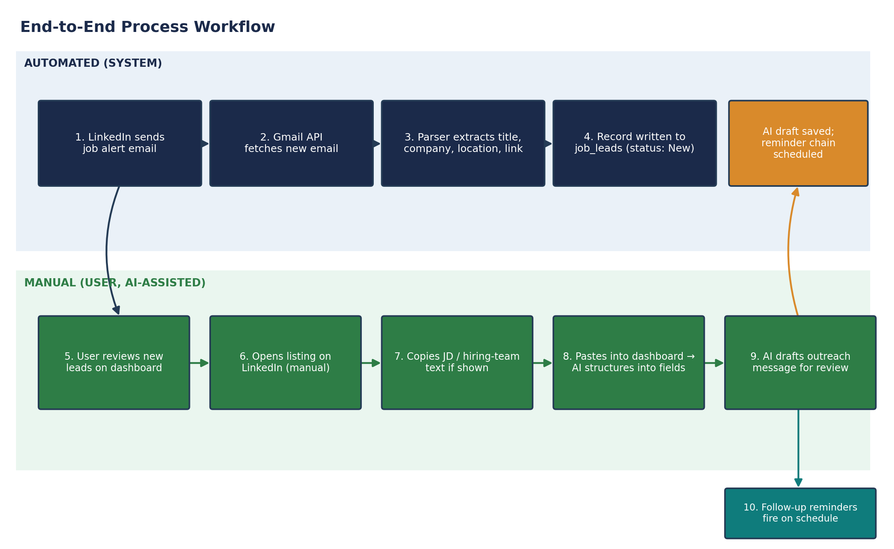
Figure 2 — End-to-end workflow across automated and manual swimlanes

8. Data Model
job_leads is the only table populated automatically. Every other table is populated through manual entry or AI-assisted structuring of text the user has copied themselves — no table in this schema is written to by any automated LinkedIn access.
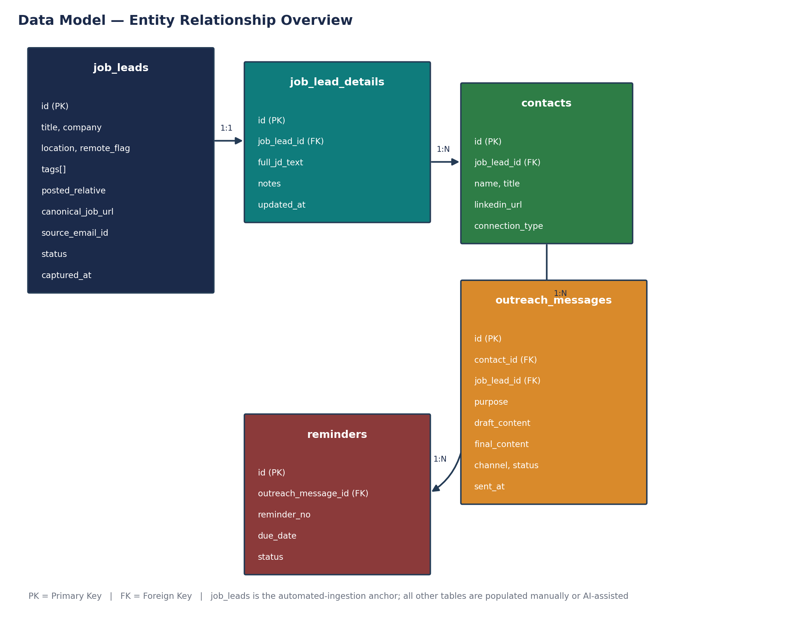
Figure 3 — Entity-relationship overview
Entity | Purpose
job_leads | One row per parsed alert email — the automated-ingestion anchor for the module.
job_lead_details | Full JD text and notes, added manually/AI-structured when the user opens a listing.
contacts | Recruiter or referral contacts tied to a lead, captured via paste-and-parse or manual entry.
outreach_messages | AI-drafted and final sent message content per contact, with channel and status.
reminders | Follow-up schedule and outcome per outreach message.

9. Non-Functional Requirements
Category | Requirement
Performance | New alert emails should be parsed and visible on the dashboard within 5 minutes of the poll/push cycle.
Security | Gmail OAuth token stored encrypted at rest; read-only scope only — no send/modify permission is requested or required.
Privacy | Single-tenant, personal-use system; no data shared with third parties beyond the OpenAI calls needed for drafting/structuring.
Reliability | A single parsing failure must not block the ingestion queue; repeated failures should alert the user (likely template change).
Usability | Dashboard is mobile-responsive, consistent with the existing tracker's Material Design direction.
Maintainability | Parser rules should be config-driven and testable independently, since LinkedIn's email template can change without notice.

10. Assumptions
- LinkedIn continues sending job-alert emails in a broadly consistent HTML structure; material template changes will require parser updates (see FR-1.7).
- This remains a single-user, personal-use system — no additional authentication/authorization layer is required beyond the owner's own Gmail OAuth.
- OpenAI API access and budget already used elsewhere in the tracker extends to this module's drafting and structuring calls.
- The existing job-app-tracker backend (FastAPI/PostgreSQL) is extended rather than a new system being stood up.

11. Dependencies
- Gmail API access and OAuth consent screen configuration for the user's own account.
- Existing tracker schema (companies, resumes, JD-match scores) for outreach drafting to reuse resume-JD context.
- OpenAI API key and quota.
- LinkedIn continuing to send alert emails in a parseable format — an external dependency with no SLA.

12. Risks & Constraints
Risk | Likelihood | Impact | Mitigation
LinkedIn changes the alert-email template, breaking the parser | Medium | Medium | Isolate parsing logic, add a failure queue with alerting, review periodically
Gmail API rate/quota limits | Low | Low | Personal alert volume is well within standard free quota
Recruiter/referral info absent from most listings (observed directly by the user) | High | Low | Designed as optional enrichment, not a blocking step in the workflow
AI misstructures pasted contact/JD text | Medium | Low | User reviews and edits before anything is saved — nothing is auto-committed
Paste-and-parse step feels tedious, reducing actual use | Medium | Medium | Keep it to a single paste field per lead; revisit if adoption is low
Gmail OAuth token compromise | Low | High | Encrypted storage, minimal read-only scope, rotate credentials periodically

13. Alternatives Considered
Alternative | Why Not Selected | Status
Automated browser scraping of LinkedIn job pages for HR/referral data | Violates LinkedIn's User Agreement; risks account restriction; fragile to DOM/template changes | Rejected
LinkedIn Talent/Jobs API integration | Partner-gated; not available to an individual, non-partner account | Rejected
Browser extension passive capture (runs in the user's own logged-in tab, not automated bot traffic) | Lower risk than scraping, but adds build scope beyond this FRD's goal | Deferred to a future phase

14. Success Metrics (KPIs)
- Percentage of alert emails parsed successfully without manual correction.
- Time from email arrival to lead visible on the dashboard (target: under 5 minutes).
- Referral coverage rate — share of leads with at least one contact captured.
- Follow-up adherence — share of sent messages with a reminder outcome recorded (vs. left unresolved).

15. Implementation Plan & Timeline
This module is proposed as the first block of Sprint 1 in the existing 3-sprint, 14-day-per-sprint plan for the job application tracker, since it directly addresses the current pain point (alert overload) with the lowest implementation risk of the planned modules.
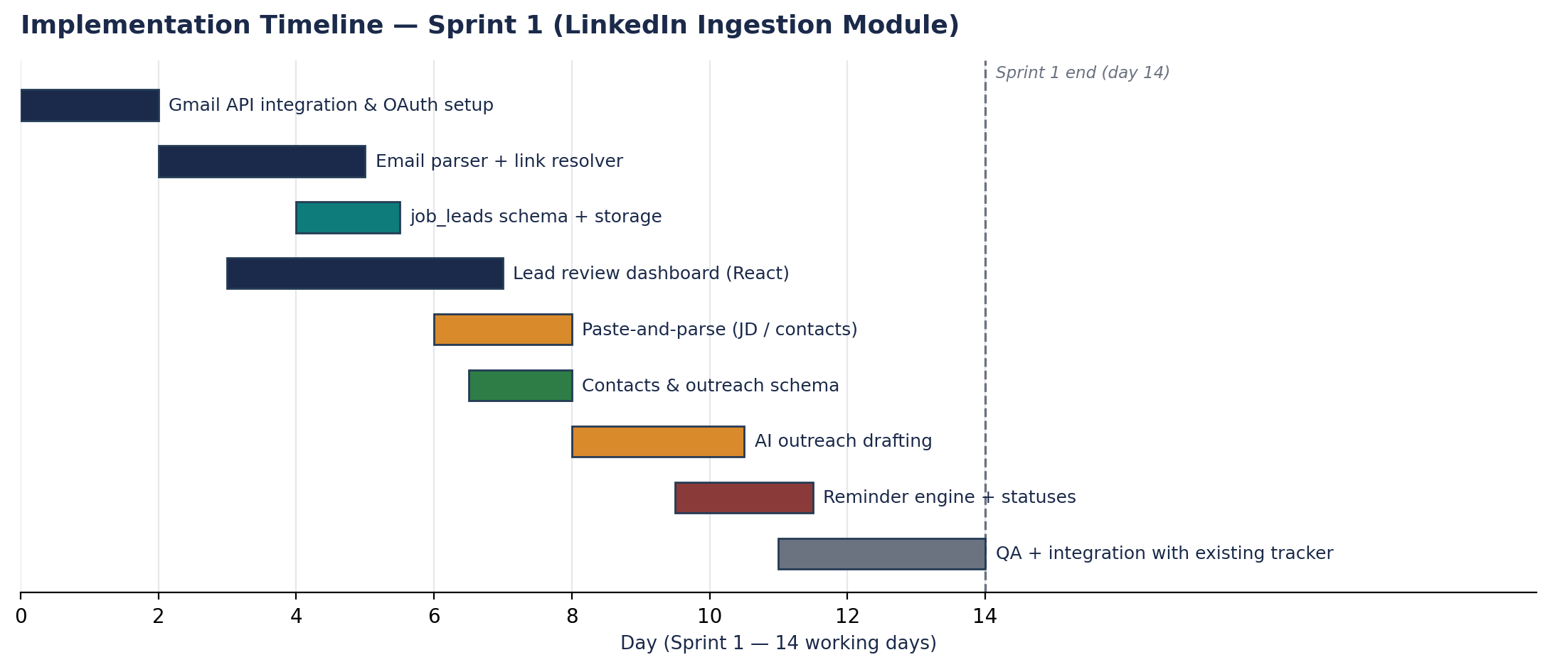
Figure 4 — Proposed Sprint 1 sequencing

16. Recommendations & Next Steps
- Build as an extension of the existing job-app-tracker (shared backend/DB) rather than a standalone system.
- Sequence the Gmail ingestion module first in Sprint 1 — it is fully automatable, lowest-risk, and solves the immediate pain point on its own.
- Build the paste-and-parse capture and AI drafting alongside the existing “reach-out” feature already planned, rather than as a separate flow.
- Defer browser-extension-based passive capture; revisit only if the manual paste step proves too tedious once in use.
- Review and sign off this FRD's scope boundary (Section 3.2) before development starts, since it is the basis for excluding LinkedIn-side automation.

Appendix A — Glossary
Term | Definition
Lead | A parsed LinkedIn job alert stored as a row in job_leads.
Paste-and-parse | The manual step of copying text from LinkedIn and pasting it into the dashboard, where AI structures it into fields.
Canonical job URL | The resolved linkedin.com/jobs/view/{id} link, after following the email's tracking redirect.
Referral coverage | Share of leads for which at least one contact has been captured.
Reminder chain | The scheduled sequence of follow-up reminders (Reminder 1, Reminder 2, …) tied to a sent message.

Appendix B — Sample Field Mapping
Example mapping from a typical LinkedIn alert email (as reviewed during feasibility discussion) to stored fields:
Email Content | Parsed Field | Example Value
“Delivery Manager - Remote — Optum · Eden Prairie, MN” | title / company / location | Delivery Manager - Remote / Optum / Eden Prairie, MN
“Actively recruiting” badge | tags[] | ["Actively Recruiting"]
“3 days ago” (at time of send) | posted_relative | 3 days ago
Tracking link in email body | canonical_job_url (after resolve) | linkedin.com/jobs/view/{id}

