TECHNICAL REQUIREMENTS DOCUMENT
LinkedIn Job-Lead Capture & Outreach Management Module
Next.js on Vercel — companion to the Functional Requirements Document
Prepared for: Narendra Gupta
Document Type: Technical Requirements Document (TRD)
Version 1.0 | Draft | 19 August 2026
Classification: Personal / Internal Use Only

Document Control
Version | Date | Author | Change Summary
1.0 | 19-Aug-2026 | N. Gupta / Claude (drafting) | First TRD — stack, architecture, schema, security, deployment

Field | Detail
Companion document | Functional Requirements Document (FRD), v1.0 — defines scope and functional requirements; not repeated here
Status | Draft — for review before Phase 1 (UI) build starts

1. Purpose & Relationship to the FRD
The FRD defines what the system must do — functional requirements, data model at a conceptual level, and scope boundaries. This TRD defines how it is built: concrete framework, hosting, database, security, and deployment decisions. It assumes the FRD's scope (Section 3 of that document) is accepted, in particular that no automated access to LinkedIn itself is in scope.
One decision here supersedes the FRD's architecture diagram: this module will be built as a single Next.js application on Vercel rather than a separate React frontend and FastAPI backend. The reasoning is in Section 3. Everything else in the FRD — functional requirements, data model, workflow — stands as written; only the implementation technology changes.

2. Technology Stack
Kept deliberately small — one hosting provider, one language, one database, and no component that isn't doing real work.
Layer | Choice | Why
Framework | Next.js 15 (App Router) + TypeScript | Single codebase and language across UI and backend; Server Components ship less JS to the phone by default
Hosting | Vercel (Hobby to start) | Your stated choice; git-push deploys, generous free tier for personal use
UI / Styling | Tailwind CSS + shadcn/ui | Utility-first and mobile-first by default; shadcn components are copied into the repo, not a heavy runtime dependency
Database | PostgreSQL via Neon (Vercel Marketplace integration) | Your stated choice; Neon is Vercel's current native Postgres path — “Vercel Postgres” as a standalone product was retired in favour of this integration — and its pooled driver suits serverless functions
ORM / migrations | Drizzle ORM + Drizzle Kit | Lightweight, SQL-close, low cold-start overhead compared to a binary query engine; schema-as-code doubles as the migration source
Auth | Better Auth (Google provider) | Self-hosted — session/user data stays in your own Postgres, no per-user vendor cost; gives you the users table for free. Auth.js (formerly NextAuth) is now in maintenance mode as of 2026, so Better Auth is the more future-proof default for a new project
AI | OpenAI API | Your stated choice; called from Server Actions only, never from the client
Gmail access | googleapis (Node client) | Reuses the same OAuth token Better Auth already stores for login — one consent screen covers both login and read-only Gmail access
Scheduling | GitHub Actions (scheduled workflow) + Vercel Cron | Vercel's own Hobby-plan cron only fires once a day; a free GitHub Actions workflow calls the sync route every 15–30 min without needing Vercel Pro. Daily Hobby cron is used separately for reminder due-checks, where once a day is genuinely enough
Version control | Git on GitHub, Vercel's native Git integration | Your stated choice; push-to-deploy removes the need for a separate CI/CD pipeline

3. Architecture Overview
One Vercel project, one repository. The UI, the mutation logic, and the auth layer all run inside the same Next.js app; Postgres is the only stateful external dependency the app itself owns. GitHub Actions and Google's own services are the only things touching the app from outside on a schedule.
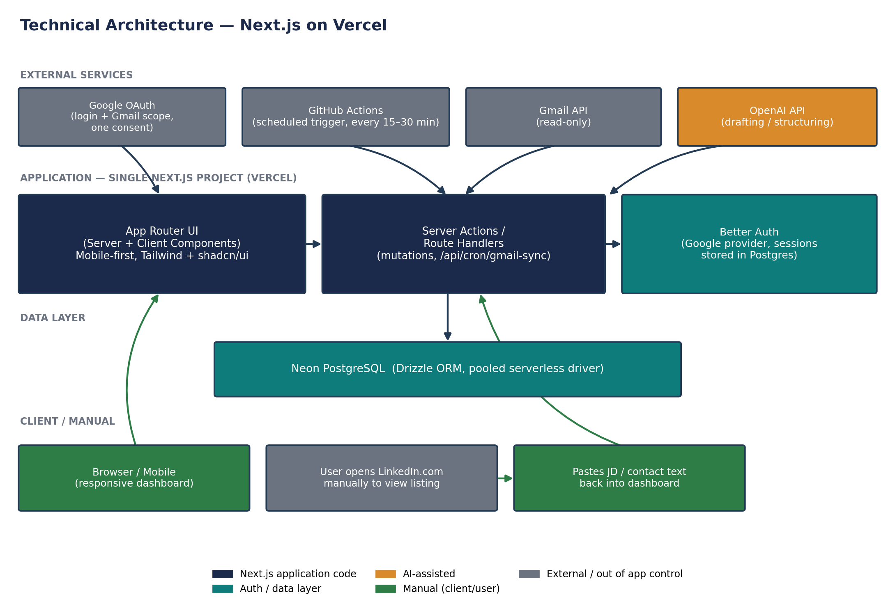
Figure 1 — Technical architecture: single Next.js app on Vercel

4. Repository Structure
One repository, structured around the build sequence in Section 12 (UI components and routes exist before the database schema or Server Actions that fill them):
/app
/(dashboard)/leads/page.tsx list + filters
/(dashboard)/leads/[id]/page.tsx detail, paste-and-parse, contacts, outreach
/api/cron/gmail-sync/route.ts GitHub Actions calls this (CRON_SECRET)
/api/cron/reminders/route.ts daily Vercel Cron, marks reminders due
/api/auth/[...all]/route.ts Better Auth handler
layout.tsx, page.tsx (login)
/components
/ui shadcn/ui primitives
/leads /contacts /outreach
/lib
db.ts Drizzle client
auth.ts Better Auth config (Google provider, allow-listed email)
gmail.ts Gmail API client + email parser
openai.ts OpenAI client + prompts
/db
schema.ts Drizzle schema — single source of truth
migrations/
/actions
leads.ts contacts.ts outreach.ts (Server Actions)
vercel.json (reminder cron entry)
drizzle.config.ts
.env.local.example

5. Mobile-First Frontend Architecture
- Design and build for a 375–414px viewport first; widen via Tailwind's sm:/md:/lg: breakpoints — never the reverse.
- Layout: stacked single-column cards on mobile; a sidebar + table/grid layout appears at md: (≥768px).
- Navigation: bottom tab bar or slide-over drawer on mobile; a persistent left sidebar replaces it at desktop widths.
- Touch targets ≥ 44×44px; no hover-only interactions — everything reachable by tap.
- The leads list renders as stacked cards on mobile and a real <table> at md:+, so nothing requires horizontal scrolling on a phone.
- Every screen is checked at 375px and 768px throughout Phase 1 (Section 12), not just at the end.

6. Database Schema
users, accounts, and sessions are generated by Better Auth's Drizzle adapter — they are not hand-designed. job_leads carries a user_id column from day one, even though only one row will ever exist there for now; that single column is what avoids a migration if the system ever needs a second user.
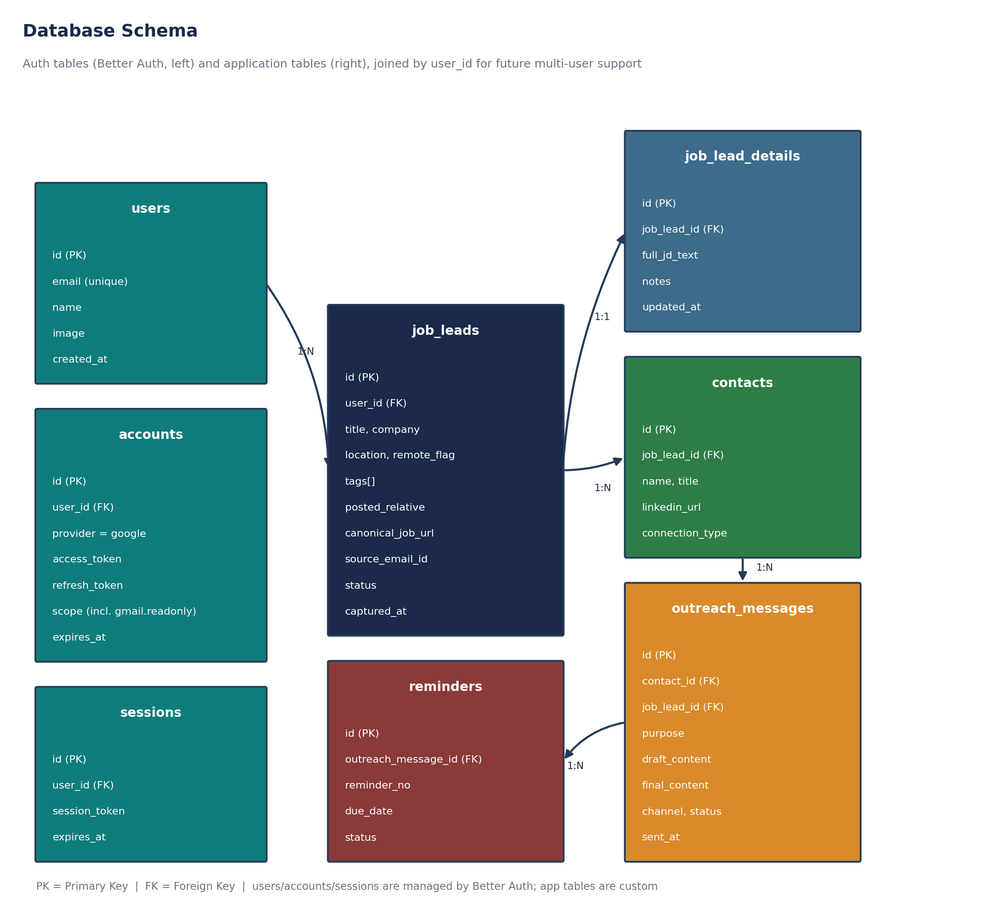
Figure 2 — Database schema: auth tables (Better Auth) and application tables
Table | Notes
users / accounts / sessions | Owned by Better Auth. accounts.scope includes gmail.readonly; accounts.refresh_token is what the Gmail sync job uses — never a separately stored credential
job_leads | One row per parsed alert email; user_id present now for future multi-user, unused in queries today (always the one owner)
job_lead_details, contacts, outreach_messages, reminders | As defined in the FRD data model — unchanged

7. Routes & Server Actions
Next.js collapses most of what would otherwise be a separate REST API into Server Actions called directly from components. Only the cron and auth endpoints are conventional HTTP routes.
Path / Action | Type | Purpose | Auth
/login | Page | Google sign-in | Public
/(dashboard)/leads | Server Component | List/filter leads | Session
/(dashboard)/leads/[id] | Server Component | Lead detail, paste-and-parse, contacts, outreach | Session
actions/leads.ts → updateStatus() | Server Action | Change lead status | Session
actions/leads.ts → parsePastedText() | Server Action | AI-structure pasted JD / contact text | Session
actions/outreach.ts → draftMessage() | Server Action | AI-draft outreach message | Session
actions/outreach.ts → markSent() | Server Action | Mark sent, schedule reminder | Session
/api/cron/gmail-sync | Route Handler (POST) | Fetch + parse new Gmail alerts | Bearer CRON_SECRET
/api/cron/reminders | Route Handler (POST) | Mark due reminders | Bearer CRON_SECRET
/api/auth/[...all] | Route Handler | OAuth callback / session endpoints | Handled by Better Auth

8. Authentication & Security
Security constraints, since this handles a live Gmail connection and outreach content:
- Login is Google OAuth via Better Auth, one consent screen requesting both identity (openid email profile) and gmail.readonly — no separate password exists anywhere in the system.
- Sign-in is restricted server-side to one allow-listed email address, checked in the Better Auth callback. Any other Google account is rejected on sign-in — this is what actually enforces “single-user for now,” not the absence of a users table.
- Sessions are httpOnly, secure, sameSite=lax cookies, validated in middleware on every request to a dashboard route or Server Action.
- Gmail scope is read-only (gmail.readonly) only. The app cannot send, delete, or modify anything in the mailbox even if a token were ever compromised.
- The cron endpoints are public URLs by necessity (GitHub Actions must reach them) but require a bearer CRON_SECRET; requests without it are rejected with 401 before any work happens.
- All Server Action inputs are validated with Zod before touching the database — nothing from the client is trusted as-is.
- Drizzle uses parameterized queries throughout; there is no raw string-built SQL, so standard SQL injection does not apply.
- Secrets (OpenAI key, Google client secret, DB URL, CRON_SECRET) live only in Vercel's encrypted environment variables — never committed, never read from client-side code.
- HTTPS is enforced by Vercel by default; Neon encrypts data at rest by default.
- Dependabot alerts enabled on the GitHub repo — free, no extra tooling needed for basic dependency hygiene.

9. Background Jobs
Job | Design
Gmail sync | GitHub Actions scheduled workflow (free tier, far more than the ~2,880 monthly minutes this needs) calls POST /api/cron/gmail-sync every 15–30 min with the shared secret. The route fetches messages newer than the last synced timestamp, parses, deduplicates, and inserts into job_leads.
Reminder due-check | A native Vercel Cron entry in vercel.json, once daily (Hobby-compatible — reminders are day-granularity by design, so daily is genuinely sufficient, not a compromise). Marks reminders whose due_date has passed so they surface on the dashboard; never sends anything itself.

10. Environments, Secrets & Deployment
Variable | Purpose | Where set
DATABASE_URL | Neon pooled connection string | Vercel env (auto-injected by the Neon integration)
BETTER_AUTH_SECRET | Session signing secret | Vercel env
GOOGLE_CLIENT_ID / SECRET | OAuth app credentials | Vercel env
ALLOWED_EMAIL | Single allow-listed login address | Vercel env
OPENAI_API_KEY | OpenAI access | Vercel env
CRON_SECRET | Shared secret for cron routes | Vercel env + GitHub Actions secret

- main branch deploys to Production; every other branch/PR gets an isolated Vercel Preview URL automatically — no separate staging server to maintain.
- No custom CI pipeline: Vercel's git integration runs the build and type-check on every push; that is the only gate needed at this scale.

11. Build Sequence
Matches your stated order — UI first, database shaped by the finished UI, APIs last — rather than the more common schema-first approach.
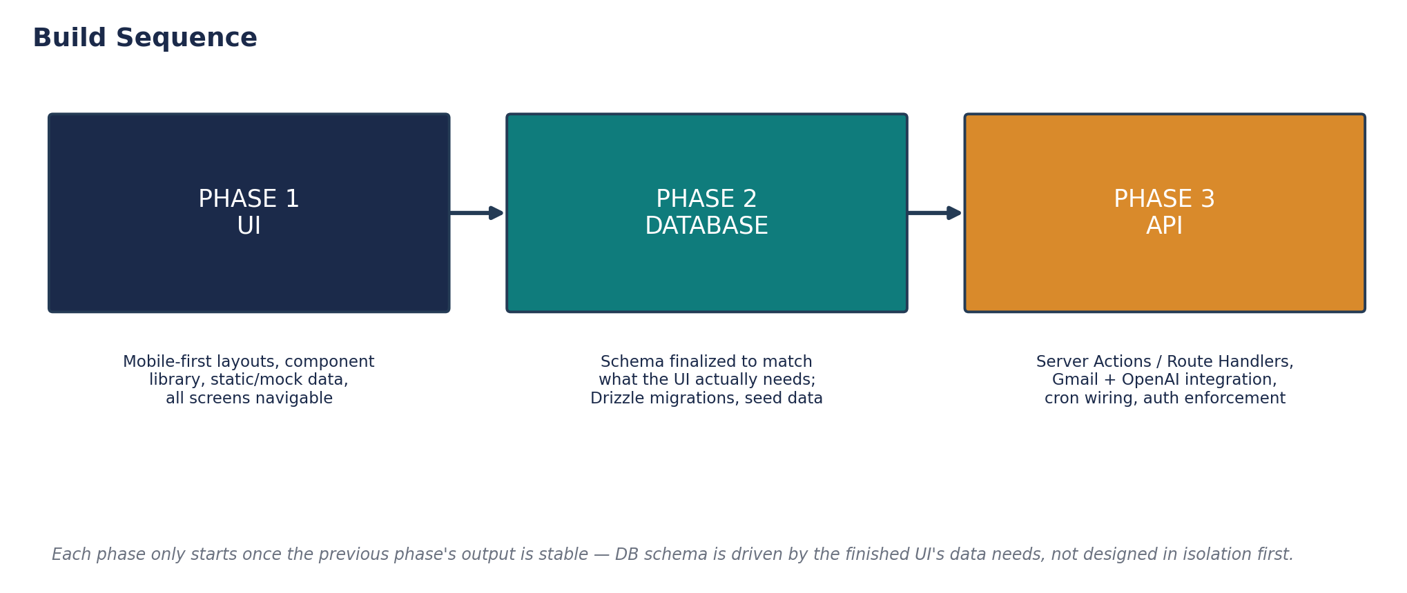
Figure 3 — Build sequence
- Phase 1 builds every screen against static/mock data — this is what surfaces the fields and filters the UI actually needs, before anything is locked into a schema.
- Phase 2 writes the Drizzle schema and migrations to match what Phase 1 revealed, not the other way around.
- Phase 3 replaces mock data with real Server Actions, wires Gmail/OpenAI, and turns on auth enforcement and the cron jobs.

12. Non-Functional / Technical Constraints
Concern | Target / Constraint
Function timeout | Vercel Hobby caps a function at 10s; the Gmail sync route must batch/paginate rather than process unbounded mail in one call
Cold starts | No persistent warm instance on Hobby; acceptable for personal, low-traffic use
Mobile performance | Target Lighthouse mobile score ≥ 90; keep client JS per route small by defaulting to Server Components
Job cost | Gmail sync runs on GitHub Actions' free minutes; reminder check runs on Vercel's free daily Hobby cron — no paid tier required to hit the stated design
Scaling headroom | Personal, single-user volume; Neon free tier and Vercel Hobby limits are not expected to bind

13. Open Items (Deliberately Deferred)
- Error tracking/observability tool (e.g. Sentry) — Vercel's built-in logs are enough to start; add only if debugging in production becomes painful.
- Automated test coverage — kept minimal at launch given single-user scope; revisit if the codebase grows past what manual checking covers comfortably.
- Vercel Pro upgrade — only worth it if the GitHub Actions polling pattern becomes limiting; not needed to ship.
- Multi-user rollout (invites, per-user OAuth app review by Google, billing) — out of scope until the user table is actually needed by a second user.

