FRESHWATER INSTRUMENTS
Synthesizer Channel Card
Datasheet
Preliminary
Document FW-DS-101, Revision 1.0, July 2026
About this datasheet
Preliminary datasheet for the Channel Card. A few system-level items (final render rate, physical details) are still being settled and are marked TBD. Full operating detail is in FW-UM-101; firmware internals in FW-EN-001.

Contents
Table of contents. In Word, select this line and press F9 to populate it.

1. Product Overview

1.1 Description
The Channel Card generates one synthesizer voice. Digital audio is converted by a CS4304 four-channel DAC and shaped in a true analogue signal path: switched-capacitor filter (SCF), state-variable voltage-controlled filter (VCF), and voltage-controlled amplifier (VCA), with every route selected by electronically controlled switches. Three converter channels provide calibratable control voltages for the analogue blocks.

1.2 Specifications
Parameter | Value | Notes
Processor | STM32H725 (Arm Cortex-M7)
Audio converter | CS4304, four channels | 1 audio + 3 CV; I2C 0x60
Audio format | 32-bit, 96 kHz | final render rate TBD (96 or 192 kHz)
Analogue processing | SCF, VCF (LP / BP / HP), VCA
Control voltages | 3, zero-point calibratable | VCA gain, VCF cutoff, VCF resonance
SCF cutoff range | 10 Hz to 20 kHz | cutoff = clock / 100
Sample memory | SDRAM, size TBD | for the render engine
RS-485 console | 115200 baud 8N1, address c:
Firmware update | USB bootloader | BOOT switch and reset

2. Block Diagram
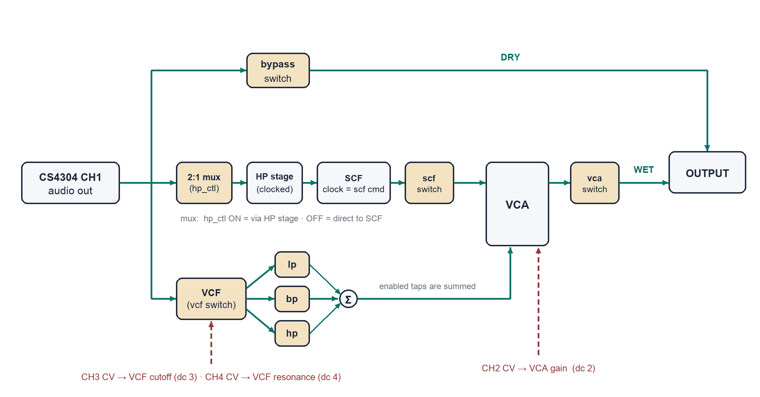
Figure 1. Analogue signal routing. Tan blocks are electronically controlled switches.

3. Converter Channel Map
Converter channel | Role | Controlled by
CH1 | Audio (playback signal) | Host volume, gain 1
CH2 | CV: VCA gain | dc 2 <-100..100>
CH3 | CV: VCF cutoff | dc 3 <-100..100>
CH4 | CV: VCF resonance | dc 4 <-100..100>

4. Switch Matrix Reference

4.1 Switches and active levels
Switch | MCU pin | Function | Active level
bypass | PB10 | Dry route: unprocessed signal to output | Low
scf | PB14 | SCF output to VCA | Low
hp_ctl | PB15 | SCF input select: HP stage (on) or direct (off) | High
vcf | PB13 | Signal into the VCF block | Low
lp | PB1 | VCF low-pass output to summing point | Low
bp | PB0 | VCF band-pass output to summing point | Low
hp | PC5 | VCF high-pass output to summing point | Low
vca | PB2 | Processed route: VCA output to output | Low

4.2 Output routing truth table
bypass | vca | Output signal
off | off | Silence; no path to the output
on | off | Dry signal only
off | on | Processed signal only
on | on | Dry and processed signals, summed

4.3 VCF output selection
lp | bp | hp | Response delivered to the VCA
on | off | off | Low-pass
off | on | off | Band-pass
off | off | on | High-pass
on | on | on | Sum of enabled outputs (any combination is permitted)

4.4 SCF input selection
hp_ctl | SCF input
on | Through the clocked HP stage
off | Direct; the HP stage is bypassed

4.5 SCF clock to cutoff
Command | Clock | Cutoff
scf 50 | 50 kHz | 500 Hz
scf 100 | 100 kHz | 1 kHz
scf 500 | 500 kHz | 5 kHz
scf 2000 | 2 MHz | 20 kHz
scf 0 | off | SCF inactive

5. System Integration
The card runs under the CPU card (Rockchip), which handles voice allocation. RS-485 carries the real-time voice and control traffic; USB carries bulk data such as sample uploads, where its buffering suits large transfers.
Function | Transport
Voice / control commands | RS-485 from the CPU card; low-latency, deterministic
Sample and bulk data | USB from the CPU card; buffered, suited to large transfers
Maintenance console | RS-485 (address c:) and USB CDC, same command set
Firmware update | USB bootloader (BOOT switch, reset)

6. Power and Physical
Parameter | Value
Supply | TBD
Power consumption | TBD
Dimensions | TBD
Connectors | TBD
Mounting | TBD

Revision History
Revision | Date | Changes
1.0 | July 2026 | Initial release

