FRESHWATER INSTRUMENTS
Synthesizer Channel Card
User Manual
Hardware Reference and Operating Guide
Document FW-UM-101, Revision 1.0, July 2026
About this manual
This manual describes the installation and operation of the FreshWater Synthesizer Channel Card: system role, block diagrams, signal routing, switch truth tables, pin assignments, device addresses, the command console, firmware updates, and troubleshooting. The companion Effect Card is documented in FW-UM-102.

Contents
1. Product Overview 4
1.1 Description 4
1.2 Key features 4
1.3 Card summary 4
2. Safety Instructions 5
2.1 Electrostatic discharge 5
2.2 Power 5
2.3 Audio transients 5
3. System Overview 5
System context 5
4. Getting Started 7
4.1 Requirements 7
4.2 Connecting the card 7
4.3 Producing the first sound 7
5. Functional Description 8
5.1 Converter channel assignments 8
5.2 Signal routing 8
6. Switch Matrix and Truth Tables 9
6.1 Switch summary 9
6.2 Output routing truth table 9
6.3 VCF output selection 9
6.4 SCF input selection 9
6.5 SCF clock 10
6.6 Level controls 10
7. Pin Assignments 11
7.1 Audio converter interface 11
7.2 Analogue routing and filter control 11
7.3 Communications and system 11
8. Interfaces and Addressing 12
8.1 RS-485 console bus 12
8.2 USB 12
8.3 I2C devices 12
9. Console Command Reference 13
Firmware Updates 14
11. Troubleshooting 15
12. Specifications 15
Appendix A. Document History 15

1. Product Overview

1.1 Description
The Channel Card generates one synthesizer voice. Digital audio received over USB (32-bit, 96 kHz) is converted by a CS4304 four-channel DAC and then shaped in a true analogue signal path consisting of a switched-capacitor filter (SCF), a state-variable voltage-controlled filter (VCF), and a voltage-controlled amplifier (VCA). Every routing decision in the analogue path is made by an electronically controlled switch, so the complete signal path is recallable and remotely controllable.

1.2 Key features
- True analogue processing per voice: SCF, VCF with low-pass, band-pass, and high-pass outputs, and VCA.
- Three dedicated control-voltage outputs (VCA gain, VCF cutoff, VCF resonance) with zero-point calibration and fine trim.
- Class-compliant USB audio, 32-bit at 96 kHz. No driver installation is required.
- Fully switched analogue routing: dry and processed paths can be used separately or combined.
- Text-based control console on RS-485 and USB.

1.3 Card summary
Item | Value
Processor | STM32H725 (Arm Cortex-M7)
Audio converter | CS4304 four-channel DAC
USB functions | Audio output (UAC2) and serial console (CDC)
Console address | c: on the RS-485 bus

2. Safety Instructions

2.1 Electrostatic discharge
The card is an exposed electronic assembly. Handle it by the edges, use a grounded wrist strap when touching connectors or components, and store the card in anti-static packaging when it is not installed.

2.2 Power
The card is powered over USB. Use a short, good-quality USB cable. Marginal cables are the most common cause of apparent malfunctions such as failed enumeration and audio dropouts.

2.3 Audio transients
Reduce downstream monitoring levels before changing routing switches or the VCA control voltage. Switching the signal path can produce audible transients.

3. System Overview

System context
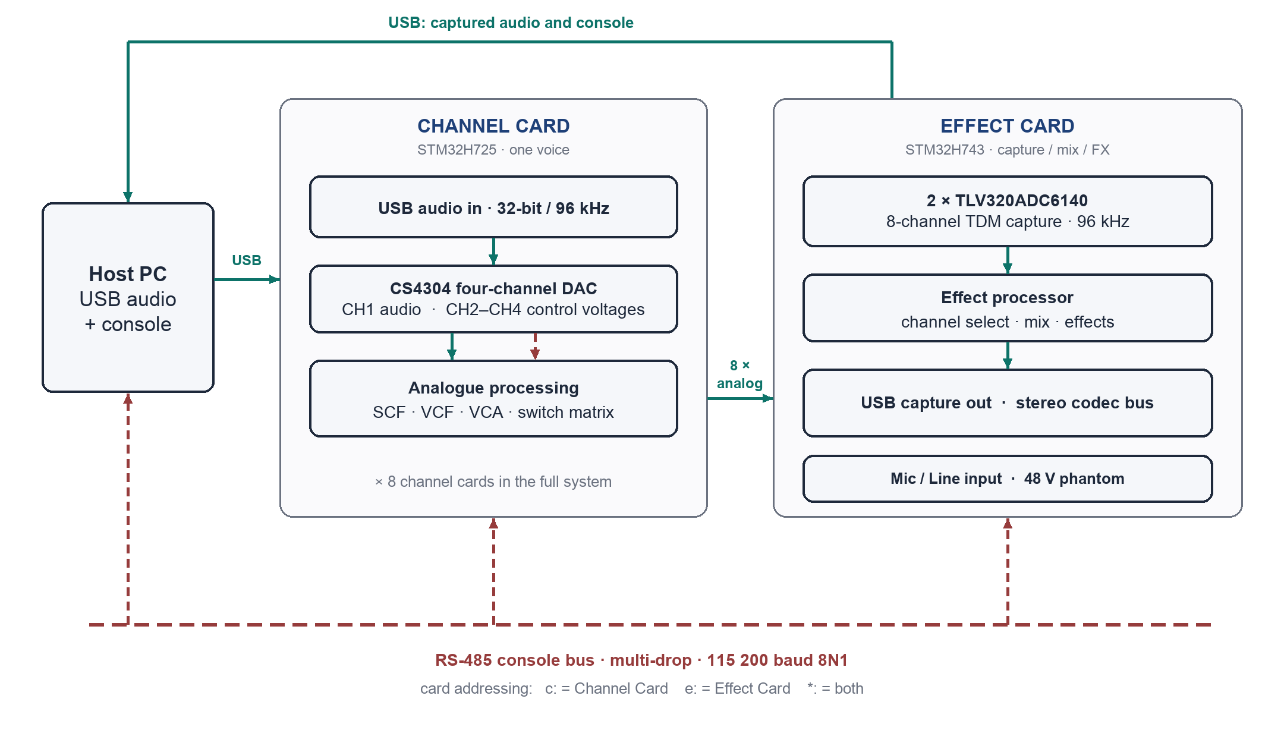
Figure 1. System overview. Solid lines carry audio; dashed lines carry control.
In the complete instrument, eight Channel Cards each generate one voice and process it in the analogue domain. The analogue outputs of all channels are digitised and mixed by the companion Effect Card, which is documented separately in FW-UM-102.
A system controller (the CPU card, Rockchip-based) performs voice allocation and commands the cards. RS-485 carries the real-time voice and control traffic; USB carries bulk data such as sample uploads, where its buffering suits large transfers.
All cards also share a multi-drop RS-485 maintenance console and are individually reachable over USB. Both transports accept the same command set.

4. Getting Started

4.1 Requirements
- A host computer with a free USB port. Windows, macOS, and Linux are supported without additional drivers.
- A USB cable.
- A serial-terminal application such as PuTTY, Tera Term, screen, or minicom.
- Optional: a USB-to-RS-485 adapter, if the shared console bus is used.

4.2 Connecting the card
- Connect the card to the host with a USB cable. The card powers up and enumerates automatically.
- Confirm that the host shows two new devices: a USB audio output device and a virtual COM port.
- Open the COM port in the terminal application. Any baud rate is accepted.
- Type help and press Enter. The card responds with its console menu.

4.3 Producing the first sound
- Select the FreshWater audio device as the output device on the host.
- On the console, type sw bypass on. This routes the unprocessed signal directly to the output.
- Play audio on the host and confirm that the signal appears at the channel output.
- To audition the processed path, type sw bypass off, sw vcf on, sw lp on, and sw vca on, then raise the VCA gain with dc 2 50.
- Sweep the filter by varying the cutoff control voltage, for example dc 3 -50 through dc 3 50.

5. Functional Description

5.1 Converter channel assignments
The CS4304 performs two roles: converter channel 1 carries the audio signal, and channels 2 through 4 generate the control voltages that steer the analogue blocks.
Converter channel | Role | Controlled by
CH1 | Audio (playback signal) | Host volume, gain 1
CH2 | Control voltage: VCA gain | dc 2 <-100..100>
CH3 | Control voltage: VCF cutoff | dc 3 <-100..100>
CH4 | Control voltage: VCF resonance | dc 4 <-100..100>

Each control-voltage output provides zero-point calibration (dczero) and fine trim in steps of 0.01 percent (dctrim). Channels 2 through 4 can also generate sine test tones (freq <ch> <Hz>) for verifying the control-voltage wiring.

5.2 Signal routing
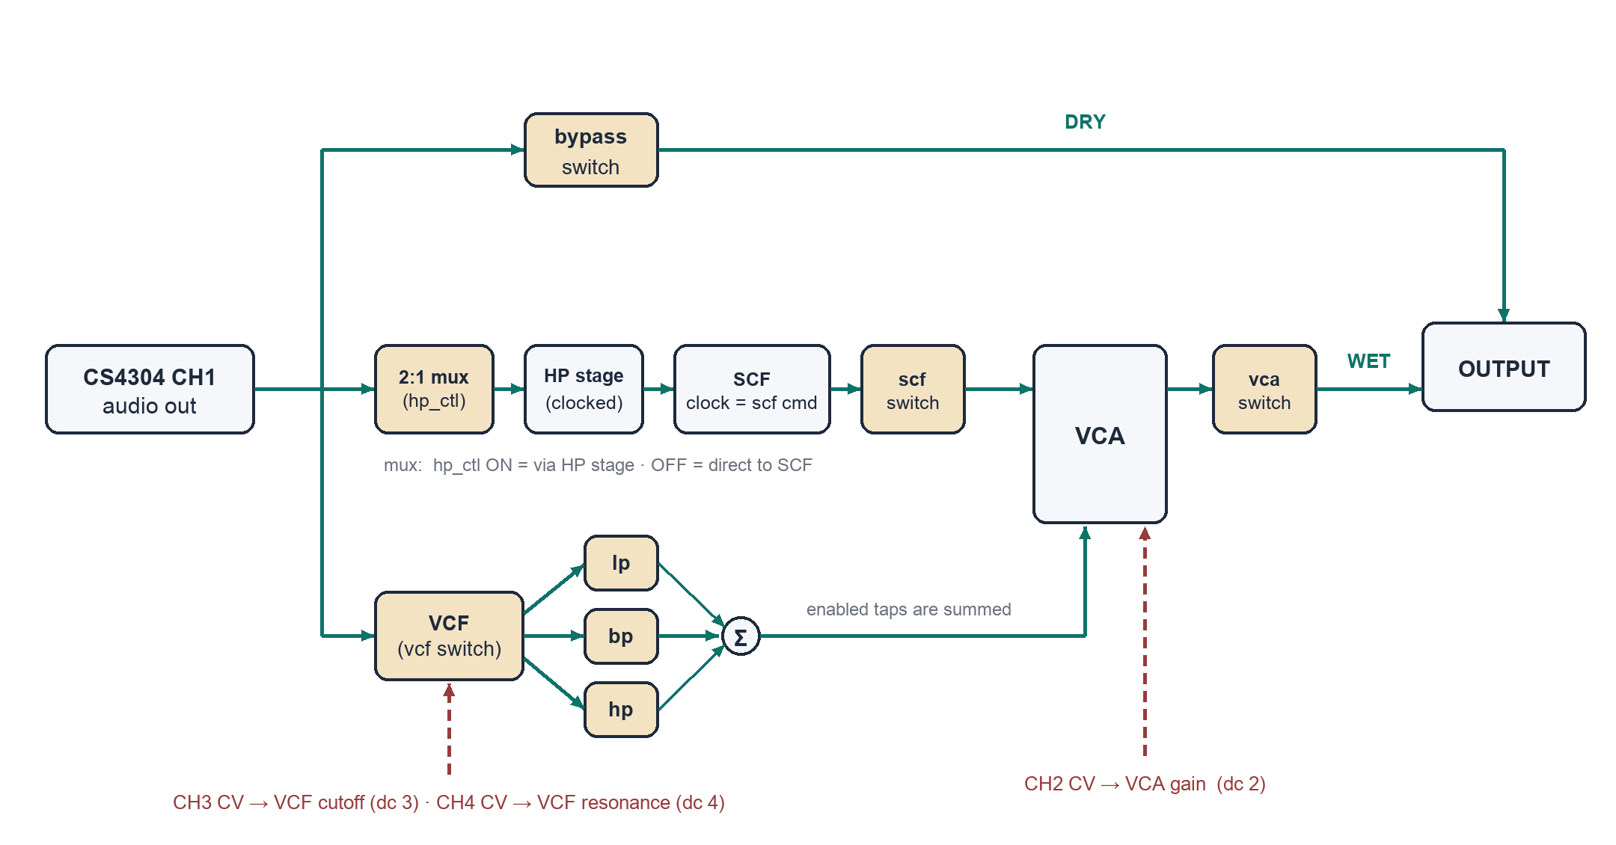
Figure 2. Signal routing. Tan blocks are electronically controlled analogue switches; each corresponds to one name accepted by the sw command.
The audio signal reaches the output through one or both of the following routes:
- Dry route: the bypass switch connects the unprocessed signal directly to the output.
- Processed route: the signal passes through the SCF or the VCF, or both, into the VCA, and then through the vca switch to the output.

6. Switch Matrix and Truth Tables

6.1 Switch summary
Switch | MCU pin | Function | Active level
bypass | PB10 | Dry route: unprocessed signal to output | Low
scf | PB14 | SCF output to VCA | Low
hp_ctl | PB15 | SCF input select: HP stage (on) or direct (off) | High
vcf | PB13 | Signal into the VCF block | Low
lp | PB1 | VCF low-pass output to summing point | Low
bp | PB0 | VCF band-pass output to summing point | Low
hp | PC5 | VCF high-pass output to summing point | Low
vca | PB2 | Processed route: VCA output to output | Low

Polarity is handled by the console
The command sw <name> on always engages the path, regardless of electrical polarity. The active level is relevant only when probing the control lines directly: every switch engages at logic low except hp_ctl, which engages at logic high.

6.2 Output routing truth table
bypass | vca | Output signal
off | off | Silence; no path to the output
on | off | Dry signal only
off | on | Processed signal only
on | on | Dry and processed signals, summed

6.3 VCF output selection
lp | bp | hp | Response delivered to the VCA
on | off | off | Low-pass
off | on | off | Band-pass
off | off | on | High-pass
on | on | on | Sum of the enabled outputs (any combination is permitted)

6.4 SCF input selection
hp_ctl | SCF input
on | Through the clocked HP stage
off | Direct; the HP stage is bypassed

6.5 SCF clock
The cutoff frequency of the switched-capacitor filter equals its clock frequency divided by 100. The clock frequency is set in kilohertz with the scf command; the duty cycle is set with the duty command.
Command | Resulting cutoff
scf 50 | 500 Hz
scf 100 | 1 kHz
scf 500 | 5 kHz
scf 2000 | 20 kHz
scf 0 | Clock off

6.6 Level controls
Three independent level controls act on the playback path:
Control | Acts on | Set by
Host volume | PCM samples on the host, in software | Operating-system volume and mute
DAC attenuator | The CS4304, per converter channel | gain <ch> <dB> on the console
VCA gain | The analogue processed route | dc 2 <-100..100> (CH2 control voltage)

7. Pin Assignments

7.1 Audio converter interface
MCU pin | Signal | Function
PA4 | DAC_SYNC | Serial-audio word clock, converter channels 1 and 2
PA5 | DAC_CLK | Serial-audio bit clock, converter channels 1 and 2
PA7 | DAC_D0 | Serial-audio data, converter channels 1 and 2
PA8 | DAC_MCLK | Converter master clock
PA9 | DAC_S_CLK | Serial-audio bit clock, converter channels 3 and 4
PB12 | DAC_S_SYNC | Serial-audio word clock, converter channels 3 and 4
PC1 | DAC_D1 | Serial-audio data, converter channels 3 and 4
PC7 | DAC_RST | Converter reset
PC10 / PC11 | SDA / SCL | Converter control bus (I2C, device address 0x60)

7.2 Analogue routing and filter control
MCU pin | Signal | Function
PB10 | BYPASS_SW | Dry-route switch
PB13 | VCF_SW | VCF path enable
PB14 | SCF_SW | SCF output switch
PB2 | VCA_SW | Processed-route switch
PB1 | LP_SW | VCF low-pass output switch
PB0 | BP_SW | VCF band-pass output switch
PC5 | HP_SW | VCF high-pass output switch
PB15 | HP_CTL | HP-stage clock (timer output)
PC6 | Filter_CTL | SCF clock (timer output; set by scf and duty)

7.3 Communications and system
MCU pin | Signal | Function
PC12 / PD2 | UART TX / RX | RS-485 console (address c:)
PB3 | RS485_CTL | RS-485 driver enable
PA11 / PA12 | USB D- / D+ | USB device (audio and console)
PA0 / PA2 / PC0 | Effect_SD / SCK / FS | Digital audio link to the Effect Card; the Channel Card is the bus slave
PB8 / PB9 | LED_R / LED_Y | Status LEDs
PA3 / PA6 / PA1 | RGB_R / G / B | RGB indicator

8. Interfaces and Addressing

8.1 RS-485 console bus
A single two-wire RS-485 bus links all cards in the system. Every card receives every message; a prefix selects the recipient. Console bus parameters: 115200 baud, 8 data bits, no parity, 1 stop bit. In the complete instrument the same bus carries the real-time voice commands from the CPU card; that protocol runs at a higher rate and will be published separately.
Prefix | Addressed card
c: | Channel Card only
e: | Effect Card only
*: or no prefix | All cards

8.2 USB
The card enumerates as a class-compliant composite device: a USB audio output (UAC2, mono, 32-bit, 96 kHz) and a virtual COM port (CDC) running the console. Commands received on the COM port are addressed to this card implicitly; no prefix is required. In the complete instrument, USB is also the bulk-data path from the CPU card, used for sample uploads and other large transfers.

8.3 I2C devices
Device | 7-bit address | Function
CS4304 DAC | 0x60 | Audio converter control. The address is strap-configured and detected automatically at power-up.

9. Console Command Reference
The console accepts plain-text commands terminated by Enter, on either transport. The help command prints the menu; the status command prints a summary of all settings.
Command | Action
help | Show the console menu (also h or ?)
status | Show all settings and health (also s)
sw | Show all switch states
sw <name> [on|off] | Set a routing switch; names: bypass scf hp_ctl vcf lp bp hp vca (Section 6)
scf <1..2000> | SCF clock in kHz; 0 = off (cutoff = clock / 100)
duty <1..99> | SCF clock duty cycle in percent (default 50)
dc <ch> <-100..100> | Control-voltage level in percent; ch = 2..4 (2 = VCA gain, 3 = cutoff, 4 = resonance)
dczero <ch> <-99..99> | Calibrate the zero-volt output code
dctrim <ch> <-999..999> | Fine zero-volt trim, steps of 0.01 percent
freq <ch> <Hz> | Sine test tone on a control-voltage channel; ch = 2..4
gain <ch> <dB> | Converter attenuation; ch = 1..4
led <on|off> | Status-LED flashing

Firmware Updates
Firmware is updated over USB through the processor's built-in bootloader. No programming hardware is required. The update requires the file supplied by FreshWater Instruments and the free STM32CubeProgrammer utility.
- Set the BOOT switch on the card to the UP position.
- Press the reset pushbutton. The card enumerates as "STM32 BOOTLOADER".
- In STM32CubeProgrammer, select USB, refresh the port list, and click Connect.
- Open the update file (.hex) supplied by FreshWater Instruments and click Download.
- Set the BOOT switch back to the DOWN position and press reset. The card restarts on the new firmware.
If the bootloader does not appear
If the bootloader does not appear, confirm that the BOOT switch is up before you press reset, try a different USB port or cable, and check the host device list for "STM32 BOOTLOADER". On Windows, install the driver bundled with STM32CubeProgrammer if the device entry shows a warning.

11. Troubleshooting
Symptom | Probable cause | Corrective action
The host does not recognise the card | Cable or port | Use a shorter, better USB cable; try another port
No sound at the output | No route enabled, or the host is muted | Check sw; enable bypass, or vcf or scf together with vca; check host volume and mute
The processed route is silent | VCA gain at zero, or no filter output enabled | Set dc 2 50; enable at least one of lp, bp, or hp together with vcf, or enable the SCF path
Control voltages are offset | Zero point out of calibration | Calibrate with dczero; fine-tune with dctrim
The console does not respond on RS-485 | Missing prefix, or bus wiring | Prefix commands with c:; check A/B polarity, termination, and 115200 8N1
The bootloader does not appear during an update | BOOT switch sequence | See Section 10

12. Specifications
Parameter | Value
Processor | STM32H725 (Arm Cortex-M7)
Audio converter | CS4304, four channels
Audio resolution | 32-bit, 96 kHz
Analogue processing | SCF, state-variable VCF (LP, BP, HP), VCA
Control voltages | 3 (VCA gain, VCF cutoff, VCF resonance), calibratable
SCF cutoff range | 10 Hz to 20 kHz (clock / 100)
USB | Class-compliant audio output and serial console
RS-485 console | 115200 baud, 8N1, address c:
Firmware update | USB bootloader (BOOT switch and reset)

Appendix A. Document History
Revision | Date | Changes
1.0 | July 2026 | First release.

