FRESHWATER INSTRUMENTS
Synthesizer Effect Card
Datasheet
Preliminary
Document FW-DS-102, Revision 1.0, July 2026
About this datasheet
Preliminary datasheet for the Effect Card. A few system-level items (final render rate, physical details) are still being settled and are marked TBD. Full operating detail is in FW-UM-102; firmware internals in FW-EN-001.

Contents
Table of contents. In Word, select this line and press F9 to populate it.

1. Product Overview

1.1 Description
The Effect Card is the capture and mixing hub of the synthesizer system. Two four-channel TLV320ADC6140 converters digitise eight analogue inputs onto a shared TDM bus; the processor de-interleaves, mixes, and processes the channels. The card also supervises the 48 V phantom supply for the microphone input path.

1.2 Specifications
Parameter | Value | Notes
Processor | STM32H743 (Arm Cortex-M7)
Audio converters | 2 x TLV320ADC6140 | I2C 0x4C / 0x4D
Analogue inputs | 8, simultaneous | TDM, 32-bit
Capture rate | 96 kHz | system-level rate TBD (96 or 192 kHz)
Mixing and effects | 8-channel mix engine | planned
Stereo output | TBD | codec bus reserved on the board
Phantom power | 48 V, supervised power-good
RS-485 console | 115200 baud 8N1, address e:
Firmware update | USB bootloader | BOOT switch and reset

2. Block Diagram
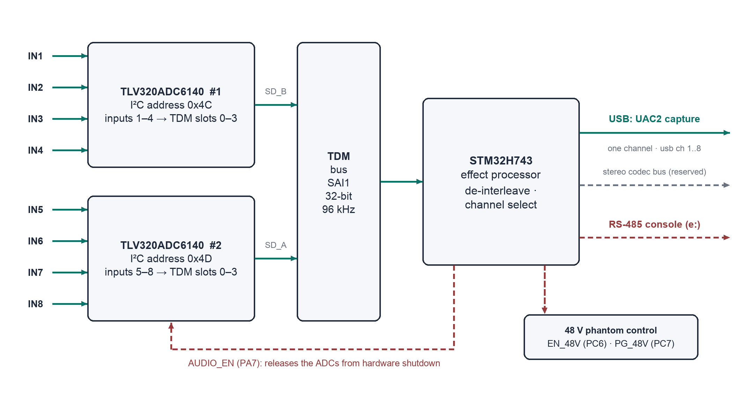
Figure 1. Capture path.

3. Input Channel Map
Inputs | Converter | I2C address | TDM slots | Selected with
IN1 to IN4 | TLV320ADC6140 no. 1 | 0x4C | 0 to 3 on data line SD_B | usb ch 1..4
IN5 to IN8 | TLV320ADC6140 no. 2 | 0x4D | 0 to 3 on data line SD_A | usb ch 5..8

4. Control Reference

4.1 Phantom rail truth table
EN_48V (PC6) | PG_48V (PC7) | Meaning
Low | Any | Rail disabled (power-up default)
High | High | Rail enabled, supply good
High | Low | Fault: rail enabled but supply not good. Switch the rail off and investigate.

4.2 Audio domain control
Signal | MCU pin | Function
AUDIO_EN | PA7 | Releases both converters from hardware shutdown; asserted at power-up. Converters do not respond on I2C while low.
ADC1_INT / ADC2_INT | PC4 / PC5 | Converter interrupt lines
INPUT_SW1 / INPUT_SW2 | PB15 / PB14 | Input path switching

5. System Integration
The card runs under the CPU card (Rockchip), which handles voice allocation. RS-485 carries the real-time voice and control traffic; USB carries bulk data such as sample uploads, where its buffering suits large transfers.
Function | Transport
Voice / control commands | RS-485 from the CPU card; low-latency, deterministic
Sample and bulk data | USB from the CPU card; buffered, suited to large transfers
Maintenance console | RS-485 (address e:) and USB CDC, same command set
Firmware update | USB bootloader (BOOT switch, reset)

6. Power and Physical
Parameter | Value
Supply | TBD
Power consumption | TBD
Dimensions | TBD
Connectors | TBD
Mounting | TBD

Revision History
Revision | Date | Changes
1.0 | July 2026 | Initial release

