FRESHWATER INSTRUMENTS
Synthesizer Effect Card
User Manual
Hardware Reference and Operating Guide
Document FW-UM-102, Revision 1.0, July 2026
About this manual
This manual describes the installation and operation of the FreshWater Synthesizer Effect Card: system role, block diagrams, the capture path, phantom-power operation, pin assignments, device addresses, the command console, firmware updates, and troubleshooting. The companion Channel Card is documented in FW-UM-101.

Contents
1. Product Overview 4
1.1 Description 4
1.2 Key features 4
1.3 Card summary 4
2. Safety Instructions 5
2.1 48 V phantom power 5
2.2 Electrostatic discharge 5
2.3 Power 5
3. System Overview 5
System context 5
4. Getting Started 7
4.1 Requirements 7
4.2 Connecting the card 7
4.3 Recording the first signal 7
5. Functional Description 8
5.1 Capture path 8
5.2 Input channel map 8
5.3 Audio domain control 8
5.4 Direct converter access 8
6. Phantom Power 10
6.1 Operating procedure 10
6.2 Rail status truth table 10
7. Pin Assignments 11
7.1 Converter TDM bus 11
7.2 Power and input control 11
7.3 Expansion buses 11
7.4 Communications and system 11
8. Interfaces and Addressing 12
8.1 RS-485 console bus 12
8.2 USB 12
8.3 I2C devices 12
8.4 Inter-card audio bus 12
9. Console Command Reference 13
Firmware Updates 14
11. Troubleshooting 15
12. Specifications 15
Appendix A. Document History 15

1. Product Overview

1.1 Description
The Effect Card is the capture and mixing hub of the FreshWater synthesizer system. Two four-channel TLV320ADC6140 converters digitise eight analogue inputs onto a shared TDM bus at 32-bit, 96 kHz. The processor de-interleaves the eight channels and streams a selectable channel to the host as a class-compliant USB capture device. The card also controls the 48 V phantom supply for the microphone input path.

1.2 Key features
- Eight-channel simultaneous analogue capture through dual TDM converters.
- Class-compliant USB audio capture, 32-bit at 96 kHz. No driver installation is required.
- Instant, glitch-managed selection of the streamed channel.
- 48 V phantom power with supervised power-good monitoring.
- Direct register access to the converters from the console for advanced configuration.
- Text-based control console on RS-485 and USB.

1.3 Card summary
Item | Value
Processor | STM32H743 (Arm Cortex-M7)
Audio converters | 2 x TLV320ADC6140, four channels each
USB functions | Audio capture (UAC2) and serial console (CDC)
Console address | e: on the RS-485 bus

2. Safety Instructions

2.1 48 V phantom power
- Keep phantom power off (48v off) except when a device that requires it is connected.
- Never connect or disconnect the input path while the 48 V rail is enabled.
- Mute or disconnect downstream monitoring before switching the rail. Enabling or disabling 48 V produces large transients.
- Do not apply phantom power to unbalanced or line-level sources.
- The rail defaults to off at power-up.
Caution: connected equipment
Applying 48 V to equipment that is not designed for phantom power can damage it permanently. Verify the connected device before enabling the rail.

2.2 Electrostatic discharge
The card is an exposed electronic assembly. Handle it by the edges, use a grounded wrist strap when touching connectors or components, and store the card in anti-static packaging when it is not installed.

2.3 Power
The card is powered over USB. Use a short, good-quality USB cable. Marginal cables are the most common cause of apparent malfunctions such as failed enumeration and audio dropouts.

3. System Overview

System context
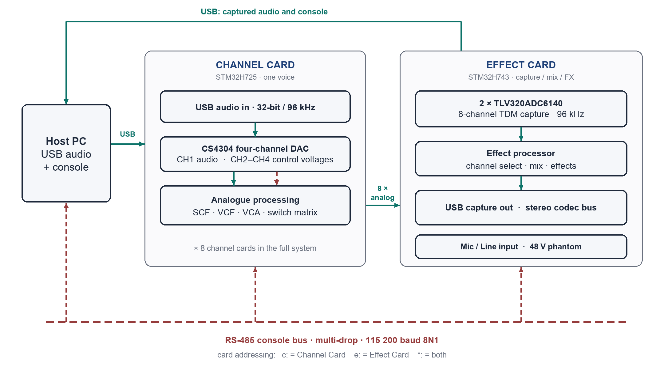
Figure 1. System overview. Solid lines carry audio; dashed lines carry control.
In the complete instrument, the Effect Card digitises the analogue outputs of up to eight Channel Cards, applies mixing and effects, and returns audio to the host. The Channel Card is documented separately in FW-UM-101.
A system controller (the CPU card, Rockchip-based) performs voice allocation and commands the cards. RS-485 carries the real-time voice and control traffic; USB carries bulk data such as sample uploads, where its buffering suits large transfers.
All cards also share a multi-drop RS-485 maintenance console and are individually reachable over USB. Both transports accept the same command set.

4. Getting Started

4.1 Requirements
- A host computer with a free USB port. Windows, macOS, and Linux are supported without additional drivers.
- A USB cable.
- A serial-terminal application such as PuTTY, Tera Term, screen, or minicom.
- Optional: a USB-to-RS-485 adapter, if the shared console bus is used.

4.2 Connecting the card
- Connect the card to the host with a USB cable. The card powers up and enumerates automatically.
- Confirm that the host shows two new devices: a USB audio capture device and a virtual COM port.
- Open the COM port in the terminal application. Any baud rate is accepted.
- Type help and press Enter. The card responds with its console menu.

4.3 Recording the first signal
- Connect a signal source to input 1, or select another input later with usb ch <1..8>.
- Confirm the capture domain is active with status. It is enabled at power-up; audio on re-enables it if required.
- Select the FreshWater capture device as the recording device on the host.
- Record. The streamed input can be changed at any time with usb ch <n>; the change takes effect immediately.

5. Functional Description

5.1 Capture path
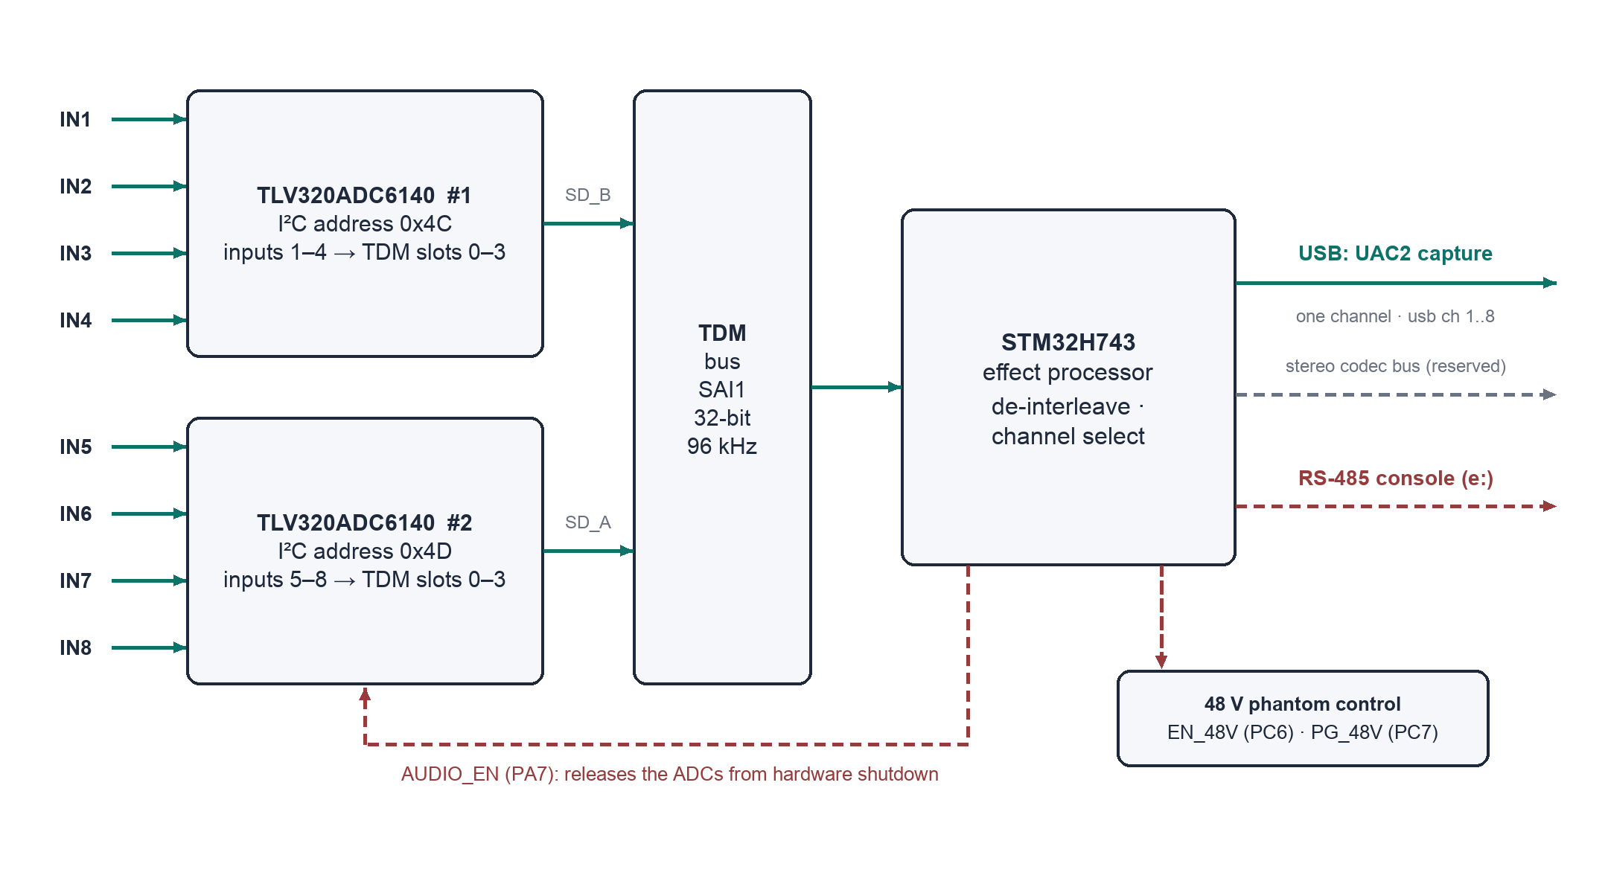
Figure 2. Capture path.
Each converter digitises four inputs and places them in four slots of the shared TDM frame. The processor receives both data lines, de-interleaves the eight channels, and forwards the selected channel to the USB capture interface.

5.2 Input channel map
Inputs | Converter | I2C address | TDM slots | Selected with
IN1 to IN4 | TLV320ADC6140 no. 1 | 0x4C | 0 to 3 on data line SD_B | usb ch 1..4
IN5 to IN8 | TLV320ADC6140 no. 2 | 0x4D | 0 to 3 on data line SD_A | usb ch 5..8

One channel streams to the host at a time; USB Full Speed cannot carry all eight channels at 32-bit, 96 kHz. Switching does not interrupt enumeration.

5.3 Audio domain control
The AUDIO_EN line releases both converters from hardware shutdown. It is asserted automatically at power-up. The command audio off places the converters in shutdown; while shut down, the converters do not respond on the control bus. The command adc init repeats the automatic converter configuration. The converters derive their sample rate from the bus clocks automatically.

5.4 Direct converter access
Converter registers can be read and written from the console: adc rd <n> <reg> and adc wr <n> <reg> <value>, with all values in hexadecimal and n = 1 or 2. This permits input-gain, filter, and format adjustments without a firmware change. Refer to the TLV320ADC6140 data sheet for the register map.

6. Phantom Power

6.1 Operating procedure
- Mute or disconnect downstream monitoring.
- Enable the rail with 48v on.
- Confirm the rail state with 48v; the response reports the enable state and the supply power-good flag.
- After use, disable the rail with 48v off and allow a few seconds for discharge before re-patching.

6.2 Rail status truth table
EN_48V (PC6) | PG_48V (PC7) | Meaning
Low | Any | Rail disabled (power-up default)
High | High | Rail enabled, supply good
High | Low | Fault: rail enabled but supply not good. Switch the rail off and investigate.

7. Pin Assignments

7.1 Converter TDM bus
MCU pin | Signal | Function
PE5 | ADC_SCK | TDM bit clock; the card is the bus master
PE4 | ADC_FS | TDM frame sync
PE3 | ADC1_DATA | Serial data from converter no. 1 (inputs 1 to 4)
PE6 | ADC2_DATA | Serial data from converter no. 2 (inputs 5 to 8)
PC4 / PC5 | ADC1_INT / ADC2_INT | Converter interrupt lines
PB10 / PB11 | SCL / SDA | Converter control bus (I2C, devices 0x4C and 0x4D)

7.2 Power and input control
MCU pin | Signal | Function
PC6 | EN_48V | 48 V phantom rail enable
PC7 | PG_48V | 48 V power-good input
PA7 | AUDIO_EN | Converter hardware-shutdown release
PB15 / PB14 | INPUT_SW1 / INPUT_SW2 | Input path switching

7.3 Expansion buses
MCU pin | Signal | Function
PD0 / PD1 / PD4 | AUDIO_BUS SCK / DATA / FS | Digital audio bus to the Channel Cards; the Effect Card is the bus master
PE0 / PD13 / PD12 / PD11 | CODEC MCLK / SCK / FS / DATA | Stereo output codec bus (reserved)

7.4 Communications and system
MCU pin | Signal | Function
PB9 / PB8 | UART TX / RX | RS-485 console (address e:)
PE1 | RS485_CTL | RS-485 driver enable
PA11 / PA12 | USB D- / D+ | USB device (capture and console)
PB13 / PB12 | LED_R / LED_Y | Status LEDs

8. Interfaces and Addressing

8.1 RS-485 console bus
A single two-wire RS-485 bus links all cards in the system. Every card receives every message; a prefix selects the recipient. Console bus parameters: 115200 baud, 8 data bits, no parity, 1 stop bit. In the complete instrument the same bus carries the real-time voice commands from the CPU card; that protocol runs at a higher rate and will be published separately.
Prefix | Addressed card
c: | Channel Card only
e: | Effect Card only
*: or no prefix | All cards

8.2 USB
The card enumerates as a class-compliant composite device: a USB audio capture interface (UAC2, mono, 32-bit, 96 kHz) and a virtual COM port (CDC) running the console. Commands received on the COM port are addressed to this card implicitly; no prefix is required. In the complete instrument, USB is also the bulk-data path from the CPU card, used for large transfers.

8.3 I2C devices
Device | 7-bit address | Function
TLV320ADC6140 no. 1 | 0x4C | Converter control, inputs 1 to 4
TLV320ADC6140 no. 2 | 0x4D | Converter control, inputs 5 to 8

The i2cscan command verifies the bus; both addresses are expected in the response.

8.4 Inter-card audio bus
A dedicated digital audio bus links the Effect Card, as bus master, to the Channel Cards. It carries system audio between the cards independently of USB and is reserved for the full-instrument configuration. A separate stereo codec bus is reserved for the instrument's master stereo output.

9. Console Command Reference
The console accepts plain-text commands terminated by Enter, on either transport. The help command prints the menu; the status command prints a summary of all settings.
Command | Action
help | Show the console menu (also h or ?)
status | Show rail, LED, and audio-domain state (also s)
48v on|off | Enable or disable the 48 V phantom rail
48v | Show rail and power-good status
usb ch <1..8> | Select the input streamed to USB; effective immediately
audio on|off | Audio domain on or off (converter hardware shutdown)
i2cscan | Scan the converter control bus (expect 0x4C and 0x4D)
adc init | Wake and configure both converters
adc rd <n> <reg> | Read a converter register (hexadecimal); n = 1..2
adc wr <n> <reg> <v> | Write a converter register (hexadecimal); n = 1..2
led on|off | Status-LED flashing
led_r on|off, led_y on|off | Manual LED control

Firmware Updates
Firmware is updated over USB through the processor's built-in bootloader. No programming hardware is required. The update requires the file supplied by FreshWater Instruments and the free STM32CubeProgrammer utility.
- Set the BOOT switch on the card to the UP position.
- Press the reset pushbutton. The card enumerates as "STM32 BOOTLOADER".
- In STM32CubeProgrammer, select USB, refresh the port list, and click Connect.
- Open the update file (.hex) supplied by FreshWater Instruments and click Download.
- Set the BOOT switch back to the DOWN position and press reset. The card restarts on the new firmware.
If the bootloader does not appear
If the bootloader does not appear, confirm that the BOOT switch is up before you press reset, try a different USB port or cable, and check the host device list for "STM32 BOOTLOADER". On Windows, install the driver bundled with STM32CubeProgrammer if the device entry shows a warning.

11. Troubleshooting
Symptom | Probable cause | Corrective action
The host does not recognise the card | Cable or port | Use a shorter, better USB cable; try another port
No captured audio | Audio domain off, or the wrong input selected | audio on; select the wired input with usb ch <n>; confirm with status
The converters are absent from i2cscan | Converters in hardware shutdown | audio on, then i2cscan (expect 0x4C and 0x4D); adc init
The rail reports a power-good fault | Supply fault or overload | 48v off; remove the load; inspect the wiring; re-enable
The console does not respond on RS-485 | Missing prefix, or bus wiring | Prefix commands with e:; check A/B polarity, termination, and 115200 8N1
The bootloader does not appear during an update | BOOT switch sequence | See Section 10

12. Specifications
Parameter | Value
Processor | STM32H743 (Arm Cortex-M7)
Audio converters | 2 x TLV320ADC6140, four channels each
Analogue inputs | 8, captured simultaneously on a TDM bus
Audio resolution | 32-bit, 96 kHz
USB capture | Class-compliant, one selectable channel
Phantom power | 48 V, supervised power-good monitoring
RS-485 console | 115200 baud, 8N1, address e:
Firmware update | USB bootloader (BOOT switch and reset)

Appendix A. Document History
Revision | Date | Changes
1.0 | July 2026 | First release.

