FRESHWATER INSTRUMENTS
Synthesizer Channel & Effects System
Firmware Engineering Reference
Internal engineering document
Document FW-EN-001, Revision 1.2, July 2026
Purpose and audience
This document is the firmware engineer's reference for the Channel Card and Effect Card. It records how the firmware is structured, why the timing-critical parts are built the way they are, which values must not be changed without hardware re-testing, and what remains to be built. It complements the user manuals FW-UM-101 and FW-UM-102, which deliberately contain no source-level information, and the architecture report, which describes the target system design. Keep this document with the repository and update it when the invariants it records change.

Contents
Table of contents. In Word, select this line and press F9 to populate it.

1. Orientation

1.1 What exists today
The repository holds two standalone bare-metal firmware projects, both verified working on hardware and building clean with no warnings:
 | Channel Card | Effect Card
MCU | STM32H725xG | STM32H743xx
CMake target | channel_MCU | effect_card
CubeMX project | channel_MCU.ioc | effect_card.ioc
Linker script | STM32H725xG_flash.ld | STM32H743xx_FLASH.ld
USB stack | TinyUSB 0.17 (ThirdParty/tinyusb) | TinyUSB 0.18 (ThirdParty/tinyusb-0.18)
USB identity | 0xCafe / 0x4013 | 0xCafe / 0x4015
USB function | UAC2 speaker + CDC | UAC2 microphone + CDC
Audio format | mono, 32-bit, 96 kHz | mono, 32-bit, 96 kHz

There is no RTOS. Each card runs a superloop (console polling, LED housekeeping, TinyUSB device task) with all audio work done in interrupt context: DMA half/complete callbacks and the USB IRQ.

1.2 Related documents
Document | Content
FW-UM-101 / FW-UM-102 | User manuals: hardware reference and operation, no code
FreshWater_Synth_Firmware_Architecture.pdf | Target architecture: 8-voice system, RS-485 voice protocol, 192 kHz render engine
channel_card/README.md, effect_card/README.md | Per-card engineering notes
README.md (repository root) | Toolchain, build, DFU, CubeMX rules

1.3 System context
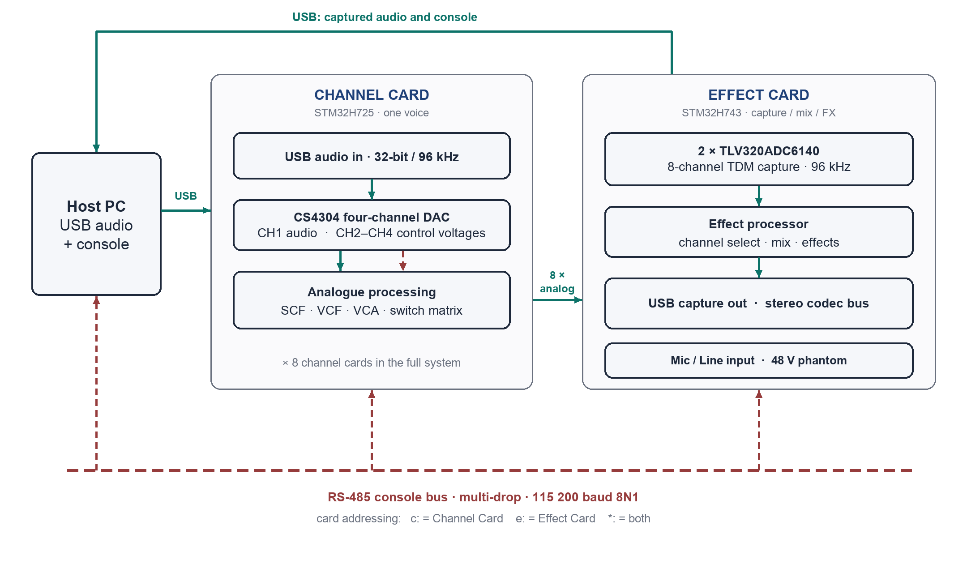
Figure 1. System overview.

2. Repository, Build, and Flash

2.1 Layout
<project>/
CMakeLists.txt hand-written sources and TinyUSB are registered HERE
CMakePresets.json Debug / Release, Ninja generator
<project>.ioc CubeMX project, source of truth for pins and clocks
Core/Inc, Core/Src generated init plus hand-written drivers
cmake/stm32cubemx/ GENERATED, never edit, never add sources here
Drivers/ vendored STM32 HAL and CMSIS
ThirdParty/tinyusb*/ vendored TinyUSB (CubeMX-safe location)
USB_APP/ descriptors, tusb_config.h, class glue
build/Debug/ .elf / .hex / .bin

Everything is vendored; a copy of the tree builds with no package manager or submodule fetch. Toolchain: STM32CubeCLT (CMake, Ninja, arm-none-eabi-gcc). The toolchain bin directory must be on PATH; a missing arm-none-eabi-objcopy fails only the final .hex/.bin conversion, after a successful link.

2.2 Commands
cmake --preset Debug
cmake --build build/Debug

Flashing is over the ST system bootloader: BOOT toggle up, reset, connect with STM32CubeProgrammer over USB, download the .hex, toggle down, reset. No ST-LINK is needed.

2.3 Version control status
Baseline warning
The known-good baseline was developed before the repository was under version control, and several regressions (CubeMX deleting files) went unnoticed for lack of a diff. The tree is now a git repository; commit before and after every CubeMX regeneration so removals show up immediately.

3. Audio Engines
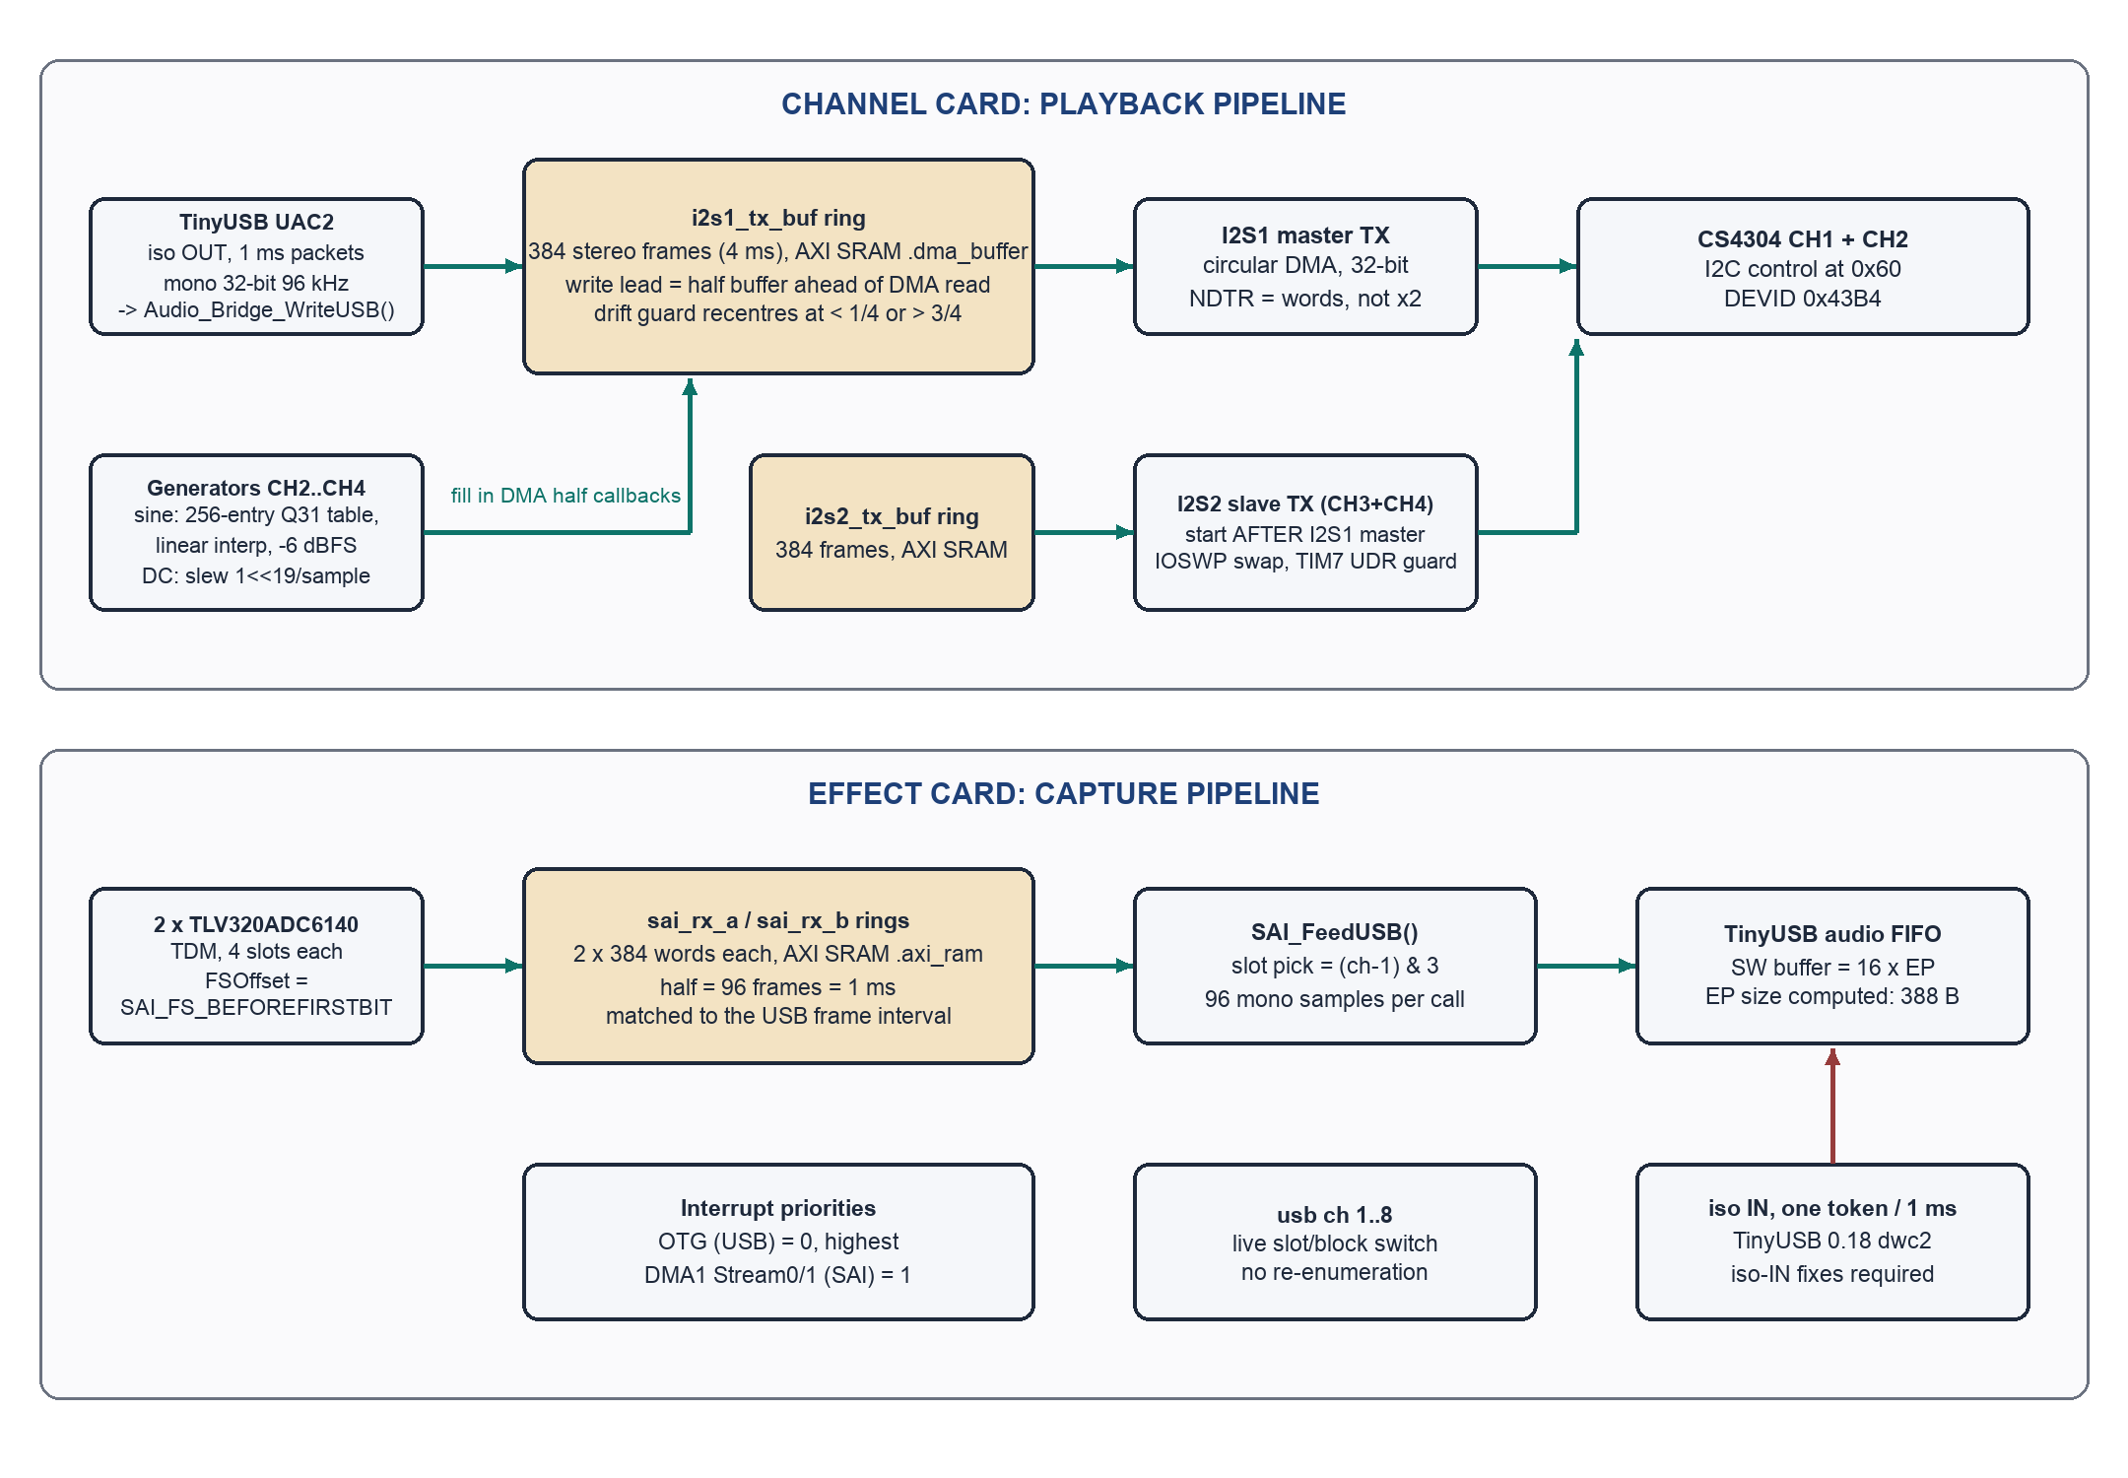
Figure 2. Firmware data flow, both cards. Tan blocks are DMA ring buffers.

3.1 Channel Card playback engine (audio_bridge.c)

Ring buffer and write lead
i2s1_tx_buf holds 384 stereo frames (4 ms at 96 kHz) in AXI SRAM. USB packets are written at usb_wr_idx, which is initialised half a buffer ahead of the DMA read position and then advances freely, decoupled from the DMA half boundaries. A drift guard recentres the write lead when host/device clock drift pushes it below one quarter or above three quarters of the buffer; this causes one tiny discontinuity every few minutes and is inaudible in practice.
Why not write per DMA half
The obvious design (copy one half-buffer per DMA callback) glitched continuously: the USB SOF cadence and the I2S DMA phase drift across each other, and whenever a packet landed on the boundary the copy raced the DMA read pointer. The free-running write lead removed the race entirely. Do not refactor back to per-half copying.

Start order and DMA sizing
- Master first: HAL_I2S_Transmit_DMA() on I2S1 must run before I2S2_Start(). The H7 SPI/I2S slave only begins shifting if its external clocks are already running when it is enabled. Every armed-before-clocks attempt froze the slave.
- The inter-start delay is a busy-wait (about 2 ms of NOPs), not HAL_Delay: Audio_Bridge_Start() runs in USB interrupt context where SysTick cannot preempt, so HAL_Delay deadlocks.
- DMA is configured word/word (32-bit): NDTR counts 32-bit transfers, so the length passed to HAL_I2S_Transmit_DMA is the word count, not twice it. Passing twice the count made circular DMA sweep double the buffer: half of the output was garbage.
- Both TX buffers sit in the NOLOAD .dma_buffer section in AXI SRAM and are cleared explicitly in Audio_Bridge_Start(). DMA1 cannot reach DTCM, where .bss would otherwise place them.

I2S2 slave path (converter channels 3 and 4)
- The H7 slave transmitter halts on underrun (UDR) until the flag is cleared. TIM7 runs as a pump/guard that clears the wedge every tick.
- The board wires PC1 (MOSI) to the converter's SDIN2, but the H7 slave transmits on MISO; CFG2.IOSWP swaps the pins internally.
- AUDIO_I2S2_IT selects the feed mode: 0 = DMA feed (preferred; guaranteed sample ordering, stable CH3/CH4 assignment), 1 = TIM7 FIFO pump (fallback; pump parity slips caused spikes and CH3/CH4 swapping). TIM7 stays enabled in DMA mode as a UDR guard only.

Signal generators
- Sine: 256-entry Q31 table with linear interpolation between entries and a 32-bit fixed-point phase accumulator per channel. Plain table lookup quantised the phase to 1/256 cycle and made zero crossings jitter by about 4 us at 1 kHz, visible on a scope. Output is padded to -6 dBFS. Cost is about 10 cycles per sample.
- DC: slew-limited approach to the target at 1<<19 per sample (full range in about 21 ms). An instant step rings the converter's interpolation filter and puts spikes on the control-voltage line.
- Phase increments are precomputed (TONE_PHASE_INC) so no ISR performs a 64-bit division.

Volume and mute
The device advertises a mute-only UAC2 feature unit, so the host operating system applies volume in software by scaling PCM before transmission; the firmware passes samples at unity and gates to silence on mute (usb_muted). The console gain command drives the CS4304's own attenuator (0.5 dB steps) and is independent of host volume. A hardware volume control was tried and removed: Windows pushed one value at enumeration and never updated it, leaving the device stuck at a stale attenuation.

CS4304 driver (cs4304.c)
- Register protocol: 16-bit register addresses and 16-bit data words, MSB first, word transactions only (address LSB must be 0).
- I2C address is CONFIG5-strapped; 0 ohm to ground gives 0x60. The driver resolves the strap and falls back to a bus scan.
- DEVID is read at init; expect 0x43B4.
- Software reset: write 0x5A to bits 15..8 of register 0x0022.
- The amp-matching pad (AMP_MATCH_PAD_HALFDB) is 0: level matching moved to an external 10k + 1k divider at the amplifier input for better SNR.

3.2 Effect Card capture engine (main.c, sai.c)

Topology
Both converters share BCLK and FSYNC generated by SAI1 Block A (master receiver). SAI1_B (slave) receives ADC1 (0x4C, inputs 1 to 4); SAI1_A receives ADC2 (0x4D, inputs 5 to 8). Each block runs circular DMA into its own ring (sai_rx_a / sai_rx_b, AXI SRAM .axi_ram section, 32-byte aligned, NOLOAD: never assume zero-init).

Cadence coupling, the load-bearing decision
SAI_FRAMES_PER_HALF is 96: each DMA half is exactly 1 ms, the USB frame interval. Producer (SAI callback pushes 96 samples) and consumer (one isochronous IN token per millisecond) tick at the same cadence, so the TinyUSB FIFO level stays near-constant. With 2 ms halves the FIFO swung from 192 to 0 every cycle, and any IN token landing on the empty phase produced a short packet: an audible dropout.

De-interleave and channel selection
SAI_FeedUSB() snapshots usb_adc_ch, returns immediately if the interrupting block does not carry the selected channel, picks slot (ch-1) & 3 from the interleaved half, and writes 96 mono samples to the TinyUSB audio FIFO. Channel switching is therefore free: the next callback simply reads a different slot or block.

USB rate limiting
- CFG_TUD_AUDIO_EP_SZ_IN stays at the computed TUD_AUDIO_EP_SIZE value (97 samples, 388 bytes). TinyUSB sends min(FIFO level, EP size) per token, so the EP size is the drain-rate limiter. Enlarging it to 128 samples let the drain outpace the producer (128/64/128/64 alternation instead of a steady 96), which is audible as ragged dropouts even in a constant test signal.
- The FIFO software buffer is 16 x EP size, absorbing scheduling jitter.
- TinyUSB 0.18 is required on this card for its dwc2 isochronous-IN fixes; 0.17 missed about 8 IN service intervals per second, each one a 1 ms hole. 0.17 is retained in-tree as a rollback (0.18 additionally compiles dwc2_common.c).

Interrupt priorities
The OTG (USB) interrupt runs at preemption priority 0; the SAI DMA streams are set to 1 after USB_App_Init(). Isochronous IN re-arming is deadline-critical (miss the token, lose the frame) while the SAI callbacks have a relaxed 1 ms deadline.

SAI TDM alignment
hsai_BlockA1.FrameInit.FSOffset = SAI_FS_BEFOREFIRSTBIT;
hsai_BlockB1.FrameInit.FSOffset = SAI_FS_BEFOREFIRSTBIT;

The TLV320ADC6140 places its first TDM slot one BCLK after the FSYNC edge. Without this override (a USER CODE section in sai.c) the SAI samples one bit early, the sign bit picks up the previous slot's LSB, and the audio is ragged square-wave noise with the real signal buried underneath.
Recorded misdiagnosis, do not repeat
A temporary 192 kHz AudioFrequency override once appeared to fix a rate problem; it was actually running the bus at double rate. AudioFrequency must stay at the generated 96K.

Converter initialisation
ADC_Init runs at boot for both devices: reset, wake, TDM 32-bit ASI format, enable and route all four inputs, power up. The converters auto-detect their sample rate from BCLK/FSYNC, so a SAI rate change needs no register writes. AUDIO_EN (PA7) gates hardware shutdown; the devices do not respond on I2C while it is low. adc rd / adc wr give raw register access for experiments (example: adc wr 1 07 3c flips BCLK polarity).

4. Shared Infrastructure

4.1 Console and RS-485 protocol
- One parser serves both transports (RS-485 and USB CDC) on each card.
- Card IDs: 'c' (Channel), 'e' (Effect); '*' broadcasts. A bare command on the RS-485 bus is treated as broadcast; on CDC it addresses the local card.
- Bus arbitration: RS485_CTL (DE/RE) doubles as a bus-busy sense line. A card samples CTL (low = free) and waits up to RS485_BUS_TIMEOUT_MS (250 ms) for the bus to free before transmitting. The Channel Card replies with a '[C] ' tag.
- Echo policy: the Channel Card does not echo typing (RS485_ECHO 0); the Effect Card is the designated echoer, so shared-bus sessions do not print every character twice.
- Wiring note: PB3 (RS485_CTL) and PC12 (UART5_TX) are wired in parallel on the Channel Card transceiver; the code accounts for this when switching direction.

4.2 TinyUSB integration
- USB is owned by TinyUSB on both cards. The generated MX_USB_OTG_xS_PCD_Init() is harmless and expected: USB_App_Init() re-owns the core registers and HAL_PCD_Start() is never called. The OTG IRQ routes to tud_int_handler(0) from a USER CODE block in stm32h7xx_it.c.
- TinyUSB lives in ThirdParty/, never Middlewares/ (CubeMX prunes Middlewares/ and deleted TinyUSB twice).
- Versions are intentionally different per card (0.17 Channel, 0.18 Effect). Do not unify without re-testing audio on hardware.
- Descriptor rule: any descriptor change requires bumping idProduct in USB_APP/usb_descriptors.c. Windows caches descriptors per VID/PID and will serve stale data otherwise; this once cost a full debugging session. Current PIDs: 0x4013 (Channel), 0x4015 (Effect). VID 0xCafe is a placeholder to be replaced before release.
- CDC buffers: 256 B RX, 512 B TX.

4.3 Memory placement rules
Card | Section | Region | Contents | Reason
Channel | .dma_buffer | AXI SRAM (D1) | i2s1_tx_buf, i2s2_tx_buf | DMA1 (D2 domain) cannot access DTCM; section is NOLOAD, cleared manually
Effect | .axi_ram | AXI SRAM (D1) | sai_rx_a, sai_rx_b | Same constraint; 32-byte aligned; NOLOAD, never assume zero-init

5. CubeMX Regeneration Contract
The .ioc is the source of truth for pins, clocks, and peripheral init. Regeneration overwrites generated files. The following rules keep hand-written code alive:
- Write only inside USER CODE sections; everything outside them is lost on regeneration.
- Register hand-written sources (cs4304.c, audio_bridge.c, and any future files) in the top-level CMakeLists.txt, never in cmake/stm32cubemx/CMakeLists.txt, which is regenerated. Both files were silently dropped by a regeneration once.
- Keep third-party code in ThirdParty/. CubeMX manages and prunes Middlewares/.
- Keep the ST USB Device middleware disabled: Connectivity > USB_OTG_xS: Device_Only; NVIC > OTG global interrupt enabled; Middleware > USB_DEVICE class: Disable. Enabling it pulls in a second stack that fights TinyUSB for the peripheral.

5.1 Post-regeneration checklist
- USB_App_Init() called in main()
- USB_App_Task() called in the main loop
- tud_int_handler(0) present in the OTG IRQ handler (stm32h7xx_it.c)
- FSOffset override present in sai.c (Effect Card)
- Hand-written sources still listed in the top-level CMakeLists.txt
- Both projects build; both boards enumerate over USB

6. Do-Not-Change Invariants
Each of these values or behaviours was established by measurement on hardware. Changing any of them requires a hardware re-test of the audio path.
Location | Invariant | Failure mode if changed
channel: audio_bridge.c | Free-running USB write lead, half a buffer ahead, drift guard at 1/4 and 3/4 | Continuous glitching (per-half copying races the DMA read)
channel: audio_bridge.c | I2S1 master started before I2S2 slave, busy-wait between | Slave never shifts, or deadlock in USB IRQ context (HAL_Delay)
channel: audio_bridge.c | DMA length = word count (NDTR counts 32-bit words) | Circular DMA sweeps 2x the buffer; half the output is garbage
channel: audio_bridge.c | DC output slew-limited at 1<<19 per sample | Converter interpolation filter rings; spikes on the CV lines
channel: linker + code | Audio buffers in .dma_buffer (AXI SRAM), cleared manually | DMA cannot reach DTCM; NOLOAD means stale contents on warm boot
channel: usb_descriptors.c | Mute-only UAC2 feature unit | Windows pushes one stale volume at enumeration and never updates it
effect: sai.c | FSOffset = SAI_FS_BEFOREFIRSTBIT on both blocks | One-bit slip; sign bit corrupted; ragged square-wave noise
effect: sai.c | AudioFrequency = 96K (never the 192 kHz override) | Bus at double rate; masks the real fault it appeared to fix
effect: main.c | SAI_FRAMES_PER_HALF = 96 (1 ms halves) | FIFO swings to empty; short packets; audible dropouts
effect: tusb_config.h | CFG_TUD_AUDIO_EP_SZ_IN = computed value (97 samples, 388 B) | Drain outpaces producer; 128/64 alternation; ragged dropouts
effect: main.c | OTG priority 0, SAI DMA priority 1 | Missed iso IN tokens; 1 ms holes in the stream
effect: CMakeLists.txt | TinyUSB 0.18 on this card | About 8 missed IN intervals per second on 0.17

7. Design Note: Sample-Rate Interpolation for the Render Engine

7.1 Problem statement
Legacy sample data exists at 7.5, 15, and 30 kHz. The render engine outputs at a fixed modern rate (96 or 192 kHz, DAC-dependent). Playback pitch varies per note, so the resampling ratio is arbitrary and continuous. Images of the source spectrum appear at n x f_src +/- f; for a 15 kHz source the first image of a 5 kHz partial lands at 10 kHz, inside the audible band, and only the interpolator attenuates it. The numbers below are from simulation at the actual system rates (scripts: interp_study*.py; sine sources, Blackman-windowed FFT, worst spurious component relative to the carrier).

7.2 Measured image rejection, 15 kHz source to 192 kHz render
Source tone | ZOH | Linear | Cubic (C-R) | Sinc 16t/128ph | Sinc 32t
1 kHz | -23 dBc | -46 dBc | -62 dBc | -97 dBc | -123 dBc
3 kHz | -12 dBc | -24 dBc | -30 dBc | -95 dBc | -116 dBc
5 kHz | -6 dBc | -12 dBc | -15 dBc | -92 dBc | -120 dBc
6 kHz | -4 dBc | -7 dBc | -8 dBc | -50 dBc | -129 dBc
6.8 kHz | -1.6 dBc | -3.3 dBc | -3.8 dBc | -20 dBc | -37 dBc

Passband droop at 5 kHz: linear -3.3 dB, cubic -1.5 dB, 16-tap sinc -0.18 dB, 32-tap 0.0 dB. Results are essentially unchanged at +7 and -5 semitones of pitch shift.
- Linear interpolation is not a clean mode: above 3 kHz it leaves images only 7 to 24 dB down and dulls the top end. It is, however, a faithful vintage mode; the original hardware was effectively a variable-clock ZOH DAC and this spur ladder is that sound.
- A 16-tap windowed-sinc polyphase (128 phases, linear blend between phase rows) is the quality sweet spot: -92 dBc or better for content below 5 kHz. The phase-table implementation measured identical to the exact kernel, so the table costs nothing in quality.
- Content in the top 1.5 kHz below the source Nyquist cannot be separated from its first image by any real-time filter (transition-band physics; 32 taps still only reaches -37 dBc at 6.8 kHz). The original instrument had the same images. Accept as character.
- The output rate is not an interpolation-quality decision: 96, 192, and 384 kHz render rates produced identical image tables. Choose the output rate on DAC and clocking grounds; rates above 192 kHz buy nothing.

7.3 Alternative: precondition the library offline
Resampling the legacy masters once, offline, to 48 kHz (mastering-grade SRC on a host) moves every runtime image to 41 kHz or higher: ultrasonic, then removed by the analogue path. Measured at unity pitch the audible band is spur-free for every method including ZOH; at +7 semitones, runtime Catmull-Rom cubic delivers -73 dBc worst audible spur with a 4-tap inner loop. Cost: 3.2x sample memory (SDRAM absorbs this easily) and a one-time library conversion step.

7.4 Recommended design
- Phase accumulator: 32-bit integer sample index plus Q32 fraction (64-bit total). increment = pitchRatio x f_src / f_out. At 192 kHz the unity increments for the legacy rates are exact binary fractions: 5/128 (7.5 kHz), 5/64 (15 kHz), 5/32 (30 kHz), so unity playback is drift-free by construction. Loop points wrap the integer part exactly.
- Per-voice quality mode (a SET_PARAM): vintage = ZOH or linear from legacy-rate data; clean = 16-tap x 128-phase polyphase, Q15 coefficients, 4 KB table in flash copied to DTCM, SMLAD dual-MAC inner loop.
- Budget: 16 MACs x 192 kHz is about 3 M MAC/s, roughly 1 to 2 percent of a 550 MHz M7 including overhead. One voice per card makes this trivial; even 32 taps fits with margin.
- Keep a sliding window of source samples in DTCM, filled ahead of the monotonic read position, so the inner loop never eats raw SDRAM latency per tap.
- Give loop regions 8 guard samples on each side so the 16-tap kernel can straddle the loop seam.
- Sequencing: ship linear first (the planned first step and the vintage mode), add the polyphase table second, and evaluate 48 kHz preconditioning once the sample-loading pipeline exists; it may make the polyphase mode unnecessary.

8. Roadmap to the Target Architecture
The architecture report defines the full instrument: eight channel processors rendering sampled voices at a fixed rate with analogue post-processing, and an effect processor mixing eight digitised returns. The current baseline is the audio I/O foundation for that system. Remaining work, in the recommended order:
- External SDRAM bring-up and test on the channel processor (sample storage).
- Fixed-rate render loop: fractional phase accumulator, linear interpolation, phaseIncrement = sourceRate / outputRate. Target rate to be confirmed (192 kHz is the working interpretation; legacy rates 7.5 / 15 / 30 kHz map to it by powers of two).
- DMA ping-pong render buffering with underrun instrumentation (the current playback path already proves the circular-DMA pattern).
- RS-485 framing and voice command set: PING/STATUS, LOAD/SELECT, NOTE_ON, NOTE_OFF, SET_PARAM, MUTE/RESET. Decided: RS-485 is the real-time command transport from the CPU card (Rockchip); the console's multi-drop addressing is the placeholder.
- ADSR/envelope and modulation generation; filter and VCA control via the existing CV outputs (dc/dczero/dctrim infrastructure).
- Sample loading over USB from the CPU card (decided: USB carries bulk data, where its buffering suits large transfers).
- Effect processor: full 8-channel mix instead of single-channel selection, effects processing, stereo codec output (the reserved SAI2 CODEC bus).
- Phantom power sequencing state machine (mute, enable, wait for power-good with timeout, settle, unmute; reverse on disable), replacing the current manual control.
- Full-system latency, tuning, and soak testing.

8.1 Open items requiring confirmation
- Exact channel DAC serial format and required fixed sample rate for the render engine.
- Effect-side ADC operating rate and TDM topology at the system level.
- Ownership of the master sample library and the transport into channel memory.
- RS-485 physical topology, baud, framing, addressing, and retry policy for the voice protocol (the 115200 console framing is not the final protocol).
- USB topology details for bulk transfer from the CPU card (the role split itself is decided: RS-485 for real-time commands, USB for bulk data).
- Interpolation quality target (linear first; higher order to be evaluated for vintage authenticity).
- Latency budget, startup sequencing, and fault-recovery behaviour.

9. Regression Checks After Audio-Path Changes
There is no automated test rig yet; these are the manual checks that have caught every regression so far.
Check | Method | Pass criterion
Playback continuity (Channel) | Play a sine from the host for several minutes | No periodic clicks; at most one tiny recentre discontinuity every few minutes
CH3/CH4 integrity (Channel) | Enable I2S2 tones, scope CH3 and CH4 | Stable channel assignment, no spikes, no swaps
CV cleanliness (Channel) | Step dc levels while scoping the CV line | Smooth slewed transitions, no filter ringing
Capture continuity (Effect) | Record a constant-amplitude tone for minutes | No dropouts; steady 96-sample cadence (no 128/64 alternation)
TDM alignment (Effect) | Record a known sine, inspect waveform | Clean sine; no square-wave raggedness (sign-bit corruption)
Channel switching (Effect) | Cycle usb ch 1..8 while recording | Immediate switch, no re-enumeration, no stuck channel
Enumeration (both) | Replug on Windows after any descriptor change | Correct devices appear; if not, PID was not bumped
Console (both) | help and status on RS-485 and CDC | Replies on both transports; correct addressing prefixes

Appendix A. Document History
Revision | Date | Changes
1.0 | July 2026 | First release, covering the known-good baseline
1.1 | July 2026 | Added Section 7: interpolation design note with simulation results
1.2 | July 2026 | Recorded the CPU-card transport decision: RS-485 for real-time commands, USB for bulk data

