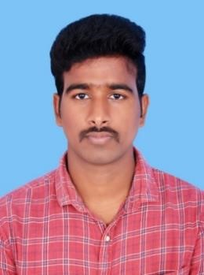

**CHITTETI NARENDRA.**

**Contact:** +91 8008840502

**Email id:** chittetinarendra2000@gmail.com.

**Career Objective.**

To succeed in an environment of growth and excellence and earn a job which provides me job satisfaction and self-development to help me achieve personal as well as organizational goals.

**Academic Profile.**

|  |  |  |  |
| --- | --- | --- | --- |
| **Degree/Course** | **Year of Passing** | **Institution** | **Percentage of marks/CGPA** |
| B.Tech  (Electrical & Electronics  Engineering) | 2022 | Siddartha  Educational  Academy Group  of Institutions | 7.01(CGPA)  (Till 8th sem) |
| Diploma | 2019 | Govt.Polytechnic  College Chandragiri | 71.57% |
| S.S.C | 2016 | Sri Sai Brilliant EM High School | 8.5(CGPA) |

**Technical Skills.**

* Programming Languages:
  1. Java Full Stack Development.
  2. HTML
  3. CSS
  4. Java Script
  5. SQL.

**Workshop.**



Completed a workshop on Fast Charging of Electric Vehicles in SEAGI College.

**Major Project**

**Electrical Power Systems by using different components.**

In this project we are going to classify the network of electrical components deployed to supply, transfer, and use electric power. An example of a power system is the electrical grid that provides power to homes and industries within an extended area. The electrical grid can be broadly divided into the generators that supply the power, the transmission system that carries the power from the generating centers to the load centers, and the distribution system that feeds the power to nearby homes and industries. Likewise we had completed the process of project.

**Area of Interest.**

* New technologies & Software development

**Personal Information.**

|  |  |  |
| --- | --- | --- |
|  |  |  |
| **Name** | **:** | Chitteti Narendra |
| **Father’s Name** | **:** | C.Ramakrishna |
| **Mother’s Name** | **:** | C.Lakshmi |
| **Date of Birth** | **:** | 15-06-2000 |
| **Languages Known** | **:** | Telugu, Hindi, English |
| **Address** | **:** | 1-77, Chelluru(V), Yerpedu(M) , Tirupati(D), A.P-517526 |
| **Hobbies** | **:** | Listening Music , Hanging out with Friends |

**Declaration.**

I hereby declare that the information furnished above is true to the best of my

knowledge.

Place : Bangalore Yours Faithfully

C.Narendra.