To check the particular service configuration through postman via config-server like below screenshot.

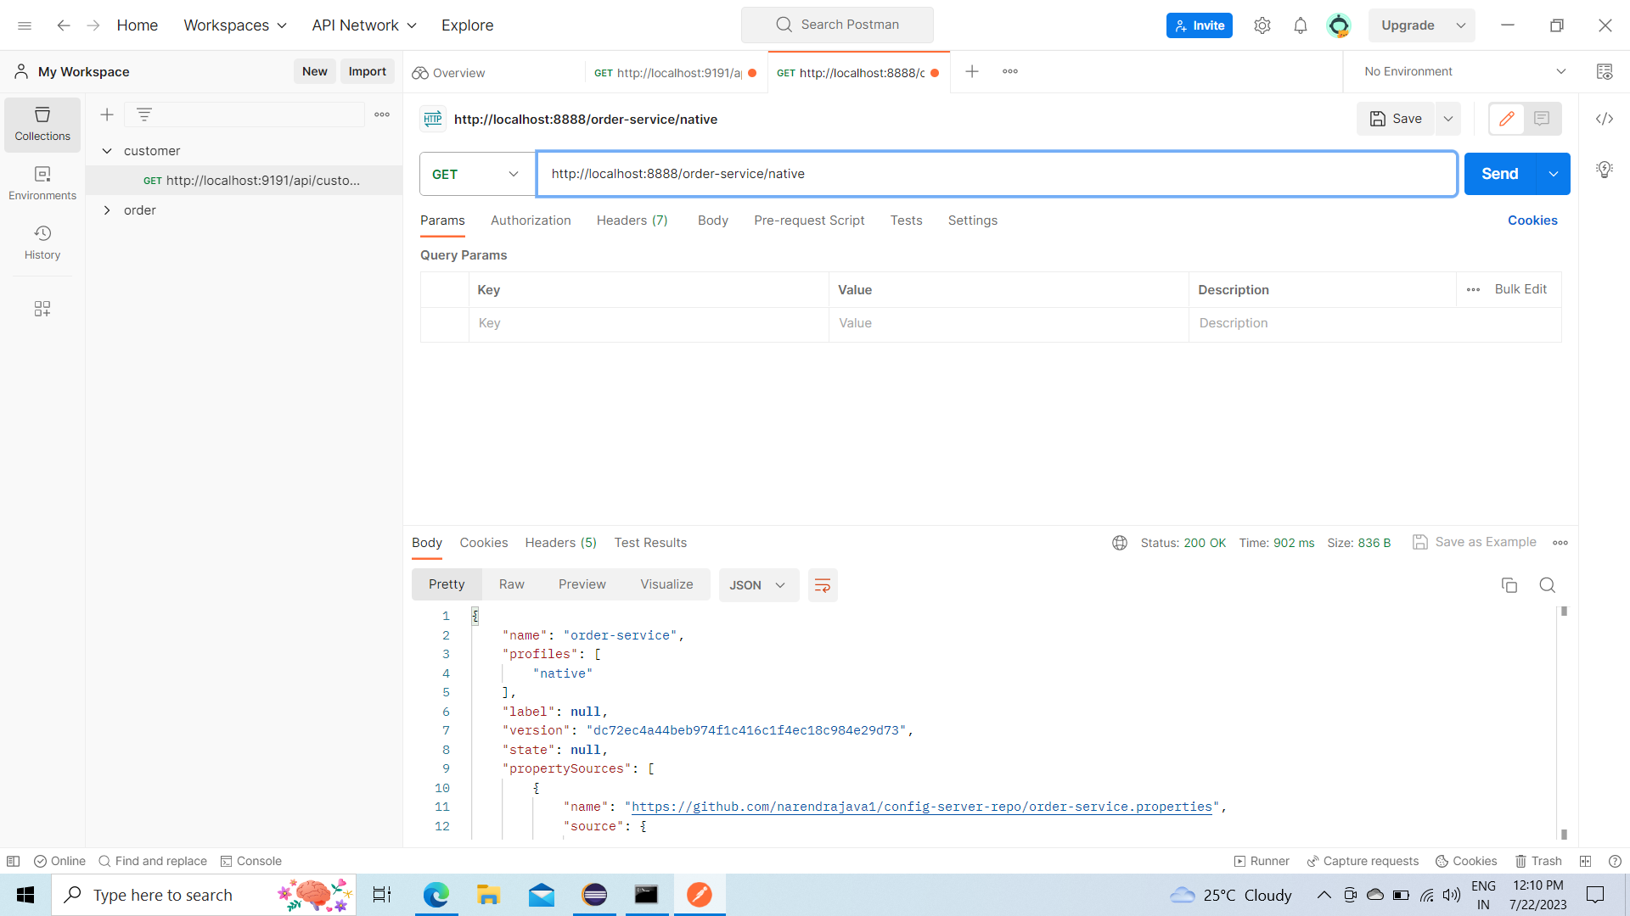

Once after u added ssl related configuration in config server. U will able to see this message in console of config server

[0;39m Discovery Client initialized at timestamp 1690009732471 with initial instances count: 1

[2m2023-07-22T12:38:52.474+05:30[0;39m [32m INFO[0;39m [35m23052[0;39m [2m---[0;39m [2m[ main][0;39m [36mo.s.c.n.e.s.EurekaServiceRegistry [0;39m [2m:[0;39m Registering application CONFIG-SERVER with eureka with status UP

[2m2023-07-22T12:38:52.474+05:30[0;39m [32m INFO[0;39m [35m23052[0;39m [2m---[0;39m [2m[ main][0;39m [36mcom.netflix.discovery.DiscoveryClient [0;39m [2m:[0;39m Saw local status change event StatusChangeEvent [timestamp=1690009732474, current=UP, previous=STARTING]

[2m2023-07-22T12:38:52.476+05:30[0;39m [32m INFO[0;39m [35m23052[0;39m [2m---[0;39m [2m[nfoReplicator-0][0;39m [36mcom.netflix.discovery.DiscoveryClient [0;39m [2m:[0;39m DiscoveryClient_CONFIG-SERVER/host.docker.internal:CONFIG-SERVER:8888: registering service...

[2m2023-07-22T12:38:52.528+05:30[0;39m [32m INFO[0;39m [35m23052[0;39m [2m---[0;39m [2m[nfoReplicator-0][0;39m [36mcom.netflix.discovery.DiscoveryClient [0;39m [2m:[0;39m DiscoveryClient_CONFIG-SERVER/host.docker.internal:CONFIG-SERVER:8888 - registration status: 204

[2m2023-07-22T12:38:52.553+05:30[0;39m [32m INFO[0;39m [35m23052[0;39m [2m---[0;39m [2m[ main][0;39m [36mo.a.t.util.net.NioEndpoint.certificate [0;39m [2m:[0;39m **Connector [https-jsse-nio-8888], TLS virtual host [_default_], certificate type [UNDEFINED] configured from [C:\Users\DELL/.keystore] using alias [secreateAlias] and with trust store [null]**

[2m2023-07-22T12:38:52.572+05:30[0;39m [32m INFO[0;39m [35m23052[0;39m [2m---[0;39m [2m[ main][0;39m [36mo.s.b.w.embedded.tomcat.TomcatWebServer [0;39m [2m:[0;39m Tomcat started on port(s): 8888 (https) with context path ''

[2m2023-07-22T12:38:52.573+05:30[0;39m [32m INFO[0;39m [35m23052[0;39m [2m---[0;39m [2m[ main][0;39m [36m.s.c.n.e.s.EurekaAutoServiceRegistration[0;39m [2m:[0;39m Updating port to 8888

[2m2023-07-22T12:38:52.731+05:30[0;39m [32m INFO[0;39m [35m23052[0;39m [2m---[0;39m [2m[ main][0;39m [36mcom.naren.ConfigServerApplication [0;39m [2m:[0;39m Started ConfigServerApplication in 6.456 seconds (process running for 7.883)

If u want to keep jks file in classpath need to configure in this way

**encrypt.keyStore.location=classpath:/config-server.jks**

**for classpath configuration we need to add in this way**

spring.application.name=configserver

spring.profiles.active=native

spring.cloud.config.server.native.search-locations=classpath:/config/{application}

management.endpoints.web.exposure.include=*

server.port=8071

encrypt.key=eazybytes

spring.sleuth.sampler.percentage=1

spring.zipkin.baseUrl=http://localhost:9411/

eureka.instance.preferIpAddress = true

eureka.client.registerWithEureka = true

eureka.client.fetchRegistry = true

eureka.client.service-url.default-zone=http://localhost:8761/eureka         #Register with Eureka