The simple application used to create a todo list.

Still some more features need to be added, app is under construction.

after installing all the dependices like flask, mysql, venv. Activate venv start mysql service the application running on

localhost:5000 should be like this:

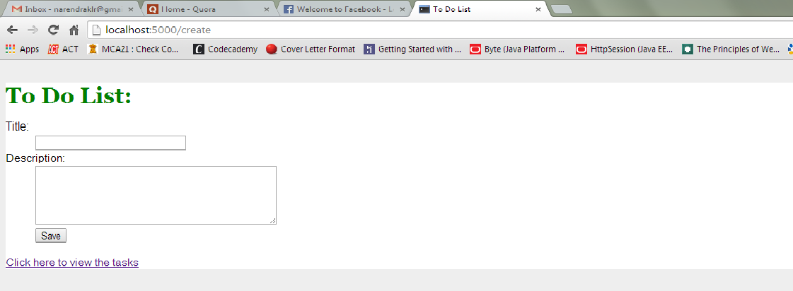  
Error msgs while creating empty tasks, view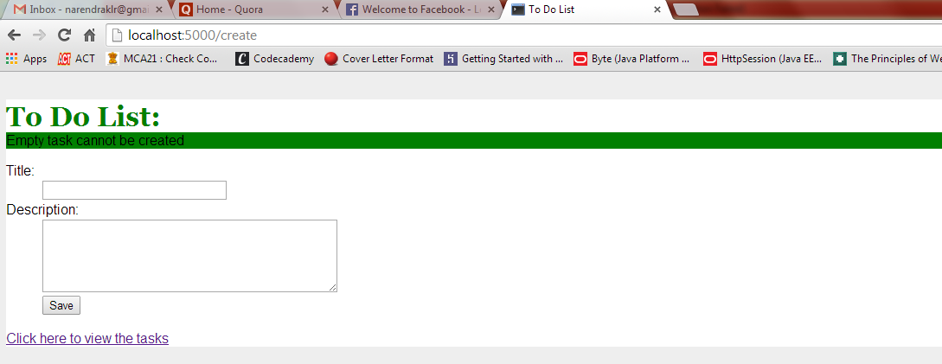Displaying tasks view. 