WEEK 4 PROJECT REPORT

Predictive Modeling and Optimization in Logistics Systems
Python • Forecasting Delivery Time • Model Evaluation • Operational Optimization

Prepared as an academic demonstration using a hypothetical dataset

Executive Summary
This project demonstrates how predictive analytics can support logistics planning by estimating shipment delivery time in hours. A reproducible synthetic dataset of 1,200 shipment records was created with distance, weight, transport mode, weather, traffic, region, priority, and holiday-period indicators. Four modeling approaches are compared: Linear Regression, Decision Tree, Random Forest, and a hyperparameter-tuned Random Forest. The latest 20% of records are reserved for testing to approximate forecasting future shipments, while TimeSeriesSplit cross-validation is used for model selection on the earlier training period. Performance is assessed with Mean Absolute Error (MAE), Root Mean Squared Error (RMSE), and R-squared (R²). The selected model can inform earlier risk flags, dispatch planning, capacity allocation, and exception management. A scenario analysis estimates the model's change in predicted delivery time when the traffic index is reduced by one point. Because the data are simulated, all performance numbers and scenario estimates are illustrative and must not be interpreted as measured real-world impact.

1. Problem Definition
Logistics teams need an early estimate of how long a shipment is likely to take so they can communicate realistic delivery windows, prioritize at-risk shipments, allocate vehicles and staff, and investigate potential bottlenecks. The prediction problem is supervised regression: use information available at planning time to forecast `delivery_hours`, the elapsed time from dispatch to delivery.
Business question: Can shipment and operating conditions predict delivery time accurately enough to support planning and exception management?
Target variable: `delivery_hours` (continuous numeric value, in hours).
Unit of analysis: one shipment record. Intended use: decision support, not automatic dispatch or customer commitments without human review.

2. Dataset Description and Simulation
The CSV contains 1,200 hypothetical shipments dated across a sequential period. Features were generated using plausible ranges and a fixed random seed for reproducibility. Delivery time was simulated from distance, transport mode, traffic, weather, region, priority, holiday period, a mild time trend, and random noise.
Field | Type | Description
shipment_date | Date | Shipment date; used to preserve chronological order
distance_km | Numeric | Shipment route distance in kilometres
weight_kg | Numeric | Shipment weight in kilograms
transport_mode | Category | Road, Rail, or Air
weather | Category | Clear, Rain, or Storm
traffic_index | Numeric (1–10) | Simulated traffic intensity
region | Category | North, South, East, or West
priority | Category | Standard or Express
holiday_period | Binary | 1 indicates a simulated holiday period
delivery_hours | Numeric target | Simulated delivery time in hours
Data quality and scope: the dataset is synthetic, not collected from a real logistics provider. Its relationships were intentionally constructed for teaching. A production project should profile missing values, duplicates, outliers, timestamp quality, and possible data leakage on the real source system.

3. Modeling Workflow
- Load and sort shipment records by shipment date.
- Define the target and select features available before or at dispatch.
- Reserve the newest 20% of records as the holdout test set; train on the earlier 80%.
- Impute numeric missing values with the median and categorical missing values with the most frequent category.
- One-hot encode categorical features and use a pipeline so preprocessing is fitted only on training folds.
- Fit and compare baseline models using the same chronological split.
- Tune Random Forest hyperparameters with four-fold TimeSeriesSplit cross-validation on training data only.
- Evaluate the final tuned model once on the holdout test set and save predictions, metrics, and scenario results.

4. Model Selection Rationale
Model | Reason for inclusion | Consideration
Linear Regression | Fast, interpretable baseline; shows whether simple additive relationships are adequate. | May underfit nonlinear effects and interactions.
Decision Tree | Captures nonlinear splits and interactions; easy to explain at a high level. | Can overfit unless tree depth and leaf sizes are controlled.
Random Forest | Ensemble of trees; generally captures nonlinear patterns more robustly. | Less directly interpretable and needs more compute.
Tuned Random Forest | Selects tree count, depth, and minimum leaf size using time-aware cross-validation. | Still requires drift monitoring and careful validation.
The tuned Random Forest is a candidate rather than a guaranteed winner. Select the model with the best validation performance while also checking stability, interpretability, operational constraints, and performance across regions and transport modes.

5. Training and Validation Code
The full runnable implementation is provided in `src/predict_and_optimize.py`. The following excerpts illustrate the key steps.
# Chronological holdout: latest 20% is reserved for testing
df = df.sort_values("shipment_date")
split = int(len(df) * 0.80)
X_train, X_test = X.iloc[:split], X.iloc[split:]
y_train, y_test = y.iloc[:split], y.iloc[split:]
# Fit preprocessing and model together to avoid leakage
pipe = Pipeline([
("prep", preprocess),
("model", RandomForestRegressor(
n_estimators=180, min_samples_leaf=3, random_state=42
))
])
pipe.fit(X_train, y_train)
predictions = pipe.predict(X_test)
# Tune only on the training period using time-ordered folds
search = GridSearchCV(
rf_pipe,
param_grid={
"model__n_estimators": [100, 180],
"model__max_depth": [None, 12],
"model__min_samples_leaf": [2, 4]
},
scoring="neg_mean_absolute_error",
cv=TimeSeriesSplit(n_splits=4),
n_jobs=-1
)
search.fit(X_train, y_train)

6. Evaluation Metrics
Metric | Definition | Interpretation
MAE | Mean of absolute prediction errors, in hours. | Easy to communicate as typical error size; lower is better.
RMSE | Square root of mean squared error, in hours. | Penalizes larger misses more strongly; lower is better.
R² | Fraction of target variance explained relative to a mean baseline. | Higher is generally better; may be negative on weak predictions.
Results on the held-out newest 20% of records:
Model | MAE (hours) | RMSE (hours) | R²
Linear Regression | 2.99 | 3.78 | 0.691
Random Forest | 3.46 | 4.36 | 0.588
Tuned Random Forest | 3.48 | 4.38 | 0.586
Decision Tree | 4.08 | 5.16 | 0.423
Interpretation: compare models primarily by MAE for a clear operational measure of average absolute error, then use RMSE to understand the effect of occasional large misses and R² for context. The best model is the one with the lowest test error and acceptable subgroup performance; do not choose solely from training accuracy.
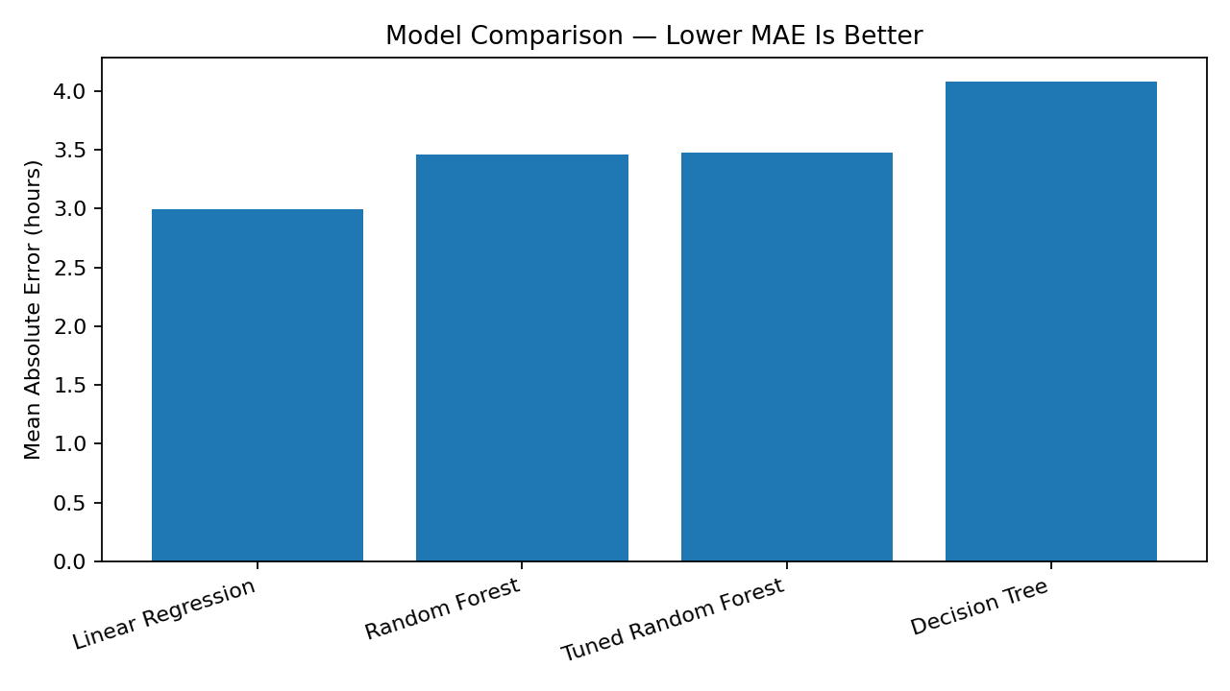
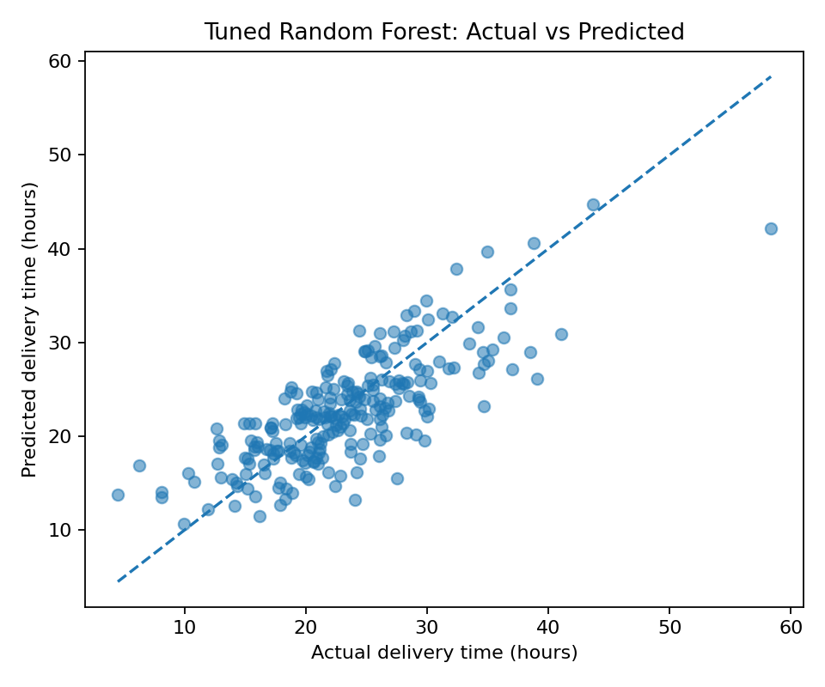
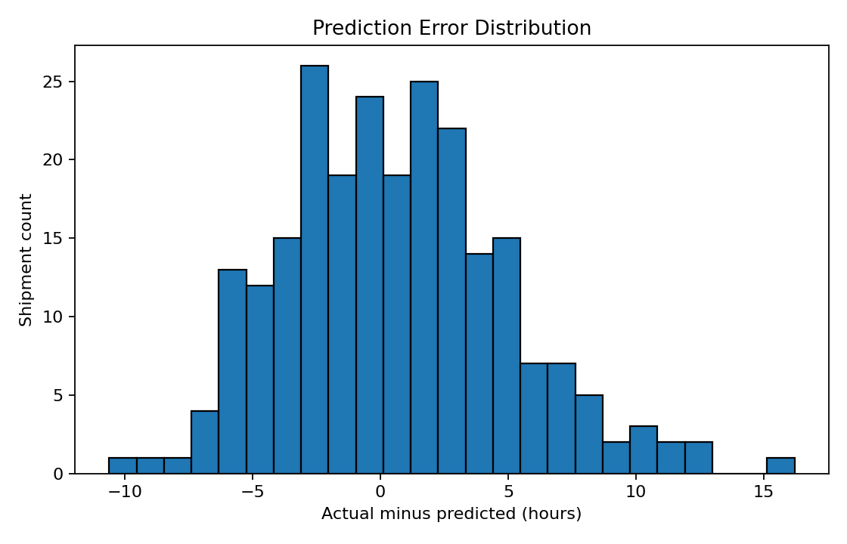

7. Cross-Validation and Hyperparameter Tuning
A chronological holdout split is used because logistics forecasting typically predicts future shipments from past observations. Random shuffling could leak temporal patterns and produce an overly optimistic estimate. Within the training period, four-fold TimeSeriesSplit preserves ordering: each validation fold occurs after its training fold. Grid search tests 100 or 180 trees, unlimited or 12-level maximum depth, and minimum leaf sizes of 2 or 4. The scoring objective is negative MAE, so the selected parameter combination minimizes cross-validated MAE. The holdout set is not used for parameter selection.
Selected hyperparameters from the demonstration run: {'model__max_depth': 12, 'model__min_samples_leaf': 2, 'model__n_estimators': 180}

8. Optimization Strategies Based on Predictions

At-risk shipment alerts
Flag shipments whose predicted delivery time exceeds the service-level target or whose prediction interval/risk buffer is unacceptable. Route flagged cases to an operations queue for human review.

Capacity and labor planning
Aggregate predicted arrivals by region, day, and transport mode to schedule dock capacity, drivers, and customer support staffing ahead of expected peaks.

Route and mode review
Compare predicted delivery time and actual cost by feasible route or mode, while respecting capacity, service promises, emissions, and safety constraints. The fastest option is not always the lowest-cost or best option.

Traffic scenario analysis
The included scenario reduces the traffic index by one point for the test records and compares predictions. Treat this as a model-based sensitivity scenario, not a causal estimate or guarantee of hours saved.

Exception management
Prioritize shipments with large prediction errors or repeated late delivery; investigate missing data, weather disruptions, handoff delays, and regional process constraints.

Closed-loop improvement
Record actual delivery outcomes, monitor MAE/RMSE monthly, check error by region/mode/weather, retrain when drift is detected, and compare model-assisted decisions with a baseline.
A fuller optimization layer could formulate a constrained assignment problem: minimize total estimated transport and delay cost while respecting vehicle capacity, driver hours, delivery windows, mode availability, and route feasibility. A predictive model supplies travel-time estimates; an optimizer chooses among feasible alternatives. Predictions alone do not solve the routing problem.

9. Key Findings and Recommendations
The synthetic experiment demonstrates an end-to-end workflow from feature preparation through time-aware validation, model comparison, and scenario analysis. Use the actual metric table above as the quantitative evidence for this run. Do not generalize these values to real carriers because the target was generated from simulated relationships.
- Start with a transparent baseline and retain the tuned ensemble only if its held-out MAE improves meaningfully.
- Use predicted delivery time to support earlier risk alerts and planning, with a human decision-maker responsible for exceptions.
- Validate data definitions and feature availability to avoid leakage—for example, do not use actual arrival timestamps to predict delivery time at dispatch.
- Evaluate performance separately by region, transport mode, priority, and weather to identify systematic errors.
- Quantify business value through a pilot: on-time delivery, overtime, failed delivery, cost per shipment, and customer notification accuracy.
- Monitor data drift and retrain using recent representative data; document model version, training date, and limitations.

10. Limitations, Ethics, and Responsible Use
- The data are simulated and may not reflect real-world distributions or causal relationships.
- The scenario analysis is predictive sensitivity analysis, not a controlled experiment.
- Forecast quality depends on input accuracy and whether conditions remain similar to training data.
- Avoid using sensitive personal information unless necessary, lawful, and properly governed.
- Provide a human override for dispatch and service decisions; monitor for unequal error rates across regions or service categories.

11. How to Run the Project on Windows
# In PowerShell, open the project folder first, then run:
python -m venv .venv
.venv\Scripts\python.exe -m pip install -r requirements.txt
.venv\Scripts\python.exe src\predict_and_optimize.py
The script writes `model_evaluation_metrics.csv`, `test_set_predictions.csv`, and `traffic_reduction_scenario.csv` to the outputs folder. The chart images in outputs are generated for the included synthetic data. The Word report is a documentation deliverable and does not need to be regenerated to run the model.

12. Conclusion
Predictive modeling can improve logistics visibility by estimating delivery times before outcomes are known. This project compares interpretable and ensemble regression models, uses time-aware validation, evaluates error in operational units, and illustrates how forecasts can support staffing, exception handling, and scenario planning. The recommended next step is to replace the synthetic dataset with approved historical shipment data, establish a leakage-safe prediction timestamp, and pilot the model alongside existing operational processes.

Appendix: Project Files
- data/hypothetical_logistics_shipments.csv — 1,200 synthetic shipments
- src/predict_and_optimize.py — complete model training, evaluation, tuning, and scenario code
- outputs/model_evaluation_metrics.csv — model comparison metrics
- outputs/test_set_predictions.csv — holdout predictions and errors
- outputs/traffic_reduction_scenario.csv — illustrative traffic sensitivity scenario
- outputs/*.png — visualizations
- README.md and requirements.txt — setup and execution instructions

