WEEK 3 TASK

Advanced Data Analysis and Visualization in Logistics
Python • EDA • Charts • Operational Insights
Academic demonstration using a hypothetical logistics dataset.

1. Executive Summary
This report explores 300 simulated shipments using Python. The dataset includes transport mode, region, distance, volume, weather, delivery time, transportation cost, and delivery status. In this synthetic sample, 88.7% of shipments are labelled on time and 11.3% late. Visualizations examine delivery-time distribution, average cost by transport mode, distance-cost relationships, numeric correlations, weather and delivery time, and late-delivery rates by region. Results are illustrative and not real company metrics.

2. Objectives
- Define a hypothetical logistics dataset.
- Inspect data quality and calculate central tendency, dispersion, distributions, and correlations.
- Create and justify multiple visualizations.
- Interpret patterns cautiously and propose recommendations.
- Provide reproducible Python code and run instructions.

3. Dataset Design and Variables
A fixed random seed generates 300 reproducible records. Cost is simulated from distance, volume, and mode-related assumptions; delivery time varies with distance, mode, region, random variation, and weather. These are design assumptions, not measured facts.
Variable | Type | Meaning
shipment_id | ID | Unique shipment identifier
region | Category | North, South, East, West
transport_mode | Category | Road, Rail, Air
distance_km | Numeric | Distance travelled
shipment_volume_units | Numeric | Shipment units
weather_condition | Category | Normal, Rain, Severe
delivery_time_hours | Numeric | Elapsed delivery time
transportation_cost_usd | Numeric | Cost in USD
delivery_status | Category | On Time or Late

4. Methodology and Data Quality
The CSV contains 300 rows and 9 columns. Missing cells: 0. Duplicate rows: 0. Pandas performs data loading, grouping, summaries, and correlations; NumPy supports reproducible simulation; Matplotlib creates the figures.

5. Descriptive Statistics
Mean describes the average, median the midpoint, standard deviation the spread, and minimum/maximum the observed range.
Variable | Mean | Median | Std dev | Min | Max
distance_km | 509.19 | 503.50 | 267.22 | 27.00 | 997.00
shipment_volume_units | 25.59 | 26.00 | 15.32 | 1.00 | 50.00
delivery_time_hours | 12.39 | 12.12 | 6.25 | 1.00 | 31.44
transportation_cost_usd | 183.37 | 175.24 | 74.01 | 37.61 | 476.33

6. Visualizations and Interpretations

Figure 1 — Delivery-time distribution
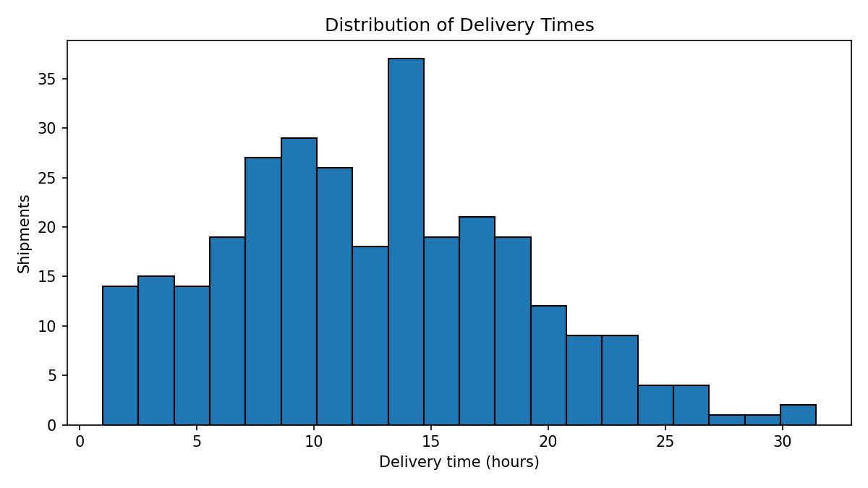
The histogram reveals the spread of delivery times, common ranges, and any long tail. This supports service-level planning.

Figure 2 — Average cost by transport mode
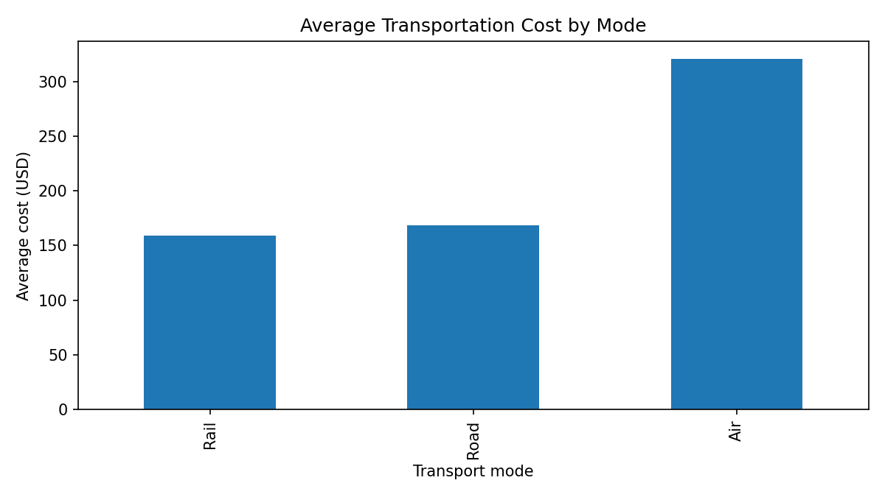
The bar chart compares average cost for Road, Rail, and Air. It suits categorical comparisons, but decisions must account for distance, volume, urgency, and service quality.

Figure 3 — Distance versus transportation cost
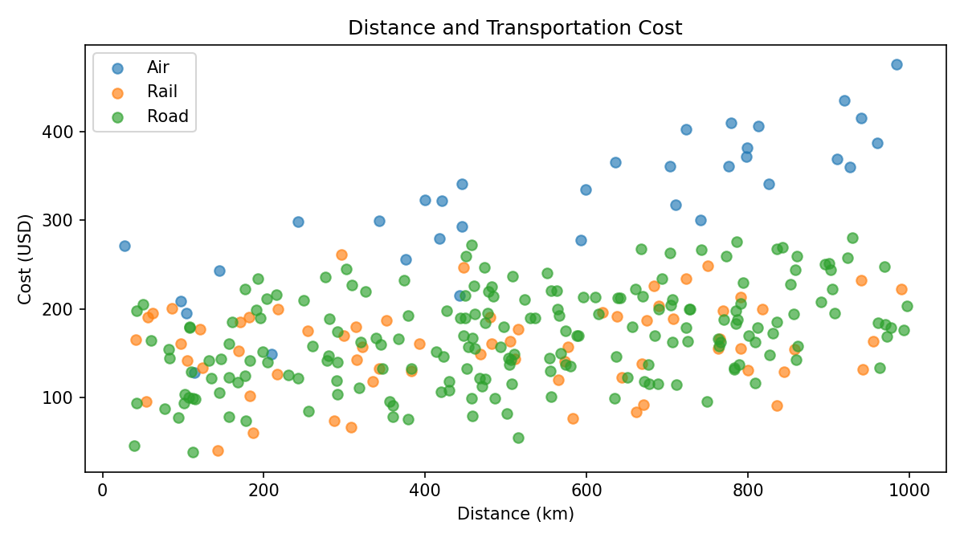
Each point represents a shipment and the legend distinguishes modes. The scatter plot shows whether cost tends to rise with distance and helps flag unusual shipments.

Figure 4 — Correlation matrix
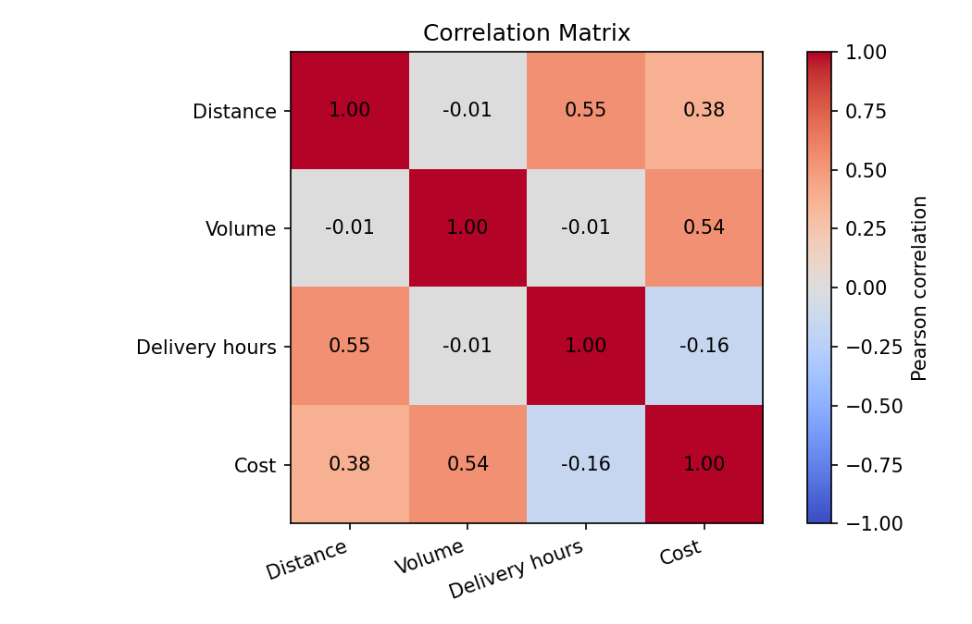
The heatmap summarizes Pearson correlations. Values near +1 indicate positive linear association, near -1 negative association, and near 0 little linear association. Correlation does not prove causation.

Figure 5 — Delivery time by weather
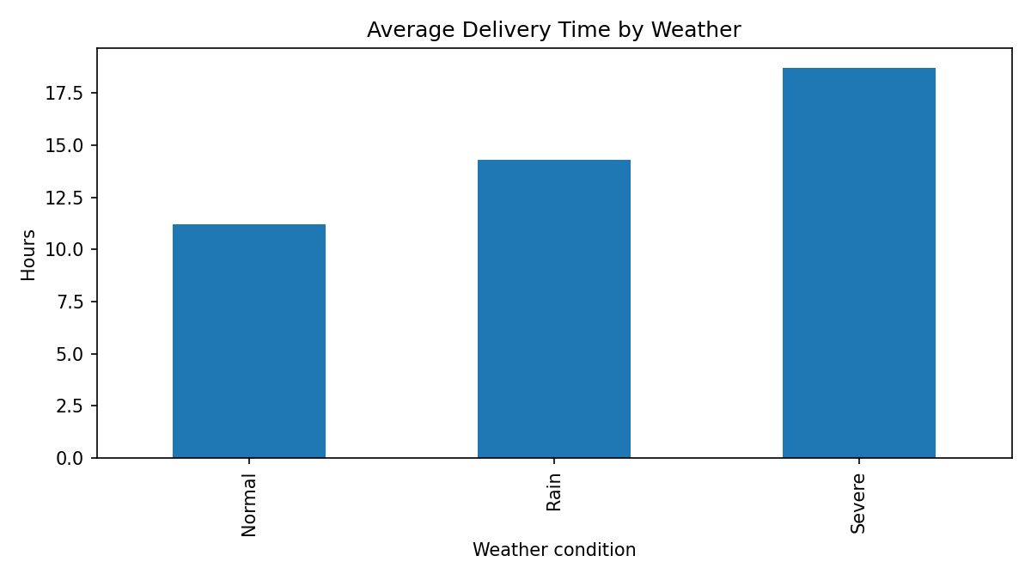
The bar chart compares average delivery time across weather categories. In real data, weather effects should be checked alongside route, distance, and transport mode.

Figure 6 — Late-delivery rate by region
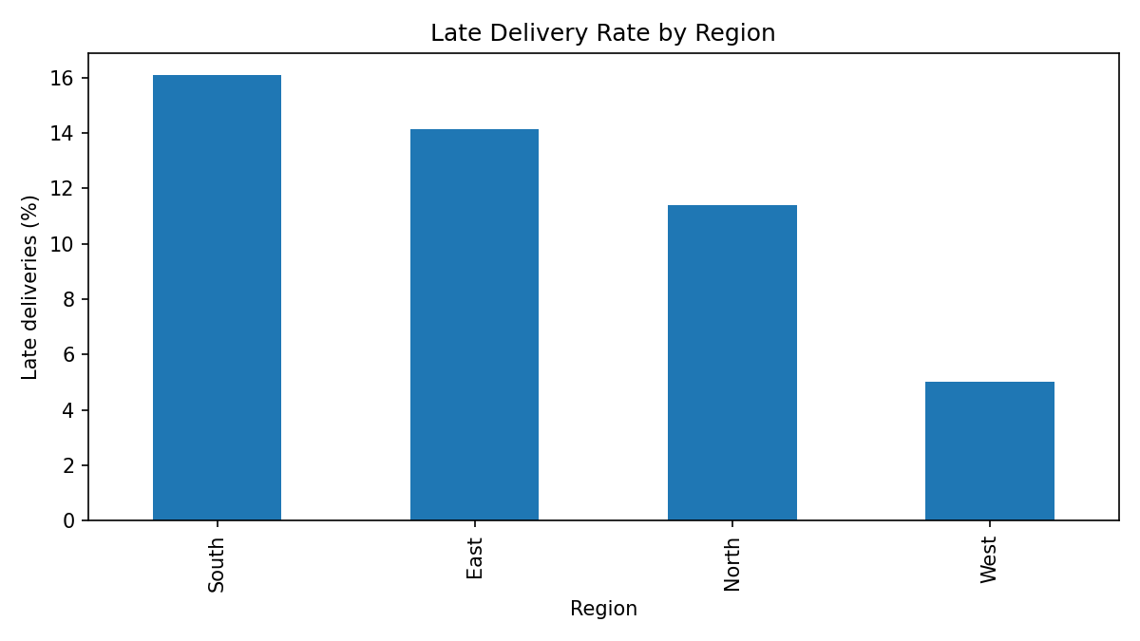
The bar chart compares the percentage late in each region. It can point to areas for investigation, but sample size and shipment mix must be considered.

7. Correlation Analysis
The correlation matrix covers distance, shipment volume, delivery time, and cost. Some associations are expected because distance and volume contribute to the simulated cost formula and mode/weather affect simulated delivery time. Treat correlation as a screening tool, not proof of cause.
Variable | Distance | Volume | Delivery hours | Cost
Distance | 1.00 | -0.01 | 0.55 | 0.38
Volume | -0.01 | 1.00 | -0.01 | 0.54
Delivery hours | 0.55 | -0.01 | 1.00 | -0.16
Cost | 0.38 | 0.54 | -0.16 | 1.00

8. Insights and Recommendations
- Cost management: Compare cost per shipment and cost per kilometre by mode while accounting for distance, volume, urgency, and delivery commitments.
- Delivery monitoring: Track median and upper-percentile delivery time as well as the mean; averages can hide a small number of long delays.
- Weather planning: Use contingency buffers and proactive updates for weather-sensitive routes, then validate impact with historical data.
- Regional bottlenecks: Investigate late rates by drilling into route, carrier, depot, dispatch time, and shipment mix.
- Outlier review: Flag unusually costly or slow shipments and determine whether they are errors, special cases, or genuine inefficiencies.
- KPI dashboard: Monitor on-time delivery rate, median delivery time, cost per shipment, cost per kilometre, and late rate.

9. Python Code Example
import pandas as pd
import matplotlib.pyplot as plt
df = pd.read_csv("data/hypothetical_logistics_dataset.csv")
print(df[["delivery_time_hours", "transportation_cost_usd"]].describe())
print(df[["distance_km", "shipment_volume_units",
"delivery_time_hours", "transportation_cost_usd"]].corr())
df.groupby("transport_mode")["transportation_cost_usd"].mean().plot(kind="bar")
plt.title("Average Transportation Cost by Mode")
plt.xlabel("Transport mode")
plt.ylabel("Average cost (USD)")
plt.tight_layout()
plt.show()
Full runnable code is in src/analyze_logistics.py.

10. Limitations
- The dataset is synthetic and does not represent an actual organization.
- Relationships partly follow the simulation rules and are not empirical discoveries.
- Descriptive charts and correlations do not establish causality.
- A real project should validate data definitions, coverage, data quality, and business context.

11. Conclusion
This project demonstrates an EDA workflow: define data, inspect quality, summarize distributions, compare categories, inspect correlations, visualize results, and develop cautious recommendations. The next step in a real operation is to replace synthetic records with approved operational data and validate findings with logistics experts.

Appendix — Run the Project
- Open the project folder in VS Code and open Terminal → New Terminal.
- Run: python -m pip install -r requirements.txt
- Run: python src/analyze_logistics.py
- Review summaries and charts in outputs/.

