ANALYZING BUILDING AND SAFETY PERMIT USING BIG DATA

Narendra Mali, California State University Los Angeles, nmali@calstatela.edu
Bhagyashree Jadhav, California State University Los Angeles, bjadhav@calstatela.edu
Mittal Vaghela, California State University Los Angeles, mvaghela@calstatela.edu
Jongwook Woo, California State University Los Angeles, jwoo5@calstatela.edu

ABSTRACT

We have analyzed the data set of Building and Safety Permit, City of Los Angeles from Data.lacity.org. The department of Building and Safety issues over 141,400 permits with an estimated valuation of over $6.8 billion annually. Large amount of raw data was getting generated every year from the permit issuance process of LA City. This data was required to analyze so that it could be used by prospective and existing vendors. The dataset has a start date from January 2013 to August 2016 and the size is 206 MB.

We aim to find out insights on count of Permits by Permit Sub-Type for new contractors, average valuation of projects, license types, annual analysis of issued permits and total permits issued per contractor. In this paper, we have used IBM Bluemix BigInsights, Hive on Hadoop, Tableau, Power view and Google fusion table technologies to analyze and visualize big data for Building and Safety Permits in the city of Los Angeles.

Keywords: Building and Safety, Data Analysis, Hadoop, Big Data, Reviews, Visualization, IBM Bluemix Biginsights, Hive, Google Fusion Table, Tableau, Power Map, Excel 3D Map

INTRODUCTION

The Department of Building & Safety provides services to Los Angeles residents through 11 different offices located throughout the City. The Department of Building & Safety reviews and approves plans for over 50,100 projects annually. (Approximately 200 projects every working day)[2]

Analysis of the raw data of all these projects could provide useful information to the new and existing contractors. Hence, this dataset was chosen to covert raw data of the projects and permits to information by using Hadoop. Contractors can use this analysis to get information about permits, projects and their average valuation. The Department issues permits for the construction, remodeling, repair of buildings and structures in the City of Los Angeles. Permits are categorized into building permits, electrical permits, and mechanical permits (which include plumbing, HVAC systems, fire sprinklers, elevators, and pressure vessels). Depending on the complexity of a project, a permit may be issued the same day with Express Permit or e-Permit ("No Plan Check" category), or a permit may require that the plans be reviewed ("Plan Check" category) by a Building and Safety Plan Check personnel. Plan Check permit has to go through different processes such as Counter Plan Check, Expanded Counter Plan Check, Regular Plan Check and Parallel Design or Permitting Process [3].

This data set also provides information about Contractors having different types of licenses. The California Contractors State License Board (CSLB) issues licenses to contract in particular trades or fields of the construction profession. CSLB issues licenses for the classification such as 'Class “A” General Engineering Contractor', 'Class “B” General Building Contractor' and 'Class “C” Specialty Contractor'.[4]

The Department of Building & Safety reviews and approves plans for over 50,100 projects annually. (approximately 200 projects every working day) This recorded data goes on increasing day by day, and hence applying big data analysis helps new and existing contractors to know about their competitors and number of permits issued in the city. The team extracted the data for analysis and visualization.
Insights are as follows, Display all the Permits, Count of Permit type and its sub permit type, Permits by Plan Check or No Plan Check to get probability of getting express permit, Number of permits by City and Permit Subtype to know about permits in nearby cities, Average valuation of different types of Permits to provide new quotations based on it, Contractor's Business Name by number of permits and their location to know competitors, Count of permits by their status, Number of permits issued in particular year, License Type by its average valuation to know how much it costs approximately, and Number of license types by its expiration date to know which licenses are expiring.

Big Data is defined as non-expensive frameworks that can store a huge variety of data set and process it in parallel [5, 6].When it comes to Hadoop, Hadoop Distributed File System (HDFS) is an integral feature. Based on Java, this file system enables large amounts of structured and unstructured data to be stored and quickly accessed across large server clusters. Building and Safety Permits dataset has 506405 number of records so using Hadoop for this analysis over traditional RDBMS was more appropriate. In contrast to RDBMS, Hadoop doesn't require the complicated transformation and schema changes that traditional databases require. In fact, Hadoop has the capability to store data in its raw form and has minimal, if any, data model restrictions. Since our dataset is of 206 MB, using Hadoop for our analysis was less expensive to employ than a conventional RDBMS as Hadoop runs on commodity hardware. In a Hadoop cluster, each computer offers its own local computation and storage. Moreover, easy scalability makes Hadoop ideal for analyzing this dataset, unlike the real-time transaction processing of a relational database. Hadoop's ability to rapidly process vast amounts of data in parallel and it's process where data is written once then read many times in large volumes made us to choose Hadoop Distributed File System (HDFS) for this analysis[7].

RELATED WORK
Building and safety data gets analyzed on different factors such as regulation, safety majors, type of permit etc. Based on these factors other data-set were analyzed.

Aysu analyzed data from Konak municipality(Turkey) for causes and distribution of various building permits and why they are not getting issued on time or why there are significant delays in issuing certain types of permits. This data was directly provided by municipality of Konak, Turkey and the outcomes were derived by taking interviews of Permit officials, inspectors and project owners [8].
Chalmet et al. introduce fire safety regulation for building evacuation. Three models were proposed based on the occupant of the building, minimum time require evacuating the entire building and bottlenecks likely to occur in such an evacuation [9].

Christina Johanna Hopfe published a paper, which was based on Uncertainty and Sensitivity Analysis in Building Performance Simulation for Decision Support and Design Optimization. The aim of this paper was to investigate different opportunities in BPS during the later phases of the design process, and to research and enable innovative applications of BPS for design support.[10]

Data-set that is been analyzed in this paper is for the City of Los Angeles, California. Data-set contains information in the form of raw data regarding building and safety permits. Projected conclusions and analysis were derived using Big data Hadoop, hive, BigInsights Cluster and visualized using Google fusion table, Tableau, Microsoft Excel, Power-Map and 3D map. After analyzing this data-set, insight were found which will be helpful for existing and future vendors to get particular type of permit. Also, vendors can decide on project estimates, demolition work, and new construction projects and know their competitors with the help of 3D maps.

RESEARCH METHODOLOGY
(DATA ANALYSIS FLOW)

We extracted Building and Safety permit data from government website of Los Angeles in .csv format. After this, we uploaded the .csv file into data storage service: Dropbox. After getting a unique link of uploaded file, we uploaded data to HDFS with PUT command. We used Hive query to create external tables on the .csv data that was uploaded in HDFS. Further, we used Hive query SELECT statement to select desired data from the external table and filter out non-desired data. Finally we used Power view in excel, 3D Map, Tableau and Google Fusion table to reproduce the selected data in the form of information by generating graphs, charts and maps.

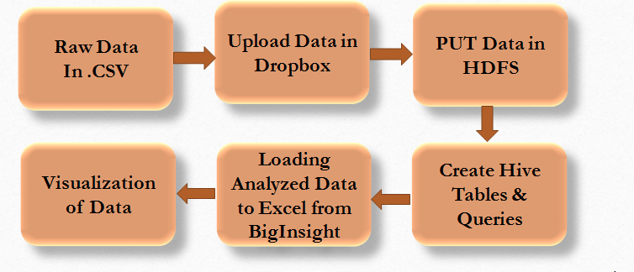
Figure 1: Flow diagram

HADOOP
Hadoop supports processing of large data sets in distributing computing environment and consists of MapReduce, Hadoop distributed file system (HDFS) and also contains many related projects such as Apache Hive, HBase and Zookeeper. Analysis on building and safety permit dataset was facilitated by Hadoop as it provides cluster for storing and analyzing large amount of unstructured data, which run on low-cost commodity computers. Cluster is group of loosely or tightly connected computers that work together as a single system. One of the core functions of Hadoop is that it offers to create multiple data blocks with replicas and then distributes data across various computer nodes to enable reliable and rapid computations.
IBM Bluemix service provides 100% open source Apache Hadoop through the IBM Open Platform. It is updated regularly to provide the best versions of the Apache Hadoop ecosystem components, including, among others, Ambari, YARN, Spark, Knox, HBase, Hive, and an encrypted HDFS. This service enables to spin up clusters within minutes and to scale them up to 20 data nodes through an intuitive GUI. It also provides the option to persist data in an object store. Take advantage of the ability to develop applications on a smaller cluster and then scale up to handle more data and use cases. Delete clusters when they are no longer required, but have your data persist on an object store instance. [11]

IBM Bluemix is the latest cloud offering from IBM. It enables organizations and developers to create quickly and easily, deploy, and manage applications on the cloud. Bluemix is an implementation of IBM's Open Cloud Architecture based on Cloud Foundry, an open source Platform as a Service (PaaS). Bluemix delivers enterprise-level services that can easily integrate with cloud applications.
- Number of data nodes used is 4.
- Number of Management Nodes used is 12.
- RAM used is 24GB
- CPU Speed 2.25 GHz

HIVE

Hive is a querying language, which offers similar syntax to SQL. Hive’s infrastructure is built on top of Hadoop. Hive was developed at Facebook and it is open-sourced for free download. The primary purpose of Hive is to query and analyze large datasets across various nodes. Hive is a high-level interface, which allows us to execute MapReduce jobs across a Hadoop cluster. MapReduce is the system used to process data in Hadoop cluster. One of the limitations of RDBMS is its lack of access and analytical capabilities towards unstructured data. Hive closes the gap on this limitation. [12]

DATA VISUALIZATION AND HIVE QL

We all know that big data is powerful; however, without visualization a lot of the knowledge may go unrecognized without making much logical sense. More often than not, data visualization allows data sets/data objects to show its true potential/power. With the help of Power View in Excel, Tableau we visualized the output of the hive queries in the form of charts, graphs and maps.

GOOGLE FUSION TABLE

It is a web service for data management. It is used for gathering, visualizing and sharing data tables. In our dataset, Fusion table is used to display areas with high density of permits in California State in the form of geographical maps. We have used below query to create basic table and to display the permits. [13]

CREATE EXTERNAL TABLE building_permit (
`Unique_ID` string, `Assessor Book` string, `Assessor Page` string, `Assessor Parcel` string, `Tract` string, `Lot` string, `PCIS Permit #` string, `Permit` string, `Permit Type` string, `Status` string, `Permit Sub-Type` string, `Status Date` string, `Permit Category` string, `Initiating Office` string, `Issue Date` string, `Address Start` string, `Address End` string, `Street Direction` string, `Street Name` string, `Street Suffix` string, `city` string, `Zip Code` string, `Work Description` string, `Valuation` string, `Contractor's Business Name` string, `Contractor Address` string, `Contractor City` string, `Contractor State` string, `License Type` string, `License #` string, `License Expiration Date` string, `Census Tract` string, `Latitude` string, `Longitude` string, `State` string, `Country` string)
ROW FORMAT DELIMITED FIELDS TERMINATED BY ','STORED AS TEXTFILE LOCATION '/user/mvaghela/Building/' TBLPROPERTIES ('skip.header.line.count'='1');

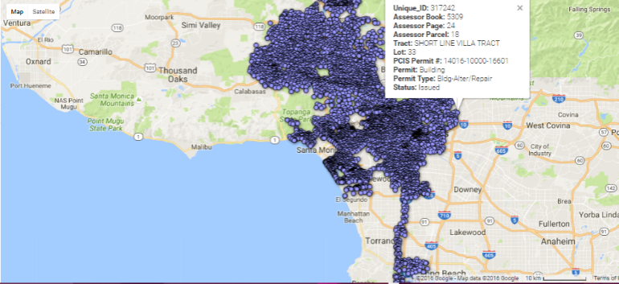
Figure 2: Google Fusion Table showing Density of Permits

Figure 2 shows the raw data with their geographical location in Google Fusion. It is used to display the density of permits. It gives us the idea of number of permits issued in the city of Los Angeles.

EXCEL POWER VIEW
Power View is an interactive data exploration, visualization, and presentation experience that encourage intuitive ad-hoc reporting. For visualizations, you want to create, start with a table, which you then convert easily to other visualizations to find one best illustrates your data. It is used to find number of permits by their sub permit types. We have below query to find the peak time in Los Angeles:

CREATE TABLE permit_count AS
SELECT `Permit`, `Permit Sub-Type`, COUNT(`unique_ID`) AS ID
FROM building_permit
GROUP BY `Permit Sub-Type`, `Permit`;

Figure 3 shows count of permits in every permit types and sub-types. It helps to find how many permits are already there in a main permit type. This information is essential for a contractor entering into a new business. Contractor can get the knowledge of permit sub-types and also their count by permit types.

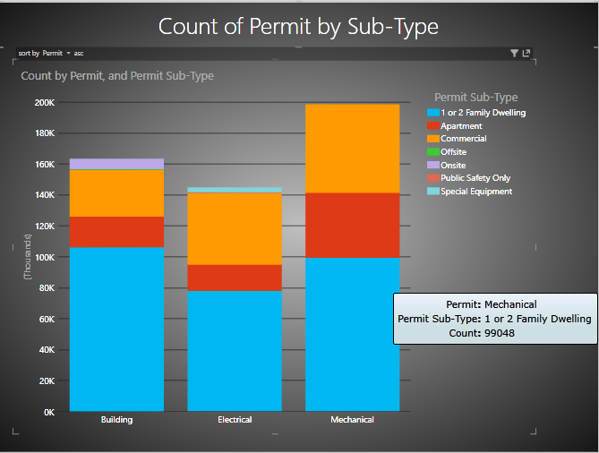
Figure 3: Count of Permits by Permit Sub-Type in Excel Power View

TABLEAU
Tableau Desktop allows users to connect to external data sources and quickly convert the data into interactive BI reports and dashboards. [12]

Figure 4 shows Packed Bubble chart using tableau to display count of License type by its average valuation to know how much it costs approximately and the conclusion is license type B (General building) has highest count amongst all the other license types. A bubble chart is a stylized way of visually representing occurrences of words used to describe tags. The biggest circle indicates highest count followed by smaller circles displaying count in descending order.

CREATE TABLE license AS
SELECT `License Type`, COUNT(`Unique_ID`),
AVG(`Valuation`)
FROM building_permit
GROUP BY `License Type`;

Following Packed Bubble chart shows count of license types by its average valuation. Contractors can use this information to find average valuation of a project and can provide project estimates based on the numbers in the chart
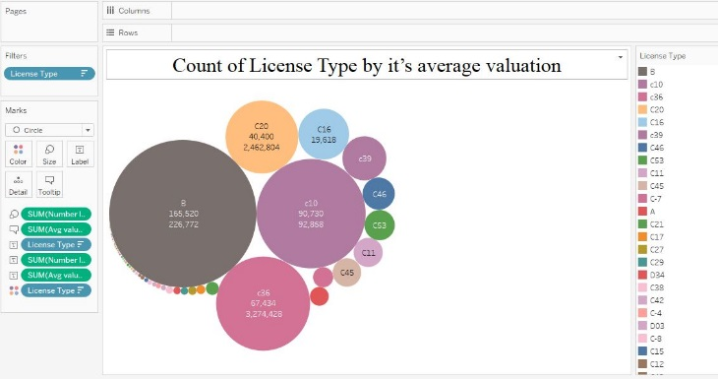
Figure 4: Packed bubble chart to find count of License Type by its average valuation

Figure 5 shows, visualized a side by side bar chart using tableau to display the number of permits issued from year 2013 to 2016 and we get to know that in 2015 highest number of permits have been issued for all the permit types (building, mechanical and electrical). Another observation is that the percentage increase is highest in Electrical Permit category when compared to previous year.

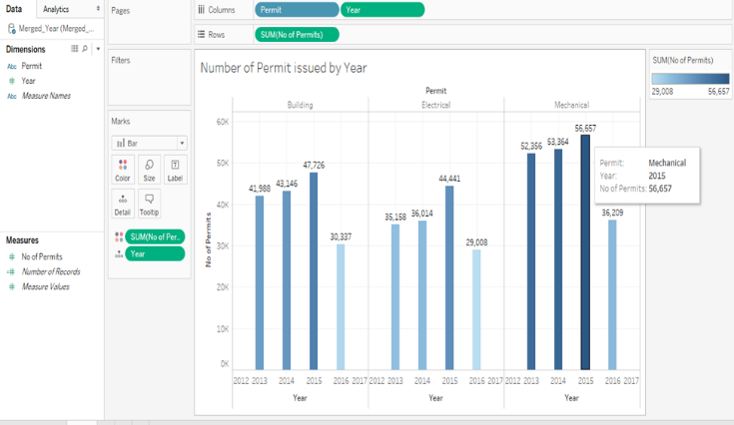
Figure 5: Side by Side bar chart to find number of permits issued in particular year

EXCEL 3D MAP
3D Maps for Excel is a three-dimensional (3-D) data visualization tool. With 3D Maps, we can plot geographic and temporal data on a 3-D globe or custom map, show it over time, and create visual tours that can share with other people.

Excel 3D map was chosen to show the Contractor's Business Name by number of permits and their location. Figure 6 shows each contractor has how many permits in each permit category. New and existing contractors can use this information to know about their competitors in the nearby location.
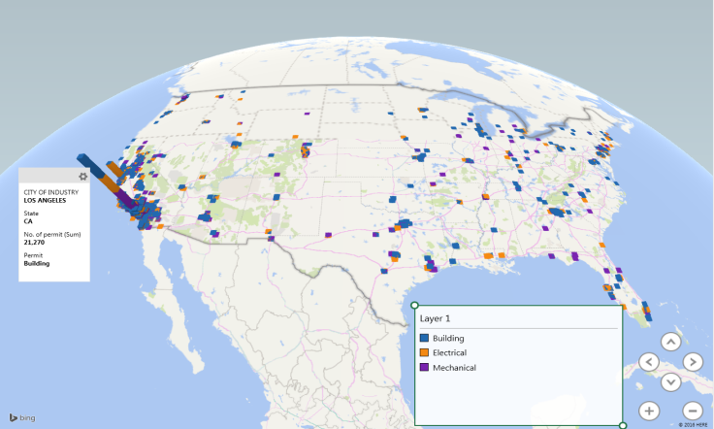
Figure 6: Excel 3D map to find count of permits of the contractors in different city

In the given Excel 3D map, we have displayed the number of permits by permit sub-types and it shows that Electrical permit count is comparatively more than the other permit sub-types.

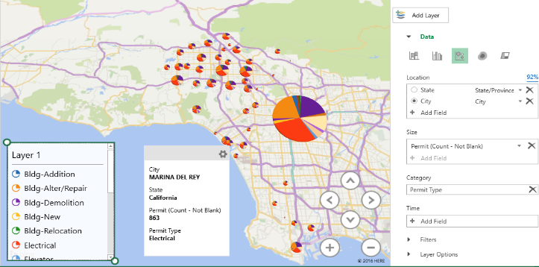
Figure 7: Excel 3D map to find number of permits by Permit Subtype

CONCLUSION
A big set of raw Building and Safety Permit data has been transformed into information and projecting the insights by generating rich visuals, graphs and charts using Hive and visualization tools. Hadoop Hive is relatively inexpensive and adopted as a solution for Big Data, which has been getting widely adopted in every industry; also it can easily scale out as data grows. After analyzing 4 years of Building and Safety Permit data, we came up with following results:

• Every year highest number of permits has been issued for Mechanical Permit type since year 2013.
• 97% of the Contractors are California residents.
• Most of the demolition work is being done in LA Downtown Area hence future construction possibility increases in that area.
• Percentage increase is highest in Electrical Permit category when compared to previous year i.e. 2014.
• Maximum number of ‘General Building’ type of licenses are going to expire in next two years.

REFERENCES

ladbs.org ‘Facts about us’, 2012. Available:http://www.ladbs.org/our-organization/messaging/a-few-facts-about-us.

ladbs.org ‘Plan Check & Permit’,2012. Available:http://www.ladbs.org/services/core-services/plan-check-permit

cslb.ca.gov ‘Contractors State License Board’,2015.:http://www.cslb.ca.gov/Resources/GuidesAndPublications/DescriptionOfClassifications.pdf

Woo Jongwook and Xu Yuhang, 2011. “Market Basket Analysis Algorithm with Map/Reduce of Cloud Computing”, The 2011 international Conference on Parallel and Distributed Processing Techniques and Applications (PDPTA 2011), Las Vegas (July 18-21, 2011)

Woo Jongwook, Oct 28 2013. “Market Basket Analysis Algorithms with MapReduce”, DMKD-00150, Wiley Interdisciplinary Reviews Data Mining and Knowledge Discovery, Volume 3, Issue 6, pp445-452, ISSN 1942-4795

DEMĠRCĠEFE A, 2009. “DELAYS IN ISSUING OF BUILDING PERMIT AND OCCUPANCY PERMIT: AN ANALYSIS OF CAUSES AND DURATIONS”, A Thesis, Graduate School of Engineering and Sciences of Ġzmir Institute of Technology

Chalmet, L.G., Francis, R.L. & Saunders, P.B. Fire Technol, 1982. “Network models for building evacuation”, 18: 90. doi:10.1007/BF02993491

Hopfe C.J. 2009. “Uncertainty and sensitivity analysis in building performance simulation for decision support and design optimization”, Loughborough University

GitHub of the Project, Available: https://github.com//narendramali1/CIS5200

