Python

Features:
- Interactive Mode:Python has support for an interactive mode which allows interactive testing and debugging of snippets of code.
- Portable:Python can run on a wide variety of hardware platforms and has the same interface on all platforms.
- GUI Programming: Python supports GUI applications that can be created and ported to many system calls, libraries and windows systems, such as Windows MFC, Macintosh, and the X Window system of Unix.
- Databases:Python provides interfaces to all major commercial databases.
  - Python has a standard DB-API interface and compatible implementations are available for all widely used database engines.
  - Python 2.5 and later includes a DB-API compliant database package, sqlite3, which uses an embedded SQL database, SQLite.
>>> import sqlite3 as dbapi
>>> db = dbapi.connect("database.db")
>>> c = db.cursor()
>>> for record in c.execute("select * from table"):
... print record
For earlier versions, this database can be downloaded separately
3. GadFly, mSQL, MySQL, PostgreSQL, Microsoft SQL Server 2000, Informix, Interbase, Oracle, Sybase

- Supports functional and structured programming methods as well as OOP.
- Provides Dynamic data types
- Supports automatic garbage collection.
garbage collector Goals: 1. any unused memory should be freed
2. No memory should be freed unless the program will not use it anymore
(In older programming languages, such as C and C++, allocating and freeing memory is done manually by the programmer )
- It can be easily integrated with C, C++, COM, ActiveX, CORBA, and Java.

Basic Programming:
    - Using Quotation" Single and Double Quotation marks are interchangeable.
    - print 'This is Jhon's car' OR print "This is "car"" throws an error.
    - To print _ This is Jhon's car following are the ways
    - print 'This is Jhon\'s car'
    - print "This is Jhon's car"
is the correct one. (Where \ is the Escape character)
    - When we use \ before any Quotation mark, it treats the Quotation mark as an character
    - To print - This is "car", following are the ways
  - print "This is \"car\""
  - print 'This is \"car\"'
  - print """This is "car""""
    - OR we can use triple Quotation marks to print Quotation marks
    - \n – New line
    - #-For comments
    - ; - end of statement in a single line

Variables and thier memory management:
    - Variables are nothing but reserved memory locations to store values.
    - It means that when you create a variable, you reserve some space in the memory
    - Pyhon reserves memory space dynamically
    - Multiple Assignment: a = b = c = 1
    - Variables in C: Like boxes:

          - int a = 1: Allocates memory for 'a'
          - a = 2: Updates(Delete and Insert) the value in that memory location

          - int b = a: Copy of the value 'a' into new memory location allocated for 'b'

    - Variables in python : Like Tags
          - a = 1: 'a' tags to the value '1' which is in one memory location

          - a = 2: 'a' chages the tag to to new memory location (The memory for value 1 is deallocated by GC automatically and allocates memory for 2)

          - b = a : Unlike C language, it doesn't create a copy of the value to another memory location. It tags the 'b' to the same memory location.

          - a+ = 1: Now the value of 'a' is updated to 3, that means it tags the another memory location which is having the value 3

    - Example :
        - >>>a = [1]*5
        - >>>print(a)
        - [1,1,1,1,1]
        - >>>print([id(value) for value in a])
        - 1598857664, 1598857664,1598857664,1598857664,1598857664

    - Observe that the same id value is for all values as there is only one value in list. The variable 'a' refers to only one memory location rather than creating 5 copies.
    - Variables in functions(Call by value and Call by reference):
    - In C language:
      - Call by value- Creates seperate copy of the variable to the new memory location.
      - Call by reference- Uses the same memory location
    - In Python:
    - Python uses a mechanism, which is known as “Call-by-Object”, sometimes also called “Call by Object Reference” or “Call by Sharing”.
      - If you pass immutable arguments like integers, strings or tuples to a function, the passing acts like call-by-value.
        - Example:
def ref_demo(x):
print("x=",x," id=",id(x))
x=42
print("x=",x," id=",id(x))

x=5
print('Address before call function:',id(x))
ref_demo(x)
print('Address after call function:',id(x))
print x
        - Outputs:
Address before call function: 1728619072
x= 5 id= 1728619072
x= 42 id= 1728620256
Address after call function: 1728619072
        - As can be seen, Python initially behaves like call-by-reference, but as soon as we are changing the value of such a variable, Python “switches” to call-by-value.
      - If we pass mutable arguments, they are also passed by object reference, but they can be changed in place in the function. If we pass a list to a function, we have to consider two cases: Elements of a list can be changed in place, i.e. the list will be changed even in the caller’s scope. If a new list is assigned to the name, the old list will not be affected, i.e. the
      - list in the caller’s scope will remain untouched.
      - Example:
def myfun(x):
print('In function, before delete: x=', x, ', address=',id(x))
del x[0]
print('In function, after delete: x=', x, ', address=',id(x))
x=list(range(10))
print('Before call function: x=', x, ', address=',id(x))
myfun(x)
print('After call function: x=', x, ', address=',id(x))
print('-'*10)
myfun(x[:])
print('After call function: x=', x, ', address=',id(x))
      - Outputs:
Before call function: x= [0, 1, 2, 3, 4, 5, 6, 7, 8, 9] , address= 34066056
In function, before delete: x= [0, 1, 2, 3, 4, 5, 6, 7, 8, 9] , address= 34066056
In function, after delete: x= [1, 2, 3, 4, 5, 6, 7, 8, 9] , address= 34066056
After call function: x= [1, 2, 3, 4, 5, 6, 7, 8, 9] , address= 34066056
----------
In function, before delete: x= [1, 2, 3, 4, 5, 6, 7, 8, 9] , address= 34047176
In function, after delete: x= [2, 3, 4, 5, 6, 7, 8, 9] , address= 34047176
After call function: x= [1, 2, 3, 4, 5, 6, 7, 8, 9] , address= 34066056
      - When the list x is passed to the function, it is call by reference. Note that the addresses of x are same no matter within or outside of the function.
      - When x[:] is called, it is indeed a copy of list x, which can be seen from the different addresses of x within and outside of the function.
      - If we want 'call by reference' with immutable arguments, we can use global variables as well as if we want 'call by refference' with mutable arguments, we can use another local variable(as 6th point) in function for that mutable argument

Standard Data Types
    - Python has five standard data types −
      - Numbers
      - String
      - List
      - Tuple
      - Dictionary
    - Numbers: integers , floating - point numbers (or floats ), and imaginary numbers
    - Strings:
  - print (str) # Prints complete string
  - print (str[0]) # Prints first character of the string
  - print (str[2:5]) # Prints characters starting from 3rd to 5th
  - print (str[2:]) # Prints string starting from 3rd character
  - print (str * 2) # Prints string two times
  - print (str + "TEST") # Prints concatenated string
    - Lists: list = [ 'abcd', 786 , 2.23, 'john', 70.2 ]
    - print (list) # Prints complete list
    - print (list[0]) # Prints first element of the list
    - print (list[1:3]) # Prints elements starting from 2nd till 3rd
    - print (list[2:]) # Prints elements starting from 3rd element
    - print (tinylist * 2) # Prints list two times
    - print (list + tinylist) # Prints concatenated lists
    - Tuples: Same as lists but ReadOnly0(Can not update)
    - EX:tuple = ( 'abcd', 786 , 2.23, 'john', 70.2 )
    - can not delete the individual element in tuple like in lists
    - Dictionaries:(https://learnpythonthehardway.org/book/ex39.html)
    - They work like associative arrays or hashes found in Perl and consist of key-value pairs
    - Ex: dict = {'name': 'john','code':6734, 'dept': 'sales'}
    - Accessing the values using keys ex: print(dict['name']) – john
    - More than one entry per key is not allowed. This means no duplicate key is allowed. When duplicate keys are encountered during assignment, the last assignment wins

Types of Operator
  - Python language supports the following types of operators −
    - Arithmetic Operators
    - Comparison (Relational) Operators
    - Assignment Operators
    - Logical Operators
    - Bitwise Operators
    - Membership Operators
    - Identity Operators
  - Membership Operators: Python’s membership operators test for membership in a sequence, such as strings, lists, or tuples. (in, not in)(evaluates existence of value in that strings, lists, or tuples and return true or false )
  - Identity Operators: Evaluates to true if the variables on either side of the operator point to the same object and false otherwise
  - ex: 1. x is y – returns true if the id(x) = id(y)
2. x is not

Python Operators Precedence
The following table lists all operators from highest precedence to the lowest.
S.No | Operator & Description
**
Exponentiation (raise to the power)
2 | ~+-  Ccomplement, unary plus and minus (method names for the last two are +@ and -@)
3 | * / % //  Multiply, divide, modulo and floor division
4 | + -  Addition and subtraction
5 | >> <<  Right and left bitwise shift
6 | &  Bitwise 'AND'
7 | ^ |  Bitwise exclusive `OR' and regular `OR'
8 | <= < > >=  Comparison operators
9 | <> == !=  Equality operators
10 | = %= /= //= -= += *= **=  Assignment operators
11 | is is not  Identity operators
12 | in not in  Membership operators
13 | not or and  Logical operators

Decision Making:
    - If , elif, else
Loops:
    - Python supports having an else statement associated with a loop statement.
      - If the else statement is used with a for loop, the else block is executed only if for loops terminates normally (and not by encountering break statement).
      - If the else statement is used with a while loop, the else statement is executed when the condition becomes false.
For loop:
    - The range() function:
>>> for var in list(range(5)):
    - Example:
for letter in 'Python': # traversal of a string sequence
print ('Current Letter :', letter)
print()
fruits = ['banana', 'apple', 'mango']
for fruit in fruits: # traversal of List sequence
print ('Current fruit :', fruit)
    - Output:
('Current Letter :', 'P')
('Current Letter :', 'y')
('Current Letter :', 't')
('Current Letter :', 'h')
('Current Letter :', 'o')
('Current Letter :', 'n')
('Current fruit :', 'banana')
('Current fruit :', 'apple')
('Current fruit :', 'mango')
    - Iterating by Sequence Index:
fruits = ['banana', 'apple', 'mango']
for index in range(len(fruits)):
print ('Current fruit :', fruits[index])

Iterator and Generator

Date & Time:
  - time.time(): returns the current system time in ticks since 12:00am, January 1, 1970(epoch).
  - time.localtime(): Returns time tuple with
  - Calendar module is there

Functions:

Function Arguments:
      - Required arguments
      - Keyword arguments
      - Default arguments
      - Variable-length arguments
    - Required arguments are the arguments passed to a function in correct positional order.
    - Keyword arguments are related to the function calls. When you use keyword arguments in a function call, the caller identifies the arguments by the parameter name. (No need of correct positional order)
    - Ex: def printme( str,str2 ):
print (str,str2)
return
printme(str2 = "my string2", str = "My string")

    - A default argument is an argument that assumes a default value if a value is not provided in the function call for that argument. .
    - Ex: def printme( str,str2 = "my string2" ):
print (str,str2)
return
printme(str2, str = "My string")
    - You may need to process a function for more arguments than you specified while defining the function. These arguments are called variable-length arguments and are not named in the function definition, unlike required and default arguments.
    - In this, for those variable-length arguments, tuples are used.(see below example)
    - Even if we pass the list to this type of functions, that list acts as a tuple in function(we can not update)
    - Example: def printinfo( arg1, *vartuple ):
"This prints a variable passed arguments"
print ("Output is: ")
print (arg1)
for var in vartuple:
print (var)
return
# Now you can call printinfo function
printinfo( 10 )
printinfo( 70, 60, 50 )
    - Example: Write a function which calculates the arithmetic mean of a variable number of values.
    - Sol: Def mean_of_variable_length(arg1, *vartuple ):
sum = arg1
for i in vartuple:
sum += i
mean = sum/len(vartuple)
return(mean)
print("enter the numbers: ")
result = mean_of_variable_length(1,2,3,4)
print("mean of the entered numbers is :", result)
    - Anonymous Functions: These are the functions with only one line statement.
    - These functions are called anonymous because they are not declared in the standard manner by using the def keyword. You can use the lambda keyword to create small anonymous functions.
    - Lambda accepts any number of arguments but returns one value in the form of expression.(see below example)
    - Example:
sum = lambda arg1, arg2: arg1 + arg2
# Now you can call sum as a function
print ("Value of total : ", sum( 10, 20 ))
    - Scope of variables: Variables that are defined inside a function body have a local scope, and those defined outside have a global scope.
Date and Time:
    - Modules related to date and time: datetime, time
    - strftime("%Y-%m-%d %H:%M") for formating
    - datetime.datetime.now() current date time

Introduction to the profilers:

Modules:
  - Below code returns all builtin functions available in that module
import <Module name>
dir(<Module name>)

  - import sys:
    - sys.argv - sys.argv is a list in Python, which contains the command-line arguments passed to the script.
    - sys.byteorder -An indicator of the native byte order. This will have the value 'big' on big-endian (most-significant byte first) platforms, and 'little' on little-endian (least-significant byte first) platforms.

  - Sdfg

str.replace(old, new[, max])

Parameters
- Old -- This is old substring to be replaced.
- New -- This is new substring, which would replace old substring.
- Max -- If this optional argument max is given, only the first count occurrences are replaced.
-> s.split()[1] -Indexing for splitting. It contains 2nd word in the sentence i.e split by space. Ex: This is a car - s.split()[1] -> is

import os
- Executing a shell command
os.system()

- Get the users environment
os.environ()

- #Returns the current working directory.
os.getcwd()

- Return the real group id of the current process.
os.getgid()

- Return the current process’s user id.
os.getuid()

- Returns the real process ID of the current process.
os.getpid()

- Set the current numeric umask and return the previous umask.
os.umask(mask)

- Return information identifying the current operating system.
os.uname()

- Change the root directory of the current process to path.
os.chroot(path)

- Return a list of the entries in the directory given by path.
os.listdir(path)

- Create a directory named path with numeric mode mode.
os.mkdir(path)

- Recursive directory creation function.
os.makedirs(path)

- Remove (delete) the file path.
os.remove(path)

- Remove directories recursively.
os.removedirs(path)

- Rename the file or directory src to dst.
os.rename(src, dst)

- Remove (delete) the directory path.
os.rmdir(path)

Files:
  - To open the file, first make sure the current working directory of a process using
import os
print os.getcwd()
  - If you want to change the directory, use cmd and type cd <directory you want to change>
  - If you want to read the file, use following code
file = open(“Exercise1.py”, “r”)
print file.read()
print file.read(5) #Reads first five characters of file
print file.readline()#Reads first line
print file.readline(5) #Reads first five lines of file
print file.readlines() #Reads all lines of file with seperated ','
file.close()
fh.close()

  - open(“<,file name>.”, “<mode>”) r- read, w – write, a-append, r+- read and write

Memory management in Python: (http://l4wisdom.com/python/python_memory.php)
1.
def function(number):
dummy = 1
number = dummy+number
return number
number = 1
print function(4)
print function #prints address of the function which is at HEAP.

- Scope: The order of checking for scope is -
    - Local scope
    - global scope
    - built-in scope
- Stack is faster than heap.
- Local scope of function, contained parameters and variables, must be stored someplace in the RAM of Computer.
- Python divided the RAM into tow parts called Run-time stack and the Heap.

- When you write k=4 it means K is reference in stack, binds to object containing 4, stored in heap. When you use del()built-in function to delete k it deletes the binding. Object containing 4 on the heap is also reclaimed by the garbage collector because there are no references pointing at it anymore.

CGI Programming:
- Common Gateway Interface
- When a user fills out a form on a Web page and sends it in, it usually needs to be processed by an application program. The Web server typically passes the form information to a small application program that processes the data and may send back a confirmation message. This method or convention for passing data back
- and forth between the server and the application is called the common gateway interface (CGI)
- When user hits the URL, the http request send to the server and returns the requested page.
- Two types of scriptings – client side, server side
- Client side- sends requests to the server, interact with local stroge, Interact with temporary storage... Ex: JS, HTML, Vbscript...
- Server side- sends response to client, interaction with database, interaction with server storage... EX: Python, PHP, .NET, JAVA....
- HTML vs CGI: HTML is static page and responsible for the look of the web page. It does not expect inputs from user.
- CGI is dynamic i.e thses are executable
- When user gives inputs and if it requires response from server, those inputs are go to server through CGI which is executable
- CGI (Common Gateway Interface) is a way for web servers and server-side programs to interact
- The server needs a way to know which URLs map to scripts and which URLs just map to ordinary HTML files
- For CGI this is usually done by creating CGI directories on the server. This is done in the server setup and tells the server that all files in a particular top-level directory are CGI scripts (located somewhere on the disk) to be executed when requested
CGI Programming Using Python:

Network Programming:
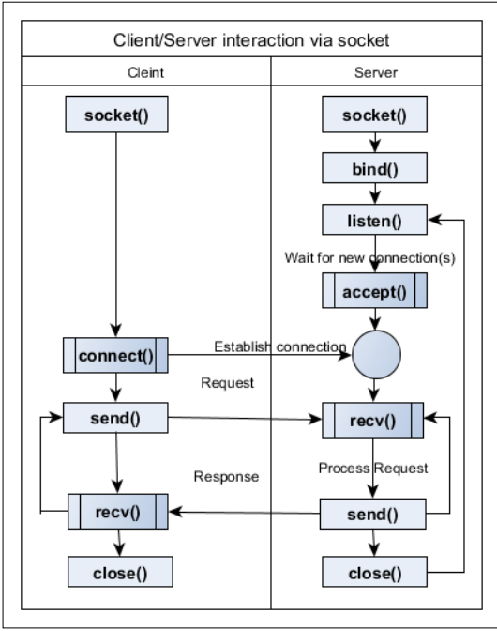
Itertools:(https://www.blog.pythonlibrary.org/2016/04/20/python-201-an-intro-to-itertools/)
Infinite iterators:

count(start=0, step=1)

cycle(iterable)

OOPS:
Motivation for this:(http://inventwithpython.com/blog/2014/12/02/why-is-object-oriented-programming-useful-with-an-role-playing-game-example/)
- Classes are like modules in our python and objects like methods
- Here, only one method is calling with different instances.
class pet:
number_of_legs = 0

def sleep(self):
print "zzz"

def count_legs(self):
print "I have %s legs" % self.number_of_legs

doug = pet()
doug.number_of_legs = 4
doug.count_legs()

nemo = pet()
nemo.number_of_legs = 0
nemo.count_legs()

XML Processing:
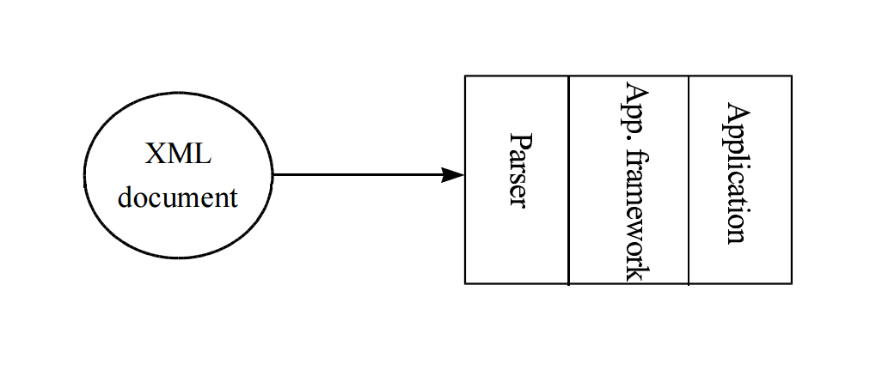

Thread Objects:
def __init__(self, group=None, target=None, name=None, args=(), kwargs=None, *, daemon=None):

GUI Programming:
- Usually root has Frames as children and Frames have widgets or more Frames as children

