AIR QUALITY PREDICTION

ABSTRACT
Air pollution has become a critical environmental concern in India, posing severe health risks to millions of people. This project aims to predict the air quality levels—categorized as Good, Moderate, or Poor using machine learning algorithms applied to historical air pollution data. The dataset, sourced from Kaggle, comprises air quality measurements collected from various Indian cities between 2015 and 2020. Key pollutant indicators such as PM2.5, PM10, NO, NO2, NOx, NH3, CO, SO2, O3, Benzene, and Toluene are used as input features, while the AQI Bucket serves as the target label. The dataset underwent thorough preprocessing including missing value imputation, categorical encoding, and class balancing using SVMSMOTE and undersampling techniques. Six classification models were implemented: Logistic Regression, MLP Classifier, Decision Tree, Random Forest, AdaBoost, and XGBoost. A custom prediction class was developed for real-time input processing and prediction. This system demonstrates how machine learning can effectively assist in environmental monitoring, enabling authorities and citizens to take timely actions to mitigate the impact of poor air quality.

Objective of the Project
To build a predictive model that classifies the air quality of Indian cities into three categories: Good, Moderate, and Poor based on pollutant concentration levels, using various supervised machine learning algorithms.

Motivation
Air pollution has emerged as a major public health crisis in India, leading to respiratory illnesses, reduced life expectancy, and environmental degradation. With increasing urbanization and industrialization, the need for accurate and timely air quality monitoring has become critical. Traditional monitoring methods are often limited in scale and efficiency. This project is motivated by the potential of machine learning to provide intelligent, data-driven predictions of air quality, enabling proactive measures. By leveraging historical air pollution data, this system aims to support environmental agencies and empower the public with real-time, location-specific air quality insights.

Problem Statement
Air pollution poses significant health and environmental challenges, particularly in urban regions of India. Despite the availability of pollution data, there is a lack of intelligent systems that can effectively predict air quality levels in real-time. The existing manual monitoring methods are often slow and limited in scope. This project aims to address this gap by developing a machine learning-based classification model that predicts air quality categories—Good, Moderate, or Poor—based on pollutant concentration data. The goal is to enable timely alerts, support environmental decision-making, and promote public awareness for improved air quality management.

Scope
The scope of this project is to build a robust, scalable, and accurate machine learning-based classification system for predicting air quality levels in Indian cities. The project covers the entire pipeline from data collection and preprocessing to model training, evaluation, and deployment. It utilizes historical air quality data (2015–2020) and classifies air quality into three categories: Good, Moderate, and Poor.
Key areas included within the project scope:
- Data cleaning, transformation, and feature engineering
- Handling class imbalance using oversampling and undersampling techniques
- Implementing and comparing multiple machine learning models
- Saving trained models and preprocessing artifacts for reuse
- Developing a prediction module for real-time use cases
This system can serve as the foundation for integrating real-time air monitoring, building dashboards, or developing mobile/web applications to inform the public and support environmental policy-making. While the current scope focuses on classification using static historical data, it can be extended to include forecasting, geospatial visualization, and live sensor integration in future developments.
SYSTEM ANALYSIS
Existing System
In existing air quality monitoring systems, traditional approaches primarily rely on static threshold-based classification and physical sensor networks to assess air quality levels. These systems analyze pollutant concentrations like PM2.5, PM10, NO2, CO, and SO2 to categorize air quality into predefined buckets such as Good, Satisfactory, or Poor. Although reliable for raw measurement, these methods do not incorporate predictive intelligence and are often limited to real-time reporting only. Moreover, earlier research utilized basic machine learning algorithms such as Decision Trees or Logistic Regression, often trained on imbalanced datasets without proper handling of minority classes, resulting in poor generalization for underrepresented pollution levels.

Disadvantages of Existing Methods
- Cannot predict future air quality trends or outcomes.
- Lack of intelligent learning and real-time adaptability.
- Poor performance in handling imbalanced class distribution.
- Limited scalability and location coverage due to sensor deployment cost.
- Inadequate use of ensemble and deep learning models for higher accuracy.
- Less focus on model interpretability and deployment for practical use.

Proposed Method
The proposed method introduces a machine learning-based classification system that predicts air quality levels Good, Moderate, or Poor—using historical pollutant concentration data. The model pipeline includes comprehensive preprocessing such as feature cleaning, imputation, one-hot encoding, and class balancing using a combination of SVMSMOTE and RandomUnderSampler. Six different classifiers including Logistic Regression, Decision Tree, Random Forest, MLP, AdaBoost, and XGBoost were implemented and evaluated.

Advantages of Proposed Method
- Provides predictive capability instead of just reactive monitoring.
- Handles imbalanced datasets effectively using advanced sampling techniques.
- Delivers high classification accuracy (up to 94.25%) using ensemble models.
- Enables easy integration into web/mobile applications via deployment-ready modules.
- Supports interpretability and further extension with feature importance tools.
- Scalable to multiple cities and adaptable to real-time sensor data in the future.

Project flow diagram
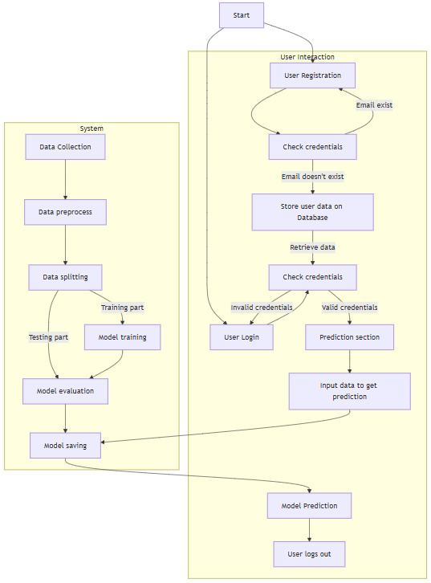
REQUIREMENT ANALYSIS
Hardware Requirements

Processor - I7/Intel Processor
Hard Disk - 160GB
Key Board - Standard Windows Keyboard
Mouse - Two or Three Button Mouse
Monitor - SVGA
RAM - 8GB

Software Requirements:
Operating System : Windows 11
Server side Script : HTML, CSS, Bootstrap & JS
Programming Language : Python
Libraries : Pandas, NumPy, Matplotlib, Seaborn, scikit-learn
IDE/Workbench : PyCharm
Technology : Python 3.6+
Server Deployment : Xampp Server
Database : MySQL

Architecture diagram
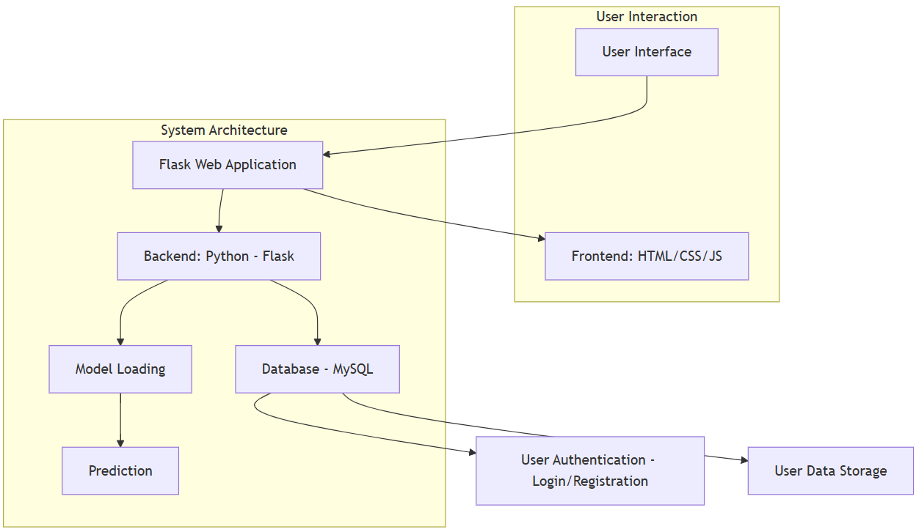

MODULES

User Module

Registration: Users can register on the platform by providing basic credentials such as username, email, and password. This registration creates a secure user account to access the air quality prediction system.

Login: After registration, users can securely log in using their username and password. This enables access to the air quality prediction functionality and personalized session handling.

Input Data: Once logged in, users can input real-time air quality indicators such as PM2.5, PM10, NO, NO2, NOx, NH3, CO, SO2, O3, Benzene, and Toluene. These values are entered through a user-friendly interface and submitted for prediction.

View Results: Upon submitting the data, the system processes the inputs using the trained XGBoost classifier and displays the predicted air quality category as Good, Moderate, or Poor. Although AQI is not used directly for prediction (to prevent data leakage), the system accurately classifies based on pollutant levels.

Logout: Users can securely log out of their session after use, ensuring privacy and security of their input and result history.

2. System Module

Data Collection The system uses the publicly available Air Quality Dataset from Kaggle, which includes data from 2015 to 2020 for major Indian cities. The dataset contains multiple air pollutants along with corresponding AQI levels.

Data Preprocessing: The raw dataset undergoes multiple preprocessing steps:
- Handling missing values using SimpleImputer with the median strategy.
- Dropping irrelevant features such as Date, Xylene, and AQI to avoid information leakage.
- Simplifying AQI_Bucket into three categories: Good, Moderate, Poor.
- One-Hot Encoding for City and Label Encoding for AQI categories.
- Feature scaling and feature engineering such as combining PM2.5 & PM10 and transforming NH3.
  - Data Balancing: To handle class imbalance in AQI categories, a hybrid sampling strategy is used:
- Oversampling minority classes (Good and Poor) using SVM.SMOTE.
- Undersampling the majority class (Moderate) using RandomUnderSampler to ensure balanced learning.
  - Data Splitting: The balanced dataset is split into training and testing sets using an 80:20 ratio with stratified sampling, ensuring the class distribution remains uniform across both sets.
  - Model Building: Six machine learning models were implemented and trained:
- Logistic Regression
- MLP Classifier
- Decision Tree Classifier
- Random Forest Classifier
- AdaBoost Classifier
- XGBoost Classifier (Best performer)
These models were trained using the processed dataset to classify air quality based on input pollutant features.
  - Model Evaluation: Each model was evaluated using:
- Accuracy, Precision, Recall, and F1-score
- Confusion Matrix to visualize the performance of each model on each class
  - Model Prediction for User Input: The deployed system loads the trained XGBoost model and related preprocessing artifacts to handle user inputs dynamically. It preprocesses the inputs in real time and returns a prediction indicating the air quality category as Good, Moderate, or Poor, offering fast and accurate classification for any location.

