STRATEGIC PRODUCT PLAN & ROADMAP
BuildSphere — A Unified Virtual Construction Platform

Table of Contents
1. Executive Summary
2. Market Analysis
3. Product Vision, Mission & Unique Selling Proposition
4. Target Audience & Market Segmentation
5. Competitive Analysis
6. Feature Prioritization
7. Roadmap & Timeline
8. Risk Analysis & Mitigation
9. Success Metrics (KPIs)
10. Conclusion

1. Executive Summary
Virtual construction — the use of digital models, cloud collaboration, and immersive technology to plan, coordinate, and monitor building projects — has moved from a niche BIM add-on to a mainstream requirement across the Architecture, Engineering & Construction (AEC) industry. Government BIM mandates, rising infrastructure investment, and labour-productivity pressure are pushing even mid-market contractors to adopt digital-twin workflows that were once reserved for large enterprises.
This document proposes BuildSphere, a cloud-native virtual construction platform purpose-built for mid-market general contractors, architecture firms, and infrastructure owners in high-growth markets such as India and Southeast Asia. BuildSphere combines BIM model coordination, clash detection, AR/VR site walkthroughs, and AI-assisted progress tracking in a single, accessible product — occupying the "high capability, high usability" white space that incumbents such as Autodesk Construction Cloud and Bentley Systems have left open at the mid-market tier.
The plan below sets out the market opportunity, product vision, target segments, competitive landscape, a prioritized feature set, a 24-month release roadmap, and the key risks and mitigations the team should track as it builds toward a Series A-ready product.

2. Market Analysis

2.1 Market Size & Growth
Independent market research points to strong, sustained growth in construction digitalization:
- The global Building Information Modeling (BIM) software market was estimated at roughly $9.5–10.6 billion in 2025–2026 and is projected to reach approximately $32.5 billion by 2036, a CAGR of about 11.8%.
- A related segment, BIM coordination software specifically, was sized at approximately $2.5 billion in 2024 and is forecast to reach $8.2 billion by 2033 (CAGR ~14.2%), reflecting particularly fast growth in the clash-detection and multi-trade coordination niche BuildSphere targets.
- Broader construction software (scheduling, cost, field management) is a larger addressable envelope, historically estimated near $3 billion by 2026 at roughly 10–11% CAGR, and continuing to expand as owners demand single-platform visibility.
- Asia-Pacific is repeatedly cited as the fastest-growing region, driven by urbanization, government BIM mandates, and large public infrastructure pipelines — directly relevant to a India/APAC-first go-to-market.
Even allowing for the wide variance across research providers (a normal feature of emerging-technology market sizing), the directional signal is consistent: double-digit growth, accelerating regulatory push for BIM adoption, and a shift toward cloud and AI-enabled tools.

2.2 Key Market Drivers
- Government BIM mandates and smart-city programs requiring digital project delivery on public infrastructure.
- Persistent skilled-labour shortages, pushing contractors toward tools that reduce rework and improve field productivity.
- Rising cost of design/construction errors, making clash detection and coordination a hard ROI case.
- Cloud and mobile maturity, allowing field crews (not just design offices) to access 3D models.
- Growing willingness among mid-market firms — historically underserved by enterprise BIM suites — to adopt SaaS tools once IT-department gatekeeping barriers are removed.

2.3 Market Challenges
- Fragmented technology stacks and low digital maturity among smaller subcontractors, slowing adoption at the field level.
- High switching costs and entrenched workflows around incumbent tools (Autodesk, Trimble, Bentley) in enterprise accounts.
- Price sensitivity and thin margins in the mid-market segment, requiring a lean, usage-based pricing model.

3. Product Vision, Mission & Unique Selling Proposition

3.1 Vision Statement
To make virtual construction accessible to every contractor — not just the largest firms — by combining enterprise-grade BIM coordination with the simplicity of a modern SaaS product.

3.2 Mission
BuildSphere gives mid-market general contractors, architects, and infrastructure owners a single, easy-to-adopt platform to coordinate building models, detect clashes before they become change orders, walk a digital twin of the site in AR/VR, and track real-world progress against plan — without the cost, complexity, or multi-month rollout of enterprise BIM suites.

3.3 Unique Selling Proposition (USP)
"Enterprise-grade virtual construction, mid-market simple." BuildSphere is the only platform positioned in the high-capability / high-accessibility quadrant of the market (see Competitive Analysis): it matches incumbents on BIM coordination depth while onboarding a project team in days rather than months, at a price point and support model designed for firms running 5–50 concurrent projects rather than 500.

3.4 Core Differentiators
- Unified workspace: model viewing, clash detection, RFIs, AR/VR walkthroughs, and progress tracking in one product, removing the need to stitch together 3–4 point solutions.
- AI-assisted progress tracking: automatic comparison of site photos/drone footage against the BIM schedule to flag delays early.
- Fast onboarding: guided setup and pre-built templates targeting a go-live in under two weeks, versus the months typical of enterprise BIM rollouts.
- Transparent, usage-based pricing that scales with active projects rather than named-seat enterprise licensing.

4. Target Audience & Market Segmentation

4.1 Primary Segments
Segment | Profile | Primary Need | Buying Trigger
Mid-market General Contractors | 20–500 employees; 5–50 concurrent projects; limited in-house BIM staff | Reduce rework and change orders through better multi-trade coordination | A costly clash or rework incident on a recent project
Independent Architecture & Engineering Firms | 10–150 employees; design-focused; need client-facing visualization | Fast, shareable 3D walkthroughs for design review and client sign-off | Client requests AR/VR or digital-twin deliverables
Infrastructure & Real-Estate Owners/Developers | In-house project management office overseeing multiple contractors | Cross-contractor visibility into schedule and progress | Portfolio-level reporting mandate from leadership or regulator

4.2 Primary Buyer Personas
- Priya, VP of Operations at a 150-person GC — evaluates tools on ROI (rework hours saved) and ease of field-crew adoption; skeptical of long implementation projects.
- Arjun, Project Architect at a 40-person design studio — wants faster client sign-off cycles using immersive walkthroughs; influences purchase but rarely holds the budget.
- Meera, PMO Lead at a developer overseeing 12 active sites — needs a single dashboard across multiple contractors' progress and risk status.

5. Competitive Analysis

5.1 Landscape Overview
The virtual construction / construction-management software market is dominated by a small number of large, capability-rich incumbents, alongside a longer tail of lighter, field-productivity point solutions:
Competitor | Strength | Gap for Mid-Market
Autodesk Construction Cloud (Forma) | Deepest BIM ecosystem; industry-standard design authoring integration | Complex, enterprise-priced, long implementation cycles
Procore | Strong end-to-end project management; large user base; good reviews | Moderate BIM/clash-detection depth; pricing scales for larger firms
Trimble (Unity Construct / Viewpoint) | Strong field and ERP integration; established in infrastructure | Fragmented product suite; steeper learning curve
Bentley Systems | Best-in-class for large infrastructure/civil projects | Overbuilt and costly for typical mid-market buildings work
Buildertrend / Fieldwire | Simple, affordable, fast to adopt | Limited true BIM coordination and clash-detection depth

5.2 Competitive Positioning Map
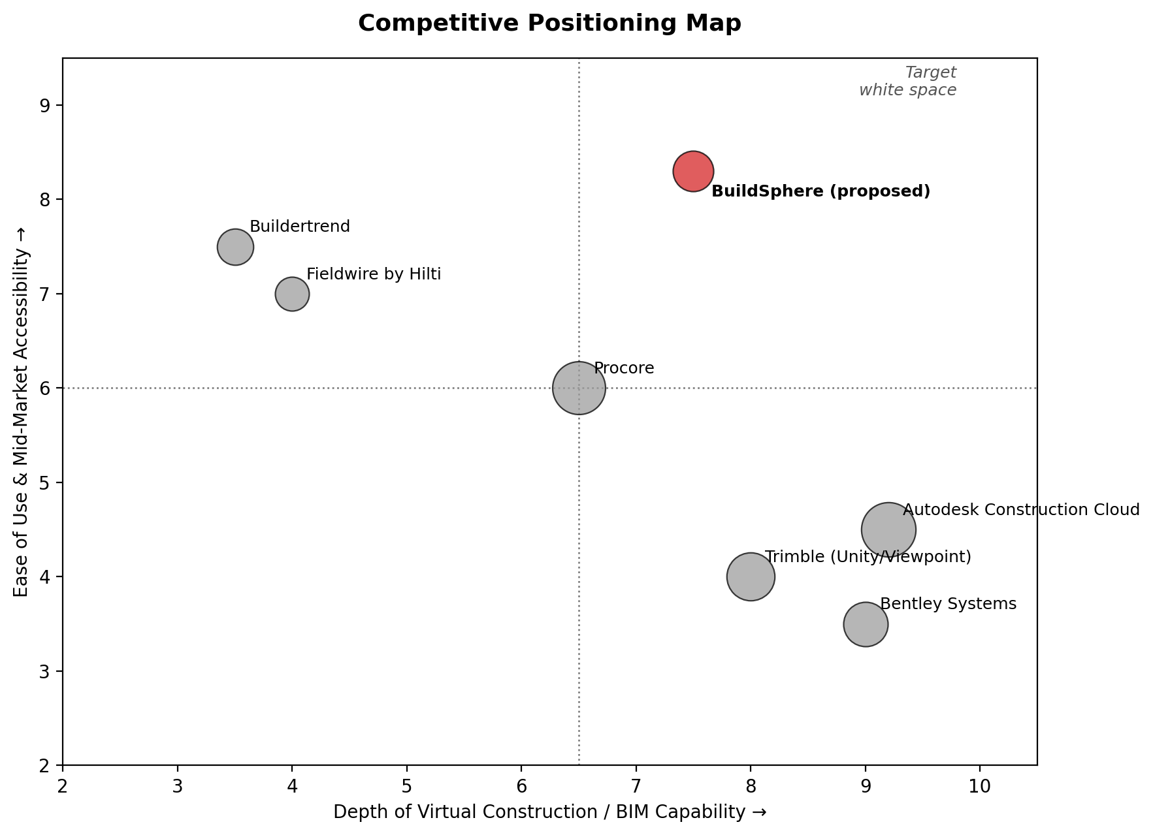
Figure 1 — BuildSphere targets the underserved high-capability / high-accessibility quadrant.

5.3 Strategic Implication
No major incumbent currently combines deep BIM/clash-detection capability with mid-market ease of adoption. BuildSphere's roadmap and pricing are deliberately designed to defend this quadrant before larger players extend downmarket or smaller tools attempt to add coordination depth.

6. Feature Prioritization
Features are prioritized using the MoSCoW framework (Must have / Should have / Could have / Won't have this cycle), balancing time-to-value for the first paying cohort against long-term differentiation.
Priority | Feature | Rationale
Must have | 3D model viewer (IFC/RVT upload & rendering) | Table-stakes; no coordination is possible without a shared model view
Must have | Clash detection engine (v1, rule-based) | Core ROI driver; directly reduces rework and change orders
Must have | Cloud collaboration, markup & RFIs | Enables the multi-firm coordination workflow the product is built for
Should have | AR/VR site walkthrough module | High differentiation for client sign-off and site briefings
Should have | Mobile field app (iOS/Android) | Extends adoption from the design office to the job site
Should have | AI-assisted progress tracking (photo/drone) | Strong differentiator; depends on Must-have data foundation first
Could have | ERP & scheduling integrations (SAP, MS Project) | Important for larger accounts but not required for early adopters
Could have | Digital twin / facility handover module | High long-term value; addresses a later stage of the building lifecycle
Won't have (this cycle) | Native cost-estimation / takeoff engine | Well served by existing point tools; integrate rather than build first

7. Roadmap & Timeline
The roadmap is organized into four phases across a 24-month horizon, moving from a design-partner pilot to MVP launch, capability scaling, and finally platform expansion into adjacent workflows and geographies.
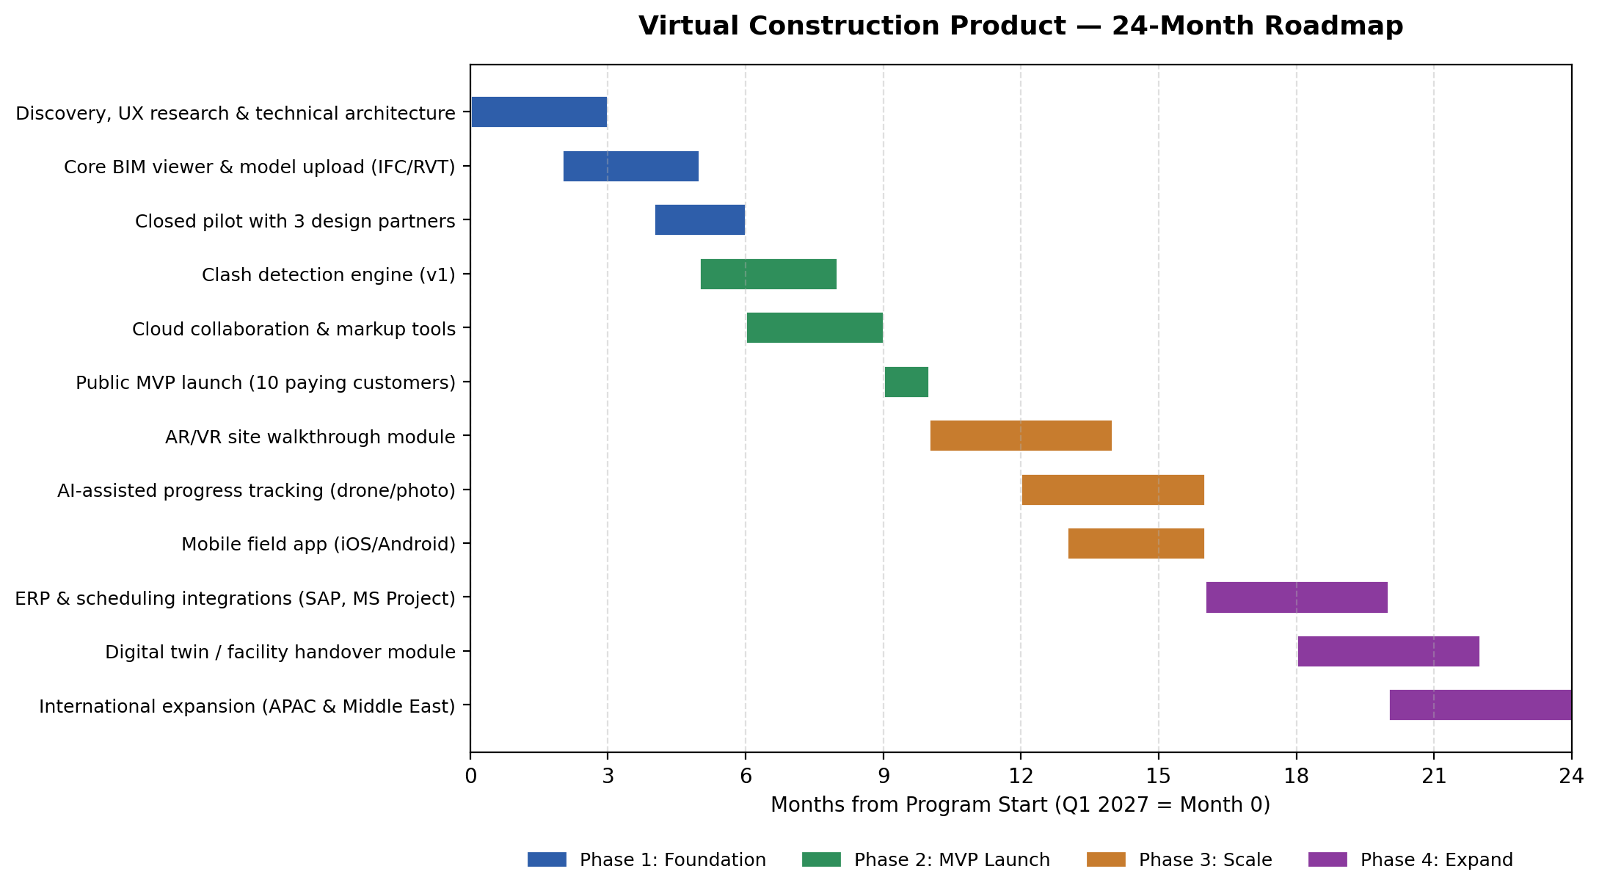
Figure 2 — 24-month product roadmap by phase.
Phase | Timeframe | Milestone
Phase 1 — Foundation | Q1–Q2 2027 | Core BIM viewer live; pilot running with 3 design partners
Phase 2 — MVP Launch | Q3–Q4 2027 | Clash detection + collaboration tools shipped; 10 paying customers
Phase 3 — Scale | H1 2028 | AR/VR walkthroughs, AI progress tracking, and mobile app in production
Phase 4 — Expand | H2 2028 | ERP integrations, digital-twin handover module, APAC/Middle East expansion

8. Risk Analysis & Mitigation
Risk | Likelihood | Impact | Mitigation
Slow adoption due to low digital maturity among subcontractors | High | High | Invest in guided onboarding, templates, and a simplified mobile-first field experience
Incumbents (Autodesk, Trimble) extend downmarket with simplified tiers | Medium | High | Move quickly to build mid-market brand loyalty and lock in integration partnerships before incumbents react
BIM data interoperability issues (IFC/RVT parsing edge cases) | Medium | Medium | Dedicate engineering capacity to a robust, well-tested import pipeline; support the most common formats first
Extended sales cycles in enterprise-adjacent accounts | Medium | Medium | Prioritize self-serve and design-partner-led growth over enterprise sales in Phase 1–2
Cloud infrastructure cost scaling with large 3D model files | Low | Medium | Use tiered storage, model compression, and usage-based pricing to align cost with revenue
Key talent (BIM/3D engineering) is scarce and competitive to hire | Medium | High | Build relationships with technical universities; consider a distributed hiring strategy

9. Success Metrics (KPIs)
- Adoption: number of active projects on the platform per quarter
- Retention: net revenue retention among mid-market accounts (target >110%)
- Product impact: average reduction in reported clash-related rework hours per project
- Time-to-value: median days from signup to first completed clash-detection report
- Growth: paying customer count and pipeline conversion rate by segment

10. Conclusion
BuildSphere addresses a clearly growing, double-digit-CAGR market with a differentiated position: enterprise-grade virtual construction capability delivered with mid-market accessibility. The phased 24-month roadmap sequences a design-partner pilot, an ROI-focused MVP, and subsequent scaling into AR/VR, AI, and integration capabilities — while the risk plan above flags the adoption, competitive, and technical risks the team should monitor most closely as the product moves from pilot to scale.

