EXTENDED ACCESS CONTROL LIST (ACL)
CONFIGURATION PROJECT
Technical Documentation
Project Title | Extended ACL Configuration on Cisco Router
Simulator | Cisco Packet Tracer
Router Platform | Cisco 1841 (IOS)
ACL Type | Extended Named/Numbered ACL
Date | 11 June 2026
Status | Completed & Verified

1. Project Overview
This project demonstrates the configuration of Extended Access Control Lists (ACLs) on a Cisco 1841 router using Cisco Packet Tracer. The objective is to enforce granular traffic policies between two branch offices and a central headquarters server network, ensuring that each branch can only access authorized services on specific servers.

1.1 Objectives
- Configure routing across all routers to establish end-to-end connectivity.
- Configure a numbered Extended ACL (ACL 101) on the Headquarters Router (Router1).
- Permit Branch 1 (192.168.1.0/24) to access Server-1HTTPS (192.168.2.1) using HTTPS (port 443) only.
- Permit Branch 2 (192.168.3.0/24) to access Server-2 HTTP (192.168.2.2) using HTTP (port 80) only.
- Permit Branch 2 access to the DNS Server (192.168.2.3).
- Deny all other unauthorized traffic to the protected server network.
- Apply the ACL on the inbound direction of Router1 interfaces (Fa0/0 and Se0/0/0).
- Verify the configuration using web browser and ping tests.

2. Network Topology
The network consists of three sites: Branch 1, Headquarters (HQ), and Branch 2, interconnected via WAN links and a central headquarters router.

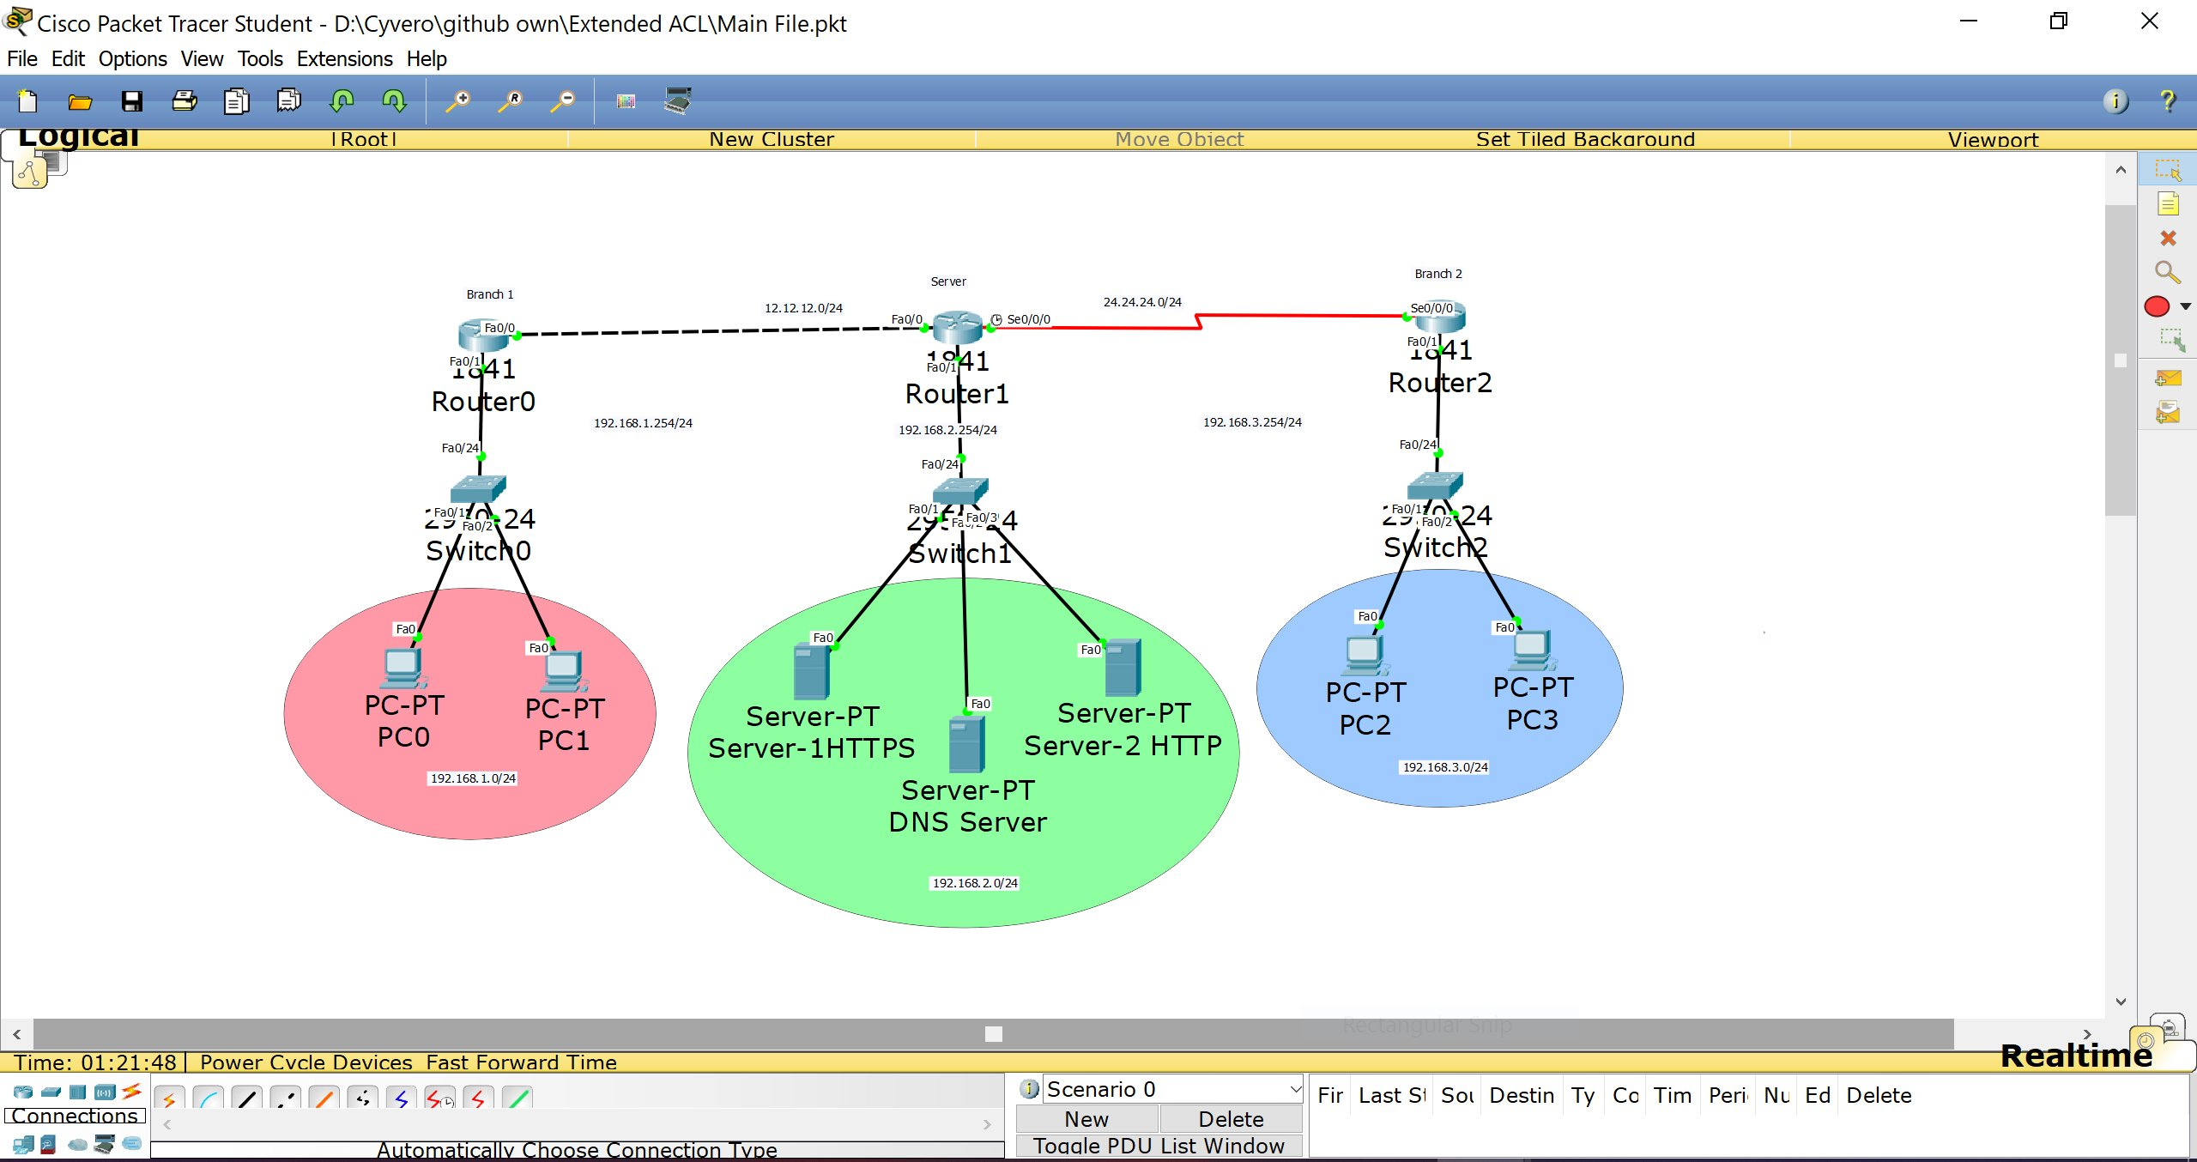
Figure 1: Network Topology in Cisco Packet Tracer

2.1 Network Addressing
Network | Subnet | Device(s) | Gateway
Branch 1 | 192.168.1.0/24 | PC0, PC1 | 192.168.1.254
HQ Server Farm | 192.168.2.0/24 | Server-1HTTPS, Server-2 HTTP, DNS Server | 192.168.2.254
Branch 2 | 192.168.3.0/24 | PC2, PC3 | 192.168.3.254
WAN Branch1-HQ | 12.12.12.0/24 | Router0 Fa0/0, Router1 Fa0/0 | —
WAN HQ-Branch2 | 24.24.24.0/24 | Router1 Se0/0/0, Router2 Se0/0/0 | —

2.2 Server Configuration
Server Name | IP Address | Enabled Service | Port
Server-1HTTPS | 192.168.2.1 | HTTPS only | 443
Server-2 HTTP | 192.168.2.2 | HTTP only | 80
DNS Server | 192.168.2.3 | DNS | 53

3. ACL Policy Design
The Extended ACL 101 is configured on Router1 (Headquarters Router) and applied inbound on both interfaces facing Branch 1 (Fa0/0) and Branch 2 (Se0/0/0). Extended ACLs are placed as close to the source as possible to reduce unnecessary traffic traversal; however, in this design, the single HQ router is the most appropriate enforcement point.

3.1 Access Policy Matrix
Source | Destination | Server | Protocol/Port | Action
Branch 1  192.168.1.0/24 | 192.168.2.1 | Server-1HTTPS | TCP / 443 | PERMIT
Branch 1  192.168.1.0/24 | 192.168.2.2 | Server-2 HTTP | TCP / 80 | DENY
Branch 1  192.168.1.0/24 | 192.168.2.3 | DNS Server | IP (all) | DENY
Branch 1  192.168.1.0/24 | 192.168.2.2 | Server-2 HTTP | IP (all) | DENY
Branch 2  192.168.3.0/24 | 192.168.2.2 | Server-2 HTTP | TCP / 80 | PERMIT
Branch 2  192.168.3.0/24 | 192.168.2.2 | Server-2 HTTP | TCP / 443 | DENY
Branch 2  192.168.3.0/24 | 192.168.2.3 | DNS Server | IP (all) | PERMIT
Branch 2  192.168.3.0/24 | 192.168.2.1 | Server-1HTTPS | IP (all) | DENY
Any | Any | — | IP (all) | PERMIT

4. ACL Configuration Commands
The following commands were entered on Router1 via the IOS Command Line Interface (CLI) in Cisco Packet Tracer.

4.1 Entering Configuration Mode
Router> en
Router# config t

4.2 Extended ACL 101 Rules
The ACL rules are entered in order. Cisco IOS processes ACL entries sequentially and stops at the first match.

Branch 1 Rules (Source: 192.168.1.0/24):
access-list 101 permit tcp 192.168.1.0 0.0.0.255 host 192.168.2.1 eq 443
access-list 101 deny tcp 192.168.1.0 0.0.0.255 host 192.168.2.2 eq 80
access-list 101 deny ip 192.168.1.0 0.0.0.255 host 192.168.2.3
access-list 101 deny ip 192.168.1.0 0.0.0.255 host 192.168.2.2

Branch 2 Rules (Source: 192.168.3.0/24):
access-list 101 permit tcp 192.168.3.0 0.0.0.255 host 192.168.2.2 eq 80
access-list 101 deny tcp 192.168.3.0 0.0.0.255 host 192.168.2.2 eq 443
access-list 101 permit ip 192.168.3.0 0.0.0.255 host 192.168.2.3
access-list 101 deny ip 192.168.3.0 0.0.0.255 host 192.168.2.1

Default Permit (allow all other traffic):
access-list 101 permit ip any any

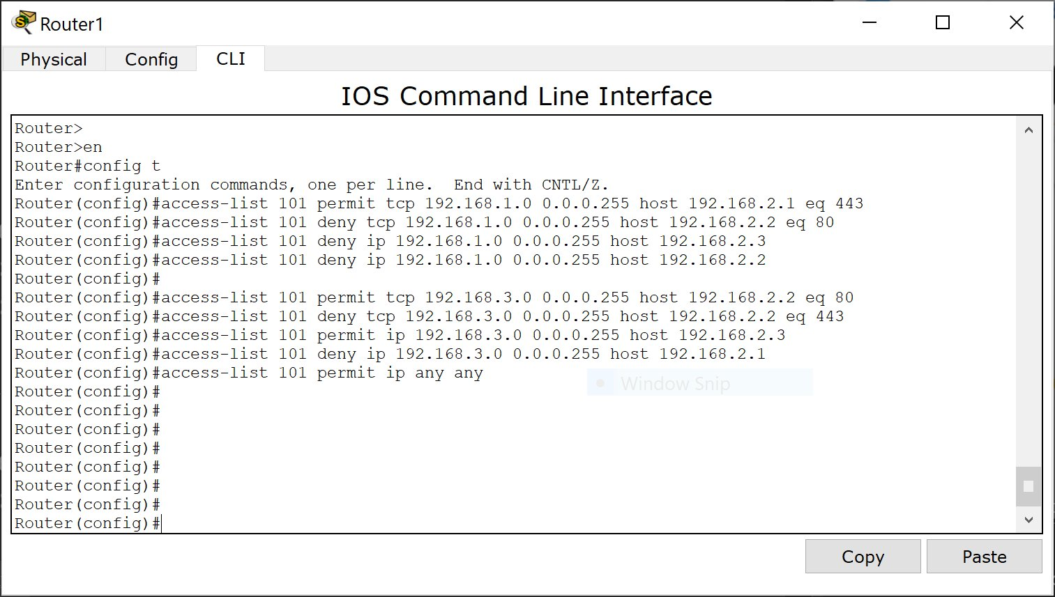
Figure 2: ACL 101 Configuration Commands on Router1 CLI

4.3 Applying the ACL to Interfaces
ACL 101 is applied inbound on both interfaces of Router1 that receive traffic from Branch networks:

interface fa0/0
ip access-group 101 in
exit
interface se0/0/0
ip access-group 101 in
exit
exit
wr

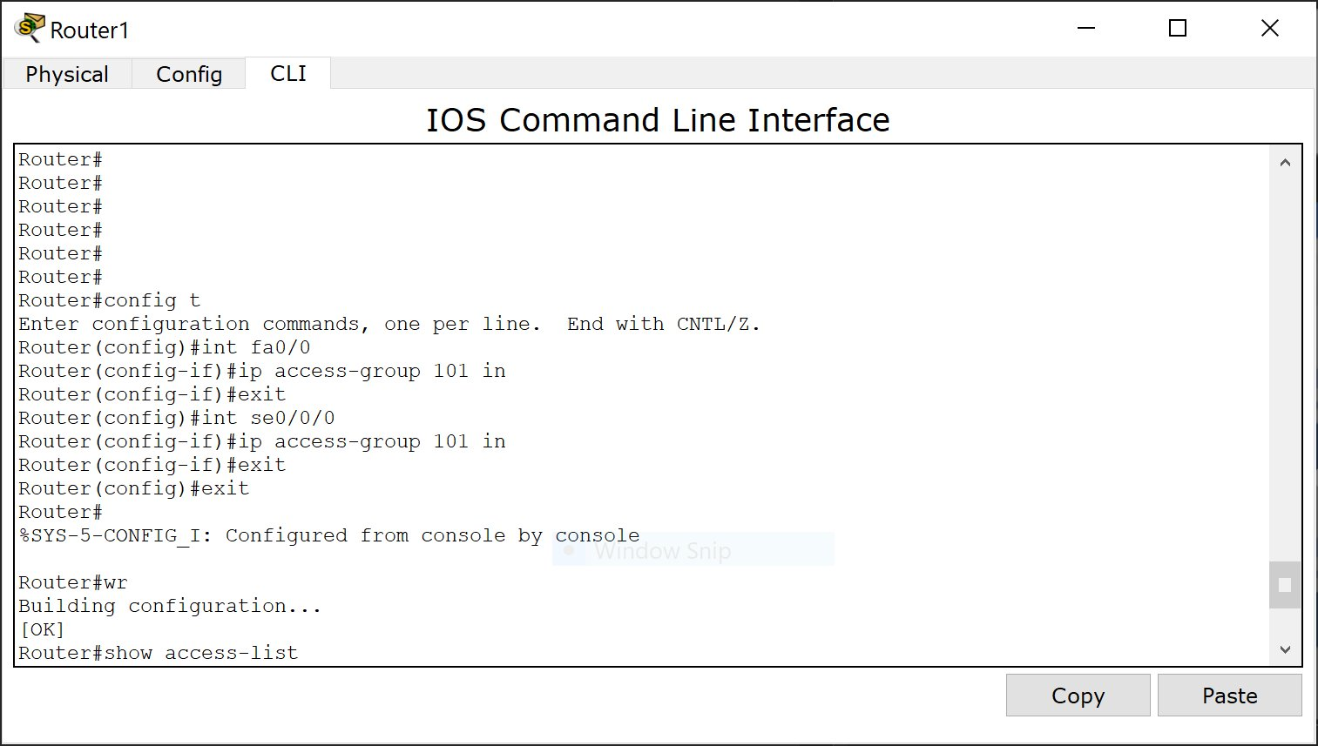
Figure 3: Applying ACL 101 to Interfaces Fa0/0 and Se0/0/0

5. Verification
After applying the ACL, the configuration was verified using the show access-list command and by performing web browser tests from the branch PCs.

5.1 Show Access-List Output

Figure 4: Output of 'show access-list' on Router1

5.2 Branch 1 Connectivity Tests (PC0 & PC1)
PC0 and PC1 belong to Branch 1 (192.168.1.0/24). According to the ACL policy, they should be able to access Server-1HTTPS via HTTPS (port 443) but NOT via HTTP, and must not reach Server-2 HTTP or the DNS Server.

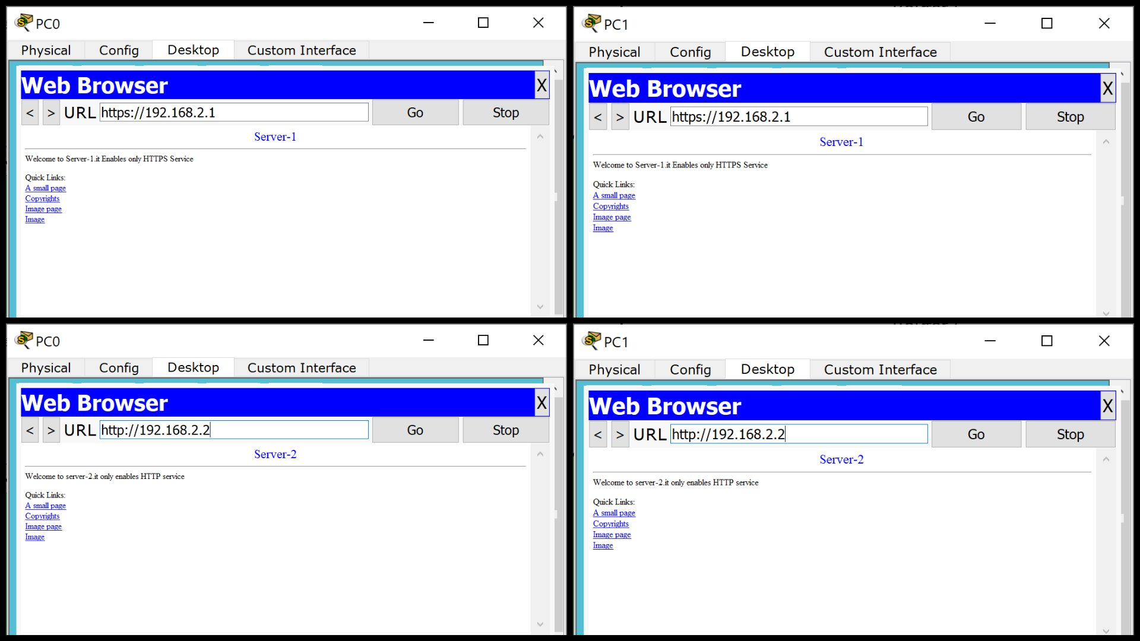
Figure 5: Branch 1 PCs (PC0 & PC1) successfully accessing Server-1 via HTTPS and Server-2 via HTTP (before ACL enforcement shown for comparison)

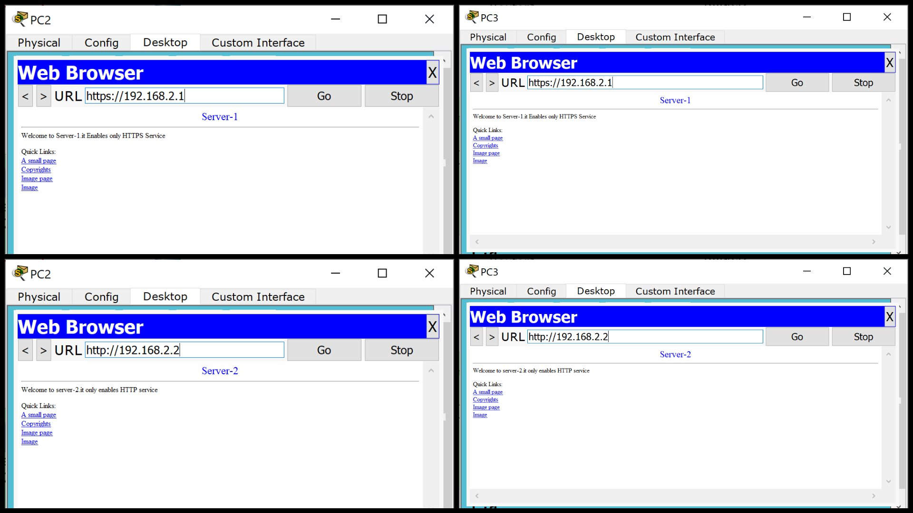
Figure 6: PC0 — HTTPS access to Server-1 (192.168.2.1) succeeds; hostname resolution tested

5.3 Branch 2 Connectivity Tests (PC2 & PC3)
PC2 and PC3 belong to Branch 2 (192.168.3.0/24). According to the ACL policy, they should access Server-2 HTTP via HTTP (port 80) and the DNS Server, but NOT access Server-1HTTPS or Server-2 via HTTPS.

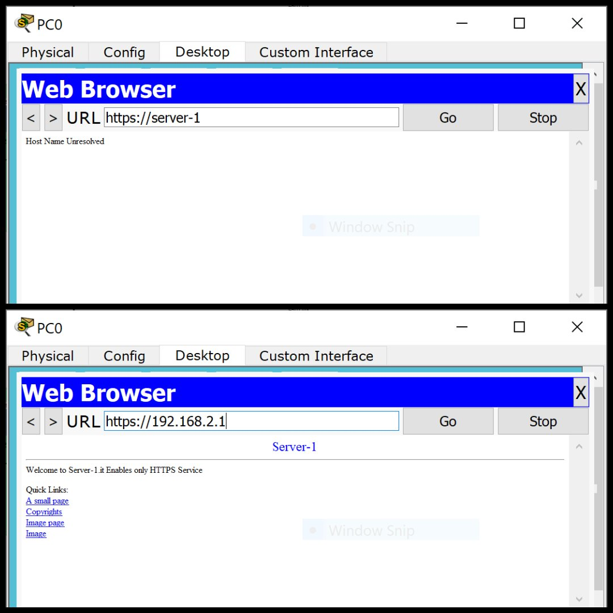
Figure 7: PC2 — HTTP access to Server-2 (http://server-2) succeeds; HTTPS to Server-2 times out as expected

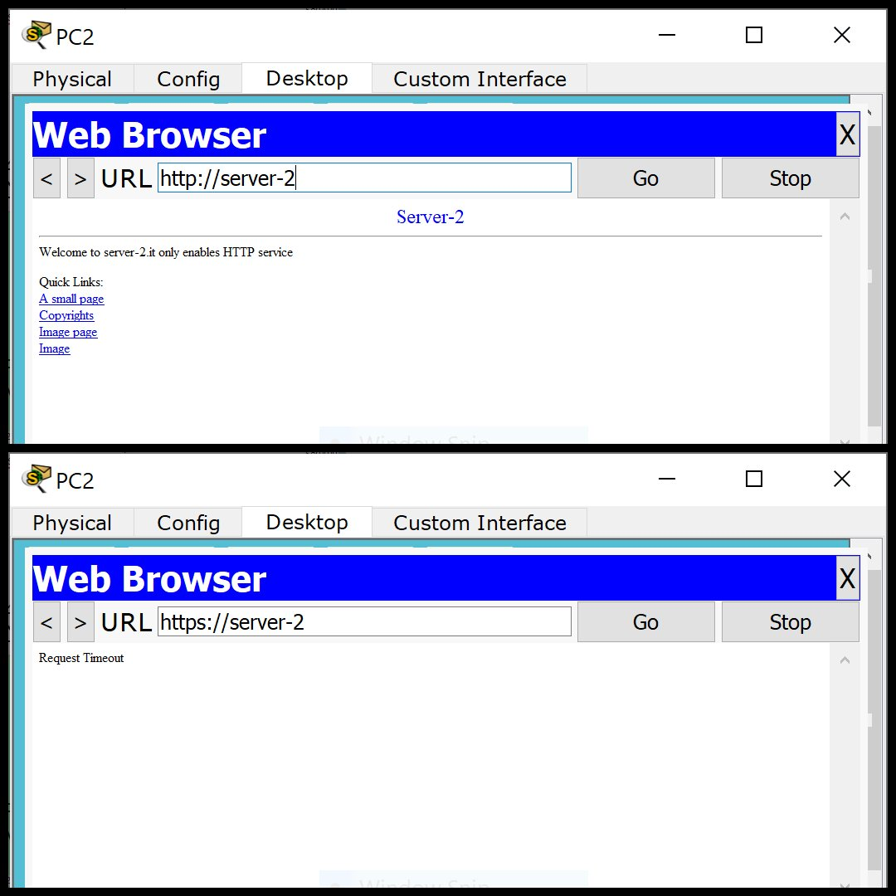
Figure 8: PC2 & PC3 — HTTPS access to Server-1 (192.168.2.1) succeeds; HTTP access to Server-2 (192.168.2.2) also permitted for Branch 2

5.4 Verification Summary
Source PC | Destination | Service | Expected | Result
PC0 / PC1 | https://192.168.2.1 | HTTPS (443) | PERMIT | ✔ Success
PC0 / PC1 | http://192.168.2.2 | HTTP (80) | DENY | ✘ Blocked
PC0 / PC1 | 192.168.2.3 (DNS) | IP | DENY | ✘ Blocked
PC2 / PC3 | http://192.168.2.2 | HTTP (80) | PERMIT | ✔ Success
PC2 / PC3 | https://192.168.2.2 | HTTPS (443) | DENY | ✘ Blocked
PC2 / PC3 | 192.168.2.3 (DNS) | IP | PERMIT | ✔ Success
PC2 / PC3 | https://192.168.2.1 | HTTPS (443) | DENY | ✘ Blocked

6. Key Concepts & Notes

6.1 Why Extended ACLs?
Extended ACLs (numbered 100-199) filter traffic based on source IP, destination IP, protocol, and port number — providing far more granular control than standard ACLs (1-99), which filter only on source IP.

6.2 Wildcard Masks
Wildcard masks are the inverse of subnet masks. A wildcard of 0.0.0.255 matches any host in the /24 subnet. For example, 192.168.1.0 0.0.0.255 matches all addresses from 192.168.1.0 to 192.168.1.255.

6.3 ACL Rule Order
Cisco IOS processes ACL entries from top to bottom and stops at the first match. Specific rules must be placed before general rules. An implicit deny all exists at the end of every ACL; the explicit permit ip any any was added to allow inter-branch and other legitimate traffic.

6.4 ACL Placement
Extended ACLs should be placed as close to the traffic source as possible. In this topology, Router1 is the central hub, so the ACL was applied inbound on both branch-facing interfaces (Fa0/0 for Branch 1 and Se0/0/0 for Branch 2).

7. Conclusion
The Extended ACL project was successfully completed. ACL 101 was configured on Router1 to enforce selective access between Branch 1, Branch 2, and the HQ server farm. The policy ensures:

- Branch 1 users can only reach Server-1HTTPS via HTTPS (port 443).
- Branch 2 users can only reach Server-2 HTTP via HTTP (port 80) and access the DNS Server.
- All unauthorized access attempts are blocked by the ACL.
- All other network traffic (e.g., between branches or to other networks) is permitted by the final permit ip any any rule.

The configuration was verified using both CLI commands (show access-list) and web browser tests from each branch PC, confirming that all ACL rules function as designed.

