Static Routing in Cisco Packet Tracer
Network Configuration Documentation
A step-by-step walkthrough of a three-router static routing topology

1. Introduction
This document describes the design, configuration, and verification of a static routing setup built in Cisco Packet Tracer. Static routing is a method of manually configuring IP routes on routers, giving the network administrator full control over the paths that packets take through the network.
Static routes are ideal for small, predictable networks where routing tables do not change frequently, and they require no routing-protocol overhead.

1.1 Objectives
- Build a three-site network with three routers, three switches, and six end devices.
- Assign IP addresses to all interfaces using three distinct /24 LAN subnets and two /24 WAN subnets.
- Configure static routes on each router so that all subnets can communicate.
- Verify end-to-end connectivity by browsing from PC0 to a web server in a remote subnet.

2. Network Topology
The logical topology consists of three routers connected in a linear chain. Each router services one LAN segment through a dedicated switch and a pair of end devices. Router0 and Router1 communicate over the 12.12.12.0/24 subnet, while Router1 and Router2 communicate over the 24.24.24.0/24 subnet.
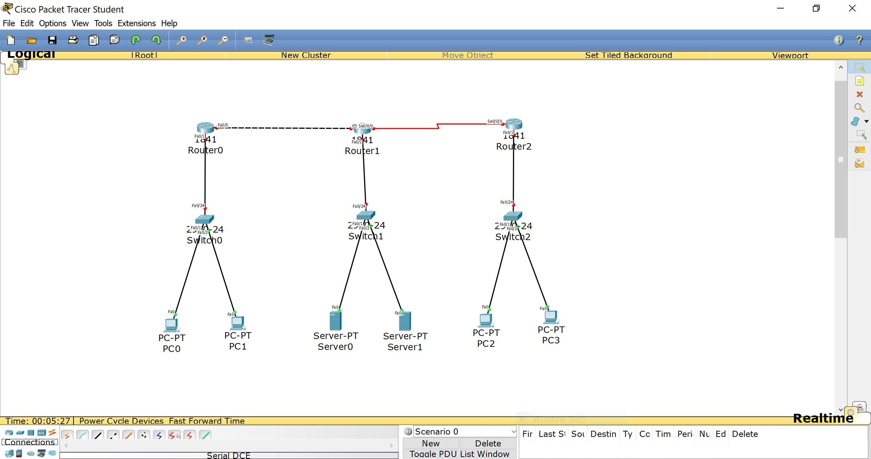
Figure 1 – Initial logical topology in Cisco Packet Tracer (before IP addressing)
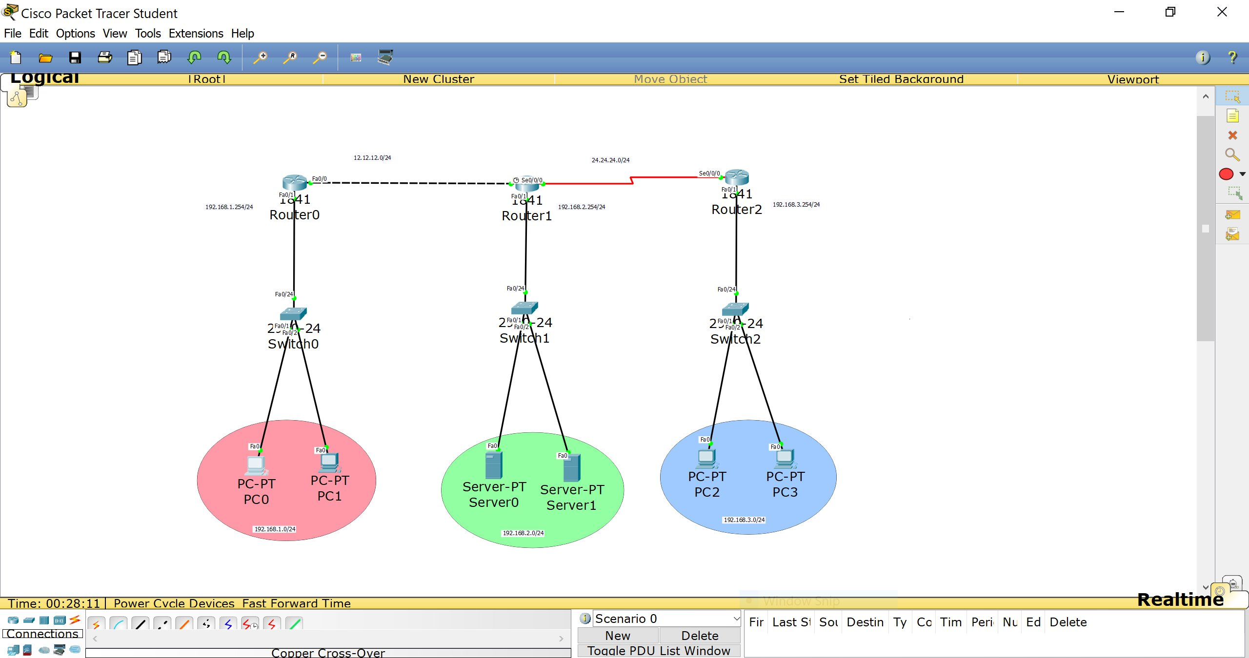
Figure 2 – Topology after IP addressing; colour-coded LAN segments are visible

2.1 Device Inventory
Device | Type | Connected To | Role
Router0 | Cisco 1841 | Switch0, Router1 (Fa0/0) | Site A gateway
Router1 | Cisco 1841 | Router0, Router2, Switch1 | Transit / Site B
Router2 | Cisco 1841 | Router1 (Se0/0/0), Switch2 | Site C gateway
Switch0 | 2960-24TT | Router0, PC0, PC1 | Site A L2 switch
Switch1 | 2960-24TT | Router1, Server0, Server1 | Site B L2 switch
Switch2 | 2960-24TT | Router2, PC2, PC3 | Site C L2 switch
PC0, PC1 | PC-PT | Switch0 | Site A clients
Server0, Server1 | Server-PT | Switch1 | Site B servers
PC2, PC3 | PC-PT | Switch2 | Site C clients

3. IP Address Plan
The following address scheme was used. All subnets use a /24 prefix (255.255.255.0).
Network | Subnet | Router Interface | Purpose
Site A LAN | 192.168.1.0/24 | Router0 Fa0/1 – .254 | PC0, PC1
Site B LAN | 192.168.2.0/24 | Router1 Fa0/1 – .254 | Server0, Server1
Site C LAN | 192.168.3.0/24 | Router2 Fa0/1 – .254 | PC2, PC3
WAN R0–R1 | 12.12.12.0/24 | R0 Fa0/0 / R1 Se0/0/0 | Inter-router link
WAN R1–R2 | 24.24.24.0/24 | R1 Se0/0/0 / R2 Se0/0/0 | Inter-router link

4. Router Configuration

4.1 Router0
Router0 is directly connected to the 192.168.1.0/24 LAN and the 12.12.12.0/24 WAN. Static routes were added for all remote subnets pointing to Router1 (12.12.12.2).
Router0(config)# ip route 192.168.2.0 255.255.255.0 12.12.12.2
Router0(config)# ip route 192.168.3.0 255.255.255.0 12.12.12.2
Router0(config)# ip route 24.24.24.0 255.255.255.0 12.12.12.2

4.2 Router1
Router1 is the central transit router. It connects to both WAN subnets and the 192.168.2.0/24 LAN. It needs routes for both the left site (via Router0 at 12.12.12.1) and the right site (via Router2 at 24.24.24.2).
Router1(config)# ip route 192.168.1.0 255.255.255.0 12.12.12.1
Router1(config)# ip route 192.168.3.0 255.255.255.0 24.24.24.2

4.3 Router2
Router2 is directly connected to the 192.168.3.0/24 LAN and the 24.24.24.0/24 WAN. All traffic for remote networks is forwarded to Router1 (24.24.24.1).
Router2(config)# ip route 192.168.1.0 255.255.255.0 24.24.24.1
Router2(config)# ip route 192.168.2.0 255.255.255.0 24.24.24.1
Router2(config)# ip route 12.12.12.0 255.255.255.0 24.24.24.1

5. Verification

5.1 Routing Table – Before Static Routes
The output of show ip route on Router0 initially showed only the two directly connected networks (C entries). No routes existed for the remote subnets, confirming that manual static routes were still required.
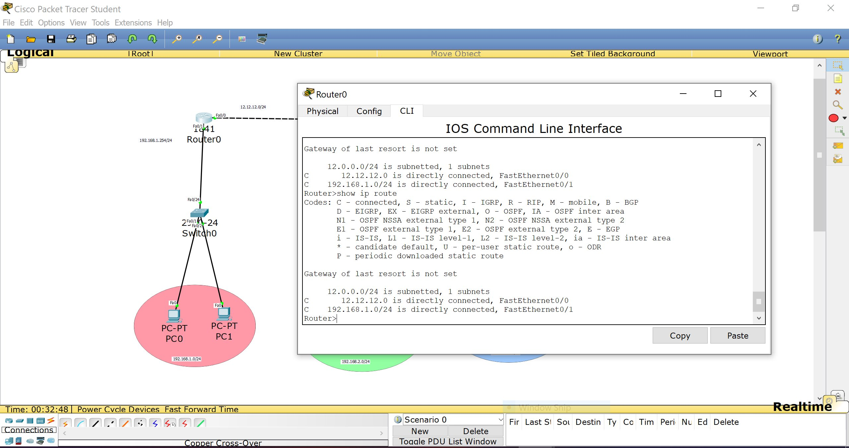
Figure 3 – Router0 routing table before static routes: only directly connected networks

5.2 Routing Table – After Static Routes
After entering the static route commands and saving the configuration, the routing table on Router0 shows five entries: two connected (C) and three static (S). The three static entries point all remote networks to the next-hop address 12.12.12.2 (Router1).
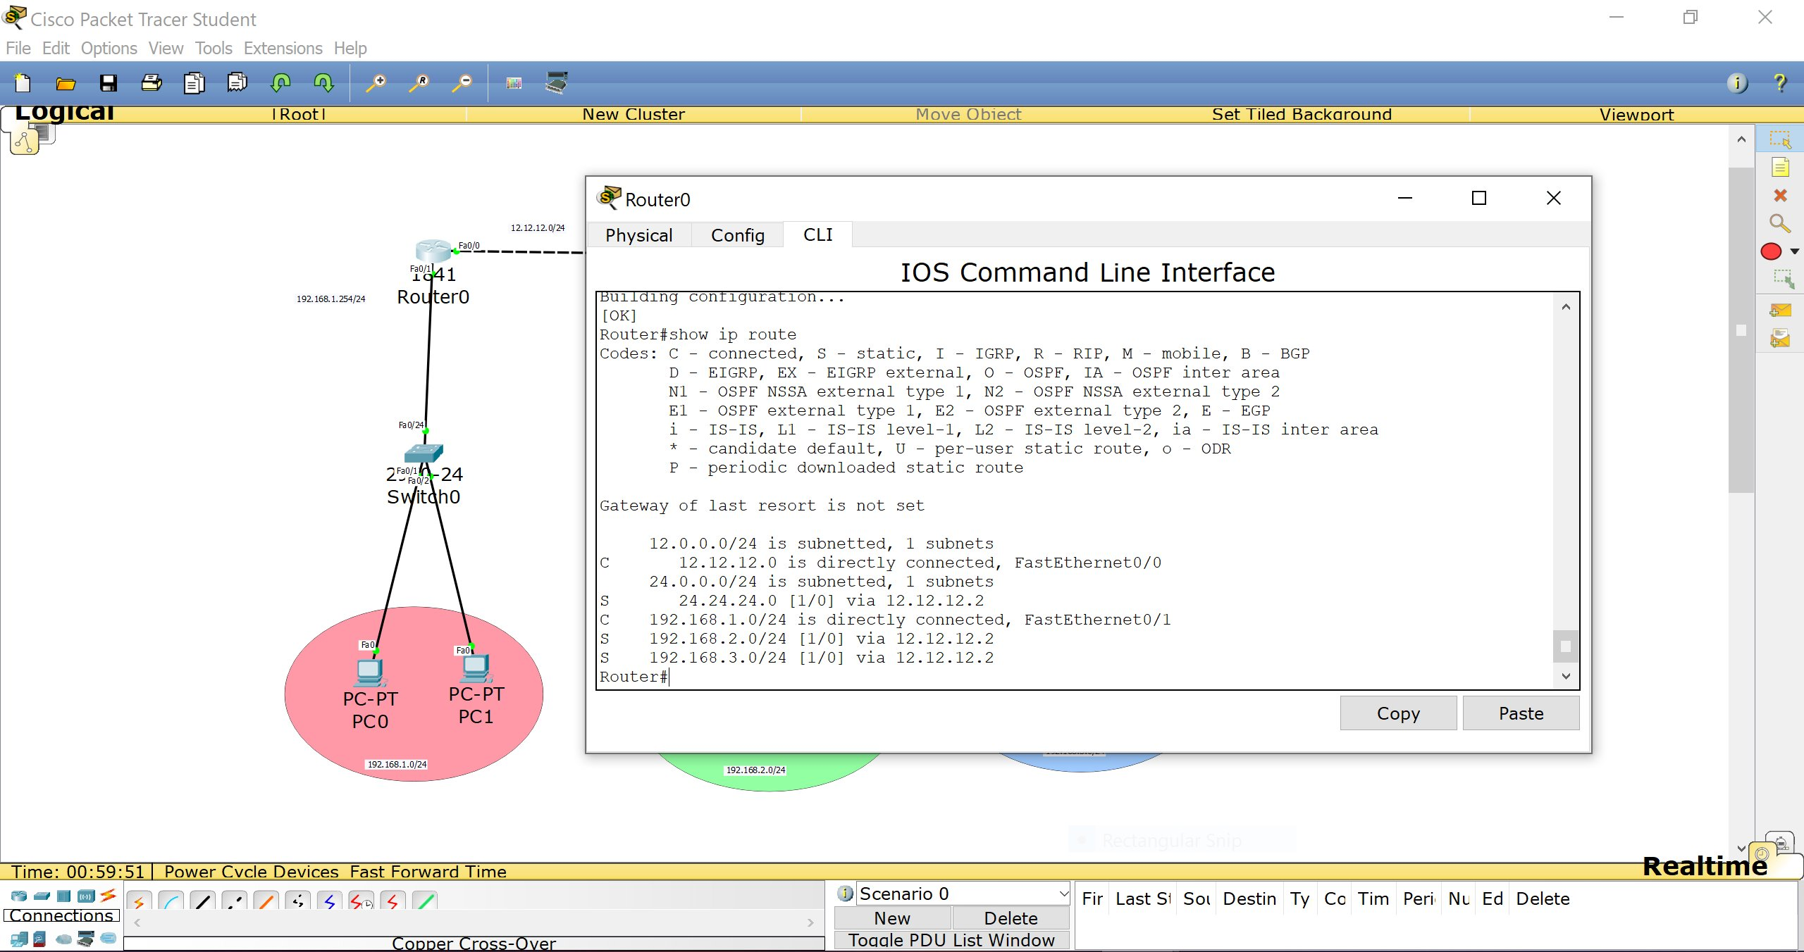
Figure 4 – Router0 routing table after static routes: S entries confirm correct configuration

Key entries visible in Figure 4:
- C 12.12.12.0 – directly connected via FastEthernet0/0 (WAN link to Router1)
- S 24.24.24.0 [1/0] via 12.12.12.2 – static route to the far WAN subnet
- C 192.168.1.0/24 – directly connected via FastEthernet0/1 (local LAN)
- S 192.168.2.0/24 [1/0] via 12.12.12.2 – static route to Site B servers
- S 192.168.3.0/24 [1/0] via 12.12.12.2 – static route to Site C clients

5.3 End-to-End Connectivity Test
The final test was performed from PC0 (192.168.1.x) using the built-in Web Browser application. Navigating to http://192.168.2.1 (Server0 on Site B) successfully loaded the Cisco Packet Tracer default web page, confirming full inter-site reachability across two routed hops.
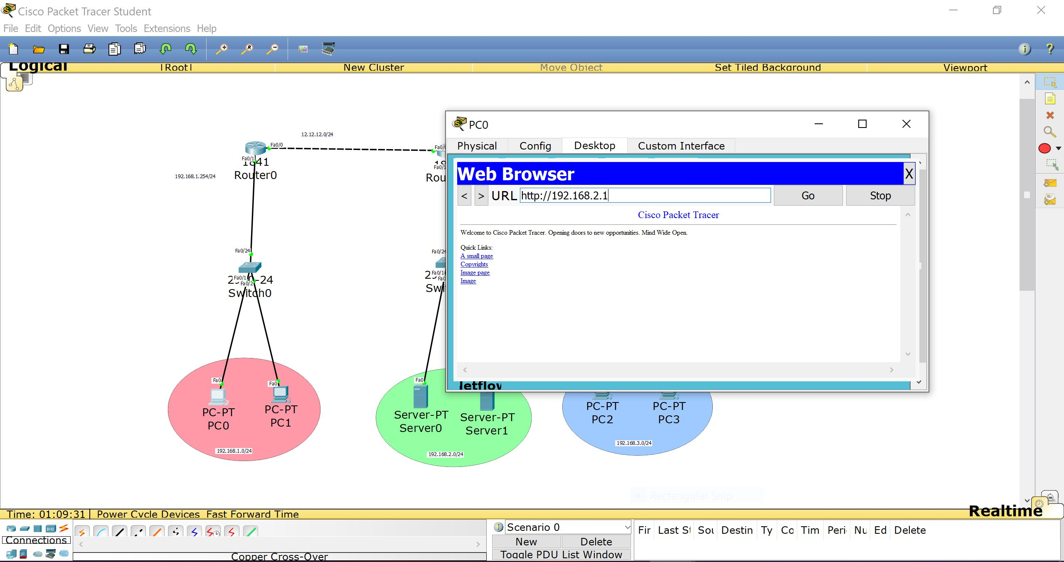
Figure 5 – PC0 Web Browser successfully accessing Server0 at 192.168.2.1

6. Troubleshooting Notes
The following issues and resolutions were encountered during the lab:
Symptom | Cause | Resolution
Red WAN link (Router1–Router2) | Serial cable needed Clock Rate | Set clock rate on DCE end: clock rate 64000
Ping fails between sites | Missing return route on remote router | Add symmetric static routes on all routers
Web page not loading | HTTP server service disabled on Server-PT | Enable HTTP under Server > Services > HTTP

7. Conclusion
This project demonstrated the end-to-end process of building a multi-site network using static routing in Cisco Packet Tracer. Key takeaways include:
- Static routes must be configured symmetrically: every router needs a route to every remote subnet.
- The next-hop address in a static route must be reachable via a directly connected interface.
- The show ip route command is the primary tool for verifying the routing table.
- Successful HTTP access from a client PC to a remote server confirms full Layer 3 connectivity.
Static routing provides simplicity and determinism for small networks, making it an excellent starting point for understanding IP routing concepts before progressing to dynamic protocols such as RIP, OSPF, or EIGRP.

