**19147911 Word Document**

**Part 2v.** Clash detection in Navisworks

**Exercise 1** Perform a clash between the two models

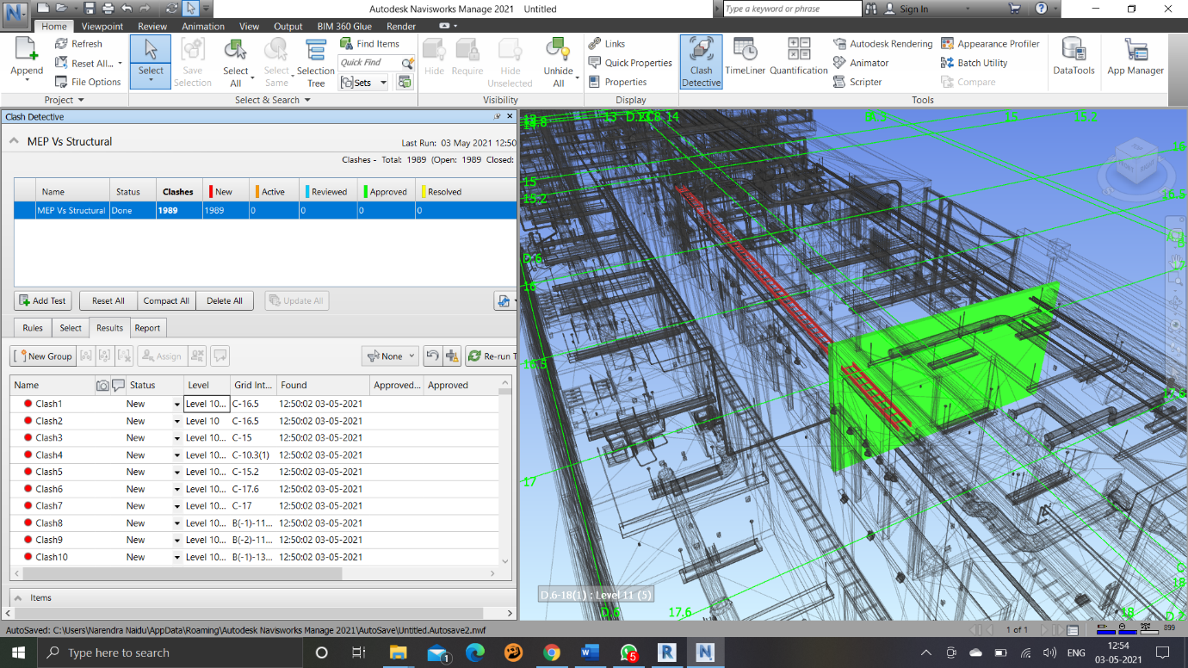

**Exercise 2** Specify the exact names of the components involved in Clash 67.

Item 1: Rectangular Duct

Item 2: Finishes - Interior - Gypsum Wall Board

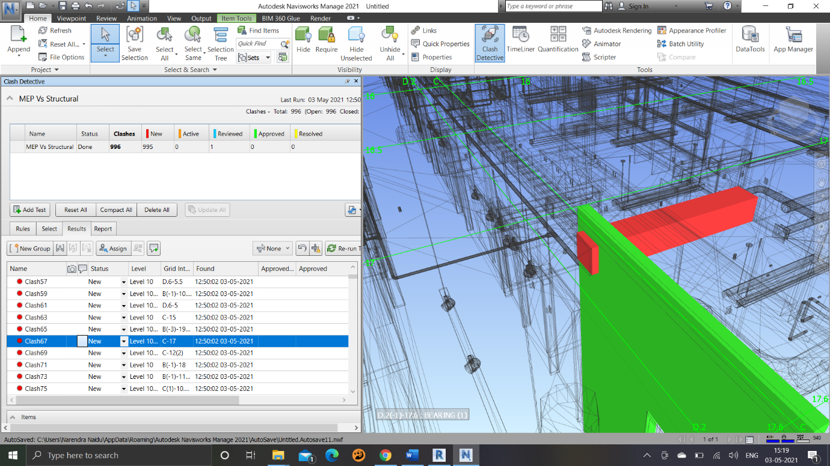

**Exercise 3** Group all the even clashes

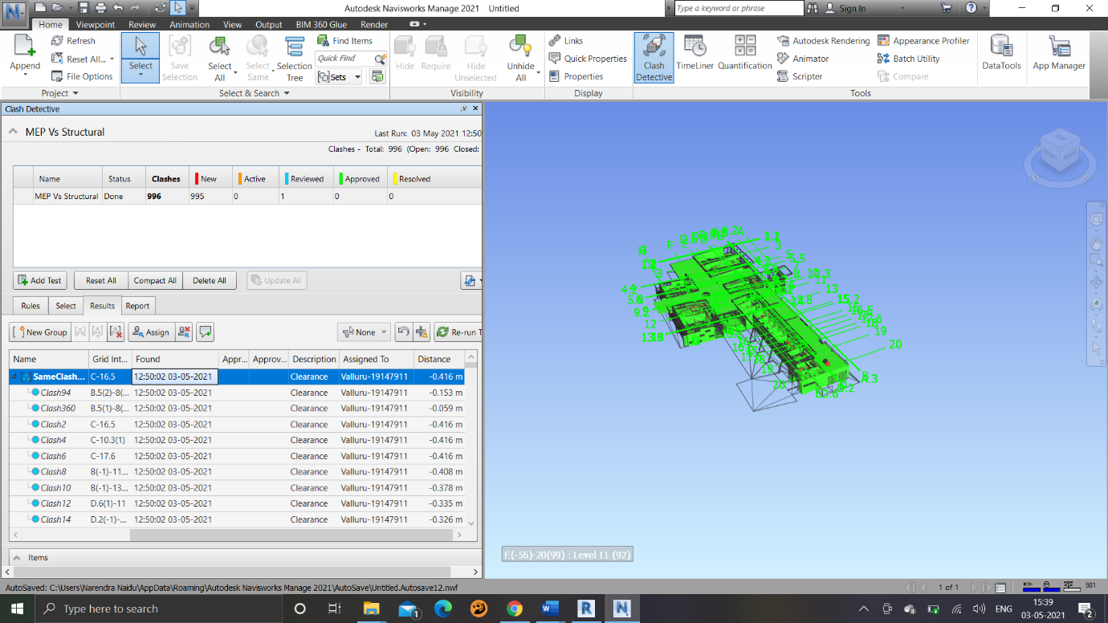

Part 2(iii):

The following is the major variations between Revit and Navisworks:

1.     Clash identification is not possible in Revit; however, this can be achieved in Navisworks to obtain precise quantities and predictions.

2.     We can get measurements in standard formats in Navis easily.

Part 2(ii): Project Scheduling in NavisWorks

