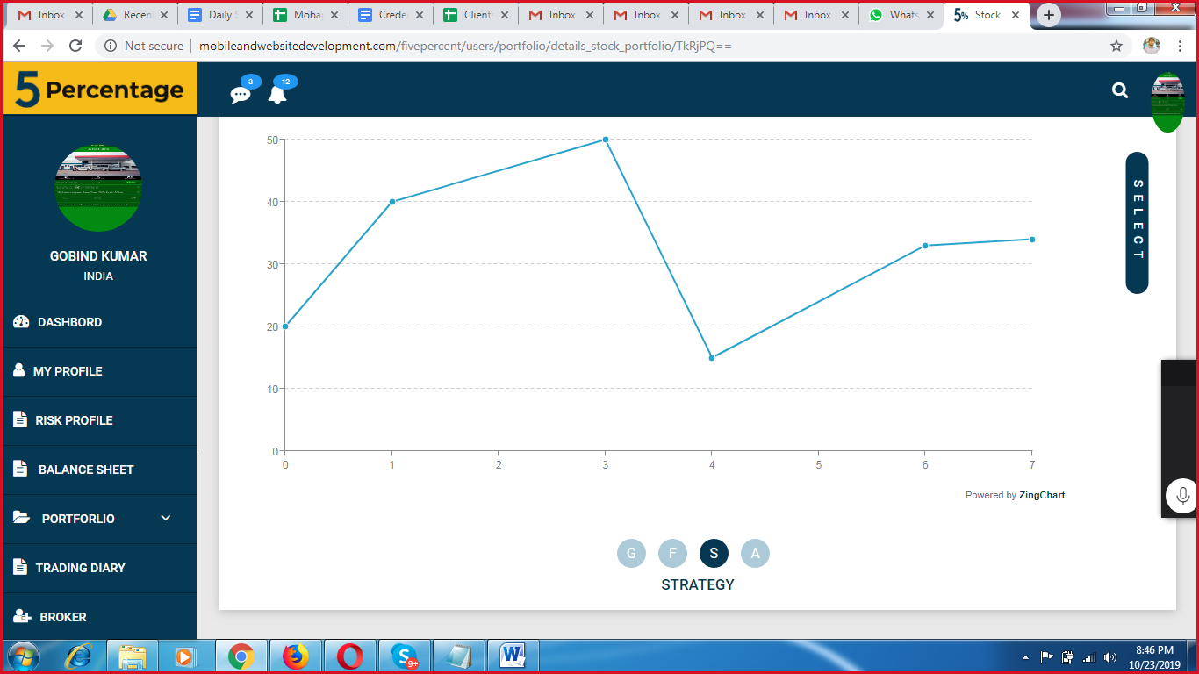

Button should be on same level for every section.

**Done!**

**Test status: Done**

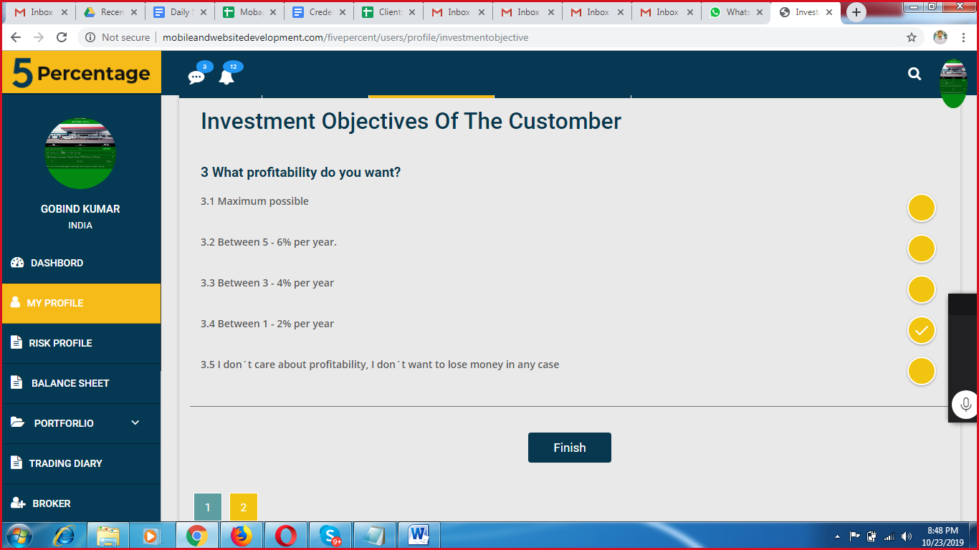

Keep finish button below pager number. Keep finish button only last page only not all.

**Done!**

**Test status: Done**

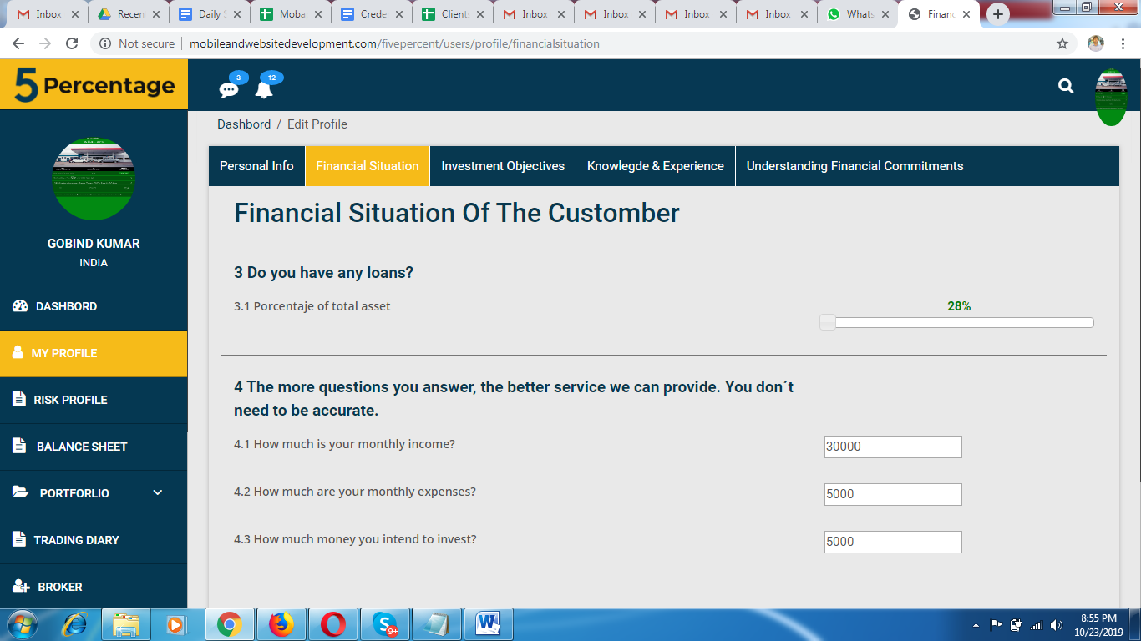

Its showing 0 for progressor but number is 28%

**Done!**

**Test status: Done**

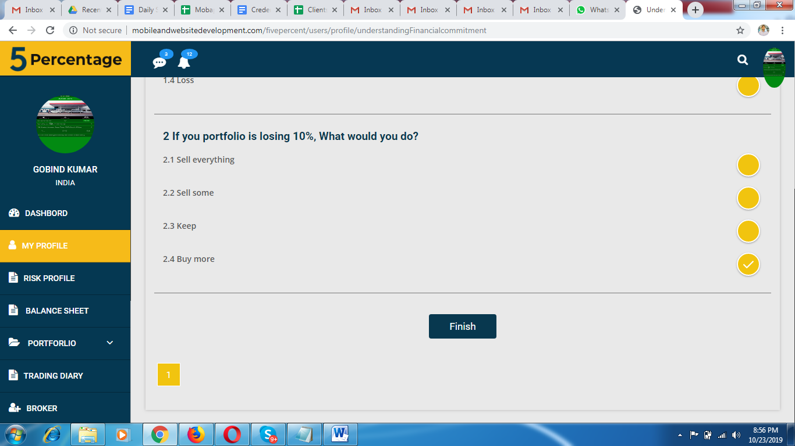

No need to show 1 if there is single page only.

**Done!**

**Test status: Done**

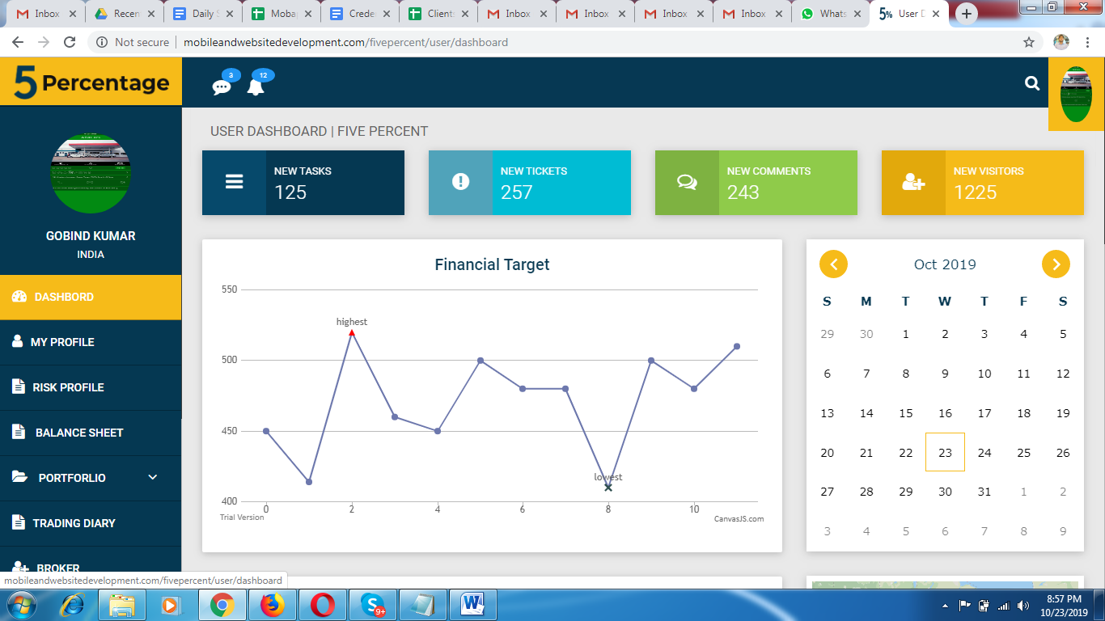

Profile image not showing correctly

**Done!**

**Test status: Done**

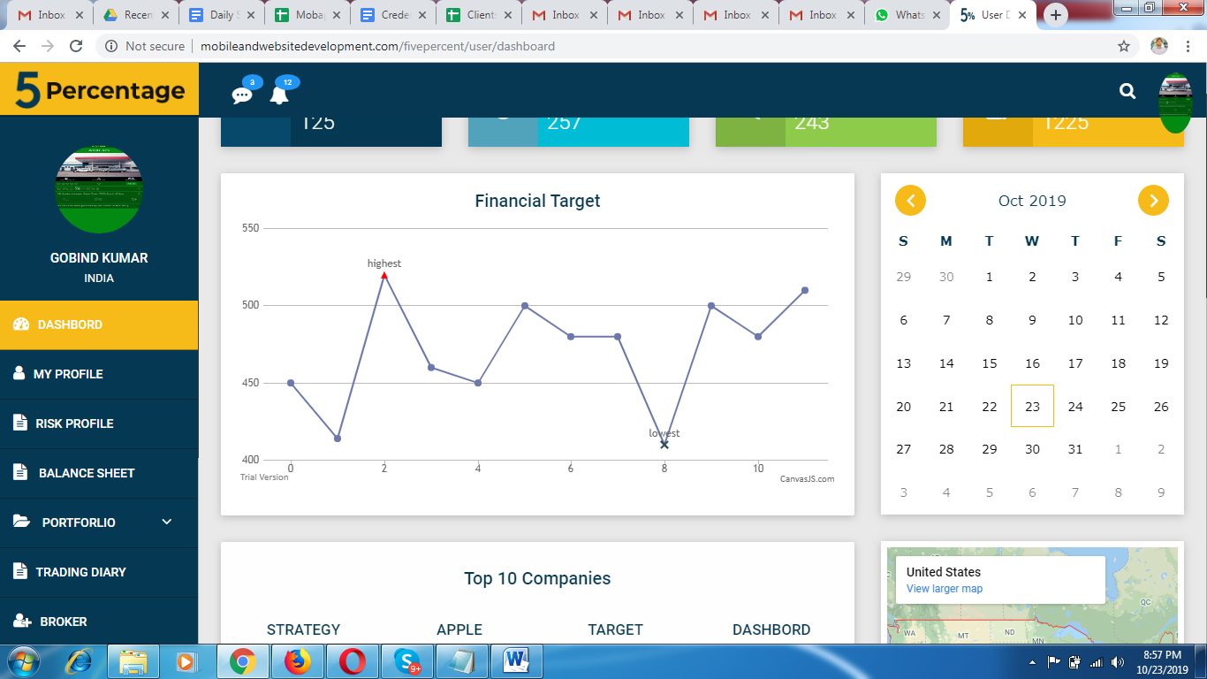

On Calendar show 5 options as per document. Its seems not customized calendar where arrow for up and down.

**Done!**

**Test status: Done**

No need to show map if its not in document.

**Done!**

**Test status: Done**

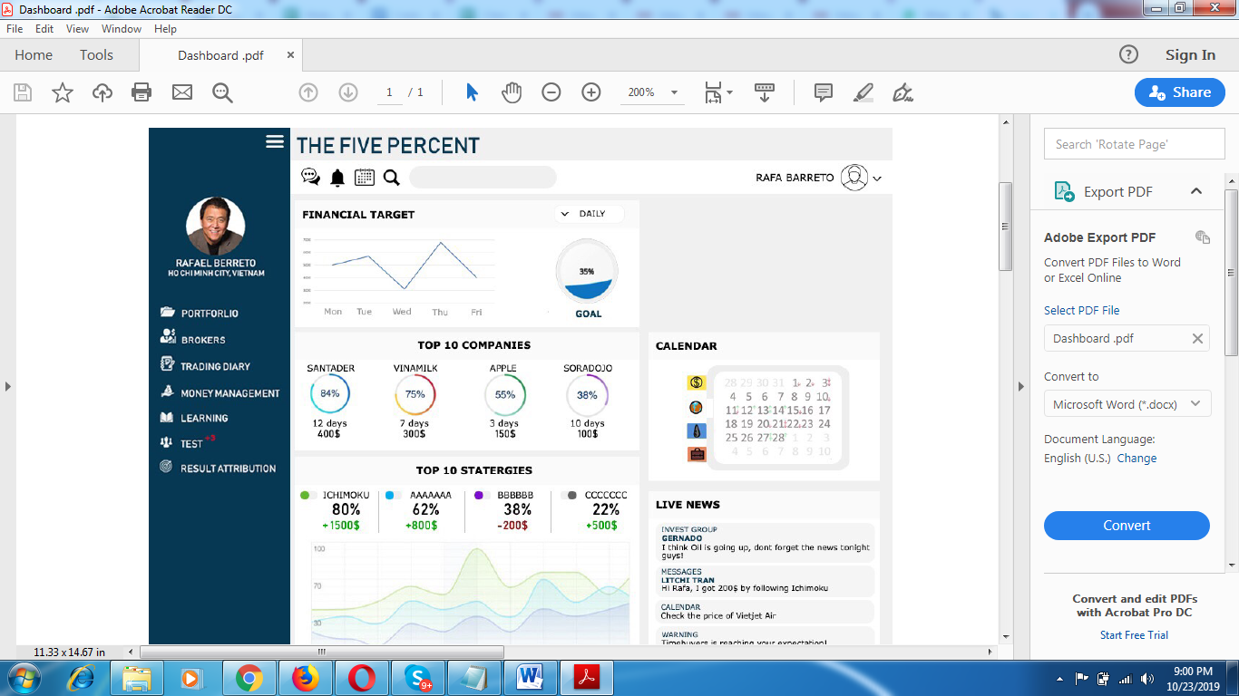

**No need to show Social Trends**

**Done!**

**Test status: Done**

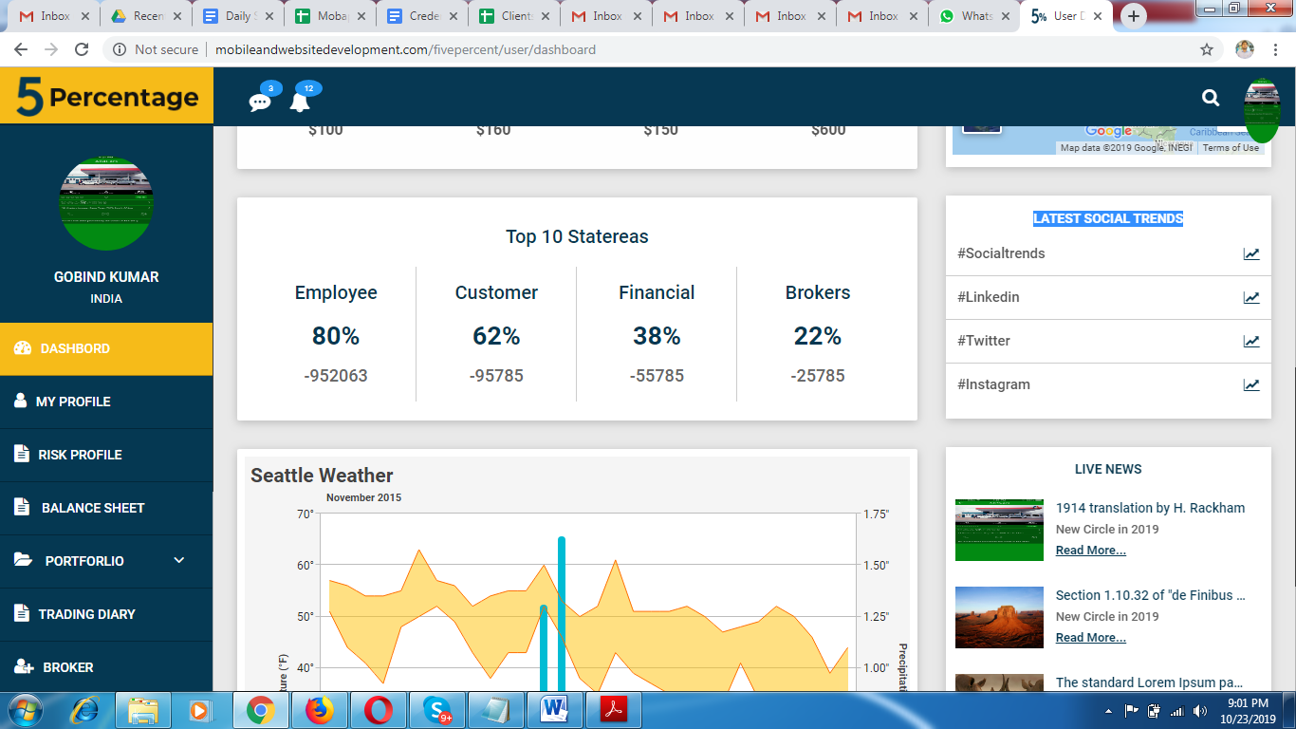

Remove below graph as its not useful for now.

**Done!**

**Test status: Done**

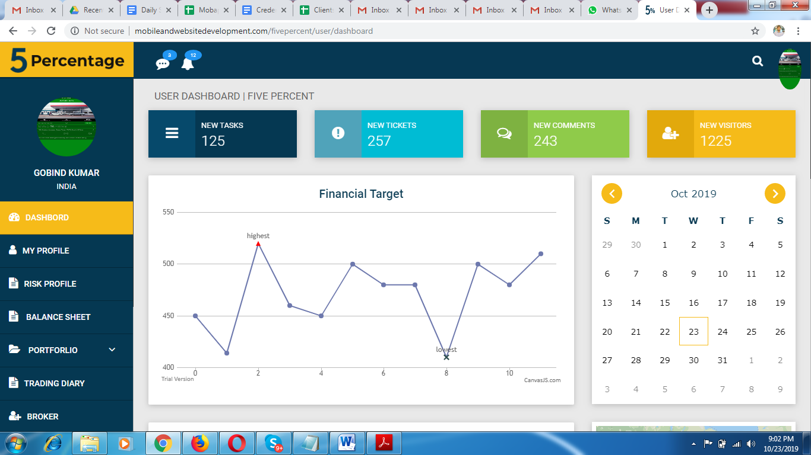

Don’t show New tasks , New Tokens etc remove these for now.

**Done!**

**Test status: Done**

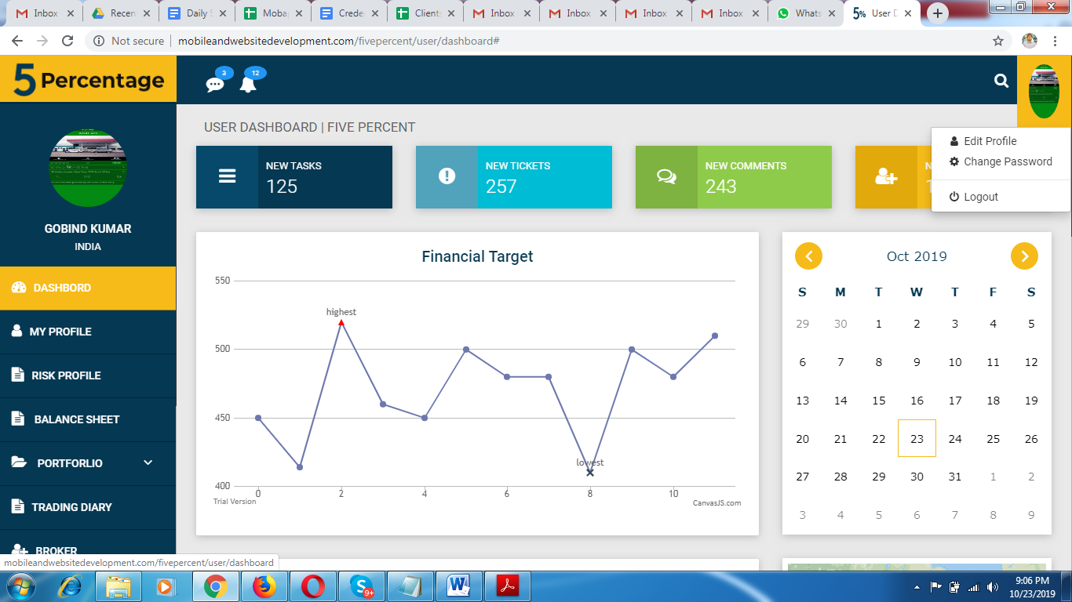

Profile popup not looking professional.

**Done!**

**Test status: Done**

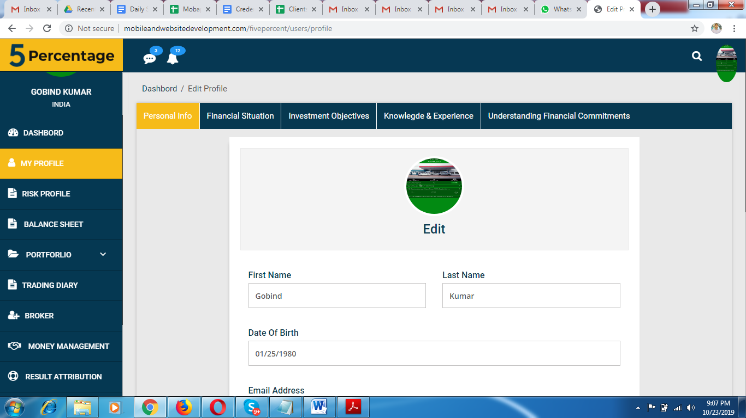

In profile don’t have option to change password.

**Done!**

**Test status: Done**

RISK PROFILE

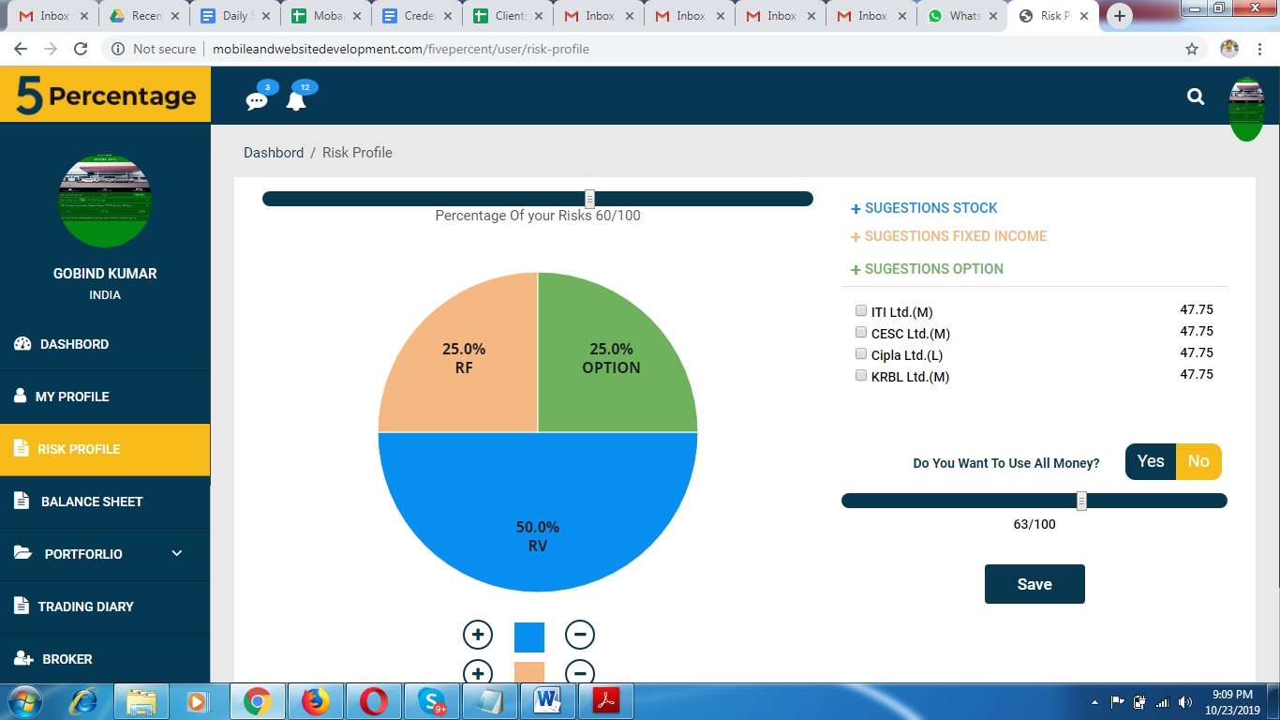

Text below first bar should be looks professional.

**Done!**

**Test status: Done**

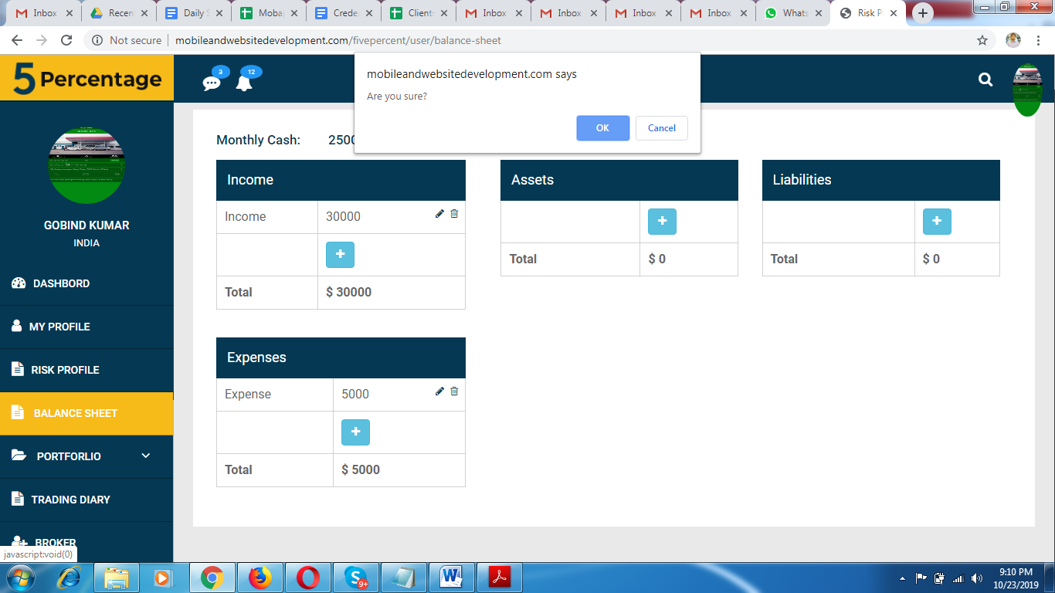

Don’t show basic Alert keep custom nice alert.

**Done!**

**Test status: Done**

STOCK Portfolio

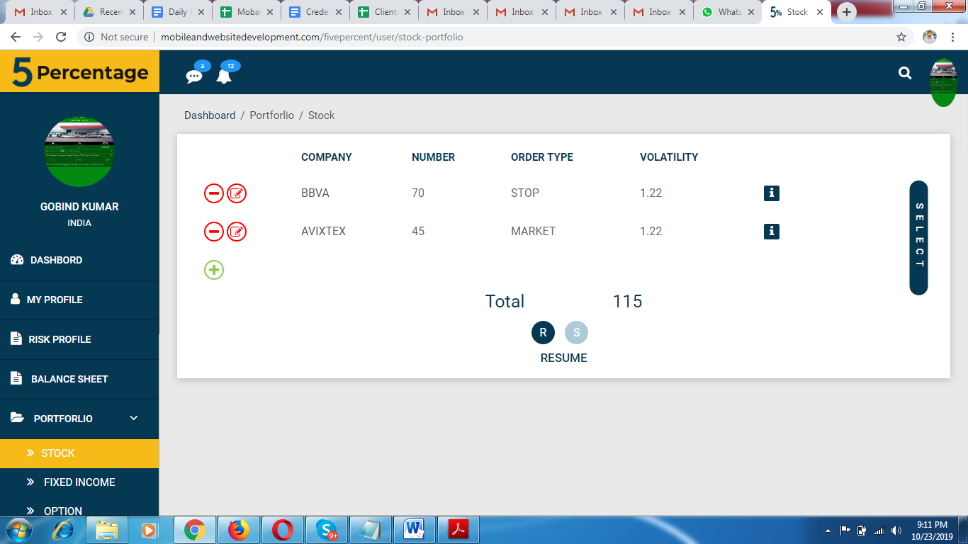

Keep both buttons on same position.

**Done!**

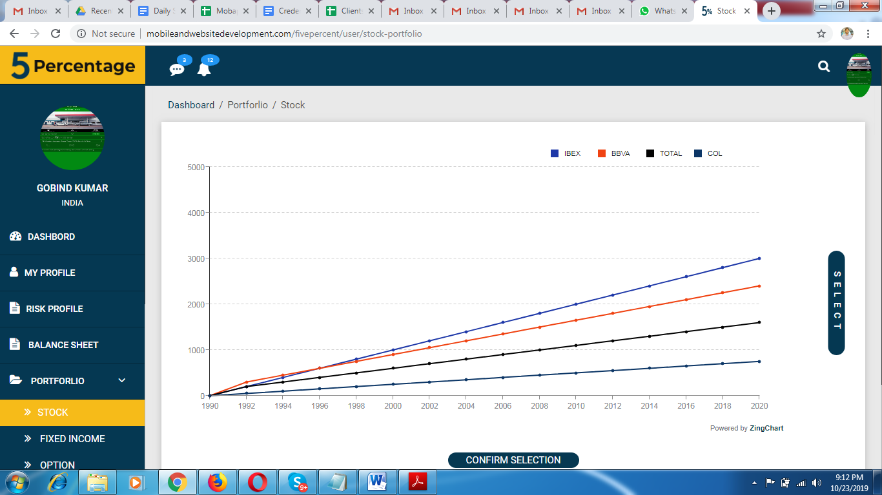

This showing very big and other screen very less.

**Done!**

**Test status: Done**

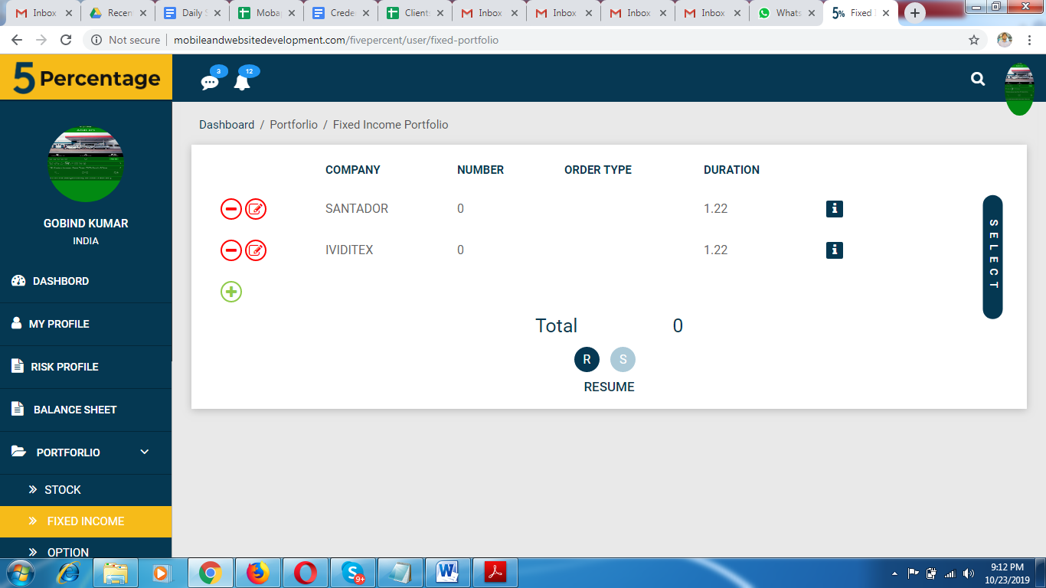

Same on that.

On click of stock shall move on stock details like Stock portfolio.

**Done!**

**Test status: Done**

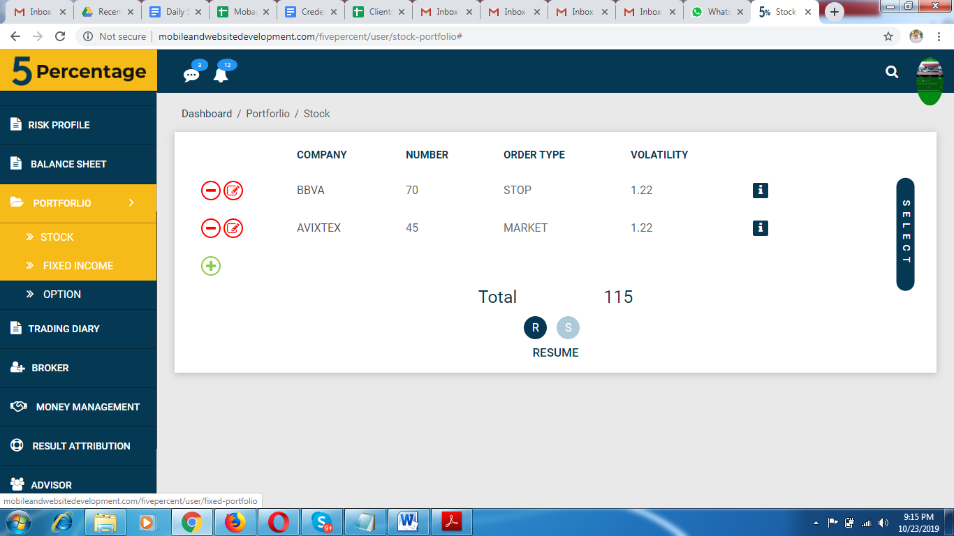

That section is not working properly.

**Done!**

**Test status: Done**

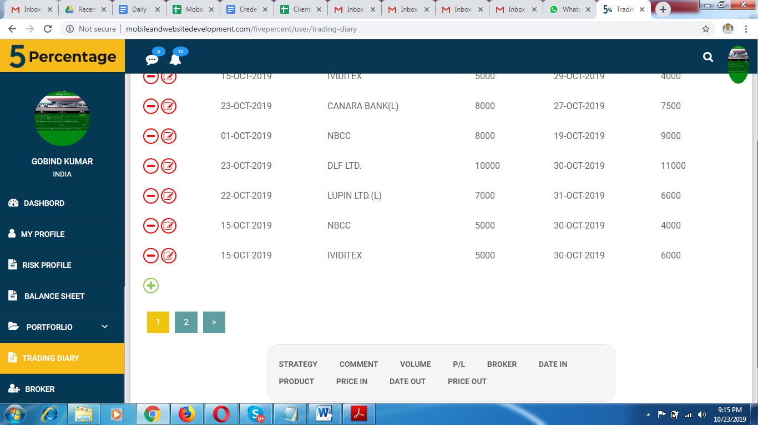

When selecting below any option it should be highlighted

**Done!**

**Test status: Done**