Please Narendra have a look to this picture

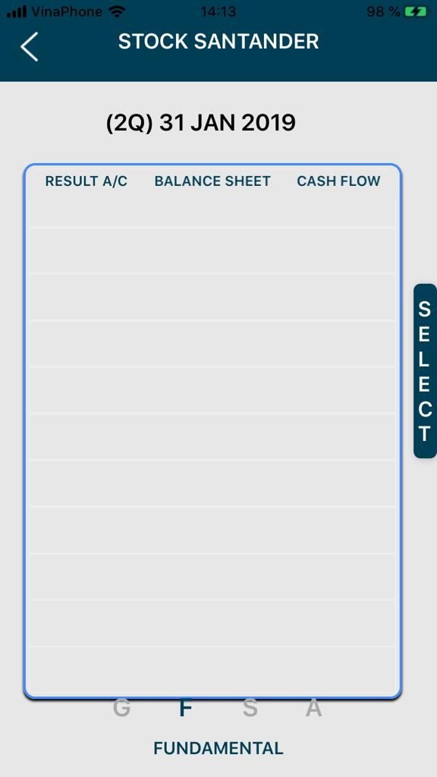

The menu cannot be seen because of the bottom line

Developer: Done

Test status: Done

2. On P/L column, is not profit or loss is a number, the amount of money I won or I lost

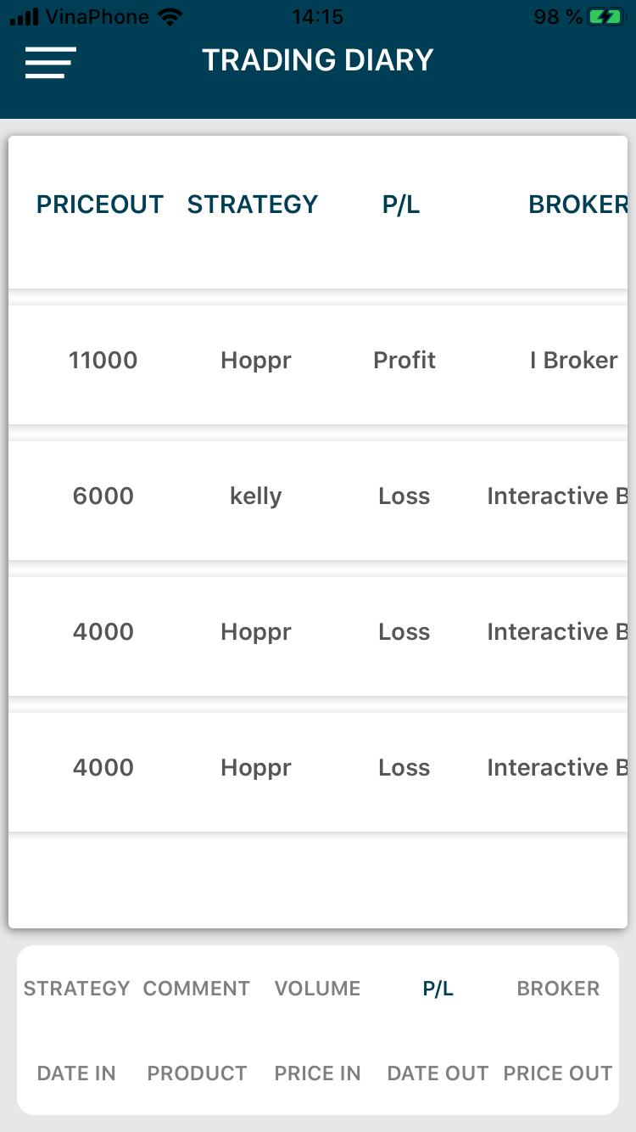

Developer: Done

Test status: Done

3. The “submit” has to be in the second page... the same as in the website

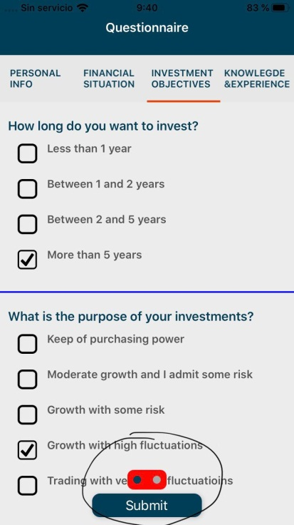

Developer: Done

Test status: Done

4.In the web is “finish” in the App is “submit” it has to be the same word

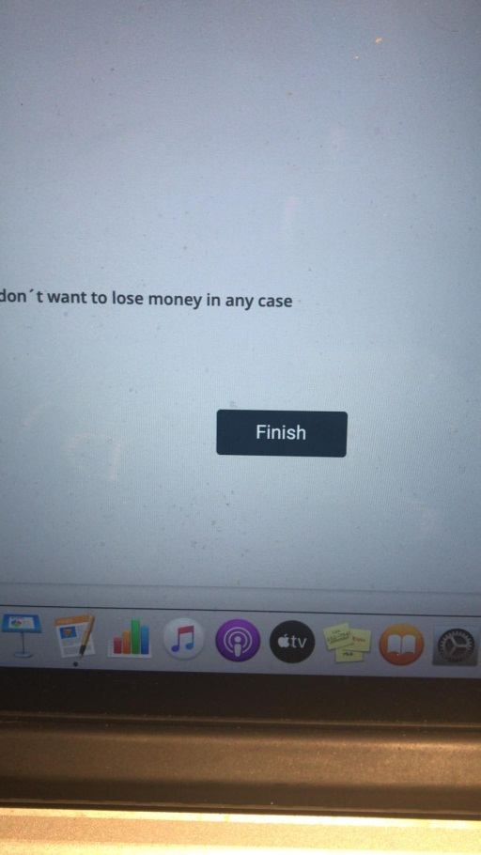

Developer: Done

5. Menus at the same level

30thOctoberPoint5.video file

Developer: Done

Test status: Done

6. Color coding: math hope negative should be in red, av win in green, av loss in red (Please check customer experience points whole application follow that)

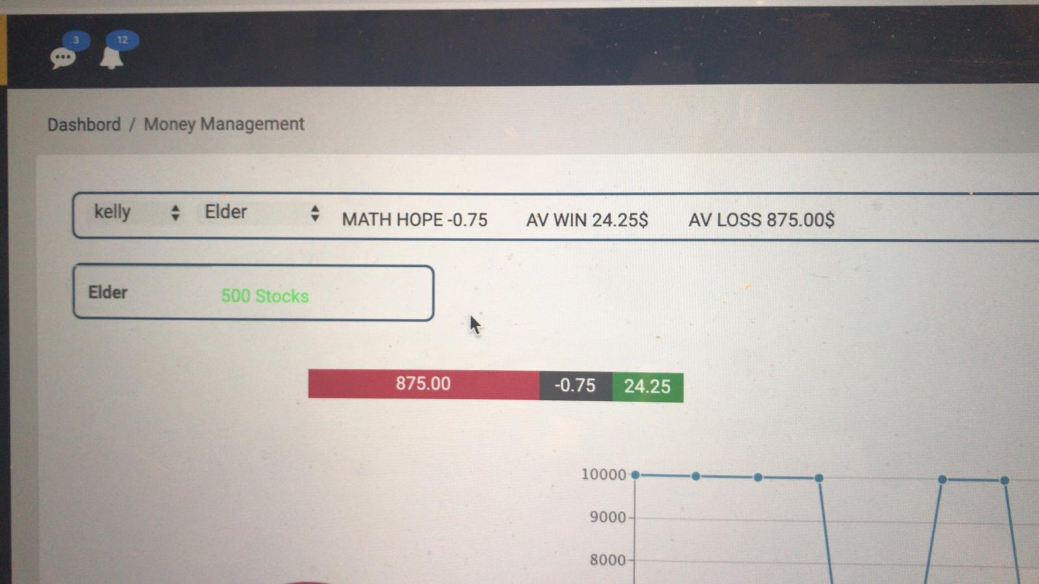

Developer: Done

Test status: Done

7. In the navigation can confuse people... cannot be dashboard / portfolio ... dashboard for the dashboard, portfolio for the portfolio

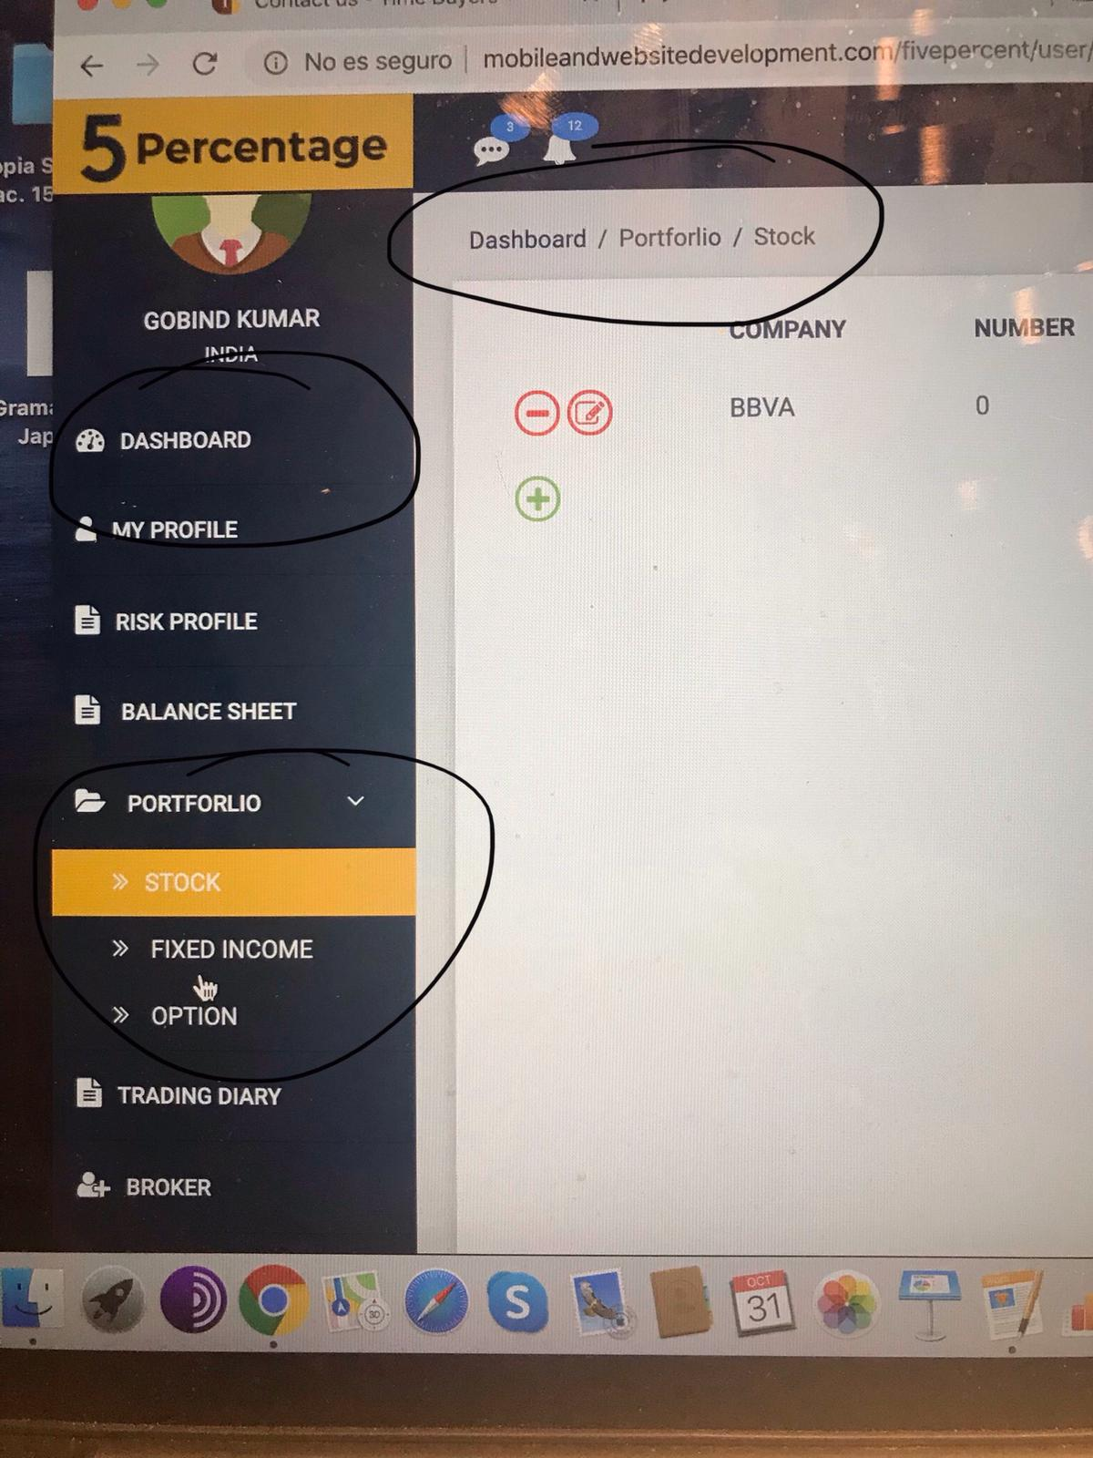

Developer: Done

Test status: Done

8. In the trading diary when you select multiple options don’t show all of them.

If I want to see them all, what is the solution?

**Narendra: Need to discuss with RAFA**

**Video – 30thOtcoberPoin8.video**

**Need to discuss**

9. The same thing Me yes at the same level

**Video – 30thOtcoberPoin9.video**

**Developer: Done**

**Test status: Done**

10. In this the menus are not at the same level and the selection of V call etc doesn’t remain in the next page

30thOctoberPoint10.video

Need to discuss

11.General points need to check:

have to check all the graphs on all the pages

to make all menus at the same level

From portfolio not only in stocks, but in fix income and options

Brokers

Almost done