Feedback May 6, 2019

Hi, I’m trying to post stuff. It wasn’t working from the app. So I tried the website. Images are not showing from either.

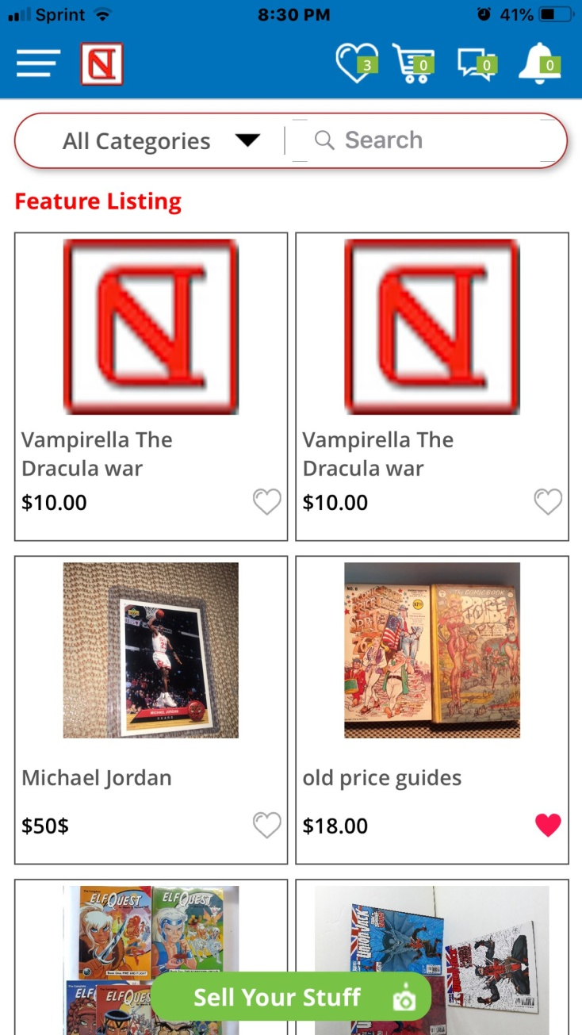

Okay so it didn’t work when I selected camera but did when I selected photo album.

Developer: Done

Test status: Done