_____________________________________________________________

**CSC134 C++ Programming**

________________________________________________________________________

**LAB 1: WRITING YOUR FIRST C++ PROGRAM**

# Objectives

In this lab assignment, students will learn:

* How to write a simple C++ program
* How to document program using comments
* How to identify input, processing and output items
* How to use fundamental data types: (int, double, char and bool)
* How to use arithmetic operators
* How to use predefined functions in a program
* How to perform input and output operations
* How to debug syntax and logic errors
* How to use file output

# COURSE PREPARATION

Read the following documents before you work for this lab assignment:

* Chapters **1,2** and **3** oflecture slides and textbook.
* The attached **IPO_Algorithm_Example.docx** document.
* The attached **Translate_IPO_into_C++.docx** document.
* Documents posted in **Course Resources -> Tutorials and Guidelines to Create and Submit C++ Programs**.

# Grading rubric

Coding:

* Add comments and indentation in the C++ code (Problem Solving, 5 pts)
* Program can be implemented and run as instructed (Problem Solving, 90 pts)

**Programs that do not compile and run receive a 0 in credit. If you are having trouble getting your program to compile, comment out the code with errors until it compiles. This way, I can see what you were trying to accomplish and give you partial credit.**

* Submit the program as instructed (Problem Solving, 5 pts)

# Instructions

**Wake Tech Average Calculator** – Write a C++ program that will ask the user for 5 numeric test grades. Calculate the average. Display the 5 test scores and the average to the screen and WRITE the 5 test scores and the average to an output.txt file.

**Use this IPO chart and desk checking table to help with your assignment:**

IPO table

| Input | Processing (Algorithm) | Output |
| --- | --- | --- |
| test1  test2  test3  test4  test5 | Processing items: NA  Algorithm:  1. enter test1, test2, test3, test4, test5  2. average = (test1 + test2 + test3 + test4 + test5)/5  3. display the 5 tests scores and the average  4. write the 5 tests scores and the average to output file | Test score 1  Test score 2  Test score 3  Test score 4  Test score 5  Average |

Desk-check table

| Test score 1 | Test score 2 | Test score 3 | Test score 4 | Test score 5 | Average |
| --- | --- | --- | --- | --- | --- |
| 90  88 | 80  66 | 70  70 | 60  98 | 50  87 | 70.0  81.8 |

* Create a **C++ program** in Visual Studio that implements the above. The program should:
* ask user for five inputs.
* calculate the average
  + hint : use cout << fixed << showpoint << setprecision(1); // for 1 decimal place
* display the following information on the screen, AND the same information should also be written in a file called “**testaverage.txt**”:

Test 1 Score: *nn*

Test 2 Score: *nn*

Test 3 Score: *nn*

Test 4 Score: *nn*

Test 5 Score: *nn*

Average: *nn.n*

Here is a sample input / output on the **screen**:

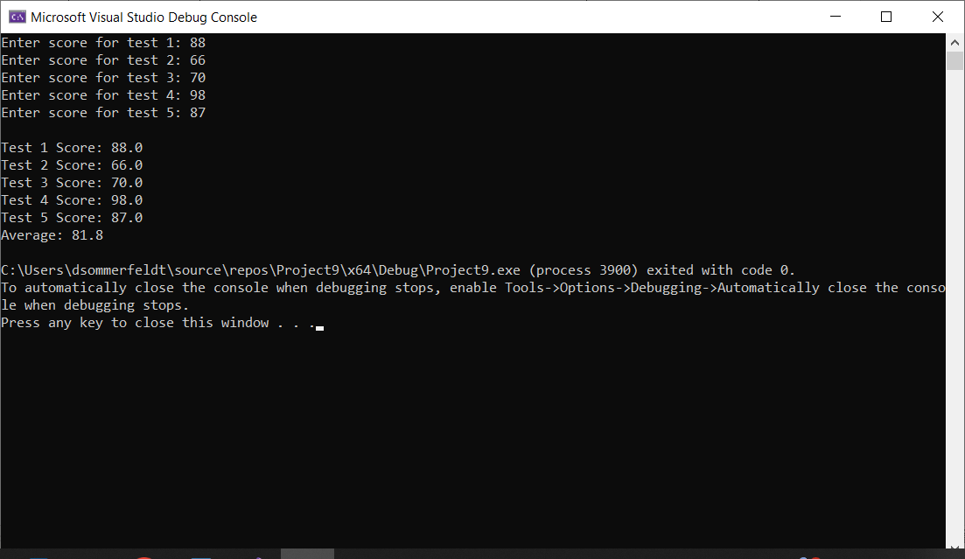

Here is the exam information saved in the file “**testaverage.txt**”:

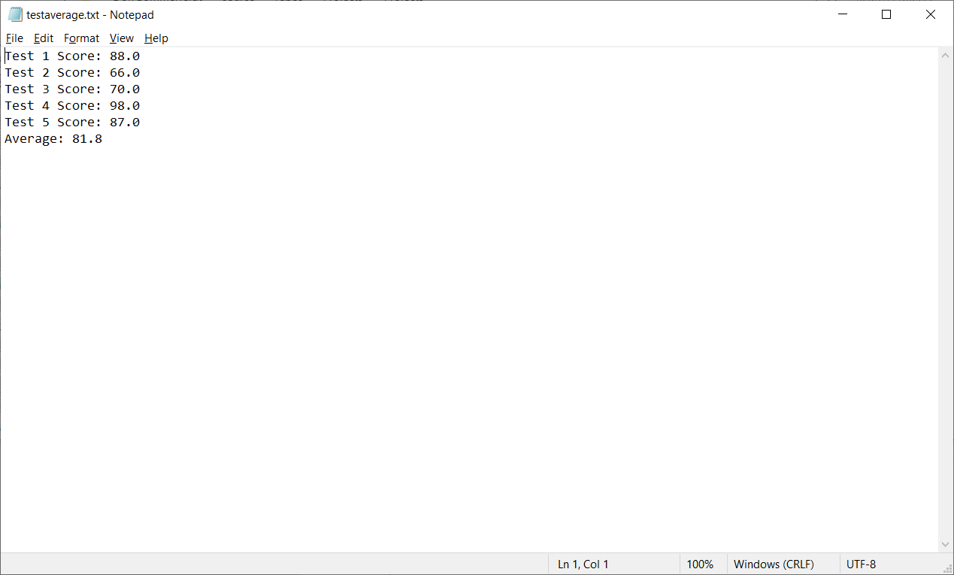

* Add comments and indents in the code.
* Use correct data type to declare variables.
* The weighted percentages could be declared as constants or used directly in the calculation.
* Display the output results as decimal format using:

**#include<iomanip>**

**cout << fixed << showpoint << setprecision(1);**

**SUBMISSION**

* You can submit your assignment by either of the following ways:
  + Only source code file (.cpp,) **OR**
  + The whole project folder (compress your entire project folder into .zip file)