This is a Cryptocurrency/Stock Bot for Discord.  
Supports 1200+ cryptocurrencies.  
Supports Stock tickers.  
Supports Predict It Presedential Election Contracts

**Usage:**

!help: Command Info

!COINTICKER: COINTICKER price/24 hr change  
      Example: !BTC  
[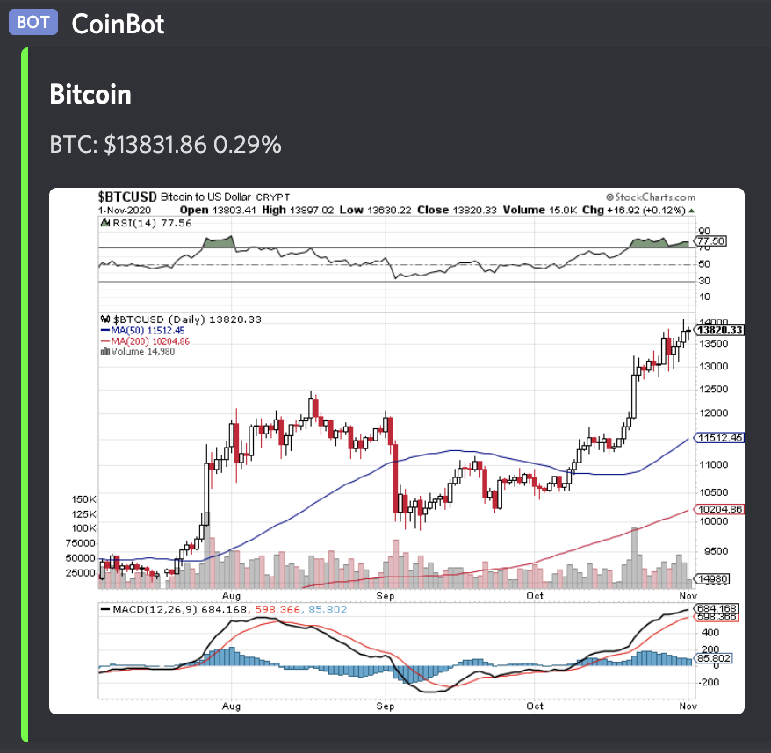](https://github.com/aonghena/CoinBot/blob/master/url)

$STOCKTICKER: STOCKTICKER price/24 hr change.  
      Example: $AAPL  
[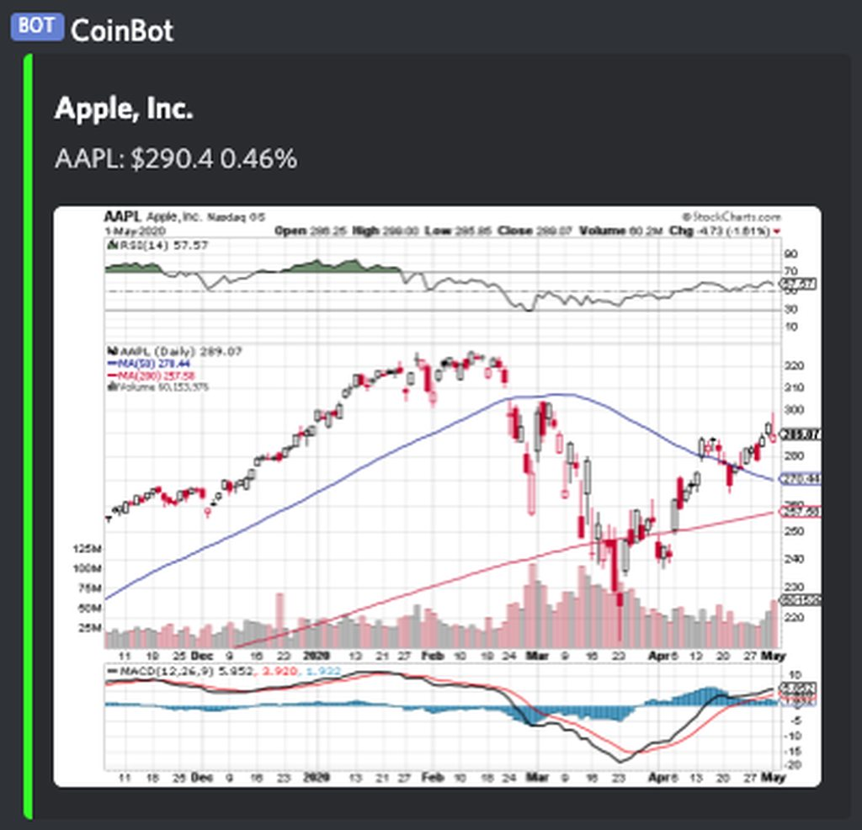](https://camo.githubusercontent.com/cbba07185ac5b71c1ce602e291cb6d956184c7c6b0c584a45bed97eecd17539f/68747470733a2f2f696d6775722e636f6d2f584c6453675363682e706e67)

!STATEABBREVATION: STATE COVID INFORMATION.  
      Example: !NY  
[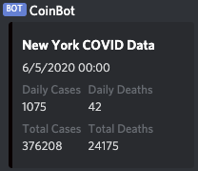](https://camo.githubusercontent.com/c3c6a16326e61f061634b225029889925a79f7d74f54b03ac128af13e097aeb1/68747470733a2f2f692e696d6775722e636f6d2f4c4a464d4457542e706e67)

!news: Return two of the most recent news articles related to cryptocurrency

!prez - PredictIt Market info