Web Portal Project
Technical Architecture –
Physical Component Model
v0.041

Developed for

Document Control

Current Version:
Owner:
Date Last Updated:
Last Updated By:
Author:
Date Created:
Reviewed By:
Approved By:
Approval Date:

Revision History
Version Number | Date Updated | Revision Author | Brief Description of Changes

Referenced Documents
Reference Number | Document Name | Vers-ion | File Name
MO2 | WebSphere Portal InfoCentre | 5.1 | http://publib.boulder.ibm.com/pvc/wp/510/ent/en/InfoCenter/index.html
MO3 | PAI Security Platform Handbook | 2.5.1 | SEC_Handbook.pdf
MO4 | Commerce InfoCentre | 5.6 | http://www.ibm.com/software/genservers/commerce/wcpe/library/lit-tech-general-en.html
MO5 | WebSphere Commerce Portal V5.4 Solutions Guide | June 2003 | http://www.redbooks.ibm.com/abstracts/sg246890.html?Open
MO6 | Portal Collaboration Security Handbook | Dec 2004 | http://www.redbooks.ibm.com/abstracts/sg246438.html?Open
MO7 | Using HATS | May 2004 | http://www.redbooks.ibm.com/abstracts/sg246099.html?Open
MO8 | Directory Issues with WebSphere Application Server (WAS) and Portal Server (WPS) | Oct 2003 | DirectoryIssues.pdf
MO9 | Learning Management System Handbook | Oct 2003 | http://www.redbooks.ibm.com/abstracts/sg247028.html?Open
MO10 | Learning Management System Content Guide | 1.0.5  Sept 2004 | http://doc.notes.net/uafiles.nsf/docs/LMS105/$File/ContentGuide.pdf
MO11 | Core J2EE Patterns | 2002 | http://java.sun.com/blueprints/corej2eepatterns/Patterns/
MO12 | Web Portal PAI Integration Discussion Paper | V0.5 | PAI Integration v0.5
MO13 | WebSphere Integration with WI 3.0 Design | V1.0 | WebSphere Integration with WI 3.0 Design.pdf

Table of Contents

1 Introduction 2
1.1 Background 2
1.2 Document Purpose 3
1.3 Audience 4
1.4 Scope 4
1.5 Issues 5
1.5.1 Open Issues 5
1.5.2 Closed Issues 5
1.6 Assumptions 5
1.7 Notation 6
2 Component Model Overview 7
2.1 Component Model Overview Diagram 7
2.2 Component Descriptions 8
2.2.1 Custom Presentation Layer 8
2.2.2 Custom Services Framework 9
2.2.3 Relational Data Store 10
3 Architectural Decisions 14
3.1 AD01 – Concurrency Management 15
3.2 AD02 – Transaction Management 16
3.3 AD03 – Session Management 17
3.4 AD04 – File Delimiters 17
Appendix E – External Review Log 18
3.4.1 Closed Issues 18
3.4.2 Open Issues 18

Introduction

Background
The customer has engaged IBM to provide a Web Portal solution. The Web Portal will integrate key services, information, people, and processes into a single role based interface and enable the customer to maintain more effective relationships with its partners by linking independently to the customers major systems.
The ultimate objective of the Web Portal is to deliver tangible cost savings to the customer by improving operational effectiveness, improved customer service, increased after-sales revenue, and significantly improved information flow and knowledge sharing between the customer and its partners for all aftermarket processes.

Document Purpose
This document forms part of the Technical Architecture deliverable for the Web Portal Project. It contains a physical level elaboration of the Component Model. This document is used to:
- Build on the Specification level of the Component Model
- Describe in detail selected components and component interactions of the system
- Define the components to be placed on the operational model, that is, that have to execute and be managed on the target platforms.
Within this document a component is defined as an encapsulated part of a software system that has a well-defined interface through which its services are accessed. Components can be functional, technical, software or hardware.
The Component Model is described using:
- Component Descriptions. These describe the responsibilities and possible implementation approaches for each component. Implementation approaches may be characterized by design patterns.
- Component Relationship Diagrams. This illustrates the static relationship between components. This includes component interfaces and cardinality of relationships between the components (one-to-one, one-to-many or many-to-many).
- Component Interaction Diagrams. The diagrams illustrate how components interact to support business processes. For a set of architecturally significant business processes, they show the dynamic relationship between components during the execution of the process.
The relationship between the Component Model and other project Web Portal Project deliverables is illustrated below.
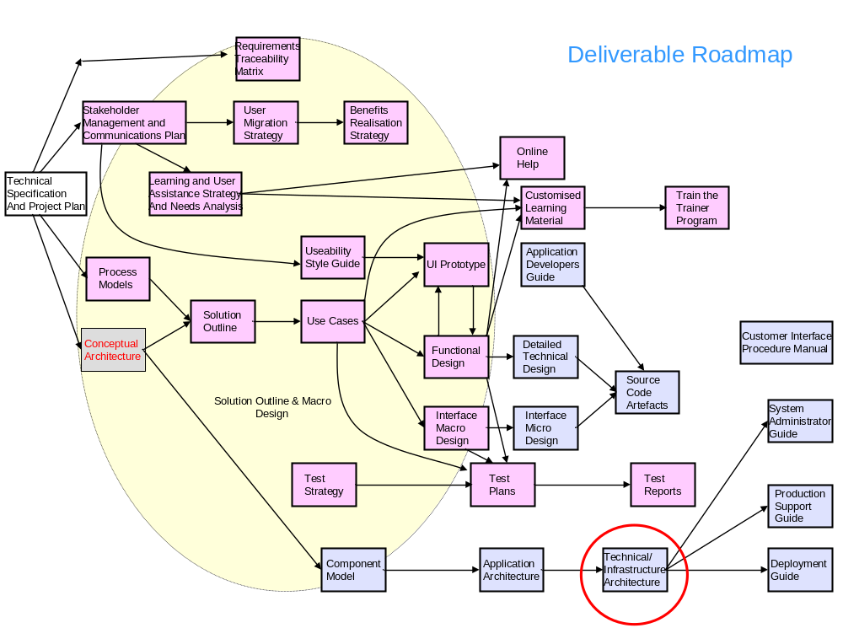
Figure 1 - Deliverable Roadmap
The remaining architectural deliverables are:
- Technical Infrastructure Architecture. The infrastructure architecture will elaborate the operational model to the physical level. It will define deployment units, nodes, zones, connections and node dependencies.

Audience
The target audience for this document are:
- Customer and IBM Architects
- IBM Developers and Support Staff

Scope
The information sources of content in this document are:
  - Technical Specification
  - Component Model

Topics Covered
The scope of topics covered in this document is defined in Attachment A to Contract Schedule 1 – Technical Specification. The following topics are included in the scope of this document:
  - Component Model – Physical Level Elaboration
The following topics are not within the scope of this document:
  - Use Cases
  - Process models
  - Application Architecture content - scope and boundaries of applications, interface definitions, data sharing
  - Specification level Component Model
  - Other Technical Architecture content - physical level Operational Model, IT Technical Implementation Plan, Infrastructure Gap Analysis, Network Requirements, Architecture Overview Diagram.

Issues

Open Issues
Id | Status | Description | Assigned To | Response

Closed Issues
Id | Status | Description | Assigned To | Response

Assumptions

Notation
The following notations are used in diagrams in this document.
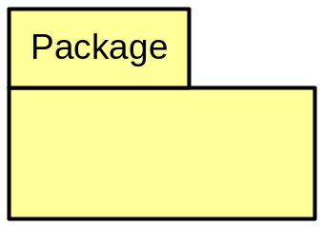 | Package. A package is a collection of components or of other packages. In this document the package notation is used for architectural layers and collections of components within those layers.
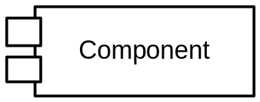 | Functional Component. A component is an independent part of the system. In this document components with names not in italics are functional components. A functional component is a logical grouping of business processes. Functional component descriptions are provided in Section 3 Functional Views.
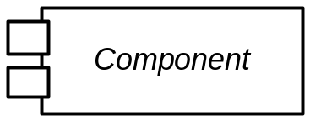 | Technical or Common Component. Technical components are hardware or software products. Common components provide logic that is re-used by multiple Functional Components. Technical and common components are depicted in diagrams with their names in italics. Descriptions for these components are provided in Section 2 Component Model Overview.

Component Model Overview

Component Model Overview Diagram
The Conceptual Component Model diagram presented in the Web Portal Conceptual Architecture [MO1] is displayed below. This diagram depicts architectural layers as packages which contain other packages.
All packages and the components they contain are described in Section 2.2 Component Descriptions of the Component Model document [MO14]. The packages marked in bold below have been identified as requiring further elaboration in this Physical Component model document. Component descriptions for these components are provided in the following section.

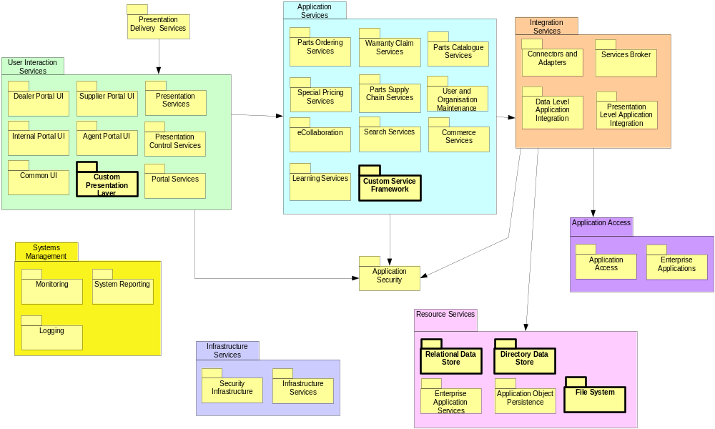
Figure 2 - Component Model Overview Diagram

Component Descriptions

Custom Presentation Layer
The following is a logical class diagram illustrating the significant Java classes that will make up the Custom Presentation Layer. This is an example based on a Parts Search screen.
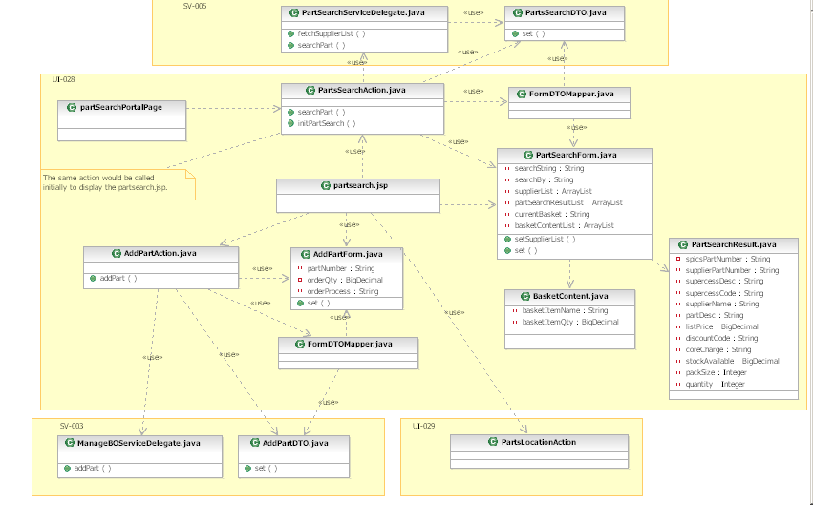
Figure 3 -Custom Presentation Layer Class Diagram
The logical classes are:
- PortalPage is a page configured in WebSphere Portal that contains the Web Application Integration portlet. This portlet is configured to submit an HTTP request the Struts Action class PartsSearchAction.
- Action is a Struts action class. This co-ordinates service invocation and mapping of data between FormBeans and Service DTO’s. The Action class may also contain presentation logic.
- ServiceDelegate is a Java class providing access to a service provided in the Custom Service Frameork.
- DTO classes are Data Transfer Objects used to decouple the presentation layer from the service layer. Each Service expects a single requestDTO parameter and returns a responseDTO.
- Form Beans are bean classes that implement the WppWebActionForm class. This is an extension of the Struts FormBean class.
- JSP Pages are used to create HTML. The Action classes forward to a JSP after populating a Form bean. The JSP displays data from the Form Beans in an HTML page.
- Other classes are helper Java classes.

Custom Services Framework
The following class diagram depicts the Custom Services Framework.
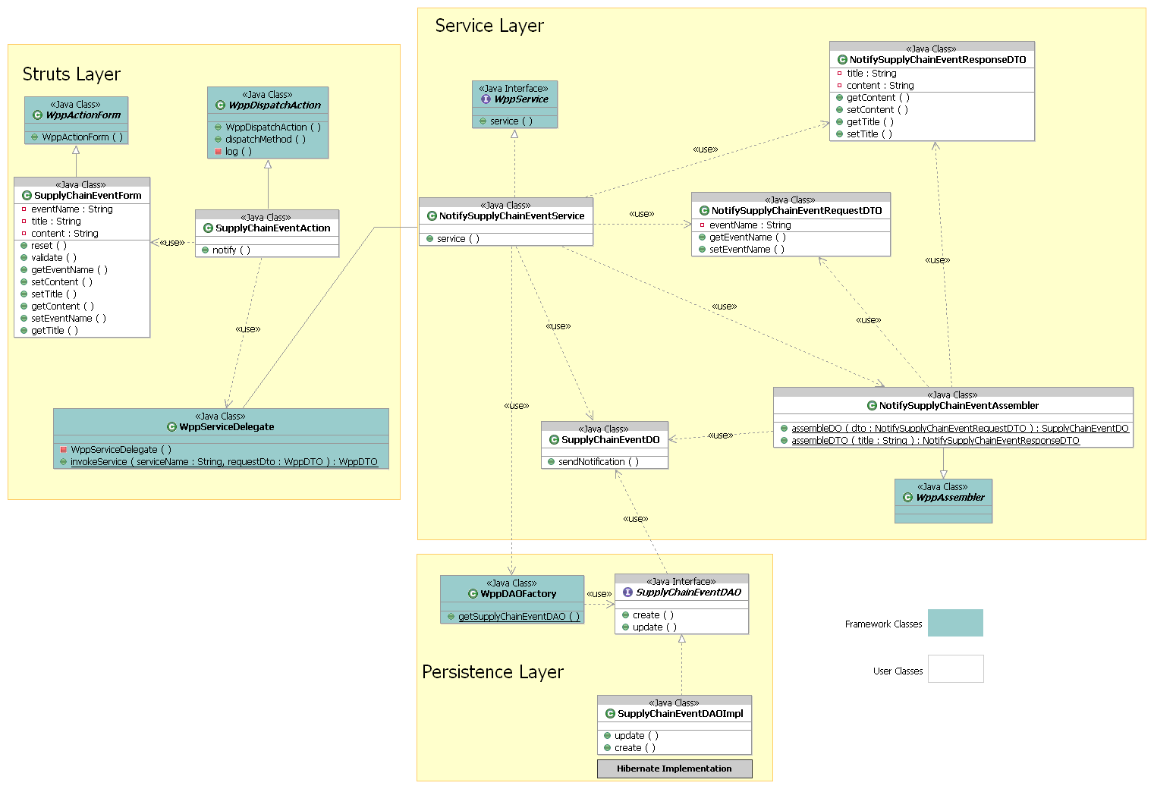
Figure 4 - Custom Services Layer Class Diagram

Some key classes within the framework are highlighted below:
- WppService (the interface implemented by all Service-layer classes)
- WppAssembler (the parent class of all DTO <-> DO assembler classes)
- WppServiceDelegate (for locating and calling Service-layer classes)
- WppDispatchAction (the parent class of all Struts-layer Action classes)
- WppDTO (the parent class of all Data Transfer Objects)
- WppDomainObject (the parent class of all domain objects)
- WppApplicationException, WppSystemException (checked and unchecked exception types)
- WppStartup, WppShutdown (application startup and shutdown hooks)

Relational Data Store
The Relational Data Store is a DB2 database. The diagram below shows the different schemas that will be contained within it.
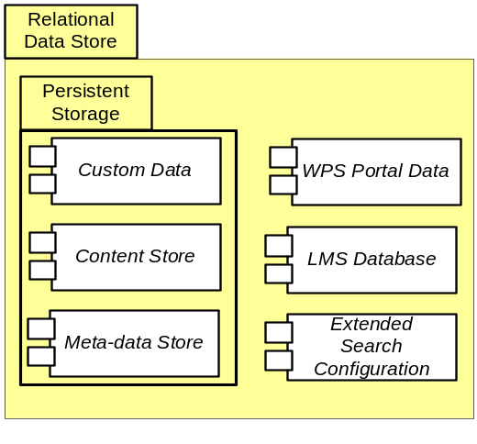
Figure 5 – Relational Data Store Components

Persistent Storage
The customer application data will be stored in a single database schema within the DB2 database instance:
Application | Schema Name | Function | Space considerations
XXXX | yyyydb | Contains stored data for the Web Portal Project. | Sizing to be determined at build phase
Access to the XXXX application data within this schema will be via a DataSource configured within the WebSphere Application Server. This DataSource will use the following database user to connect to the database:
Application | Database user | Function
XXXXX | yyyyyyyusr | Core user for the WPPAUP application.  Will own approximately 88 tables.
The tables and columns to be included in the XXXX schema are described in Error: Reference source not found.

WPS Portal Data
The Portal InfoCenter contains information regarding how WPS uses the database. It can be found under WebSphere Portal > Configuring > Database (Windows/UNIX) > Planning > DB2.
WPPAUP will use the following schemas created when DB2 is configured for use by WebSphere Portal.
Application | Schema Name | Function | Space considerations
WebSphere Portal  Member Manager | wpsdb | Used for WebSphere Portal and Member Manager (at a minimum) or to hold all data. Stores information about user customizations, such as Pages, and user profile and login information. | The amount of database space that is required depends on the number of WebSphere Portal users and portal objects, such as pages and portlets.
Document Manager  Personalization | jcrdb | db2inst1 | NOT USED IN WPPAUP  Used by Document Manager and Personalization components. Contains documents, personalization rules, personalization campaigns, and document library configuration information.
Feedback | fdbkdb | Used by Feedback components. Contains the information that is logged by your web site for generating reports for analysis of site activity. | The amount of database space that is required for logging depends on the amount of traffic to the site. The amount of data that is logged per login-enabled page can vary.
Likeminds | lmdb | db2inst1 | NOT USED IN WPPAUP  Used for LikeMinds data. Contains the recommendations to be displayed to users when their interactions with your Web site have been analyzed and predictions generated.
The following users are also required:
Application | Database user | Function
WebSphere Portal | wpsdbusr | Core user.  Will own approximately 76 tables. Owns WebSphere Portal core objects, which includes tables that store the user customizations made to Pages.
Member Manager | wmmdbusr | Member Manager user.  Will own approximately 17 tables. Owns the Member Manager objects, which includes the tables that store login information about WebSphere Portal users.
Document Manager  Personalization | icmadmin | NOT USED IN WPPAUP  DB2 Content Manager Runtime Edition user (documents and personalization).  Will own approximately 100 tables used for document management and personalization. Tables are dynamically created based on the resources that you define for content management.
Feedback | feedback | Feedback user.  Will own approximately 48 tables used for logging site and personalization usage.
Likeminds | lmdbusr | NOT USED IN WPPAUP  Likeminds user.  Will own the tables used to hold the web site usage analysis routines and recommendation text.

LMS Application Data
The following information is from the Lotus Learning Management System Handbook [MO9]:
The Learning Management System uses relational databases to store all of its business data. During the LMS installation the following logical databases will be created:
Application | Schema Name | Function | Space considerations
LMS Database | To be determined in build phase | This is the core database of the LMS. It stores all user, course, tracking, and resource information. It is only used by LMS. | Depends on number of LMS users
LMS Audit Database | To be determined in build phase | This database is used as an activity log of administrative actions performed by users (system configuration, user enrolment, or course catalogue administration). In case of misconfigurations, for example, it can be used to trace the activities that led to the current situation. LMS only writes to the Audit database and does not use or report on the written information itself. | Depends on the number of courses run and LMS users.
LMS Delivery Server Database | To be determined in build phase | This contains the course structure data for offerings that have been deployed to a Delivery Server. It also contains the tracking data that is generated when a user attends a course. This data is then transferred by Web Services to the LMS and stored in its database as well. One Delivery Server database is required to support each Delivery Server. It does not need to reside on the same database server as the LMS and Audit databases. In a distributed environment, for example, you might consider using a database server that is physically closer to the Delivery Server | Depends on the number of courses run
The database users created for LMS are not known at this time and will be determined during the build phase.

Extended Search Configuration
Extended Search configuration data will be stored in a single schema:
Application | Schema Name | Function | Space considerations
Extended Search | To be determined at build phase | This contains information about extended search data sources and how to search them. It also stores network addresses, saved queries, saved result sets, and data that was downloaded by a web crawler. | Sizing to be determined at build phase
The database users created for LMS are not known at this time and will be determined during the build phase.

Architectural Decisions
An architecture is understood partly through the record of the important decisions made during its development. This section documents important decisions about aspects of the architecture made during the Macro Design phase. These decisions were made according to the Architecture Principles defined in the Conceptual Architecture and are summarised in the following table. They are further elaborated in the sections below in terms of the problem being addressed, the alternatives considered, and the decision taken.
Table 1 – Summary of Architectural Decisions
ID | Problem Description | Architectural Decision | Status
AD01 | How to provide optimistic concurrency. | Combination of custom fields and Hibernate automated version checking on update. | POC
AD02 | How to provide transaction management. | Use J2EE Container Managed Transactions provided by WebSphere Application Server. | Closed
AD03 | Where will Session data be stored | HTTP Session | Closed
AD04 | What file delimiter will be used in flat text files. | Comma separated values | Closed
AD05 | How will exceptions be handled | See discussion in AD05. | Closed

AD01 – Concurrency Management
Problem Description | How to provide optimistic concurrency.
Reference | Component Model 1.05
Assumptions | None
Alternatives | We are using Hibernate to provide O-R mapping in the data layer. Hibernate supports three strategies.  See http://www.hibernate.org/hib_docs/v3/reference/en/html/transactions.html#transactions-optimistic  - Application version checking (Section 12.3.1) Hibernate provides automatic increment of a version or timestamp column on each table. We code our own logic to check the version/timestamp before setting any attribute or before saving to database. Results in a SQL statement before each update. This would best be incorporated into a DAO layer. Complications with checking trees of objects. We would need to start tracking dirty domain objects and provide each domain object with an isDirty() method that checks the isDirty() method of each of its children. Hibernate does this for us with each of the other methods.  - Long session and automatic versioning (Section 12.3.2) Requires a Stateful EJB Session bean. Store Hibernate Session object for duration of an 'application transaction' or sequence of user operations that require concurrency checking. Eg. Create Hibernate Session on retrieval of data to be displayed in a screen for a user to edit. Store the Session in a Stateful Session Bean. Re-use the Session when the user clicks Save.  - Detached objects and automatic versioning (Section 12.3.3) Each interaction with the persistent store occurs in a new Session. However, the same persistent instances are reused for each interaction with the database. The application manipulates the state of detached instances originally loaded in another Session and then reattaches them using Session.update(), Session.saveOrUpdate(), or Session.merge().  - CMP Entity with WAS J2EE Extension for "wsOptimisticUpdate” Access Intent. An alternative to Hibernate is to use CMP Entity Beans. This alternative was investigated to ensure we didn’t forgo a simple solution when we selected Hibernate for OR mapping. The J2EE specifications do not include requirements for Containers to support optimistic concurrency and this is left to the Bean Provider. WebSphere provides proprietary extensions that do support it - see: http://www-128.ibm.com/developerworks/websphere/techjournal/0406_persson/0406_persson.html  As described in the article we would use an Access Intent of "wsOptimisticUpdate" - this will "issue a normal select statement to load the data into the entity bean, perform its updates, and then issue an overqualified update statement when committing the data".  Issues with this are that it :  (a) only ensures concurrency within processing of a single request (eg. just confirms that no-one modifies the data in the millisecond time period between bean instantiation, modification and save)  (b) does not ensure concurrency across an 'application transaction' (eg. user retrieves data in one request, looks at it in a web page for a few seconds, edits and saves - causing a second request. Optimistic concurrency checking must confirm the version of data retrieved in the first request has not been modified in the database before committing the save of the second request).
Decision | A combination of Option (1) and Option(3) will be used. A prototype is required to confirm that Hibernate will behave as expected. If successful, this solution will provide clear decoupling of presentation and data layer implementation, without needing to store data in session.  If behaviour is not as described below, then Option (2) will be used. This retains decoupling, thereby supporting other presentation layers that might require serialisation of objects and loss of the Hibernate instance. It requires session data in the EJB container.  All Domain Objects (and therefore database tables) will have the following attributes:  - Datetime LastUpdated  - String LastUpdatedBy  - Datetime Created  - String CreatedBy  When an object is read from the database the LastUpdated attribute will also be read. This will be included in the DTO and passed up to the Presentation Tier where the DTO is placed inside a Form bean. Unless the Form is stored in the HTTP Session, the LastUpdated value must then be rendered in the JSP page as a hidden <input> field. When the Web Page is submitted, the LastUpdated value is placed into a DTO and passed to a Service with other new values for our Domain Object. The Service will retrieve the primary key attributes from the DTO and use these to load the Domain Object from the database. New values in the DTO are then copied to the Domain Object. At this point the value for LastUpdated that was first retrieved from the database will overwrite the value in the Domain Object just loaded.  The LastUpdated datetime will be used by Hibernate to apply optimistic concurrency. When an update statement is issued, the WHERE clause of the update will specify that only a row with a Lastupdated value matching the value in the Domain Object will be updated. If this value has changed since the object was first read, the update will fail with a concurrency exception.

AD02 – Transaction Management
Problem Description | How to provide transaction management.
Reference
Assumptions | None
Alternatives | The following strategies are available for transaction management:  - EJB Container Managed Transactions. The WebSphere Application Server provides transaction management. Invoking code via an EJB allows application developers to avoid the need to code any commit() or rollback() statements. WAS transaction management follows the J2EE EJB 2.0 specification and is widely used worldwide. It can be considered to be mature, scalable and reliable.  - Hibernate Transaction Management Hibernate provides a similar level of automation of transaction management. This does not follow the J2EE EJB 2.0 specification.
Decision | Option (1) will be used.

AD03 – Session Management
Problem Description | Where will Session data be stored ?
Reference
Assumptions | None
Alternatives | The following strategies are available for storage of session data:  - HTTP Session.  - EJB Session via Stateful Session Bean  - Database.  - Client side cookies.
Decision | Option (1) HTTP Sessions will be used, with Option (2) Stateful Session Beans used if required by the solution to AD01 Concurrency Management.  HTTP Session data for a user should be kept to below 4 Kbytes on average. In some circumstances a larger amount of session data may be required – for example if processing an uploaded file. In these cases the Session data must be cleared when the user clicks away from the screen that requires the large amount of session data.

AD04 – File Delimiters
Problem Description | What file delimiter will be used in text files imported into and exported from the Portal ?
Reference
Assumptions | None
Alternatives | The following options are available as field delimiters in flat text files:  - Commas. CSV files are often used and can be read by spreadsheet tools such as Excel without the user needing to define delimiters in a popup window. Any values that contain commas must be contained within double quotes.  - Pipe. The pipe character “|” is rarely used in normal text and so does not require use of double quotes around values. If loaded into Excel a user must specify that the file delimiter is a “|”.  - Tab Character. The tab character not usually used in normal text and so does not require use of double quotes around values. If loaded into Excel a user does not need to specify that the file delimiter is a tab.
Decision | Option (1) the Comma Character will be used. This provides an easy method of reading the file in a spreadsheet application. If commas are included in a field value of an uploaded or downloaded file they can be enclosed in double quotes. CSV files are supported by many products, including the product we intend to use to provide export functionality.  Upload processing will need to include validation that the correct number of fields are provided for each line. If a comma is included within the value of a field and the value is not enclosed in double quotes then the number of fields found on that line would be greater than expected and the file would be rejected.  Use of Tabs has the downside that diagnosing errors is difficult because tabs cannot be easily spotted by human readers. Use of Pipes provides poor usability when loading the file into a spreadsheet.

Appendix E – External Review Log
This section identifies any issues that are closed or remain unresolved in the review time frame.
These issues are documented here as agreed opened issues in the approved document.
The feedback is categorised by open and closed issues in sections below as follows:
- Closed issues
- Open Issues

Closed Issues
This section lists feedback that has been addressed and closed.
Item # | Section | Page | Reviewer | Description | Severity | Response Description | Response | Reviewer Comments

Open Issues
Item # | Section | Page | Reviewer | Description | Severity | Response Description | Response | Reviewer Comments

