**INTODUCTION**

* The Raspberry Pi is a Credit-card sized computer. It can be plugged into Smart TV and keyboard.
* Raspberry Pi 4 Model B is the latest product and it offers ground-breaking increases in processor speed, multimedia performance, memory, and connectivity compared to the prior-generation.
* For the end user, Raspberry Pi 4 Model B provides desktop performance comparable to entry-level of x86 PC systems.

**SPECIFICATION**

|  |  |
| --- | --- |
| **Processor:** | Broadcom BCM2711, quad-core Cortex-A72 (ARM v8) 64-bit SoC @ 1.5GHz |
| **Memory:** | 1GB, 2GB, 4GB or 8GB LPDDR4 (depending on model) with on-die ECC |
| **Connectivity:** | 2.4 GHz and 5.0 GHz IEEE 802.11b/g/n/ac wireless LAN  Bluetooth 5.0 BLE  Gigabit Ethernet port  2 × USB - 3.0 ports  2 × USB - 2.0 ports |
| **GPIO:** | Standard 40-pin GPIO header (fully backwards-compatible with previous boards) |
| **Video & Sound:** | 2 × micro-HDMI ports (up to 4Kp60 supported)  2-lane MIPI DSI display port  2-lane MIPI CSI camera port  4-pole stereo audio and composite video port |
| **Multimedia:** | H.265 (4Kp60 decode)  H.264 (1080p60 decode, 1080p30 encode); OpenGL ES, 3.0 graphics |
| **SD card:** | Micro SD card slot for loading operating system and data storage |
| **Input Power:** | 5V DC via USB-C connector (minimum 3A*)  5V DC via GPIO header (minimum 3A*)  Power over Ethernet (PoE)–enabled (requires separate PoE HAT) |
| **Environment:** | Operating temperature 0–50ºC (ambient) |

**RASPBERRY PI 4 – BOARD**

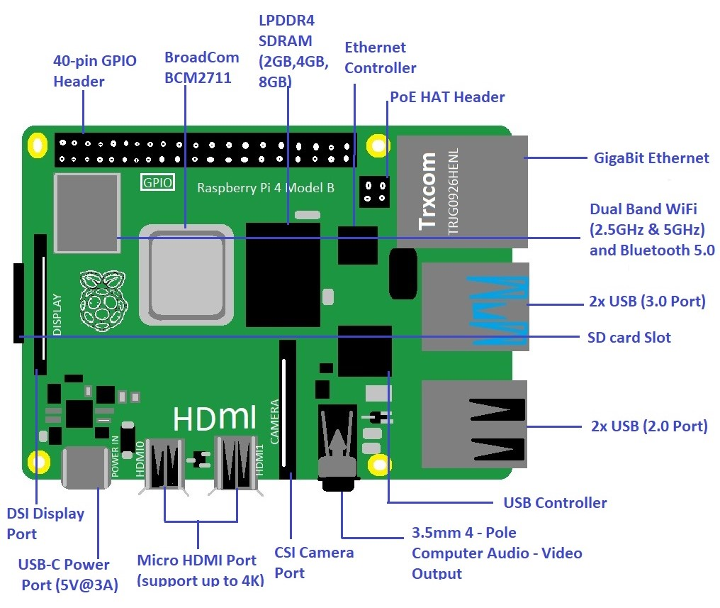

Note: SD card slot is given at the back of Raspberry Pi board

**FEATURES**

* This Model Featuring Broadcom System on chip (SoC), which includes quad core ARM 64-bit Compatible CPU @1.5GHz and an on-chip Graphics Processing Unit (GPU, Video Core VI @500MHz).
* It comes with true Gigabit Ethernet Capable of sending Ethernet Frames at rate of one gigabit per second (1 billion bits per Second)
* Secure Digital (SD) cards are used to store the operating system and program memory in either the SDHC or Micro SDHC sizes.
* The number of GPIO pins which support common protocols such as **SPI** (*Serial Peripheral Interface*), **I2C** (*Inter Integrated Circuit*) and **UART** *(Universal Asynchronous Receiver and Transmitter)*

**OPERATING SYSTEM**

* The Raspberry Pi 4 has a 64-bit Architecture, the board is compatible with Pi 64-bit OS.
* The Foundation provides Raspbian, a Debian-based Linux distribution for download, as well as third party Ubuntu, Windows 10 IOT Core, RISC OS, and specialized media center distributions.
* It promotes Python and Scratch as the main programming language, with support for many other languages.

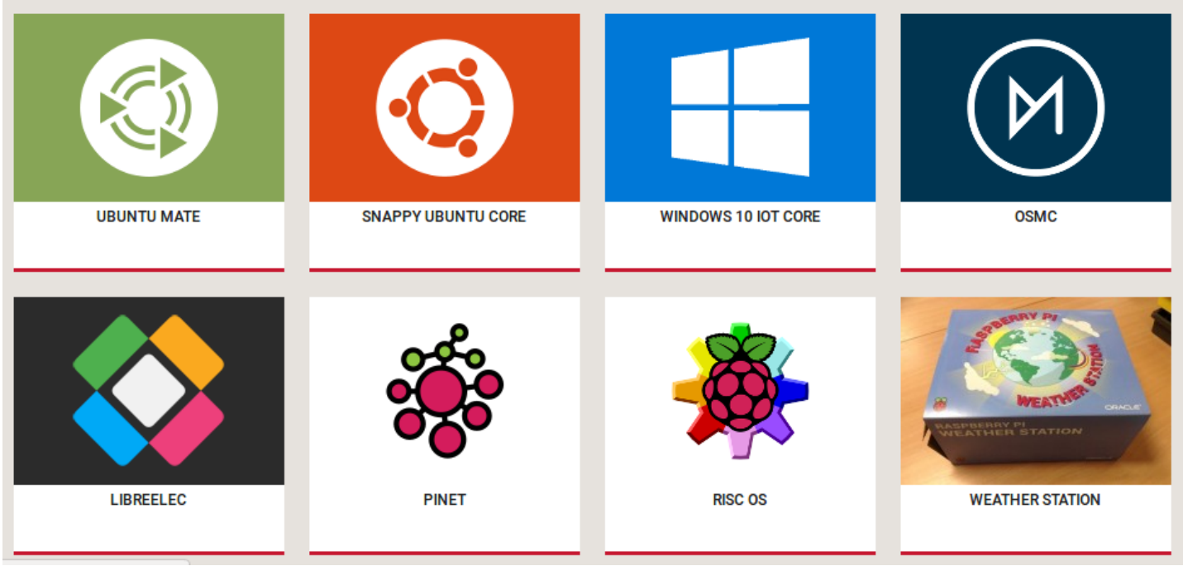

**GPIO PIN**

* GPIO stands for *General Purpose Input Output* pins. It is used to connect Raspberry pi board to external input/output peripheral devices.
* It acts as standard interface for connecting a single-board computer/microprocessor to other devices through (GPIO) pins.
* GPIO pins do not have any specific function, these pins can be customized using the software.

* This model B consists of a 40-pin GPIO header. Out of these 40 pins, 26 pins are GPIO pins.

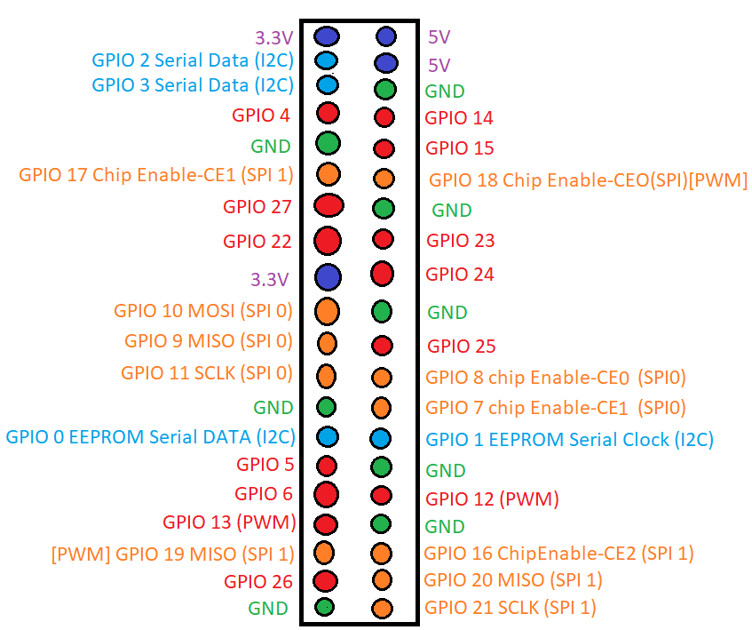

**What is mean by GPIO Pin...?**

* A pin that can be set as an input or output and is controlled in run time is called a GPIO pin.
* Input voltage between *1.8V* and *3.3V* is read as **HIGH** by the Raspberry pi and input voltage are *lower than 1.8V*, it is read as **LOW**.

**POWER PINS**

* The raspberry pi 4 model B board consists of two 5V pins, two 3.3V pins, and 8 ground pins (0V).
* **5V** -> The 5v pin outputs the 5 volts coming from the USB Type-C port.
* **3.3V** -> The 3v pin is used to provide a stable 3.3v supply to external components.
* **GND** -> The ground pin is commonly referred to as GND.

**What is PWM...?**

* **PWM -** *Pulse Width Modulation*
* With the help of PWM, an analog value is being modulated on a digital signal.
* Software PWM is available on all pins.
* Hardware PWM is available on these pins only: GPIO12, GPIO13, GPIO18, GPIO19.

**SPI PINS**

* 5 Pins are required for the SPI communication:
  + GND - Ground
  + SCLK - Serial Clock
  + MOSI - Master Out Slave In.
  + MISO - Master In Slave Out
  + CE - Chip Enable

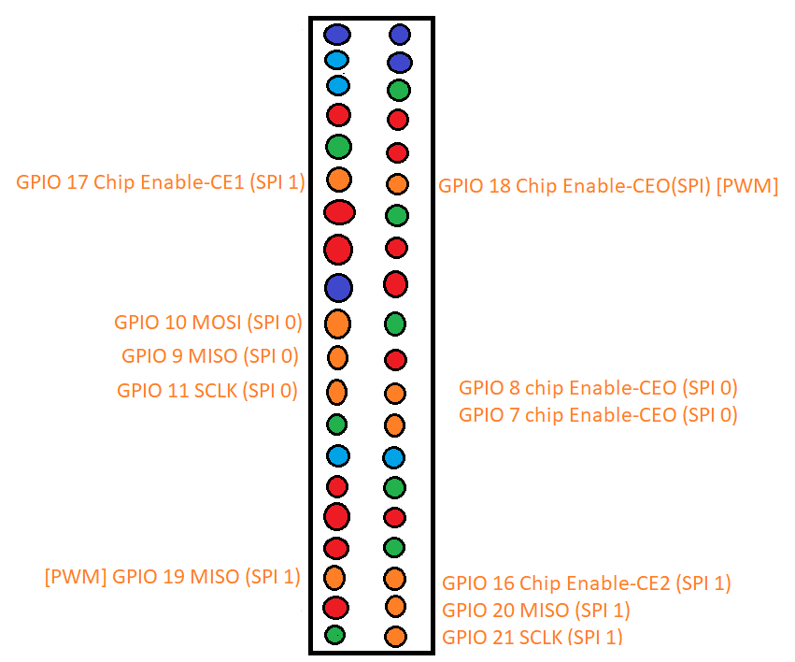

* **GND** - Connect the GND pin from all the slave components and the Raspberry Pi 4 board together.
* **SCLK -** Clock for SPI communication.
* **MOSI** - This pin is used to send data from the master to a slave.
* **MISO -** This pin is used to receive data from a slave to the master.
* **CE -** We need to connect one CE pin per slave (or peripheral devices) in our circuit.
* **SPI 0** -GPIO9 (MISO), GPIO10 (MOSI), GPIO11 (SCLK), GPIO8 (CE0), GPIO7 (CE1)
* **SPI 1** -GPIO19 (MISO), GPIO20 (MOSI), GPIO21 (SCLK), GPIO18 (CE0), GPIO17 (CE1), GPIO16 (CE2)

**What is mean by SPI...?**

* **SPI** (*Serial Peripheral Interface*) is “Synchronous” Full duplex communication protocol and it uses master-slave communication to fast communicate between one/ more peripheral devices.
* It supports only multi-Slave and does not support multi-Master.
* During Communication, data is shifted out from master and shifted into slave and vise-versa through Shift registers.

**I2C PINS**

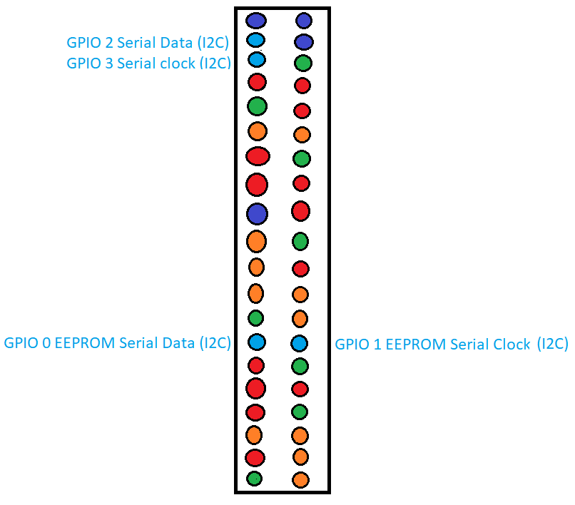

* I2C protocol requires two connections:
  + **SDA** - Serial Data
  + **SCL** - Serial Clock
* **SDA -** It is Most helpful resource for transmitting the Data.
* **SCL** - The Speed ofData transfer is controlled through the SCLK unit.
* **Data -** (GPIO2), Clock (GPIO3)
* **EEPROM Data -** (GPIO0), EEPROM Clock (GPIO1)

**What is meant by I2C....?**

* **I2C** (*Inter-Integrated Circui*t) is “Synchronous” low-speed two-wire serial communication protocol and uses master-slave roles between the board and the peripheral devices.
* It supports both Muti Master and Multi Slave.
* I2C is used in Various Control Architecture such as:
  1. **SMB** – *System Management Bus*
  2. **PMB** – *Power Management Bus*
  3. **IPMI** – *Intelligent Platform Management Interface.*

**UART PINS**

* **UART** (*Universal Asynchronous Receiver / Transmitter*) is an “Asynchronous” Serial Communication protocol that provides a way to communicate between two Microcontroller/Devices.
* TX pin transmits the serial data to the RX pin of another device and RX pin receives the serial data coming from TX pin of the other device.
* **TX – GPIO14**
* **RX - GPIO15**

**SCHEMATIC DIAGRAM OF RPi 4**

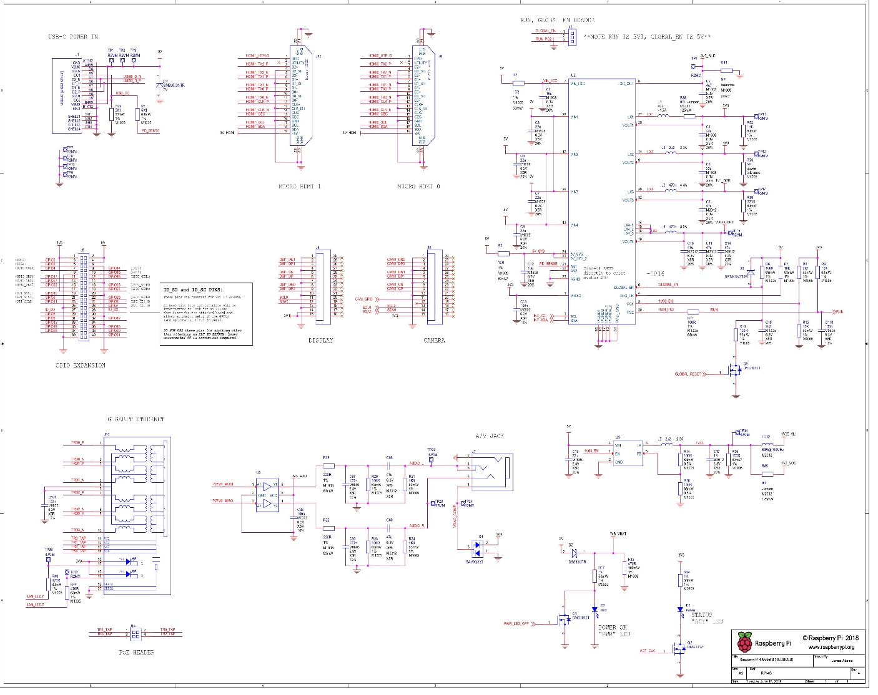

**APPLICATION**

The following are the Raspberry Pi 4 Applications.

* Used in making a portable game console
* Employed in-network Ad-blocker
* Used in Airplay speaker
* Used in wearable timelapse camera
* Incorporated in-home network music system
* Used in embedded system IoT projects
* Employed in making guitar pedal
* Used in making FPV robot
* Incorporated in WiFi security camera