# 1.Website immediately after creating elastic bean stalk (blue color php page)

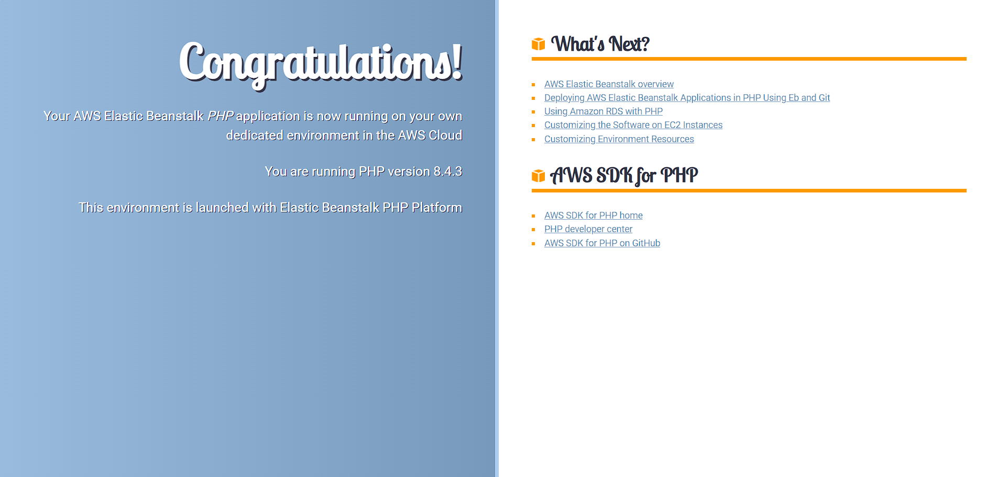

# 2.Website after deploying your code from github (first time)

# 

# 3.Website after making changes to index.html and running the changes through code pipeline

# 