MACHINE LEARNING OPERATIONS
END-TO-END ASSIGNMENT REPORT
AIMLCZG523 | Assignment 01
Heart Disease Risk Prediction: data, experiments, CI/CD, and API serving
Prepared from the implementation and validation evidence in the project repository
Report date: 16 October 2026
Repository: naresh-infra/mlops-heart-disease-assignment
Academic integrity note: this report describes this repository's own implementation and observed results. CI deployment was verified in a temporary Kind cluster; no persistent cloud or Kubernetes deployment is claimed.

1. Executive Summary
Objective, project scope, and outcome
This assignment operationalizes a binary heart-disease risk classifier as a repeatable machine-learning service. The implementation connects data acquisition, missing-value treatment, visual exploratory analysis, preprocessing, model selection, experiment tracking, API inference, telemetry, automated tests, Docker packaging, and Kubernetes deployment configuration.
The service predicts target 0 (healthy) or 1 (risk detected) from 13 clinical attributes. The prediction API also returns a probability-based risk score, a status label, and measured latency. The model and preprocessor are persisted together in one scikit-learn pipeline so serving uses the same transformations learned during training.

Objectives
Mapped to the assignment rubric
- Acquire and clean the Cleveland Heart Disease data; generate class-balance, correlation, and clinical-feature visualizations.
- Compare Logistic Regression and Random Forest using stratified cross-validation, parameter search, and a held-out test partition.
- Record parameters, metrics, serialized models, tuning tables, and EDA figures in MLflow.
- Provide validated FastAPI endpoints, structured logs, and Prometheus metrics.
- Use GitHub Actions to install dependencies, lint, run scripts and tests, build a Docker image, and exercise container endpoints.
- Supply Kubernetes manifests and document the operational evidence and remaining live-deployment steps.
Evidence: local unit tests and strict lint passed. GitHub Actions run 13 passed dependency installation, linting, data preparation, EDA, training, all tests, Docker image build and smoke test, plus rollout and health/prediction verification in an ephemeral Kind Kubernetes cluster. A persistent cloud or local-cluster deployment has not been performed.

2. Dataset Acquisition and EDA
Source, cleaning, and observed data profile
The source is the Cleveland processed dataset published by the UCI Machine Learning Repository. The project configuration stores the source URL, local raw-data path, target name, input column names, split fraction, and deterministic random seed.
The loaded dataset contains 303 records and 14 columns. After target binarization, class counts are 164 healthy and 139 disease-risk records. The loader treats '?' as missing, imputes ca and thal using their medians, and maps the original disease-severity values above zero to class 1.
The reusable EDA module creates three 300-DPI charts: target class balance, a clinical-variable correlation heatmap, and target-separated histograms with density estimates for age, resting blood pressure, cholesterol, and maximum heart rate. The same figures are logged to each candidate's MLflow run.
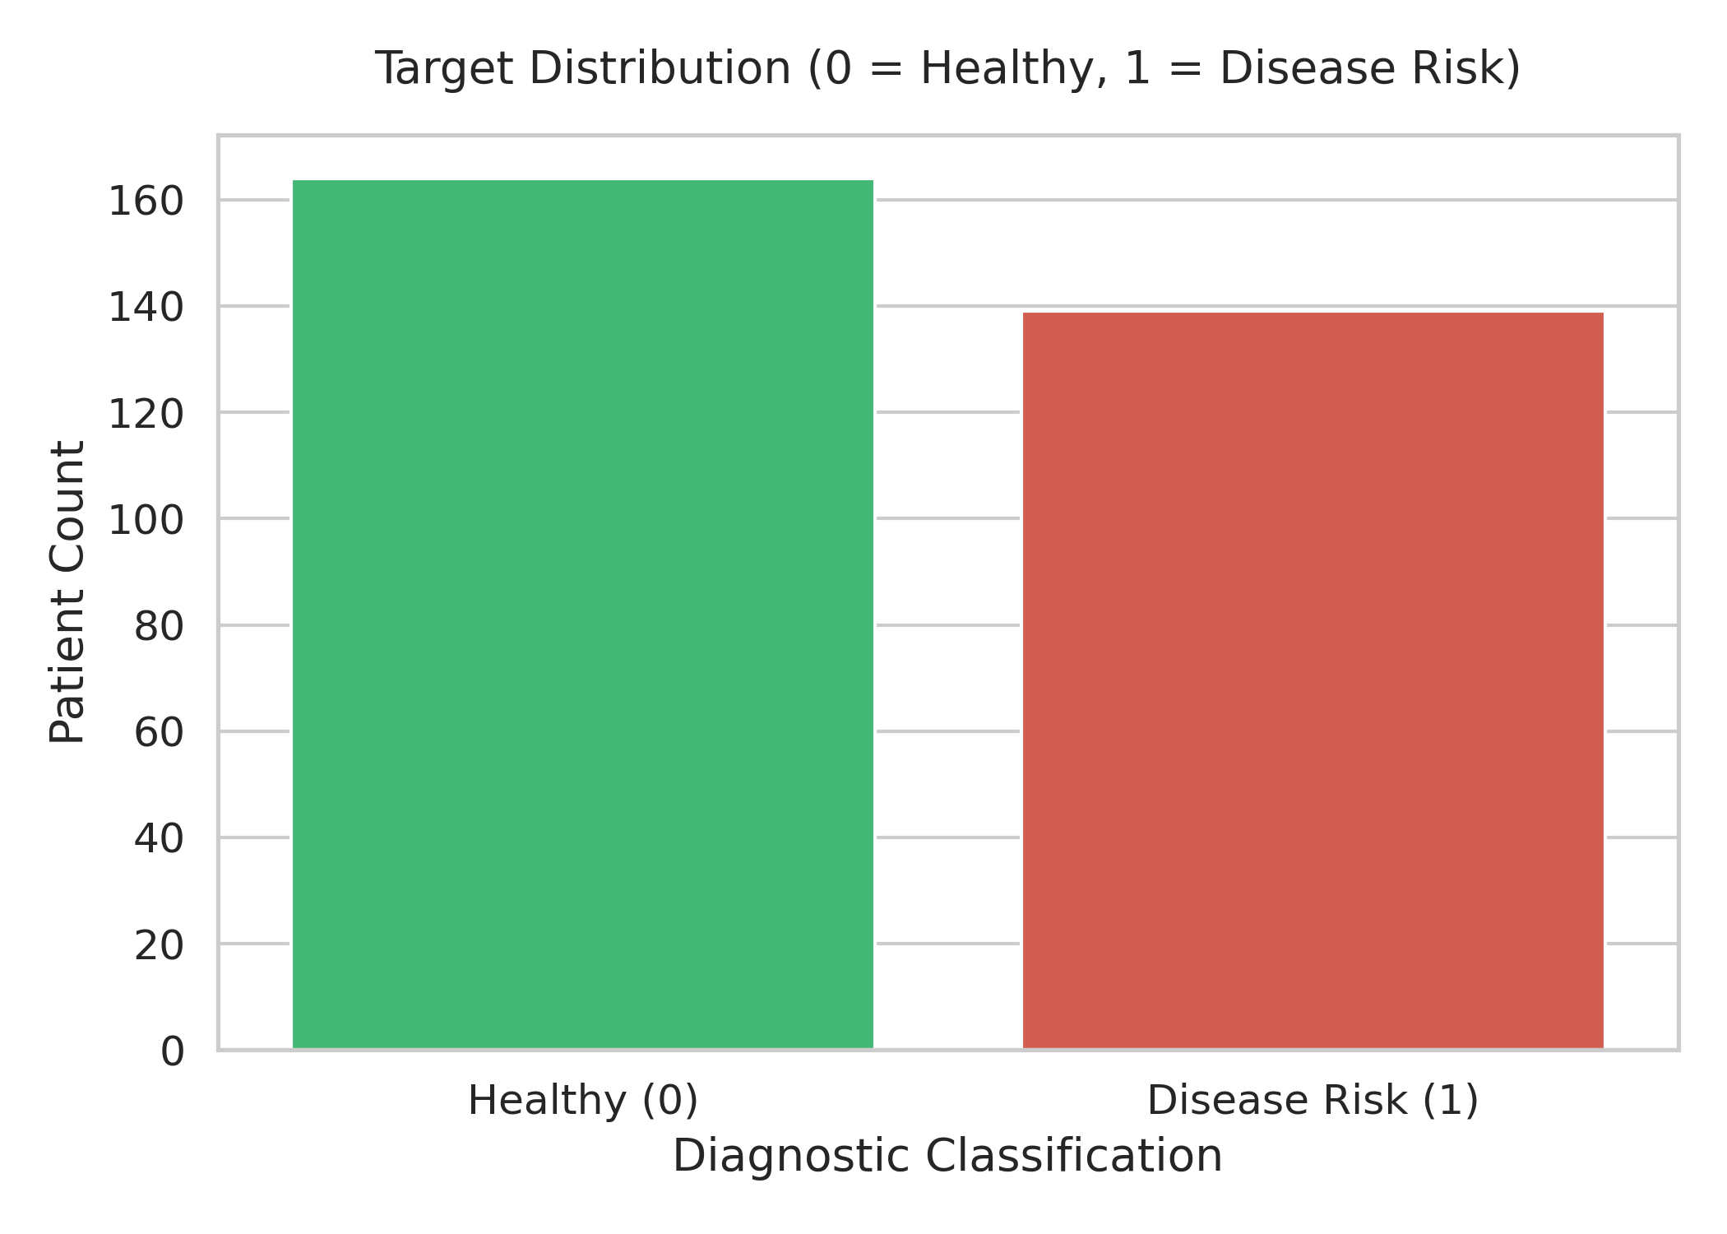
Figure 1. Target class balance
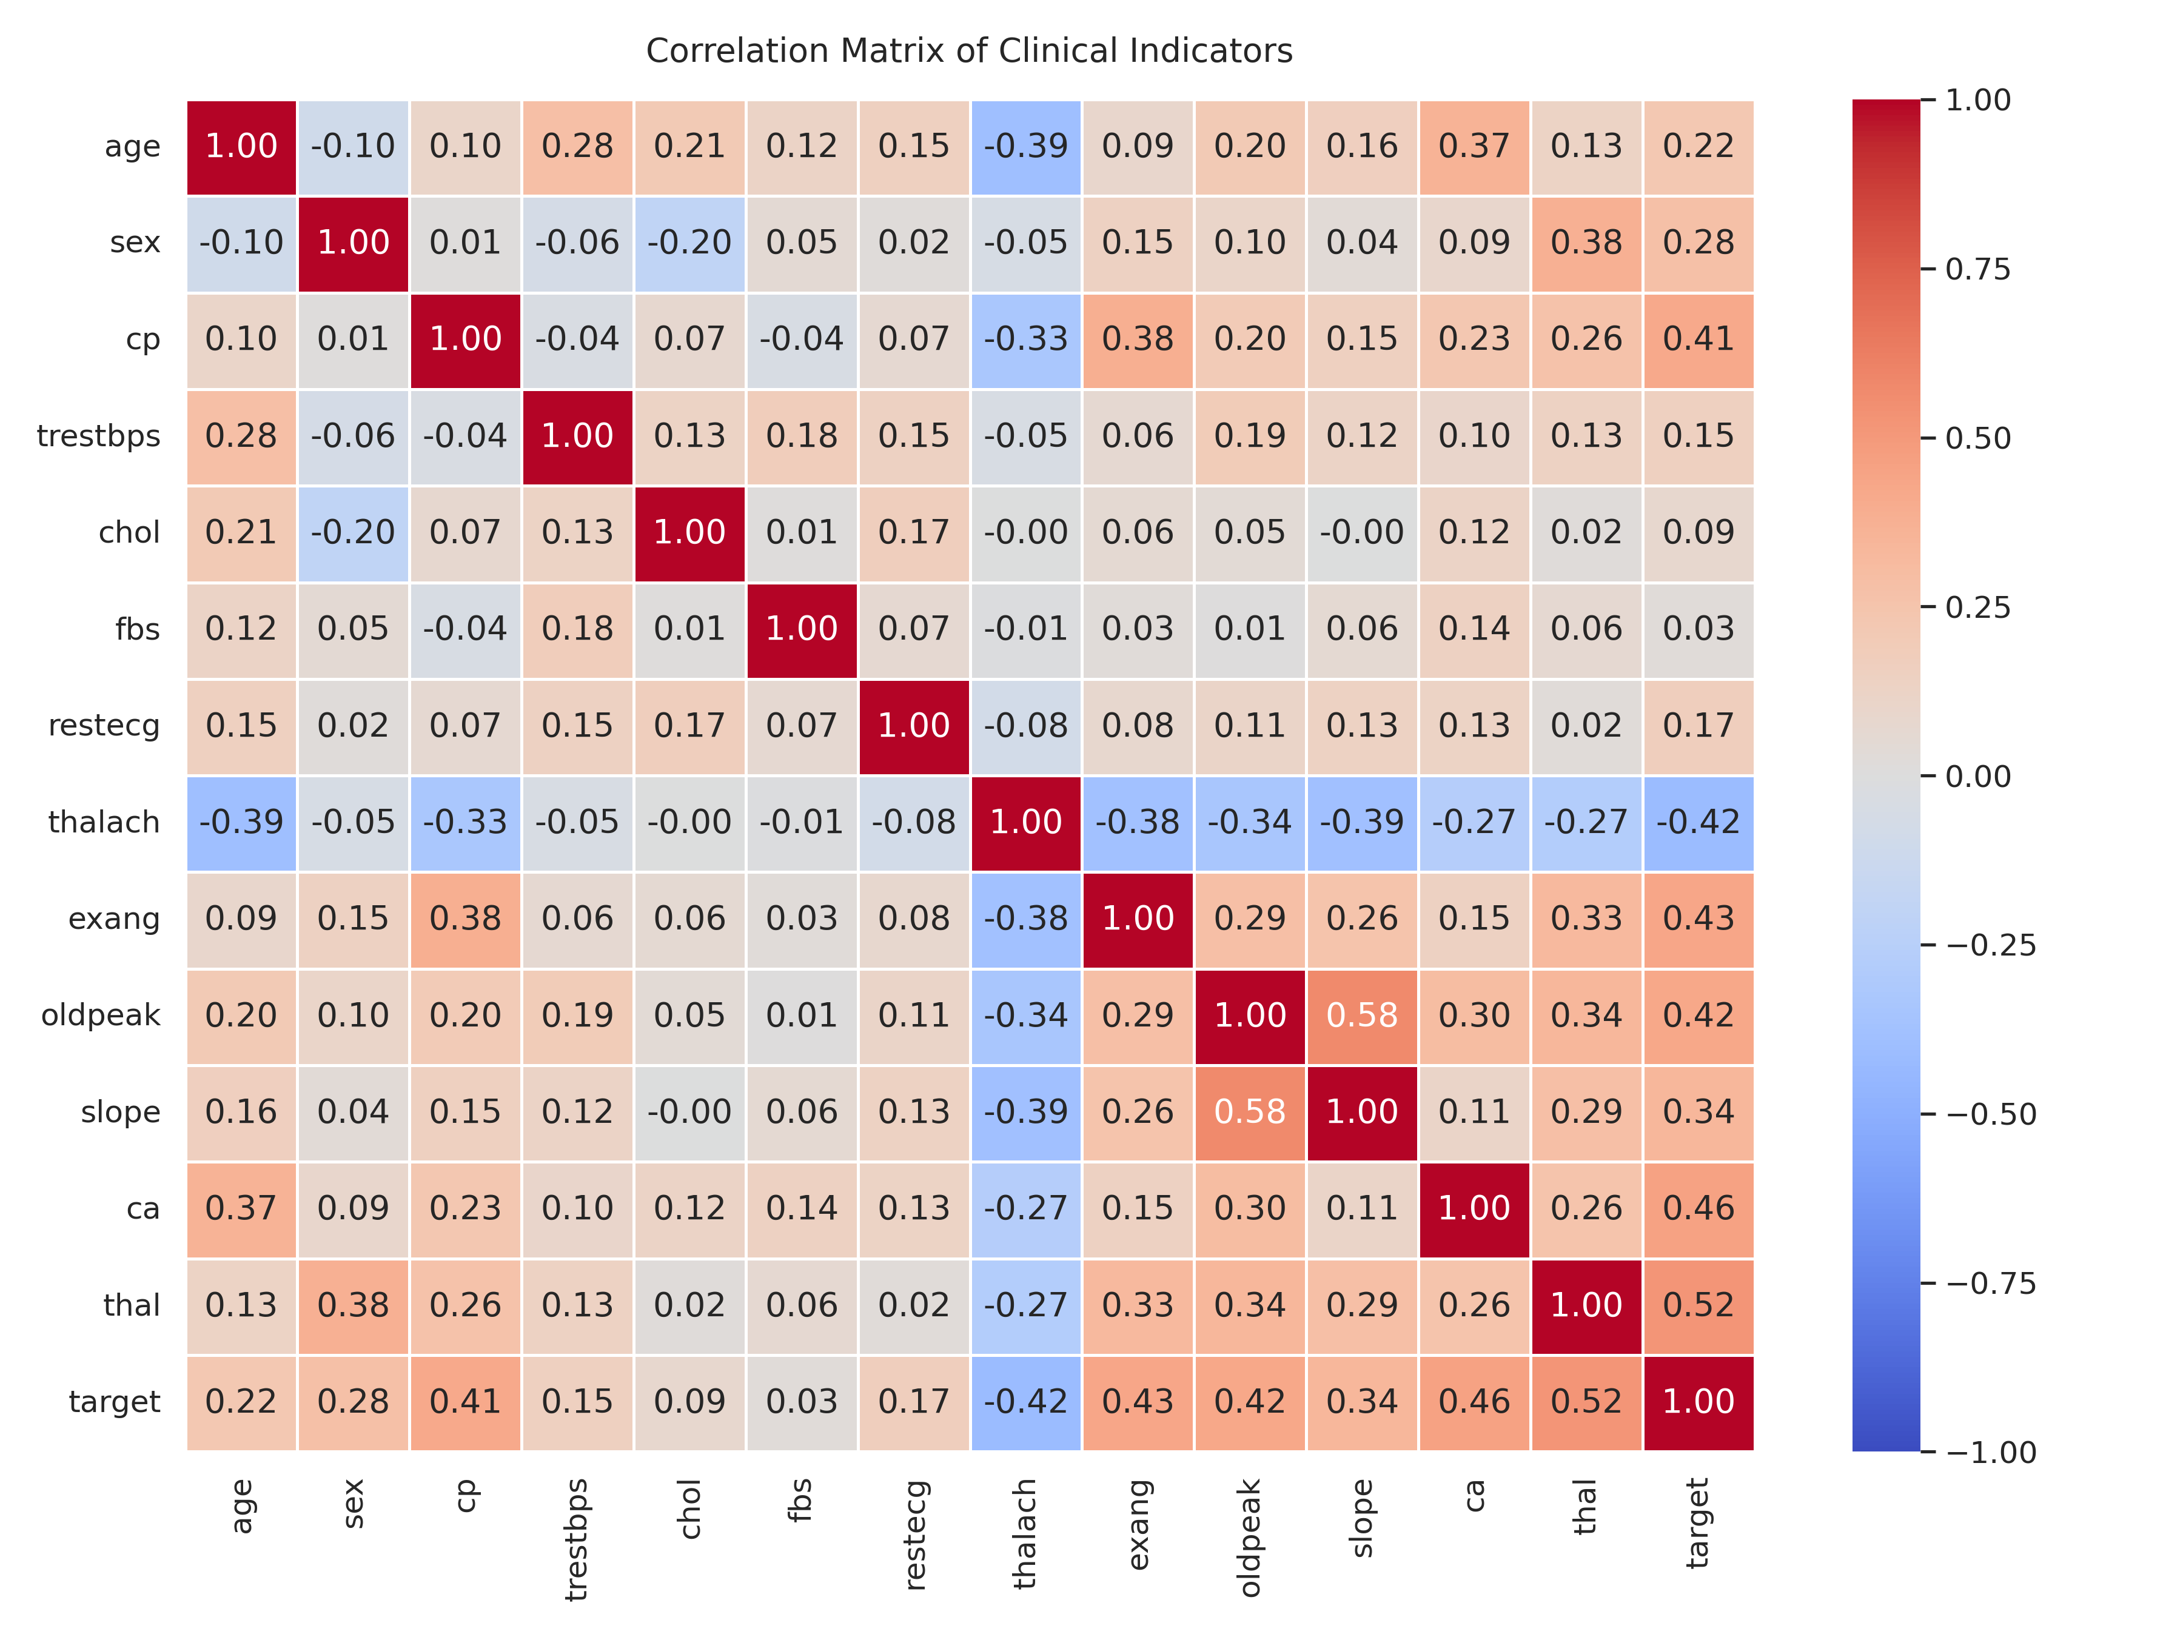
Figure 2. Clinical feature correlations

3. Feature Engineering and Model Development
Leakage-aware selection and evaluation
Five numerical features are standardized. Eight categorical/code-valued clinical fields are one-hot encoded with unknown categories ignored. The ColumnTransformer and classifier are combined in a scikit-learn Pipeline, keeping feature transformations attached to each model artifact.
The data is split once using a stratified 80/20 train/test split and random seed 42. GridSearchCV performs stratified 5-fold cross-validation within the training partition, selects each family?s best configuration by ROC-AUC, and raises immediately for failed candidate fits. The held-out test partition is used for the final evaluation and is not used for parameter search.
Candidate | Search space | CV ROC-AUC | Test accuracy | Test ROC-AUC
Logistic Regression | C: 0.01, 0.1, 1, 10 | 0.9025 | 0.8852 | 0.9665
Random Forest | 100/200 trees; depth None/3/5; split 2/4 | 0.9073 | 0.8852 | 0.9416

These are results from the isolated training verification run in this workspace, not a guarantee of performance on new populations. The winning pipeline was Random Forest because its mean CV ROC-AUC was 0.9073. Although Logistic Regression had a higher held-out ROC-AUC in this particular split, candidate selection followed the predeclared CV ROC-AUC rule rather than selecting after inspecting test results.
The final pipeline is saved to models/heart_disease_pipeline.pkl. Data schema, feature transformation output shape, and absence of transformed NaN values are tested.

4. Experiment Tracking and Reproducibility
MLflow evidence and saved artifacts
Each candidate model is represented by an MLflow run named after its estimator family. Runs capture the CV fold count, test split, selected parameters, CV means and standard deviations for accuracy, precision, recall, and ROC-AUC, and final held-out test metrics for the same four measures.
- Logged model: fitted preprocessing-plus-estimator pipeline for each candidate.
- Logged tuning evidence: complete GridSearchCV result table, including candidate configurations and fold scores.
- Logged visual evidence: all three EDA plots under the run's eda artifact path.
- Production artifact: joblib-serialized winning fitted pipeline.
- Tracking location: environment-configurable MLflow URI; local training defaults to the repository's mlruns folder.
A disposable-copy verification run completed both searches and created two MLflow runs. It confirmed CV and test metrics, model outputs, EDA artifact folders, and tuning tables. The existing repository has local MLflow history; changes to these local generated stores were intentionally not mixed into the code commit.

Reproducibility limits
What should be pinned for long-lived production use
requirements.txt declares minimum versions, not a full lockfile. CI installs from that manifest and runs pip check, but the developer workstation currently has unrelated global package conflicts. A project-specific virtual environment and a generated, reviewed lockfile would improve repeatability across machines. Pickle/joblib loading should only be performed on trusted model artifacts, and training and serving dependency versions should be recorded together.

5. Inference API
Request validation, responses, and service behavior
FastAPI loads models/heart_disease_pipeline.pkl at application startup. GET /health returns a success response only after the model loads. POST /predict validates all required patient fields and value ranges, constructs the input DataFrame, and returns the binary prediction, positive-class probability, status label, and inference latency. Invalid schemas return HTTP 422; unavailable model state returns HTTP 503.
Endpoint | Purpose | Evidence
GET /health | Readiness / model loaded | TestClient test; CI container check
POST /predict | Validated JSON inference | Valid and invalid schema tests; CI sample request
GET /metrics | Prometheus exposition | Mounted Prometheus ASGI app

The service records request count by endpoint/status, inference-duration histogram, and prediction counts by class. Inference logs are structured JSON and include prediction, risk score, latency, and submitted fields. Because clinical inputs are sensitive, real deployments should minimize or remove raw input values from logs and apply access control, retention, and privacy policies before handling real patient data.
Example response: {"prediction": 0, "risk_score": 0.1524, "status": "healthy", "latency_ms": 71.65}. The returned probability is a model score, not a diagnosis or clinical recommendation.

6. System Architecture
Data-to-service flow
The architecture separates data cleaning, feature preparation, model development, tracking, artifact packaging, and inference. CI checks code and exercises the same container artifact intended for deployment.
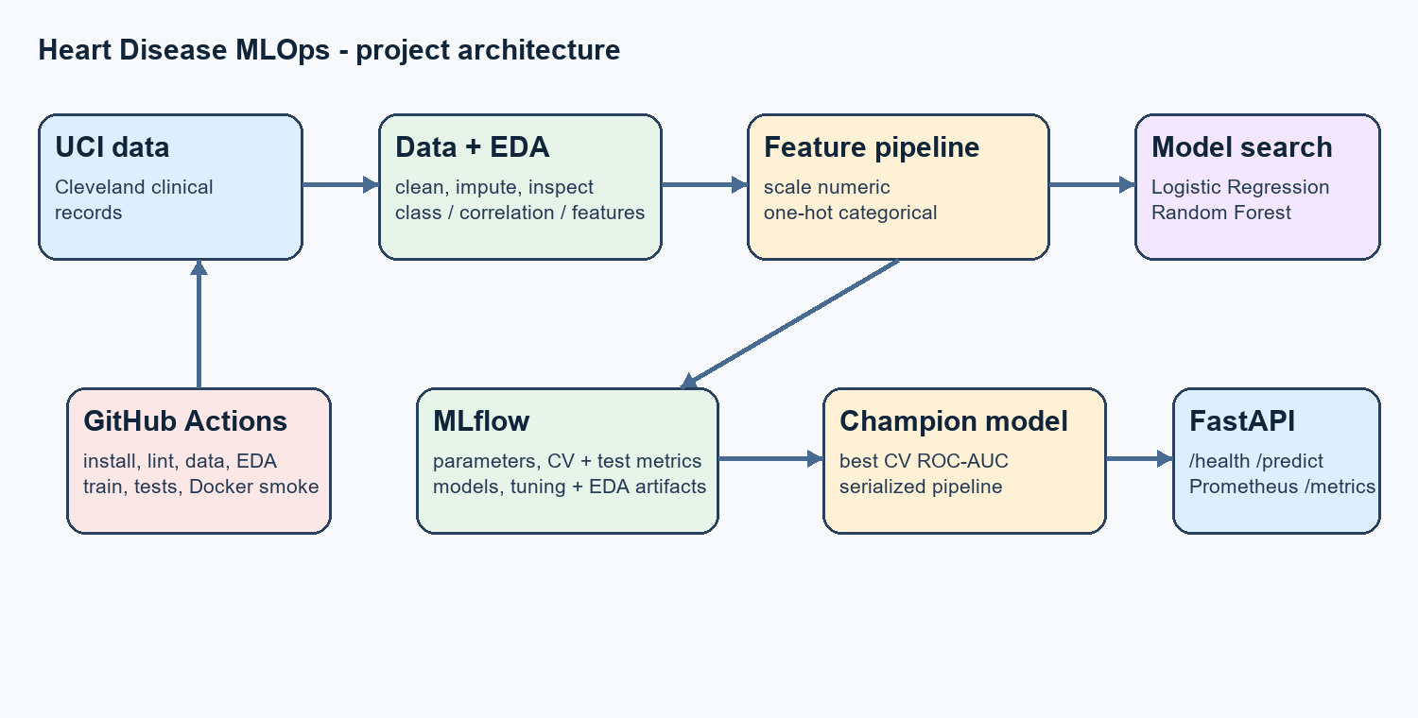
The preprocessing and estimator remain in one artifact so training-time transformations are reused at inference. MLflow supplies experiment evidence; the API remains independently deployable and exposes Prometheus telemetry. The Kubernetes Deployment, Service, and Ingress manifests are configuration inputs to a cluster deployment; a manifest by itself is not evidence that a cluster is running.

7. Automated Testing and CI/CD
Fail-fast validation and stored workflow outputs
The GitHub Actions workflow runs on pushes and pull requests targeting main. Its steps install Python 3.11 dependencies from requirements.txt, run pip check, execute Ruff without auto-fixing, run the data preparation and EDA scripts, train and track models, run pytest, build the Docker image, and run a container smoke test.
- The smoke test polls GET /health for readiness, then posts a valid patient JSON document to POST /predict and asserts response fields and probability bounds.
- A shell trap prints container logs and removes the temporary test container, including on failure.
- Workflow artifacts include MLflow run data, EDA figures, and the generated production model; upload runs even if an earlier step fails.
- Tests cover source schema and labels, missing-value imputation and target binarization, preprocessing, EDA figure creation, API health, valid inference, and input validation.
GitHub Actions run 13 completed successfully for commit 7459aab. It passed lint, data preparation, EDA, model training, pytest, Docker build and container health/prediction checks, and deployment/API verification in an ephemeral Kind cluster: https://github.com/naresh-infra/2025ae05860-mlops-heart-disease-assignment/actions/runs/38850696415. This verifies the automated CI deployment, not a persistent cloud service.
Local validation in this workspace: strict Ruff passed; all 7 tests passed; workflow and Kubernetes YAML parsed; and training/MLflow verification succeeded in a temporary copy. The test output includes dependency deprecation warnings that are not test failures.

8. Containerization and Deployment
Configuration versus verified deployment
The multi-stage Dockerfile installs requirements in a Python 3.11 builder, copies the application, configuration, and model into a slim runtime image, runs as a non-root service user, and exposes port 8000. CI now builds and starts this image and sends health and prediction requests.
Kubernetes assets include a two-replica Deployment with resource requests/limits and readiness/liveness probes, a LoadBalancer Service, and an Ingress. The unnecessary path rewrite was removed so API endpoint paths are preserved.

Deployment verification status
No live cluster is claimed in this report
The local Docker Desktop and Kubernetes contexts were unavailable during development. GitHub Actions run 13 subsequently built and ran the image, then deployed the manifests to an ephemeral Kind cluster. The workflow confirmed deployment rollout and exercised the service health and prediction endpoints. This is verified temporary-cluster deployment evidence; it is not a persistent cloud deployment.
To complete a genuine local deployment demonstration: start Docker Desktop; start Minikube with an available driver; build the image into Minikube's image store or push it to a registry and use that image in the Deployment; apply deployment.yaml, service.yaml, and ingress.yaml; wait for rollout/readiness; expose the service; call /health and /predict; and capture actual cluster and API evidence. Do not label the existing CI screenshot as Kubernetes deployment proof.

9. Reproduction, Conclusions, and References
Practical hand-off and remaining evidence

Reproduction commands
Run from the project root after activating a fresh Python 3.11 environment
python -m pip install -r requirements.txt
python -m pip check
python -m src.data_loader
$env:PYTHONPATH='.'; python notebooks\01_exploratory_data_analysis.py
python -m src.train
python -m pytest tests -v
python -m uvicorn src.app:app --host 0.0.0.0 --port 8000
docker build -t heart-disease-api .
docker run --rm -p 8000:8000 heart-disease-api

Conclusion
Implemented work and evidence still required
The repository demonstrates the core end-to-end MLOps path: data cleaning and EDA, reusable preprocessing, tuned model candidates, stratified CV plus held-out evaluation, MLflow evidence, a validated inference API, telemetry, tests, Docker packaging, CI, and Kubernetes deployment configuration. GitHub Actions run 13 passed Docker build/runtime checks and Kubernetes rollout and API verification in an ephemeral Kind cluster. A persistent cloud/cluster deployment and its screenshots remain outside the verified evidence. The pipeline screen recording is included in the repository.

References
- UCI Machine Learning Repository, Heart Disease Data Set: https://archive.ics.uci.edu/dataset/45/heart+disease
- Project configuration: config/config.yaml; implementation: src/; automated checks: tests/ and .github/workflows/ci-cd.yml.
- Documentation: scikit-learn Pipeline/GridSearchCV; MLflow Tracking; FastAPI; Prometheus client instrumentation.
Assignment deliverables verified in this repository include the green CI run with container runtime smoke tests, ephemeral Kubernetes rollout and endpoint checks, and the real pipeline screen recording. The accompanying project_overview.mp4 is a separate slide-based overview. A persistent cloud/cluster deployment and its screenshots are not included; CI evidence is from a temporary Kind cluster.

