**A**

**SYNOPSIS REPORT**

On

**CODEXA**

Submitted in partial fulfilment of the requirements of the degree of

**BACHELOR OF TECHNOLOGY**



Submitted by

Naresh Mali (19etccs204)

Ashish Jain (19etccs200)

Krishna Goswami (18etccs055)

Tarun Tailor (18etccs089)

**COMPUTER SCIENCE & ENGINEERING**

**TECHNO INDIA NJR INSTITUTE OF TECHNOLOGY, UDAIPUR**

**DECEMBER 2021**

**PROBLEM STATEMENT**

Building an application is quite challenging for developers especially when you are a new coder or you are a solo coder. Quite often developers get stuck in their projects due to some errors. Sometimes it’s also difficult to build some specific features and there you just want readymade code snippets. In all these cases, you may need help from your coder friend or your colleague. Most of the time the other person has to look into your code to fix the error or to provide you with any kind of help in the project. Here comes the importance of code-sharing websites that help share your code with someone else to debug the issue. These code-sharing websites allow developers to share a specific part of the code, function, or code snippets. All you just need to do is to copy and paste your code on these websites and then give this link to your team member or your friend.

There are a few code sharing and Blog sharing websites out on the web with different features. You just need to choose the best one as per your needs. In this article, we have put together some useful and best code-sharing websites that you could use. There are some already great platforms out there that help the user to place their code fine and securely GitHub, git, Code Pen, etc.

So, in our project titled Codexa in these users can upload their code snippets and blogs to publish on the website it is a far private sort of web app which allow the user to upload their daily work in form of blogs or it can be their code or any sort of information available there.

**OBJECTIVE AND SCOPE**

The main objective of our Webapp is to provide the user a platform where users can easily upload a blog or the code snippets or any file which they want to store. And in any case as a developer or content writer we created a lot of files due to storage issues we can’t store them in the local so here is the Codexa platform which allowed the user to store their content in form of a Blog or it can be any information as well.

Since the usability and accessibility of the internet are growing tremendously day by day a sort of new opportunity is created because of the widespread of the internet. Through the internet, there is what we are consuming is content so basically, the content industry is a highly paid and booming sector but most people can’t afford to buy hosting and domain services because they are very much costly and can’t be purchased by anyone easily. There are very much free services also available which allow the user to maintain or upload their content such as medium.com

Medium.com is the highly traffic platform a or we can say that we have another platform such quora.com these two platforms also allow the user to post here content on their site to and the main thing is that they are free of cost.

So, in order to complete with these, we have created our responsive webapp with have following objective listed as below.

To provide New and Updated Content

* User Authentication.
* No illegalities
* Data Security
* Single Login
* Valuable Content
* Powerful Backend

And, far better functionality added to our app because at backend we have use Google Firebase which helps our app to get a super backend performance but here we are gone with some cap because firebase is freemium service and it doesn’t allow as much as feature to boost up or app but then too we have created a super authentication service and a storage bucket and use real time firebase database

**METHODOLOGY AND TOOLS**

In this topic we will get to introduce to Tools and the Methods or the environment that helped us to create our Web Application, this topic includes all the Materials and Techs we used to create our Web App.

In this project we will use the following Technologies:

* HTML 5
* Angular JS
* CSS3
* Bootstrap
* ES6 JavaScript
* Node.JS
* MongoDB

**SOFTWARE USED**

* Operating System: Windows 10
* Front-End: Angular JS
* Back-End: Node.js, ES6
* Data Base: MongoDB
* Development Platform Used: VS Code
* Synchronization / Version Control Platform: GitHub

**APPLICATION**

We are gone through with some less facility because there is short span of time and most of us are new to this

* NO Privacy issues.
* End User Approach.
* No need to share User’s information to accessing Website.
* Free to Use.
* No involvement of third-party websites.
* Simple and effective UI.
* User Cantered UX approach
* Responsive Web Application works on all Platforms.
* User can update their profile.
* User can reset their password.

**FUTURE SCOPE**

It is almost impossible to see what would happen in the near future to this application or how the future would affect our Application , as multiple factors play a major role in Future development that is what If some new Technology would develop that would be used in my Application .In the development process of any product, the team must have a future vision also in order to get a great scope for the product or we can say that it helps the app or the product to sustain in the market to meet the industries levels. And it could change the entire Working of the Application. By working of course, I meant the Look and Feel Not the Aim of our Application i.e. Codexa But we do have some Idea what we can do to Develop Our Project Further

So here are some of the Function which we want to introduce in our future version of the product are listed below:

* Greater UI/UX experiences
* We will add a super and tough validation in text area tag in which can only type or paste only the desired code or service.
* Improve Authentication Services.
* More categories with effective management

In my Opinion this Application Has a Bright Future in the Upcoming Times if it gets updated Frequently as there is no Shortage of Competition, Again the Development of this Application cannot be Predicted As time And Technologies Are the major Factors That Can Affect its Development

**PROJECT TIMELINE**

**Pert Chart**

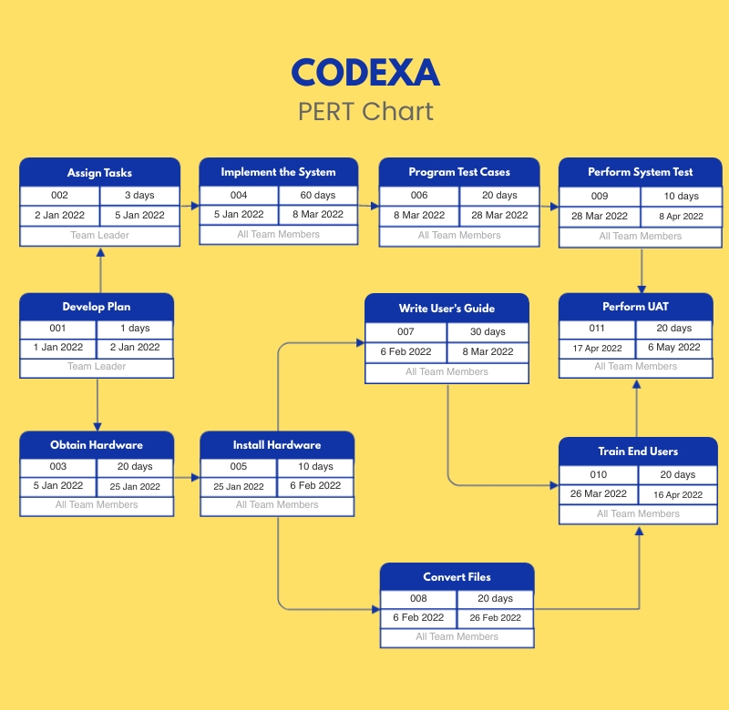

**REFERENCES/BIBLIOGRAPHY**

Developing or creating a product need a lot of go through with documentation so hence this are some of the links we use during the web app development.

* <https://www.w3schools.com/>
* <https://www.geeksforgeeks.org/>
* https://university.mongodb.com/
* <https://nodejs.org>
* <https://youtube.com>

**GROUP DETAILS**

Team Name: Runtime Terror

Branch: Computer Science & Engineering

Semester: 7th

Naresh Mali (Team Leader) – 19ETCCS204

Email: [19etccs204@technonjr.org](mailto:19etccs204@technonjr.org)

Mobile: 9251304304

Ashish Jain – 19ETCCS200

Email: [19etccs200@technonjr.org](mailto:19etccs200@technonjr.org)

Mobile: 7023888259

Krishna Goswami – 18ETCCS055

Email: [18etccs055@technonjr.org](mailto:18etccs055@technonjr.org)

Mobile: 9214034315

Tarun Tailor– 18ETCCS089

Email: [18etccs089@technonjr.org](mailto:18etccs089@technonjr.org)

Mobile: 8233211909