Automated AI-Driven Loan Underwriting & Document Fraud Detection System
Second Review – Technical Supplement
Naresh S | Roll No: 2436MCA0047 | Reg. No: 67224200080

1. Overall System Design
This section describes the system as actually implemented at the Second Review stage: a decoupled three-tier architecture matching the one proposed in the First Review, with the full forensics, reconciliation, scoring and human-review pipeline built and tested end-to-end.

1.1 Architecture Overview
The system is organised into three independently deployable tiers, communicating over HTTPS/REST, matching the block diagram proposed in the First Review (Figure 5.1):
Tier | Responsibility
Presentation (Next.js 14 / React / Tailwind CSS) | Applicant portal (apply, upload, track status) and loan officer console (queue, split-screen document/heatmap viewer, ledger table, decision panel, audit trail).
API Gateway (Node.js 18 / Express) | JWT authentication and role-based access control (Applicant / Officer / Admin), magic-byte file validation, request orchestration, SQLite persistence, asynchronous dispatch of the analysis pipeline.
AI & Forensics Microservice (Python 3.11 / FastAPI) | PDF structural/metadata inspection, Error Level Analysis, ledger table extraction (pdfplumber + OpenCV-grid + Tesseract OCR fallback), deterministic ledger reconciliation, DTI/AMB calculation, XGBoost credit-risk scoring.

Why split this way: the gateway owns identity, authorization and persistence; the Python service owns pure computation (OCR, forensics, ML). Each tier is independently developable and testable, and the forensics service has no knowledge of HTTP sessions or the database – it only receives a file buffer and returns a structured verdict.

1.2 Request Flow and Asynchronous Processing
A key design decision made since the First Review is that document analysis now runs asynchronously rather than blocking the applicant's upload request. Originally, the upload endpoint awaited the entire forensics + ledger + XGBoost pipeline before responding – on a real document this could take several seconds, during which the applicant's browser simply waited with no feedback.
The upload endpoint now performs only fast, synchronous validation (magic-byte / MIME check, document-type check), immediately marks the application PROCESSING, and responds within milliseconds. The full pipeline then runs in the background; its result is written to the application record, and the frontend polls the application endpoint every 2.5 seconds while the application is not yet in a final state, so the UI updates itself with no further action from the user.
Step | Actor | Action
1 | Applicant | Submits loan details + uploads a document in one combined form.
2 | Gateway | Validates magic bytes, creates the application row, sets status = PROCESSING, responds immediately (HTTP 202).
3 | Gateway → Forensics service | Dispatches the file to the FastAPI microservice in the background (not awaited by the HTTP response).
4 | Forensics service | Runs metadata/font inspection, ELA, ledger extraction + reconciliation, DTI/AMB, and calls the XGBoost scorer.
5 | Gateway | Persists the result, computes the routing decision, writes a WORM audit-log entry, updates application status.
6 | Frontend (polling) | Applicant and officer views refresh automatically; the officer sees the full evidence set, the applicant sees only a status timeline.
7 | Officer | Confirms (one click for AUTO_APPROVE) or manually reviews / overrides / rejects; this decision is itself audit-logged.

This change was verified with a live timing test against the running services: the upload request returned in under 50 milliseconds in every trial, with the full pipeline result (forensics + ledger + credit score) appearing a few seconds later purely through polling – no page refresh or resubmission required.

1.3 Authentication, Authorization and Input Safety
- JWT-based authentication; tokens carry the user's id and role and are validated on every API route.
- Role-based access control: an Applicant can only see and act on their own applications; only Officer/Admin roles can issue a decision; the applicant view deliberately omits forensic internals (heatmap, metadata flags, ledger breakdown) – it only ever shows a status timeline and the final outcome.
- Magic-byte validation on every upload: the first bytes of the file buffer are checked against known signatures (%PDF-, \xFF\xD8\xFF for JPEG, the PNG signature) before the file is forwarded anywhere – a renamed executable or script cannot pass as a document.
- Password-protected PDFs: a session-only passphrase is accepted on upload and used once for that request; it is never written to disk, the database, or a log line. If a document turns out to be encrypted and no password (or the wrong one) was supplied, the application status becomes PASSWORD_REQUIRED and the same upload widget reappears for a retry – the applicant never loses their in-progress application.

1.4 Decision Routing Matrix
Three independent signals – structural/metadata forensics, ledger-math consistency, and the XGBoost credit score – are combined into one of four outcomes. Only the two fully deterministic checks (metadata fingerprinting and ledger arithmetic) are permitted to drive an automatic reject/fraud-alert; Error Level Analysis is treated as a diagnostic aid shown to the officer rather than an auto-gate, since it produces false positives on clean, sharply-scanned documents – a deliberate deviation from the First Review's original decision table, explained further in the Deviation section of the main Second Review Report.
Metadata / Font Flag | Ledger Math | Credit Score | Routing
Tampered | Any | Any | REJECT_FRAUD_ALERT
Clean | Drift / unverifiable | Any | MANUAL_REVIEW
Clean | Consistent | ≥ 750 (LOW risk) | AUTO_APPROVE (recommendation)
Clean | Consistent | 600–749 (MEDIUM) | MANUAL_REVIEW
Clean | Consistent | < 600 (HIGH) | REJECT

Even AUTO_APPROVE is only ever a recommendation: the officer console shows a “System check passed” panel with a single “Confirm & Approve” action – nothing is finalized without an accountable human decision (see Figure 5).

1.5 Persistence Schema
Data is persisted across five tables (SQLite in the current prototype; see the Deviation section for why MySQL, as originally proposed, was not used at this stage). Unlike the First Review's ER diagram, which groups the forensic/financial/risk results into JSON sub-documents on the applications table, the implementation uses flat typed columns throughout – simpler to query, index and validate at this scale, at the cost of needing a migration if a field is added later.
Table | Key fields | Purpose
users | id, fullName, email (unique), passwordHash, role | Credentials and role for Applicants, Officers and Admins. Passwords are bcrypt-hashed; the plaintext is never stored.
applications | id, applicantId (FK), loanAmount, tenureMonths, isTampered, tamperConfidence, isMathConsistent, verifiedMonthlyIncome, calculatedDTI, creditScore, riskBand, recommendation, status, lastError | The master record for one loan application: the applicant's request, every forensic/financial/risk result, and the current workflow status (including PROCESSING, PASSWORD_REQUIRED and ANALYSIS_FAILED – states introduced for the asynchronous pipeline in Section 1.2).
documents | id, applicationId (FK), docType, storageKey, mimeType, elaHeatmapBase64 | One row per uploaded file; the ELA heatmap is stored alongside it so the split-screen viewer can render both without re-running analysis.
ledger_line_items | id, applicationId (FK), documentId (FK), txnDate, credit, debit, balance, expectedBalance, isMathDrift | One row per reconciled transaction; expectedBalance and isMathDrift are the output of the Module 5 reconciliation algorithm (Section 4.2), not re-derived at display time.
audit_logs | id, applicationId (FK), reviewedBy (FK, nullable), actionTaken, evidenceHash, timestamp | Append-only (WORM) log of every automated check and human decision; reviewedBy is null for system-generated entries.

1.6 Technology Stack
Layer | Technologies
Frontend | Next.js 14 (App Router), React 18, Tailwind CSS, TypeScript
Gateway | Node.js 18, Express, better-sqlite3, jsonwebtoken, bcrypt, multer (file upload handling)
Forensics / ML service | Python 3.11, FastAPI, PyMuPDF (fitz), pdfplumber, OpenCV (cv2), Pillow, pytesseract (Tesseract OCR), XGBoost, NumPy, scikit-learn
Database | SQLite (WAL mode) for the single-user prototype
Testing / Tooling | Playwright (browser smoke tests for both applicant and officer flows), ESLint, TypeScript compiler checks

1.7 Live Performance Verification
The asynchronous upload design described in Section 1.2 was verified against the running services rather than assumed from the code alone:
- Upload request latency (magic-byte validation → HTTP 202 response): consistently under 50 milliseconds across repeated trials, regardless of document size or whether the document later turned out to need a password.
- Full pipeline turnaround (forensics + ELA + ledger reconciliation + XGBoost scoring, visible to the frontend via polling): a few seconds per document on the development machine, dominated by Tesseract OCR when the OCR fallback path is exercised.
- All three decision branches (AUTO_APPROVE, MANUAL_REVIEW, REJECT_FRAUD_ALERT) were driven end-to-end through the real HTTP API – register, create application, upload, poll – not through a mocked UI state, confirming the gateway and forensics service agree on the same outcome the officer console displays.

2. Data Set

2.1 Credit-Risk Training Data
The XGBoost credit-risk model is trained on the public “Give Me Some Credit” dataset (Kaggle), consisting of approximately 150,000 anonymised borrower records with a binary label indicating serious delinquency (90+ days past due) within two years.
Field | Description
SeriousDlqin2yrs | Target label – 1 if the borrower experienced 90+ days delinquency within two years.
RevolvingUtilizationOfUnsecuredLines | Total balance on credit cards/lines divided by the sum of credit limits.
age | Borrower's age in years.
NumberOfTime30-59DaysPastDueNotWorse | Count of times 30-59 days past due in the last 2 years.
DebtRatio | Monthly debt payments, alimony and living costs divided by monthly gross income.
MonthlyIncome | Monthly income.
NumberOfOpenCreditLinesAndLoans | Count of open loans and credit lines.
NumberOfTimes90DaysLate | Count of times 90+ days past due.
NumberRealEstateLoansOrLines | Count of mortgage and real-estate loans, including home equity lines.
NumberOfTime60-89DaysPastDueNotWorse | Count of times 60-89 days past due in the last 2 years.
NumberOfDependents | Number of dependents excluding the borrower (spouse, children, etc.).

Dataset Statistics (measured on the actual training data used)
Metric | Value
Total records | 150,000
Positive label rate (SeriousDlqin2yrs = 1) | 6.68%
Missing MonthlyIncome | 29,731 rows (19.8%)
Missing NumberOfDependents | 3,924 rows (2.6%)
Mean age / std. dev. | 52.3 years / 14.8 years
A known data-quality issue in the raw dataset, visible from the measured statistics above, is worth noting honestly: the age column contains a minimum value of 0 and a maximum of 109, both implausible for a loan applicant – clear data-entry artifacts rather than real borrowers. These are treated the same way as the RevolvingUtilization/DebtRatio outliers below (clipped rather than dropped, so a small number of corrupt rows cannot dominate training).
Preprocessing
- Missing MonthlyIncome and NumberOfDependents values are median-imputed.
- RevolvingUtilization and DebtRatio contain extreme outliers (ratios in the thousands from data-entry artifacts); these are clipped to reasonable upper bounds before training so a handful of corrupt rows cannot dominate the loss.
- The label is heavily imbalanced (6.68% positive class, measured above), consistent with real-world default rates – handled via XGBoost's scale_pos_weight rather than naive resampling, to avoid distorting the probability calibration.
Training & Evaluation
- 80/20 stratified train/validation split, preserving the class ratio in both partitions.
- Model: XGBoost gradient-boosted trees (binary:logistic objective), trained on the eleven features above.
- Evaluation metric: AUC-ROC on the held-out validation split – achieved ≈ 0.87, meaning the model is quite effective at ranking risky vs. safe borrowers relative to a random baseline of 0.5.
- At inference time, the applicant's own stated/verified figures (income, existing debt, dependents) are mapped into this same feature space, along with a verified monthly income figure derived from the applicant's own reconciled bank statement rather than the self-reported number alone.
The model's scores are illustrative of the ML scoring layer working end-to-end; they are not calibrated against this system's own lending outcomes, since no proprietary underwriting history exists at the prototype stage (see Deviation section).
Feature Importance (measured on the trained model)
XGBoost's gain-based feature importance, read directly from the trained model, confirms the features the First Review identified as primary risk signals actually dominate the model's decisions – delinquency-history features account for roughly 87% of total importance, far outweighing income or dependents:
Feature | Importance | Rank
NumberOfTimes90DaysLate | 0.4536 | 1
RevolvingUtilizationOfUnsecuredLines | 0.1691 | 2
NumberOfTime30-59DaysPastDueNotWorse | 0.1455 | 3
NumberOfTime60-89DaysPastDueNotWorse | 0.1202 | 4
NumberRealEstateLoansOrLines | 0.0303 | 5
age | 0.0194 | 6
NumberOfOpenCreditLinesAndLoans | 0.0167 | 7
DebtRatio | 0.0166 | 8
MonthlyIncome | 0.0149 | 9
NumberOfDependents | 0.0138 | 10

2.2 Synthetic Test Documents
Because no real bank statements are available for testing (and none should be used, for privacy reasons), three synthetic PDF bank statements plus a password-protected variant were generated specifically to exercise every branch of the forensics and reconciliation pipeline:
File | What it demonstrates | Expected routing
sample_clean.pdf | Internally consistent ledger; no editing-tool metadata fingerprint. | AUTO_APPROVE
sample_tampered.pdf | One balance cell edited, breaking the running-balance reconciliation. | MANUAL_REVIEW
sample_photoshopped.pdf | Ledger arithmetic is consistent, but the /Producer tag reads “Adobe Photoshop”. | REJECT_FRAUD_ALERT
Password-encrypted PDF | Any of the above, re-saved with AES-256 encryption and a user password. | PASSWORD_REQUIRED until the correct password is supplied

All four were generated programmatically (PyMuPDF + ReportLab) so the exact ledger numbers, metadata tags and encryption are known in advance, making every expected outcome in the Test Cases table independently verifiable rather than assumed.

3. Modules Completed with Screenshot
All nine modules from the First Review's eight-week work plan are implemented and have been exercised end-to-end against the running application – the screenshots below were captured from a live session (not mocked), using the clean, tampered and Photoshop-fingerprinted sample documents to drive the system through every decision branch.

Module 1 – Secure Authentication & Role-Based Access
JWT-based login/registration with two selectable roles (Applicant, Loan Officer); every API route is authorized server-side against the token's role, not just hidden in the UI.
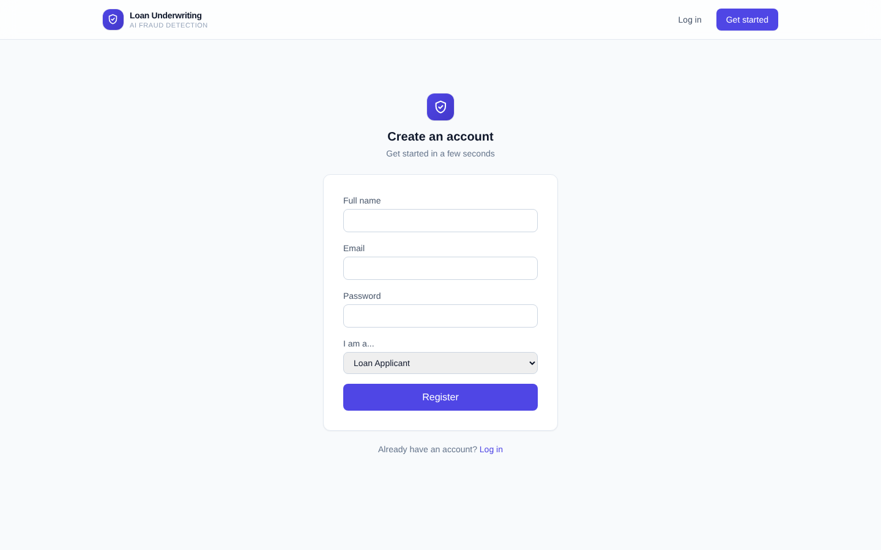
Figure 1. Registration screen – role selection (Applicant / Loan Officer) feeds directly into RBAC.

Module 2 – Application & Document Intake
Loan details and the supporting document are submitted together in a single form, with magic-byte file validation and an optional password field for encrypted PDFs.
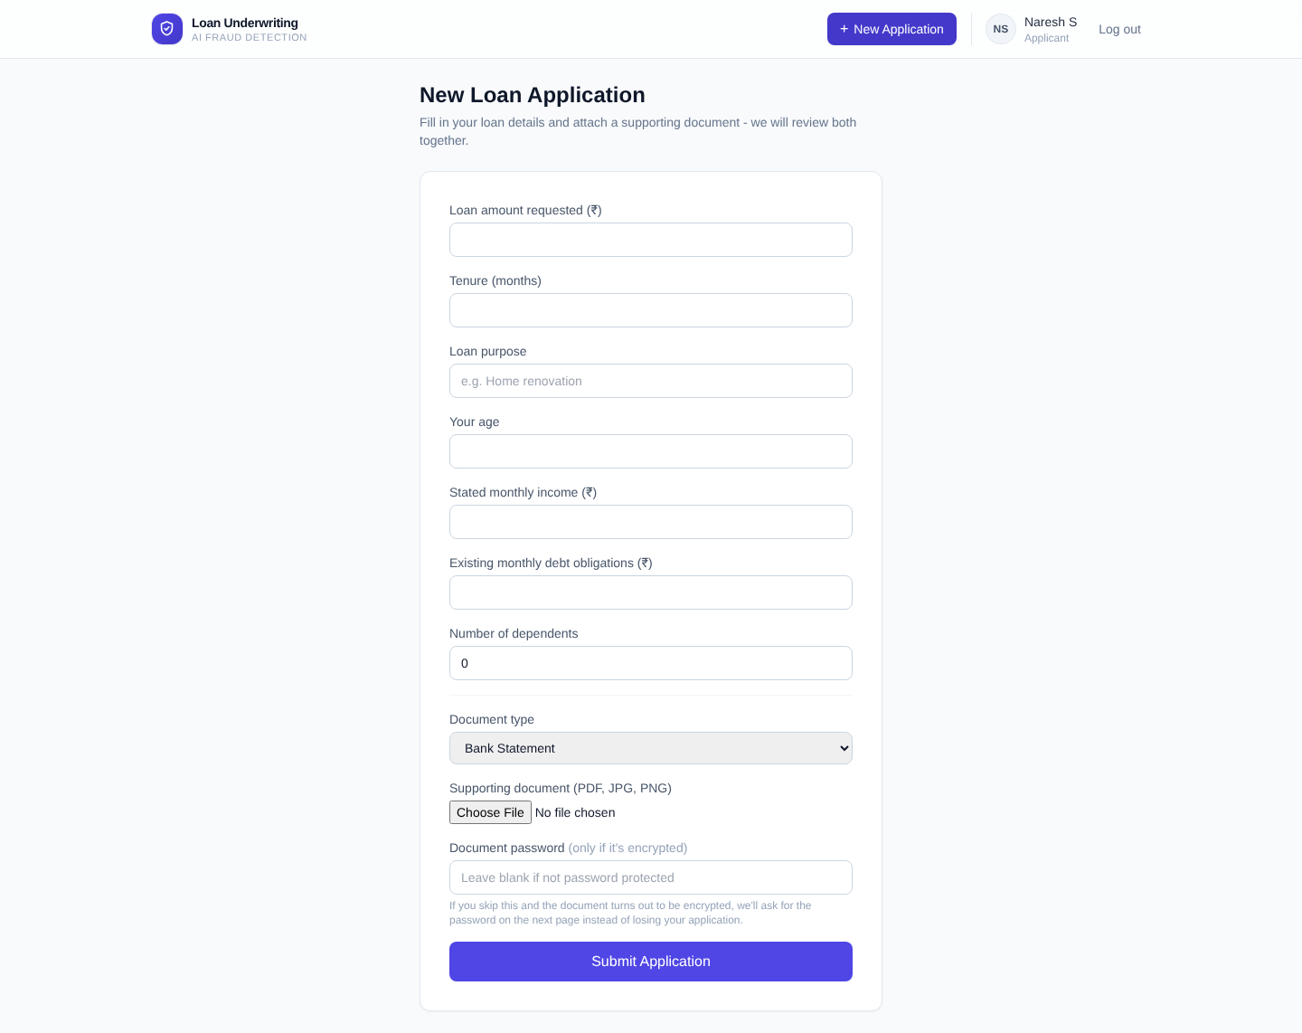
Figure 2. Combined apply + upload form, including the optional document-password field.
On submit, the applicant is redirected immediately with a success banner while analysis continues in the background – this is the asynchronous design described in Section 1.2.
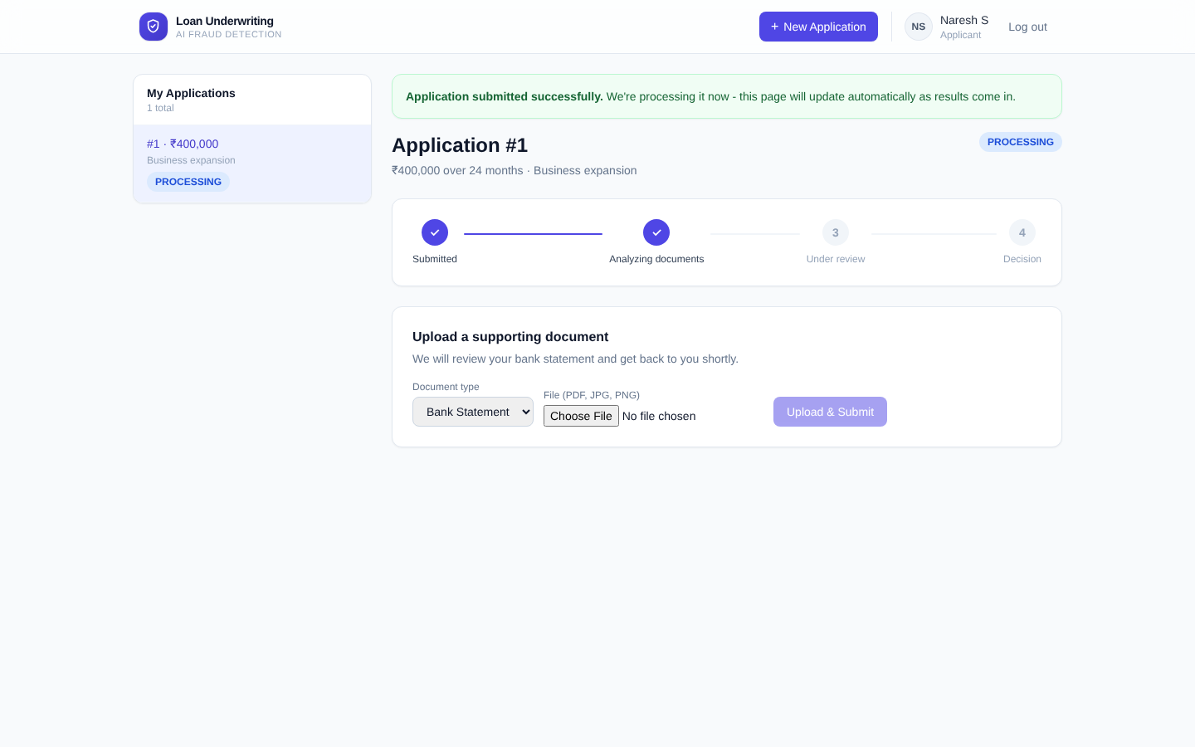
Figure 3. Immediate “submitted successfully” acknowledgement and live status timeline, shown while the backend pipeline is still running.

Module 3 – Structural / Metadata Forensics
PyMuPDF traverses the PDF's internal structure – the /Producer, /Creator and /ModDate tags, and the font resource dictionaries of every page – to detect the fingerprint of an editing tool (Photoshop, Canva, generic PDF editors) or a spliced/substituted font family. This is a deterministic, zero-false-positive check: either the tag matches a known editing tool or it does not.
Figure 7 (fraud scenario, Module 7 below) shows this module in action – the officer console surfaces a red “Forensic anomalies detected” banner reading “Document Producer/Creator matches known editing tool: 'photoshop'”, which alone is sufficient to route the application to REJECT_FRAUD_ALERT regardless of the credit score.

Module 4 – Error Level Analysis (ELA)
A deterministic image-forensics formula: the document page is recompressed at a fixed JPEG quality, and the pixel-level difference between the original and the recompressed version is rendered as a heatmap – regions that were edited after the original save tend to compress differently and light up. The split-screen viewer (visible in every officer screenshot in this section) places the original document and its ELA heatmap side by side for direct visual comparison.
ELA is deliberately kept diagnostic-only in this implementation (see Section 1.4): it is shown to the officer as a visual aid, but it never by itself triggers an automatic rejection, because it is prone to false positives on clean, sharply-scanned documents.

Module 5 – Ledger Extraction & Reconciliation
Transaction tables are extracted via pdfplumber for digital PDFs, with an OpenCV grid-detection + Tesseract OCR fallback for scanned statements. Every row is then checked with exact-precision decimal arithmetic:
Expected_Balanceᵢ = Balanceᵢ₋₁ + Creditᵢ − Debitᵢ
A row where |Balanceᵢ − Expected_Balanceᵢ| exceeds a small tolerance is flagged as a math drift and highlighted in red in the officer's ledger table – shown clearly in Figure 6, where two consecutive rows fail the check after a deliberately altered balance cell.
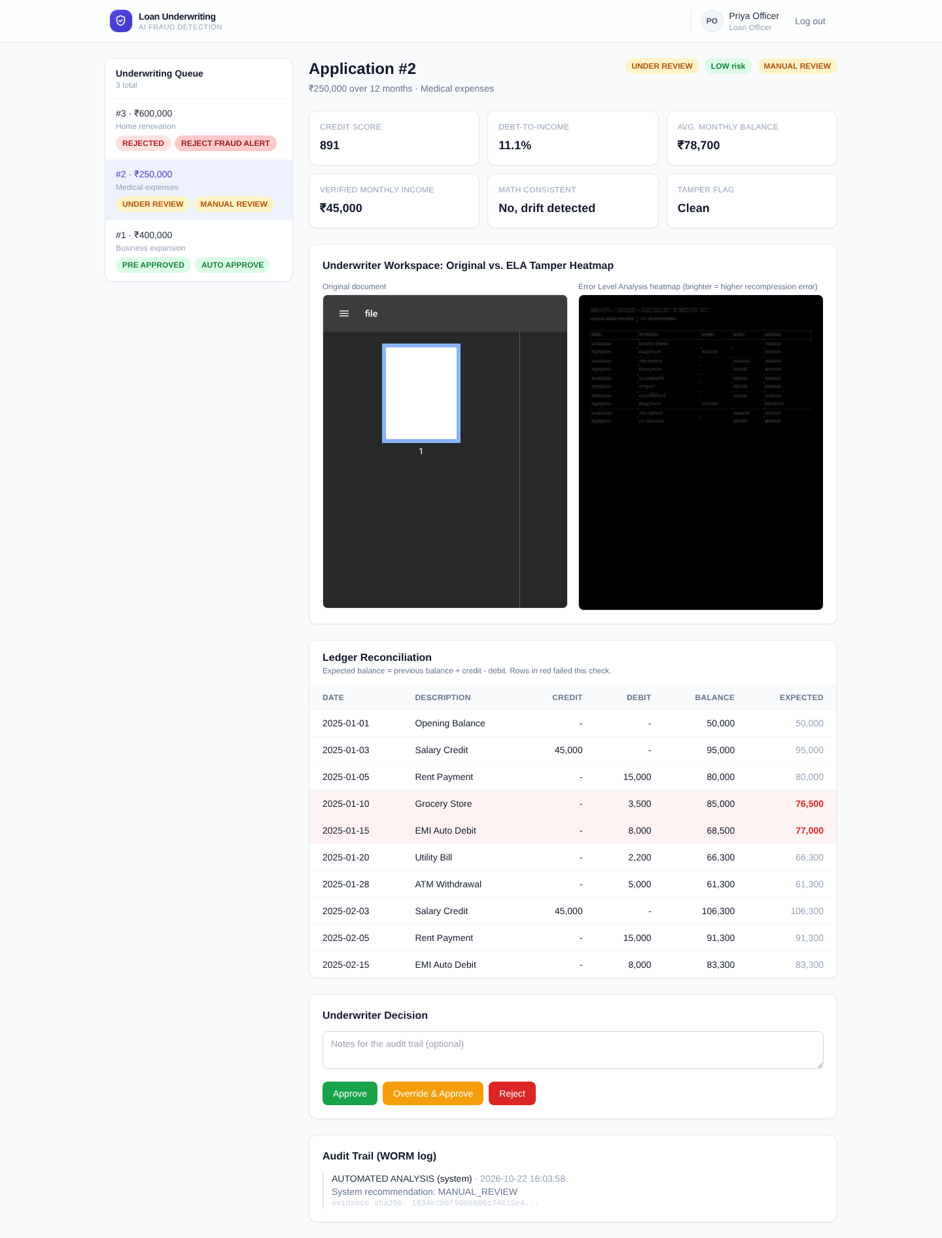
Figure 6. Manual-review case: ledger rows flagged in red where the running balance fails reconciliation, routing this application to MANUAL_REVIEW.
On total extraction failure (e.g. an unsupported scanned layout), the system does not silently assume the ledger is consistent – it records isMathConsistent as unknown, adds a visible anomaly note, and routes to MANUAL_REVIEW instead of auto-approving on missing evidence.

Module 6 – Solvency Metrics & Credit Risk Scoring
Debt-to-Income and Average Monthly Balance are computed deterministically from the verified ledger, and fed – together with age, existing debt and dependents – into the XGBoost model described in Section 2.1 to produce a 300–900 credit score and a LOW / MEDIUM / HIGH risk band. These figures are displayed as summary cards at the top of every officer review screen (see Figures 5–7).

Module 7 – Decision Routing Engine
The deterministic tri/four-state matrix from Section 1.4 combines the outputs of Modules 3, 5 and 6 into a single recommendation, shown as a status/recommendation badge pair at the top of the officer's view. All three branches were exercised live:
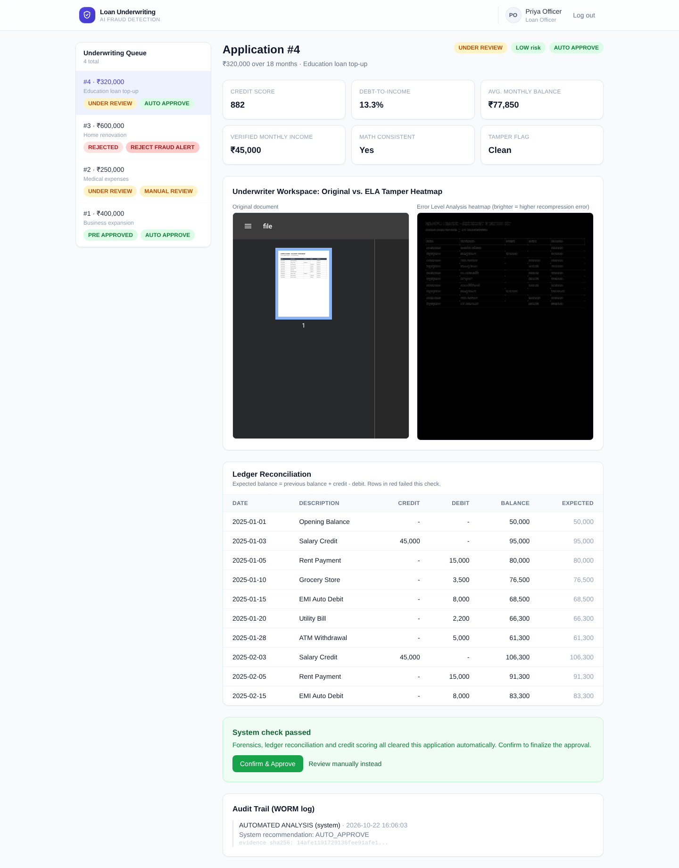
Figure 5. AUTO_APPROVE case – all three checks cleared; the officer still confirms with one click rather than the system finalizing silently.
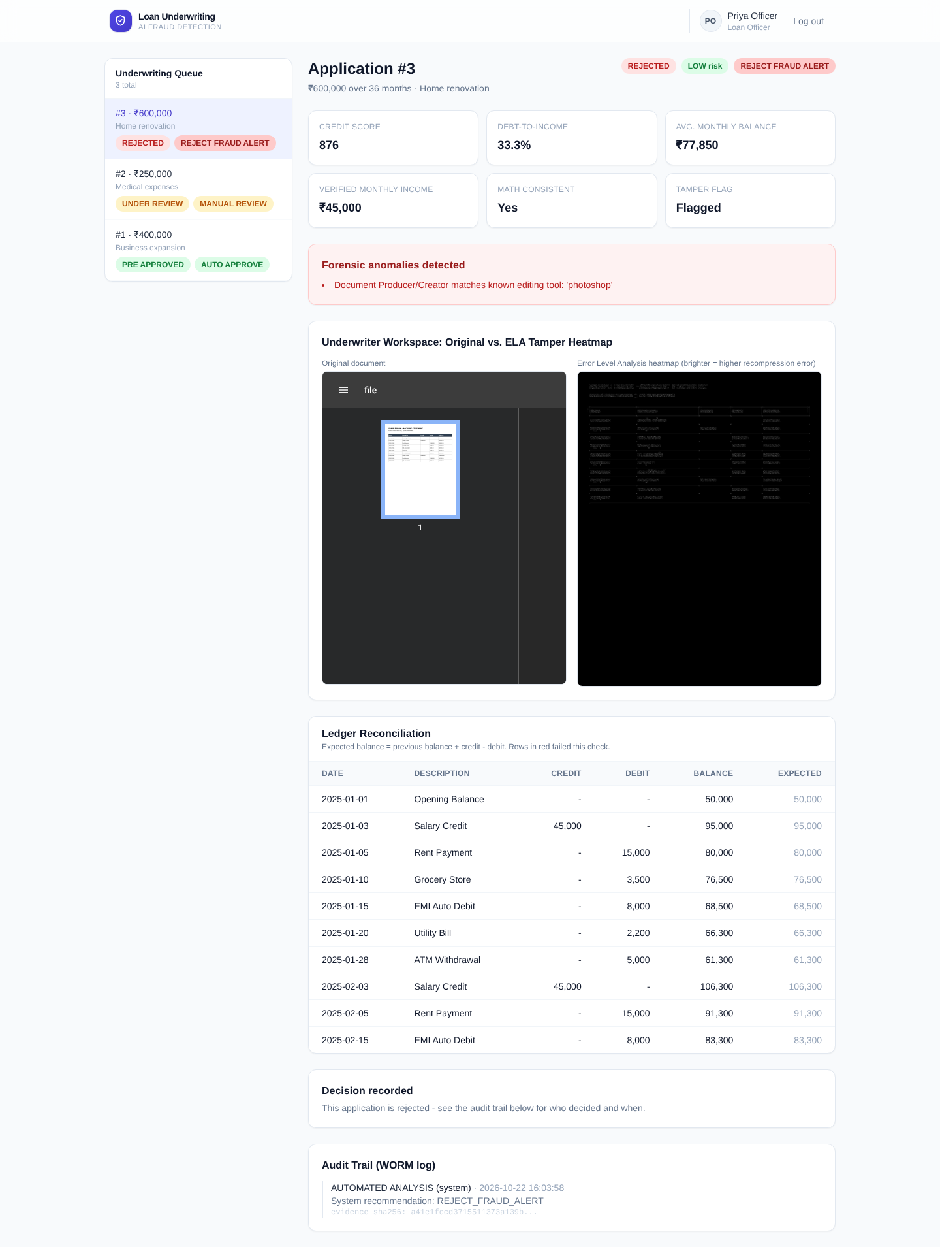
Figure 7. REJECT_FRAUD_ALERT case – the metadata forensic anomaly (Module 3) alone is sufficient to auto-reject.

Module 8 – Officer Review & Human-in-the-Loop Confirmation
Every application – including an AUTO_APPROVE recommendation – requires an explicit officer action before it is finalized. Figure 5 shows the one-click “Confirm & Approve” path offered when every automated check has already passed; Figure 6 shows the full manual panel (Approve / Override & Approve / Reject, with optional notes) offered for MANUAL_REVIEW cases. On the applicant side, none of this forensic detail is exposed – only a status timeline and the final outcome are shown, consistent with the role-based design in Section 1.3:
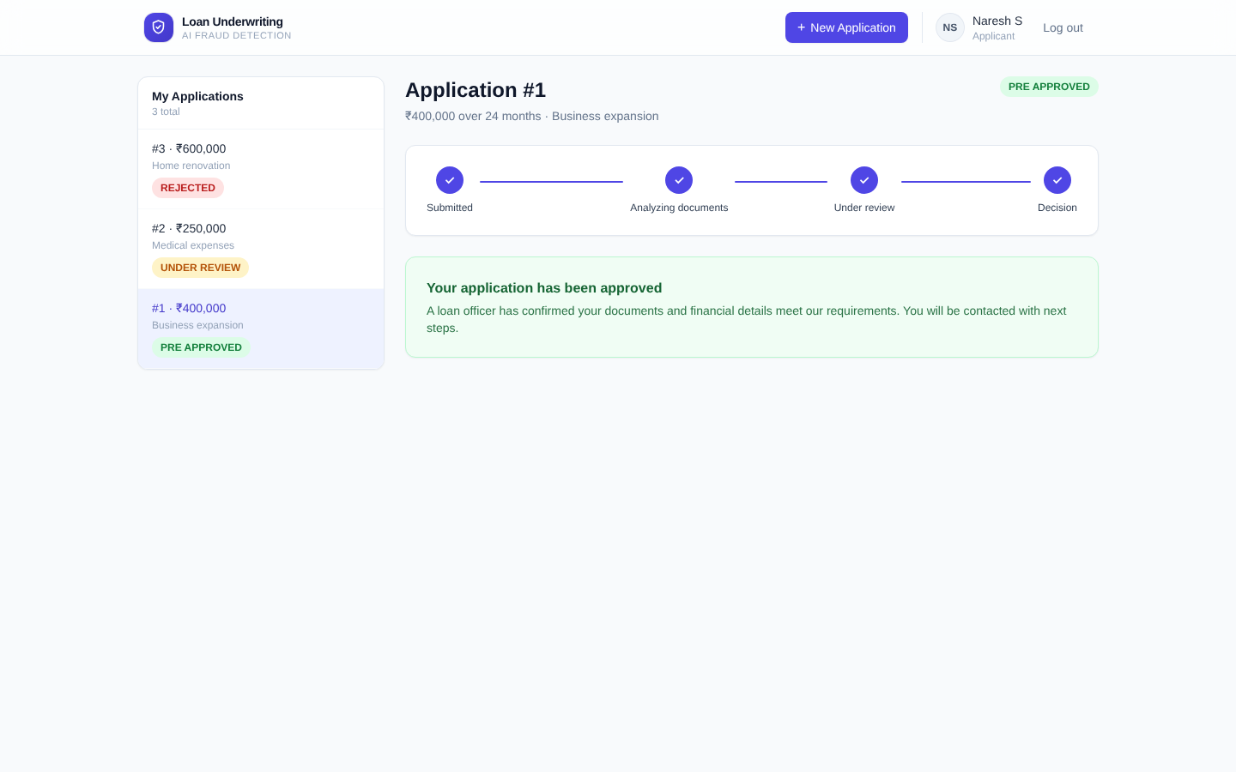
Figure 8. Applicant's own view of the same application after the officer's approval – status only, no forensic internals.
The underwriting queue itself (Figure 4) lets an officer move between applications without returning to a separate list page, each entry showing its live status and recommendation badge.
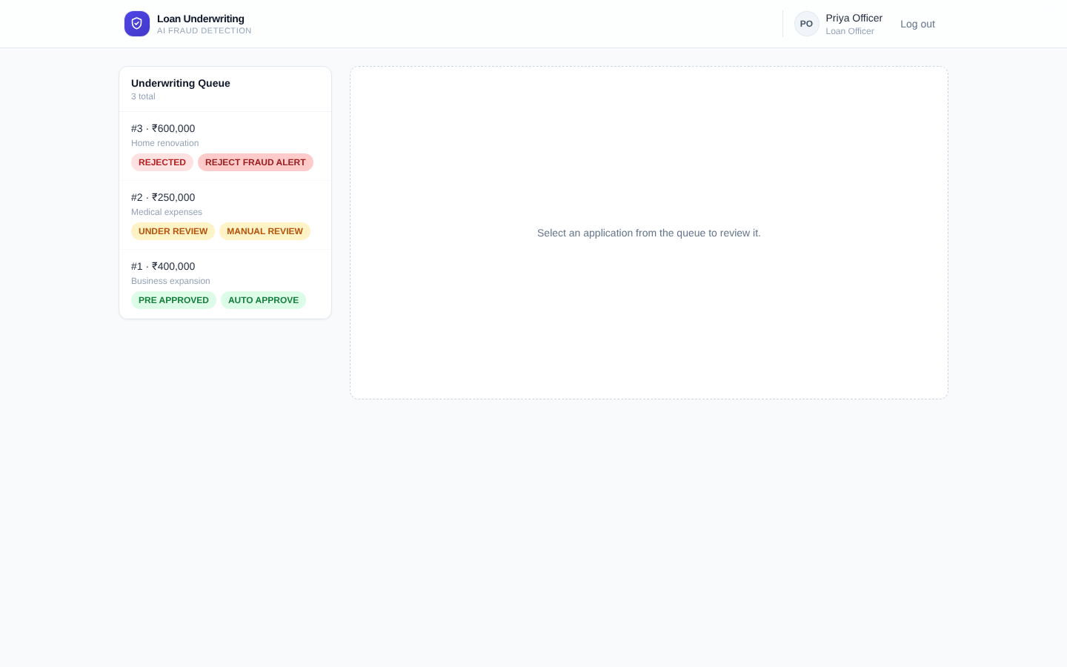
Figure 4. Officer's underwriting queue – persistent sidebar, live status per application.

Module 9 – Audit Logging
Every automated check and every human decision is written to an append-only (Write-Once-Read-Many) audit log, each entry carrying a SHA-256 hash of the evidence it refers to, the reviewing officer's identity (or “system” for automated entries) and a timestamp. This is visible at the bottom of every officer review screen (Figures 5–7) – e.g. an “AUTOMATED_ANALYSIS” entry recording the system's recommendation, followed by an “APPROVE by <officer name>” entry once a human confirms it. This produces an independently verifiable record that a disputed decision can later be proven to match the exact evidence it was based on.

4. Pseudo Code for Incomplete Modules
All nine modules from the First Review's Week 1–8 work plan are functionally complete and have been exercised end-to-end against the running application, as demonstrated in Section 3 with live screenshots rather than mock-ups. No module is incomplete at this review stage, so there is no pending work requiring pseudocode.
For completeness and as an engineering reference, the pseudocode for the three core deterministic algorithms – already implemented and tested – is included below.

4.1 Error Level Analysis (Module 4)
function runErrorLevelAnalysis(pageImage):
original ← decodeToRGB(pageImage)
recompressed ← JPEGEncode(original, quality = 92)
diff ← abs(original − recompressed) // per-pixel luminance difference
heatmap ← clip(diff × 15, 0, 255) // scale factor S = 15, 8-bit grayscale
tamperScore ← (stdDev(diff) / (mean(diff) + 1e-5)) × 10.0
if tamperScore > 35.0 or max(diff) > 220:
return { tampered: true, heatmap, tamperScore }
return { tampered: false, heatmap, tamperScore } // shown to officer regardless; never auto-gates

4.2 Deterministic Ledger Reconciliation (Module 5)
function reconcileLedger(rows):
rows ← sortByDate(rows)
balance ← rows[0].balance // opening balance, taken as the anchor
for i in 1..len(rows):
expected ← balance + rows[i].credit − rows[i].debit // exact Decimal arithmetic, no floats
rows[i].expectedBalance ← expected
rows[i].isMathDrift ← abs(rows[i].balance − expected) > 0.01
balance ← rows[i].balance
if rows is empty:
return { isMathConsistent: null, extractionFailed: true } // never silently 'consistent'
return { isMathConsistent: not any(r.isMathDrift for r in rows), rows }

4.3 Decision Routing (Module 7)
function routeDecision(isTampered, isMathConsistent, creditScore):
if isTampered:
return REJECT_FRAUD_ALERT // metadata/font fingerprint only - never ELA alone
if isMathConsistent is null or isMathConsistent == false:
return MANUAL_REVIEW // drift, or extraction failed - never assumed clean
if creditScore >= 750: return AUTO_APPROVE // recommendation only - officer still confirms
if creditScore >= 600: return MANUAL_REVIEW
return REJECT

