**GIT TAGS EXERCISE**

|  |  |
| --- | --- |
| **Action** | **Command Used** |
| Create Repository | git init |
| Check status | git status |
| Add untracked files to staging area | git add . |
| Commit | git commit -m “message” |
| Add files to staging area and commit in one go | git commit -am “message” |
| Create tag | git tag -a <tag-name> -m <message> |
| Display all tags | git tag |
| Checkout specific tag | git checkout <tag-name> |
| Show log | git log |
| Add local repository to github | git remote add origin <github-repo-url> |
| Push changes to remote | git push -u origin <branch- names> |
| Push all tags | git push --tags |

1. Create a repository

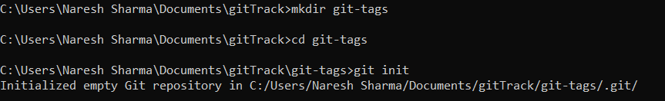

1. Create two files in master branch, then create a tag 1.0.0 for first release from master.

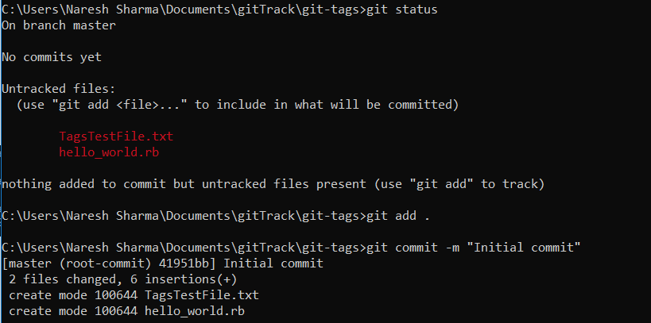

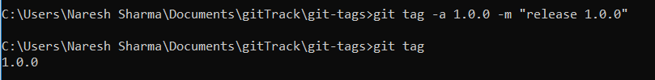

1. Now, perform some changes in previous files and create another tag 1.0.1.

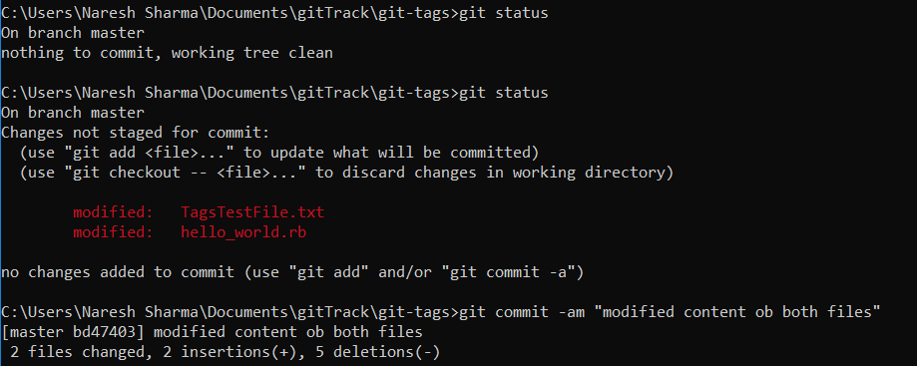



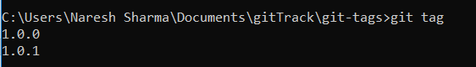

1. Now, create another file file3 and create a tag 1.1.0.

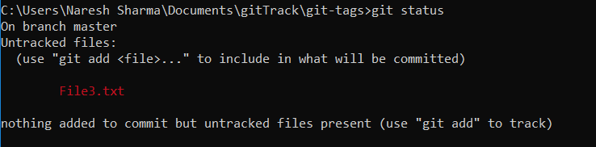

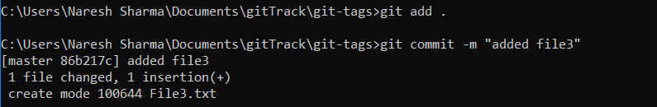

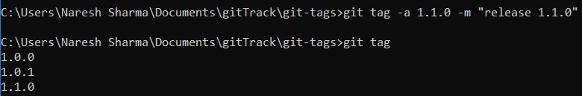

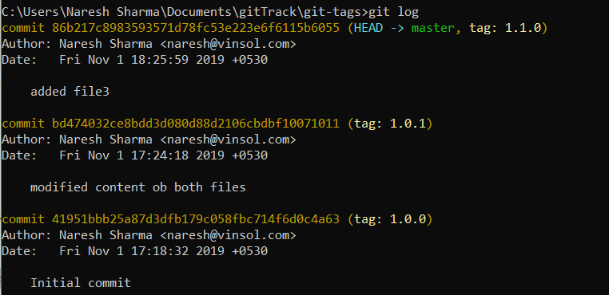

1. Now in 1.0.1 release, do some changes in existing files and create another tag 1.0.2

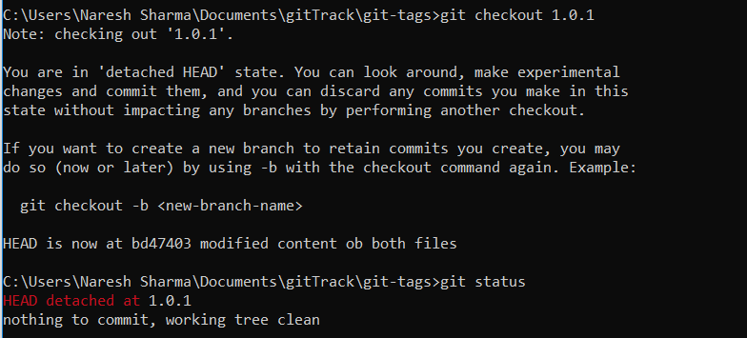

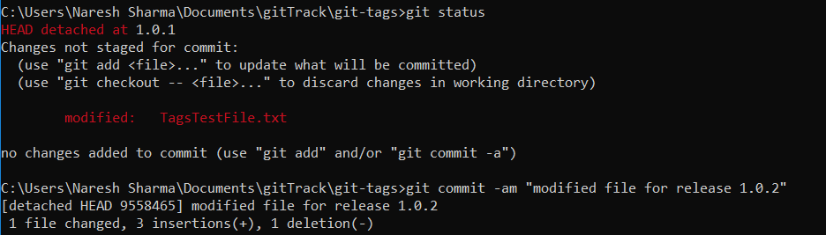

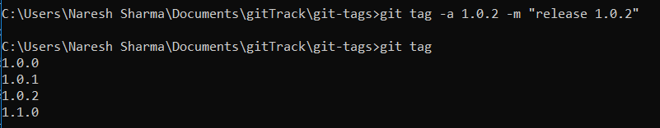

1. Also do some changes in release 1.1.0, create a tag for next release 1.1.1.



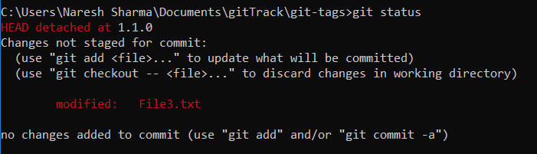



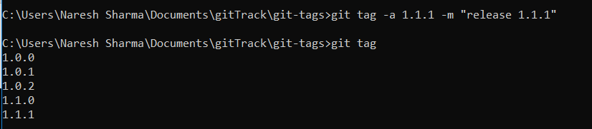

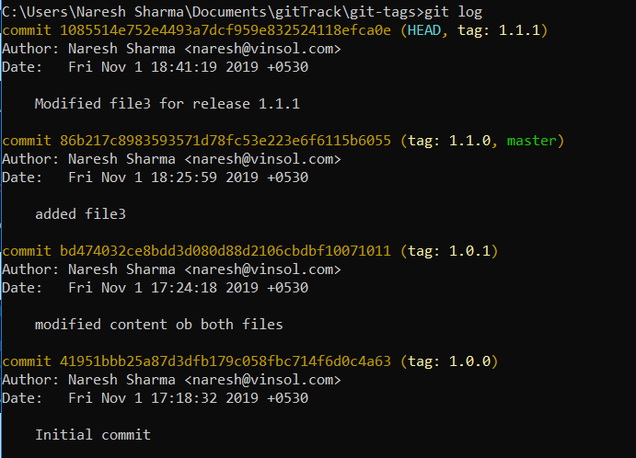

Push repository to github.



