1. **LOW LEVEL DESIGN**

Low Level Design

# Crop Production Analytics

|  |  |
| --- | --- |
| **Written By** | Harsha Dhunde |
| **Document Version** | 0.3 |
| **Last Revised Date** | 22/12/2022 |

**1LOW LEVEL DESIGN**

# DOCUMENT CONTROL

**Work Flow Record:**

|  |  |  |  |
| --- | --- | --- | --- |
| **Sr.No** | **DATE** | **AUTHOR** | **COMMENTS** |
| 1 | 22- Dec-  2022 | Harsha & Naresh | Introduction and architecture and flow decided.  Discussion of cleaning the data  Such as Grouping of age, Education, Job, follow ups and Duration of Calling |
| 2 | 25 - Dec-  2022 | Harsha & Naresh | Cleaning of data in Python |
| 3 | 28 - Dec  2022 | Harsha & Naresh | Connecting Final Csv to Power BI |
| 4 | 1- Jan  -2023 | Harsha & Naresh | Discussion of Charts and Tabs Required in the Report. |
| 5 | 7- Jan -  2023 | Harsha & Naresh | Representation of charts & discussions on Drawbacks |
| 6 | 11- Jan-  2023 | Harsha,Naresh | 2nd Cut for the Reports and Discussion. |
| 7 | 15-Jan-  2023 | Naresh | Final Power BI Report |
| 8 | 17-Jan-  2023 | Harsha,Naresh | Discussion on Creation of required documents Such as HL LLD, Architecture, Wireframe, Videos. |
| 9 | 21-Jan 2023 | Harsha,Naresh | Allotment of Task Harsha- HLD, LLD  - Architecture, DPR Naresh - Vedio Naresh- Wireframe |
| 10 | 25-Jan-  2023 | Harsha | Final Submission of Wire Frame |
| 11 | 27-Jan 2023 | Harsha | Final Submission of HLD & LLD |
| 12 | 30-Jan-  2023 | Harsha | Final Submission of Architecture, DPR |
| 13 | 3 -Feb - 2023 | Naresh | Creation of YouTube Video |

**3 LOW LEVEL DESIGN**

# Contents

**1.**

Introduction 04

* 1. What is Low-Level Design Document? 04
  2. Scope 04

1. Architecture 05
2. Architecture Description 08
   1. Data Description 08
   2. Data Transformation 08
   3. Data insertion into database 08
   4. Connection with Snowflake 08
   5. Export Data from database 12

3.6 Deployment ……………………………………………………………… 12

3

1. **LOW LEVEL DESIGN**

# Introduction

## What is Low-Level design document?

The goal of the LDD or Low-level design document (LLDD) is to give the internal logic design of the actual program code for the Bank Marketing Analytics dashboard. LDD describes the class diagrams with the methods and relations between classes and programs specs. It describes the modules so that the programmer can directly code the program from the document.

## Scope

Low-level design (LLD) is a component-level design process that follows a step-by-step refinement process. The process can be used for designing data structures, required software architecture, source code and ultimately, performance algorithms. Overall, the data organization may be defined during requirement analysis and then refined during data design work.

1. **LOW LEVEL DESIGN**

# 2. Architecture

**Power BI Server Architecture**

Power BI has a highly scalable, n-tier client-server architecture that serves mobile clients, web clients and desktop-installed software. Power BI Server architecture supports fast and flexible deployments.

The following diagram shows Power BI Server’s architecture:

**5LOW LEVEL DESIGN**

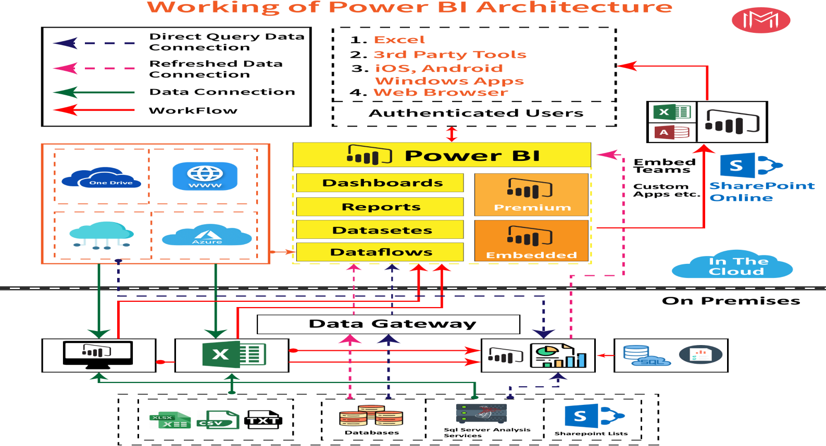

**Power BI** is internally managed by the multiple server processes.

1. **Data sourcing/integration**

Power BI reports can be comprised of data from various data sources. These data sources can be either online or in your organisation’s local data stores and can take many types and forms.

The Power BI Service has its own inbuilt data connectors which allows easier connectivity to many common data source types, such as Snowflake, Oracle, My SQL & Flat files, CSV, Excel and XML. There are other various connectors to source data from online websites, news feeds, SaaS services and social media.

There is a 1GB dataset limit in Power BI for imported datasets, however this restriction can be eliminated by creating a direct or a live connection. The Power BI Gateway is a piece of software that you can install in your local environment that builds the bridge between local on-premise data sources and the Power BI cloud service.

**6 LOW LEVEL DESIGN**

## Data transformation

At this stage, imported data in the staging area may not be in a form that is suitable for reporting. Therefore, it may be necessary to transform this unstructured data into a more structured and usable format.

The Inbuilt Power Query engine in Power BI Desktop provides a lot of transformation capabilities, such as:

* + removing duplicates
  + removing or renaming columns
  + replacing values with something else
  + building relationships
  + creating user defined hierarchies

Ideally, underlying source data will be coming from a data warehouse or other structured data source helping to minimize the effort required to transform data.

## Report building

After sourcing and transforming data, report authors can build Power BI reports and dashboards. There are two main tools which can be used to build reports in Power BI. Power BI Desktop is a free tool available to download and the Power BI Service is an online tool that provides similar capabilities in report building.

Power BI Desktop contains many interactive visualisations (dashboard components) and there are a lot of custom visualisations available in the marketplace too. A broad range of filtering and slicing capabilities are also available in Power BI as in other popular reporting tools.

## Publishing reports

Once reports are built, they need to be published to the Power BI Service for organisation-wide distribution. Report Authors can publish their reports to the Power BI Service using Power BI Desktop. There are two main areas where reports can be published:

My Workspace

1. **LOW LEVEL DESIGN**

No one else can access reports published to My Workspace unless shared. It is a good testing area for report authors.

Other Authorised Workspaces

This can act as a central repository for all authorised users to share their reports and collaborate.

## Creating dashboards

Often the last step in building reporting content is creating dashboards. Authorised users can log in to the Power BI Service and create dashboards by pinning visuals from different reports or an entire report as a live page.

Filtering or slicing is not a feature you find in Power BI dashboards, however dashboard visualisations maintain the filter settings which were selected at the time of pinning the visual from the report.

# Architecture Description

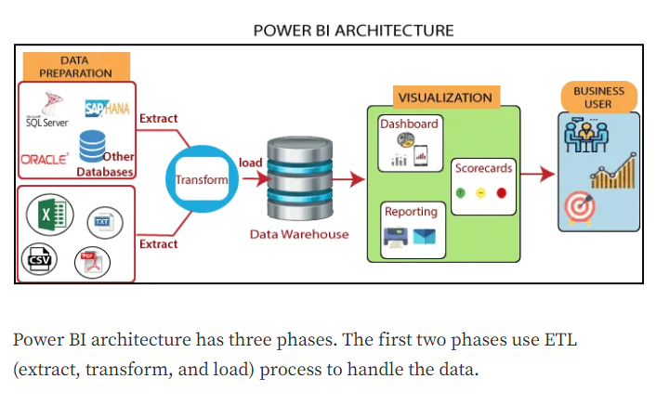

## Data Description

The Dataset contains house price of cities that fall under the categories A,B and C based on the availability of parking, rainfall, its built-up area etc

* + - Age: age (numeric)
    - job : type of job (categorical:

"admin.","blue-collar","entrepreneur","housemaid","management","retired","self-employe d","services","student","technician","unemployed","unknown")

* + - marital : marital status (categorical: "divorced","married","single","unknown"; note: "divorced" means divorced or widowed)
    - education (categorical: "basic.4y","basic.6y","basic.9y","high.school","illiterate","professional.course","university.de gree","unknown")
    - default: has credit in default? (categorical: "no","yes","unknown")
    - housing: has housing loan? (categorical: "no","yes","unknown")
    - loan: has personal loan? (categorical: "no","yes","unknown")

**# related with the last contact of the current campaign:**

* + - contact: contact communication type (categorical: "cellular","telephone")
    - month: last contact month of year (categorical: "jan", "feb", "mar", ..., "nov", "dec")
    - day_of_week: last contact day of the week (categorical: "mon","tue","wed","thu","fri")

1. **LOW LEVEL DESIGN**
   * duration: last contact duration, in seconds (numeric). Important note: this attribute highly affects the output target (e.g., if duration=0 then y="no"). Yet, the duration is not known before a call is performed. Also, after the end of the call y is obviously known. Thus, this input should only be included for benchmark purposes and should be discarded if the intention is to have a realistic predictive model.

**# other attributes:**campaign: number of contacts performed during this campaign and for this client (numeric, includes last contact)

* + pdays: number of days that passed by after the client was last contacted from a previous campaign (numeric; 999 means client was not previously contacted)
  + previous: number of contacts performed before this campaign and for this client (numeric)]
  + poutcome: outcome of the previous marketing campaign (categorical: "failure","nonexistent","success")

## Data Transformation

In the Transformation Process, we will convert our original datasets with other necessary attributes format. And will merge it with the Scrapped dataset.

## Data Insertion into Database

1. Database Creation and connection - Create a database with name passed. If the database is already created, open the connection to the database.
2. Table creation in the database.
3. Insertion of files in the table

## Make the Snowflake connection and set up the data source

**Step 1: Configuring Power BI**

Launch Power BI on your workstation and select Snowflake from the connect column on the left. This will open a dialogue box where you need to provide the connection details for Snowflake.

To connect with tableau, you will need to provide information about the server which hosts your database. If you want to connect to a contained database, you can also specify the name of the database.

**10LOW LEVEL DESIGN**

To connect with a port other than the default port, you need to specify the port and server as follows:

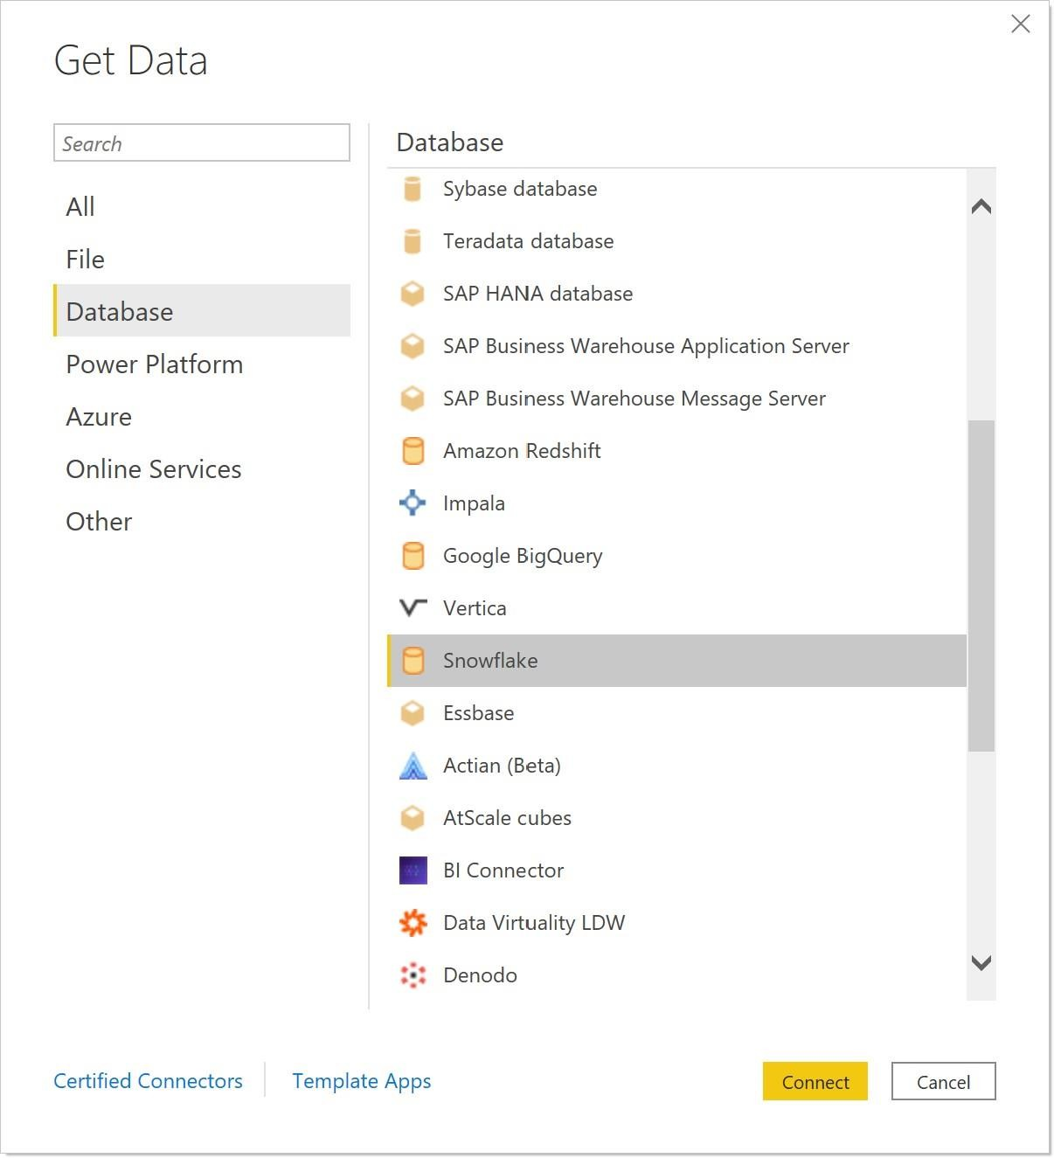

There are two ways in which you can sign-in to the server, either by using Windows authentication or by using the username and password. Using the username and password becomes a must if you’re working with a password-protected server in a non-Kerberos environment.

**Bank Marketing Analytics** 11

1. **LOW LEVEL DESIGN**

Click on Sign in to establish a connection. This will enable a connection without SSL. To establish an SSL enabled connection, click the Require SSL checkbox before you sign in.

Snowflake provides an option to let the user queries access the modified rows even before they have been committed. This option is called Read Uncommitted data. It saves time by preventing complex queries such as extract refreshes from locking the database and causing a delay. If this option is unchecked, Power BImakes use of default isolation levels.

If you want to run a specific SQL command every-time a new connection is established, you can use the Initial SQL option. This will open a dialogue box, where you can specify your desired SQL query.

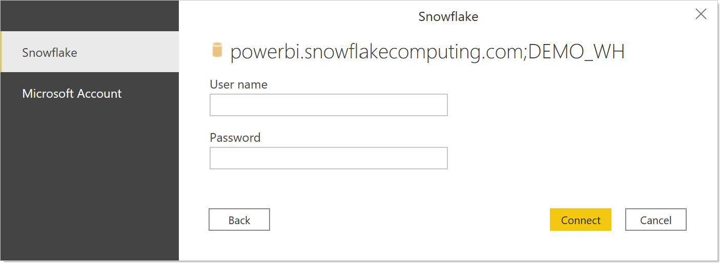

**Step 2: Configuring Data Source**

The data source page loads up after configuring the Power BIconnector and successfully signing in. This is how the page looks like:

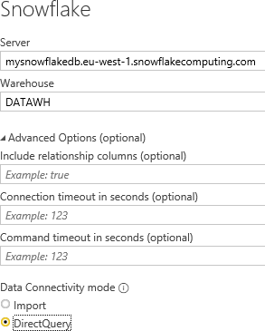

Select the data source name option and give a unique name to the database you are using. It’s considered a good practice to have a unique name as it makes it much easier for users to identify the database from which data is being fetched.

To select the desired schema, you can use the schema drop-down list from the column on the left. You can also perform a text-based search to find the desired option. Now similarly find and select the desired table and drag it onto the canvas.

This is how you can connect Snowflake with Power BI . Now click on the sheets tab to begin the analysis.

Custom SQL features can be used to focus on specific SQL statements, rather than querying the entire database. Click on the Custom SQL option from the panel on the left. A new dialogue box will now open up, where you can provide the query you want to execute.

1. **LOW LEVEL DESIGN**

## Export Data from Database

Data Export from Database - The data in a stored database is exported as a CSV file to be used for Data Pre-processing.

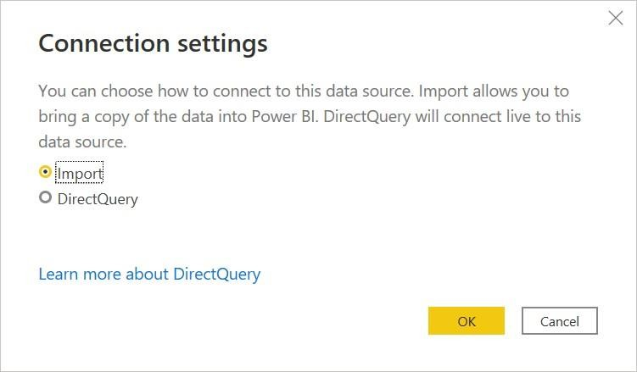

## Deployment.

Once you’ve completed your dashboard,

You may be prompted to log into your Power BI Public profile first if this is your first time publishing.

* + - Publish and go to the power BI App, then do the steps shown in the picture.

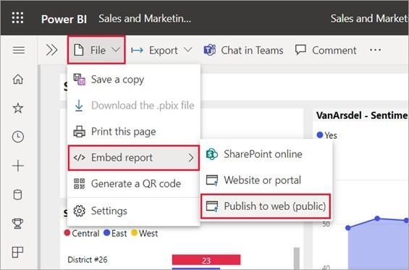

Next, Copy the Embed Code and share it to the desired person.

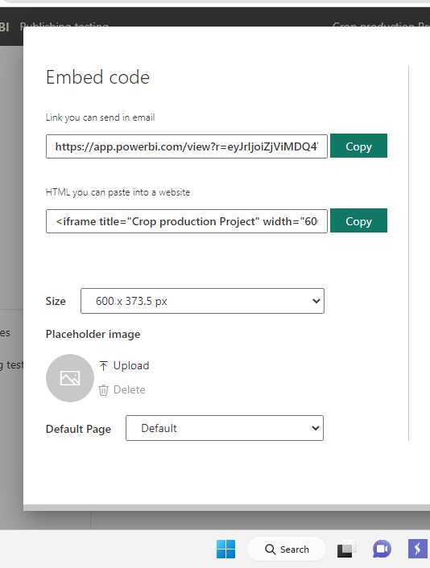

Here in the below screenshot, we can see that out workbook has been published to Power BI public.

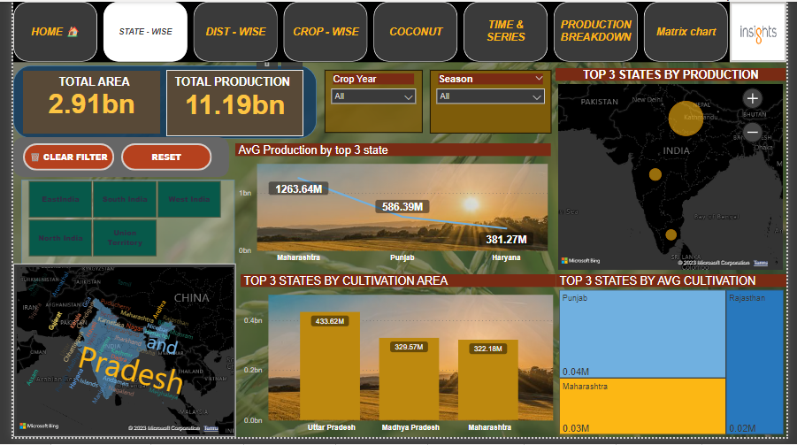

# Unit Test Cases

|  |  |
| --- | --- |
|  |  |
| Relation between Age Group and Subscription status in both the Campaigns (C.C & P.C) | Created Stacked Bar Chart which shows difference between  C.C & P.C |
| Relation between Customers Education and Subscription status in both the Campaigns (C.C & P.C) | Created Stacked Bar Chart which shows Relation difference between C.C & P.C for Customers Education and Subscription status |
| Relation between Follow Up status and Subscription status in both the Campaigns (C.C & P.C) | Created Stacked Bar Chart which shows Relation difference between C.C & P.C for Follow Up status and Subscription status |
| Relation between Default status and Subscription status in both the Campaigns (C.C & P.C) | Created Stacked Bar Chart which shows Relation difference between C.C & P.C for Default status and Subscription status |
| Relation between Account Balance and Loans from C.C with Subscription Status | Uses Sunburst Chart to know %ge split in Current Campaign |
| Relation between Job Type and Loans from C.C with Subscription Status | Uses Sunburst Chart to know %ge split in Current Campaign |