Name: Kadiyala Naresh

Rg.no.: 192110312

Course: object oriented C++

Code: DSA0163

1)2

#include<iostream>

using namespace std;

class B;

class A

{

public:

int a;

A()

{

a=10;

}

friend void sub(A,B);

};

class B

{

public:

int b;

B()

{

b=20;

}

friend void sub(A,B);

};

void sub( A A1, B B1)

{

cout<< A1.a-B1.b;

}

int main()

{

A t;

B s;

sub(t,s);

return 0;

}

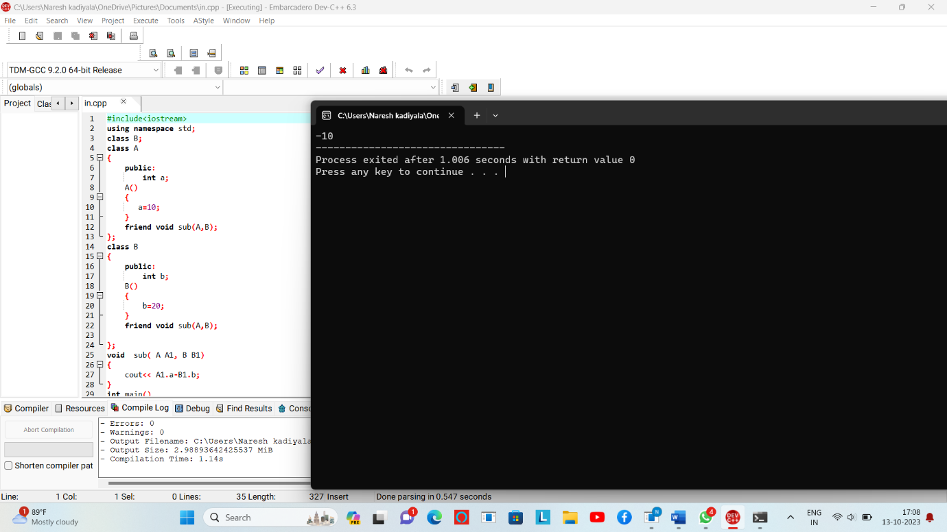

2)

#include<iostream>

using namespace std;

class B;

class A

{

public:

int a;

A()

{

a=10;

}

friend void sub(A,B);

};

class B

{

public:

int b;

B()

{

b=20;

}

friend void sub(A,B);

};

void sub( A A1, B B1)

{

cout<< A1.a-B1.b;

}

int main()

{

A t;

B s;

sub(t,s);

return 0;

}

