**Web Technology**

**Naresh Kumar**

**22IT3025**

**Lab-4**

**T1 :**

<!DOCTYPE html>

<html lang="en">

<head>

<meta charset="UTF-8">

<meta name="viewport" content="width=device-width, initial-scale=1.0">

<title>Naresh's T1</title>

<style>

body {

text-align: center;

padding: 50px;

font-family: Arial, sans-serif;

}

h1 {

color: #333;

}

button {

padding: 10px 20px;

font-size: 16px;

cursor: pointer;

}

</style>

</head>

<body>

<h1 id="heading">WELCOME </h1>

<button onclick="changeColor()">Click me to change color</button>

<script>

function changeColor() {

var heading = document.getElementById("heading");

var button = document.querySelector("button");

var randomColor = getRandomColor();

heading.style.backgroundColor = randomColor;

heading.innerText = "Color changed!";

button.style.backgroundColor = randomColor;

}

function getRandomColor() {

var letters = '0123456789ABCDEF';

var color = '#';

for (var i = 0; i < 6; i++) {

color += letters[Math.floor(Math.random() * 16)];

}

return color;

}

</script>

</body>

</html>

**Output**



**T2.a :**

<!DOCTYPE html>

<html lang="en">

<head>

<meta charset="UTF-8">

<meta name="viewport" content="width=device-width, initial-scale=1.0">

<title>Naresh's T2.a</title>

<style>

body {

text-align: center;

padding: 50px;

font-family: Arial, sans-serif;

}

h1 {

color: #333;

}

button {

padding: 10px 20px;

font-size: 16px;

cursor: pointer;

}

</style>

</head>

<body>

<h1 id="heading">WELCOME </h1>

<button onclick="changeColor()">Click me to change color</button>

<script>

function changeColor() {

var heading = document.getElementById("heading");

var button = document.querySelector("button");

heading.style.backgroundColor = 'rgb(144,238,144)' ;

heading.innerText = "Color changed to light green ";

button.style.backgroundColor = 'rgb(144,238,144)';

}

</script>

</body>

</html>

**Output**

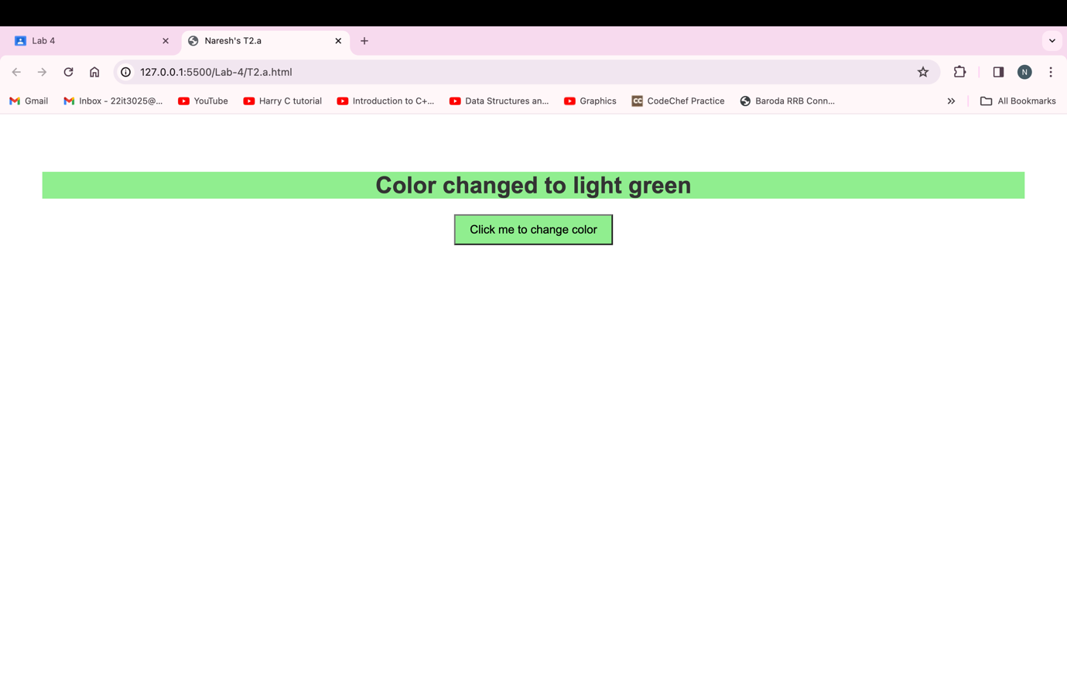

**T2.b**

<!DOCTYPE html>

<html lang="en">

<head>

<meta charset="UTF-8">

<meta name="viewport" content="width=device-width, initial-scale=1.0">

<title>Naresh's T2.b</title>

<style>

body {

text-align: center;

padding: 50px;

font-family: Arial, sans-serif;

}

h1 {

color: #333;

}

button {

padding: 10px 20px;

font-size: 16px;

cursor: pointer;

}

</style>

</head>

<body>

<h1 id="heading">WELCOME </h1>

<button onclick="changeColor()">Click me to change text color</button>

<script>

function changeColor() {

var heading = document.getElementById("heading");

var button = document.querySelector("button");

heading.style.color = 'rgb(255,0,0)' ;

heading.innerText = "Text color changed to Red ";

}

</script>

</body>

</html>

**Output**

**T2.c**

<!DOCTYPE html>

<html lang="en">

<head>

<meta charset="UTF-8">

<meta name="viewport" content="width=device-width, initial-scale=1.0">

<title>Naresh's T2.c</title>

<style>

body {

text-align: center;

padding: 50px;

font-family: Arial, sans-serif;

}

h1 {

color: #333;

}

button {

padding: 10px 20px;

font-size: 16px;

cursor: pointer;

}

</style>

</head>

<body>

<h1 id="heading">WELCOME </h1>

<button onclick="changefontsize()">Click me to change text's fontsize</button>

<script>

function changefontsize() {

var heading = document.getElementById("heading");

heading.style.fontSize = '40px';

heading.innerText = "Text's font size changed to 40px";

}

</script>

</body>

</html>

**Output**

**T2.d**

<!DOCTYPE html>

<html lang="en">

<head>

<meta charset="UTF-8">

<meta name="viewport" content="width=device-width, initial-scale=1.0">

<title>Naresh's T2.d</title>

<style>

body {

text-align: center;

padding: 50px;

}

h1 {

background-color: lightblue;

padding: 20px;

border-radius: 10px;

}

button {

padding: 10px;

font-size: 16px;

margin-top: 20px;

}

</style>

</head>

<body>

<h1 id="heading">Hello, World!</h1>

<button onclick="changeStyle()">Change Style</button>

<script>

function changeStyle() {

var heading = document.getElementById("heading");

heading.style.backgroundColor = "lightgreen";

heading.innerHTML = "Text Changed!";

}

</script>

</body>

</html>

**Output**

**T3 :**

<!DOCTYPE html>

<html lang="en">

<head>

<meta charset="UTF-8">

<meta name="viewport" content="width=device-width, initial-scale=1.0">

<title>Naresh's T3</title>

<style>

.color-change {

background-color: #3498db;

color: #ffffff;

}

</style>

</head>

<body>

<h1>Color Changer</h1>

<button onclick="changeColor()">Change Color</button>

<script>

function changeColor() {

alert("Before assigning class attribute.");

document.body.className = "color-change";

document.body.innerHTML = "<h1>Color Changed!</h1>";

alert("After assigning class attribute.");

}

</script>

</body>

</html>

**Output**

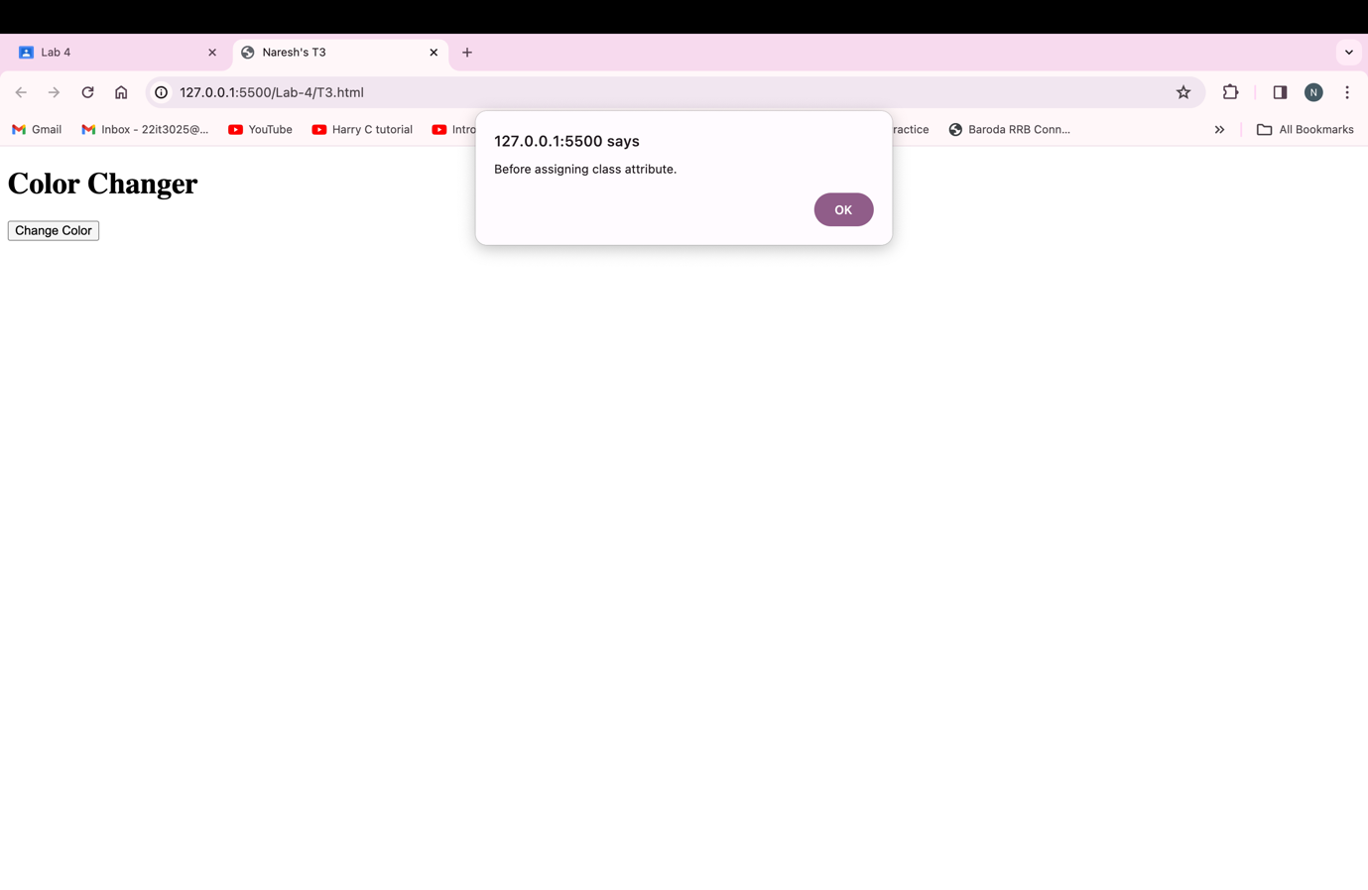

**T4 :**

<!DOCTYPE html>

<html lang="en">

<head>

<meta charset="UTF-8">

<meta name="viewport" content="width=device-width, initial-scale=1.0">

<title>Naresh's T4</title>

<style>

body {

font-family: Arial, sans-serif;

margin: 20px;

}

#main-section {

border: 1px solid #ccc;

padding: 20px;

margin-bottom: 20px;

}

#new-content {

color: #ff5733;

font-size: 1.2em;

font-weight: bold;

}

</style>

</head>

<body>

<h1>Main Section</h1>

<section id="main-section">

<p>This is the initial content of the main section. And if you want to replace the content that is within the main section with the content that is outside the main secction ; Please pree the button</p>

</section>

<button onclick="changeContent()">Change Content</button>

<script>

function changeContent() {

var mainSection = document.getElementById("main-section");

mainSection.innerHTML = "<p id='new-content'>This is the content that was outside the main section and also having different style .</p>";

window.scrollTo(0, 0);

}

</script>

</body>

</html>

**Output**

**T5 :**

<!DOCTYPE html>

<html lang="en">

<head>

<meta charset="UTF-8">

<meta name="viewport" content="width=device-width, initial-scale=1.0">

<title>Naresh's T5</title>

<style>

#external-h1 {

color: black;

}

.color-change-class {

color: blue;

}

</style>

</head>

<body>

<h1 id="external-h1">Heading Outside Main Section</h1>

<button onclick="changeColorMethod1()">Method 1</button>

<section id="main-section">

<p>This is the initial content of the main section.</p>

<p>Click the buttons to change the color of the heading.</p>

</section>

<button onclick="changeColorMethod2()">Method 2</button>

<button onclick="changeColorMethod3()">Method 3</button>

<script>

function changeColorMethod1() {

document.getElementById("external-h1").style.color = "red";

}

function changeColorMethod2() {

document.getElementById("external-h1").style.color = "blue";

document.getElementById("external-h1").classList.add("color-change-class");

}

function changeColorMethod3() {

document.getElementById("external-h1").style.color = "green";

}

</script>

</body>

</html>

**Output**

**T6 :**

<!DOCTYPE html>

<html lang="en">

<head>

<meta charset="UTF-8">

<meta name="viewport" content="width=device-width, initial-scale=1.0">

<title>Naresh's T6</title>

<style>

body {

font-family: Arial, sans-serif;

margin: 0;

padding: 20px;

}

.grid-container {

display: grid;

grid-template-columns: repeat(5, 1fr);

grid-template-rows: auto;

gap: 10px;

}

.icon {

width: 50px;

height: 50px;

object-fit: cover;

}

.version {

text-align: center;

font-size: 1.2em;

}

</style>

</head>

<body>

<div class="grid-container">

<img class="icon" src="https://upload.wikimedia.org/wikipedia/commons/thumb/e/e1/Google_Chrome_icon_%28February_2022%29.svg/256px-Google_Chrome_icon_%28February_2022%29.svg.png" alt="Chrome">

<img class="icon" src="https://upload.wikimedia.org/wikipedia/commons/thumb/a/a0/Firefox_logo%2C_2019.svg/440px-Firefox_logo%2C_2019.svg.png" alt="Firefox">

<img class="icon" src="https://upload.wikimedia.org/wikipedia/commons/thumb/f/f6/Edge_Logo_2019.svg/200px-Edge_Logo_2019.svg.png" alt="Edge">

<img class="icon" src="https://upload.wikimedia.org/wikipedia/commons/thumb/5/52/Safari_browser_logo.svg/128px-Safari_browser_logo.svg.png" alt="Safari">

<img class="icon" src="https://upload.wikimedia.org/wikipedia/commons/thumb/4/49/Opera_2015_icon.svg/240px-Opera_2015_icon.svg.png" alt="Opera">

<div class="version">Version 97.0</div>

<div class="version">Version 97.0</div>

<div class="version">Version 98.0</div>

<div class="version">Version 15.4</div>

<div class="version">Version 84.0</div>

</div>

</body>

</html>

**Output**

