**WEB TECHNOLOGY**

**Naresh Kumar**

**22IT3025**

**Lab – 2**

**T1 :**

<!DOCTYPE html >

<html>

<head>

<title>Naresh's T1</title>

</head>

<body>

<h1>Introduction</h1>

<p>Hello Everyone , I am Naresh Kumar .</p>

<p>I am a 2nd year student of Information Technology Department in Rajiv Gandhi Institute of Petroleum Technology</p>

<h2>Academic Qualifications</h2>

<p>I got 92.50% in Secondary Education</p>

<p>I got 92.80% in Senior Secondary Education</p>

<h3>Competitive Exams Qualifications</h3>

<p>I Qualified JEE Mains with 92.90 percentile and JEE Advanced with 25K rank.</p>

</body>

</html>

**Output**

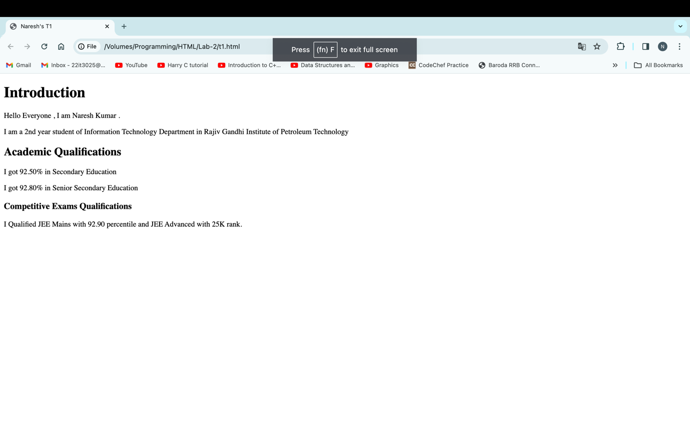

**T2 :**

<!DOCTYPE html>

<html>

<head>

<title>Naresh's T2</title>

</head>

<body>

<header>

<h1>The Cosmos Pic</h1>

</header>

<img src="download.jpg" alt="Cosmos Image" width= 400px height = 250px>

<p>Here is a pic of Cosmos .The word cosmos comes from the Greek word kosmos, which means "order," "harmony," and "the world". The ancient Greeks thought that the world was perfectly harmonious and impeccably put in order. </p>

</body>

</html>

**Output**

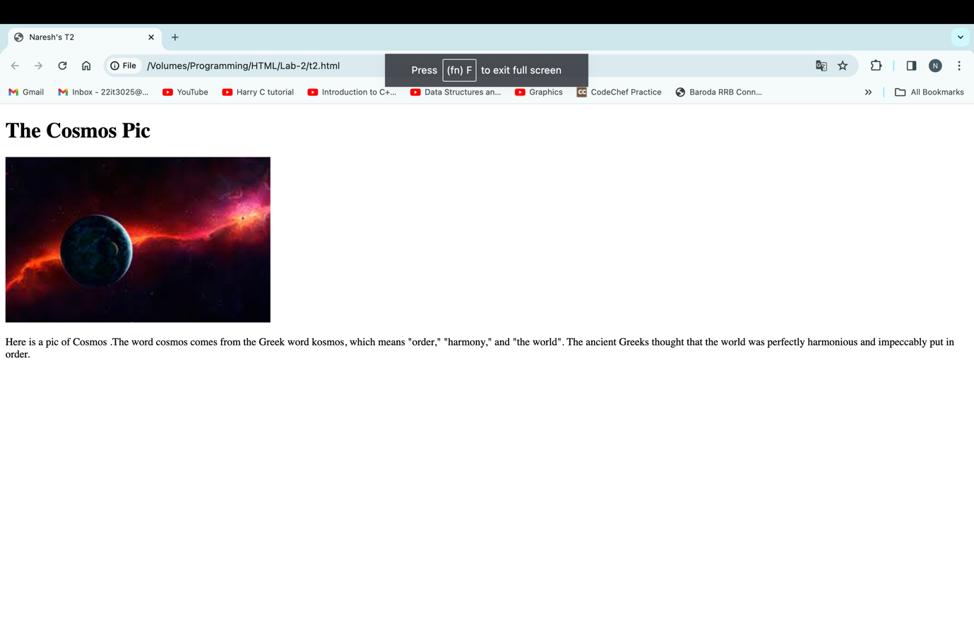

**T3 :**

<!DOCTYPE html>

<html>

<head>

<title>Naresh's T3</title>

</head>

<body>

<ol type="I">

<li>India

<ol type="i">

<li>Hindi</li>

<li>English</li>

</ol>

</li>

<li>Russia

<ol type="i">

<li>Russian</li>

<li>Tatar</li>

</ol>

</li>

<li>Spain

<ol type="i">

<li>Spanish</li>

<li>Catalan</li>

</ol>

</li>

</ol>

</body>

</html>

**Output**

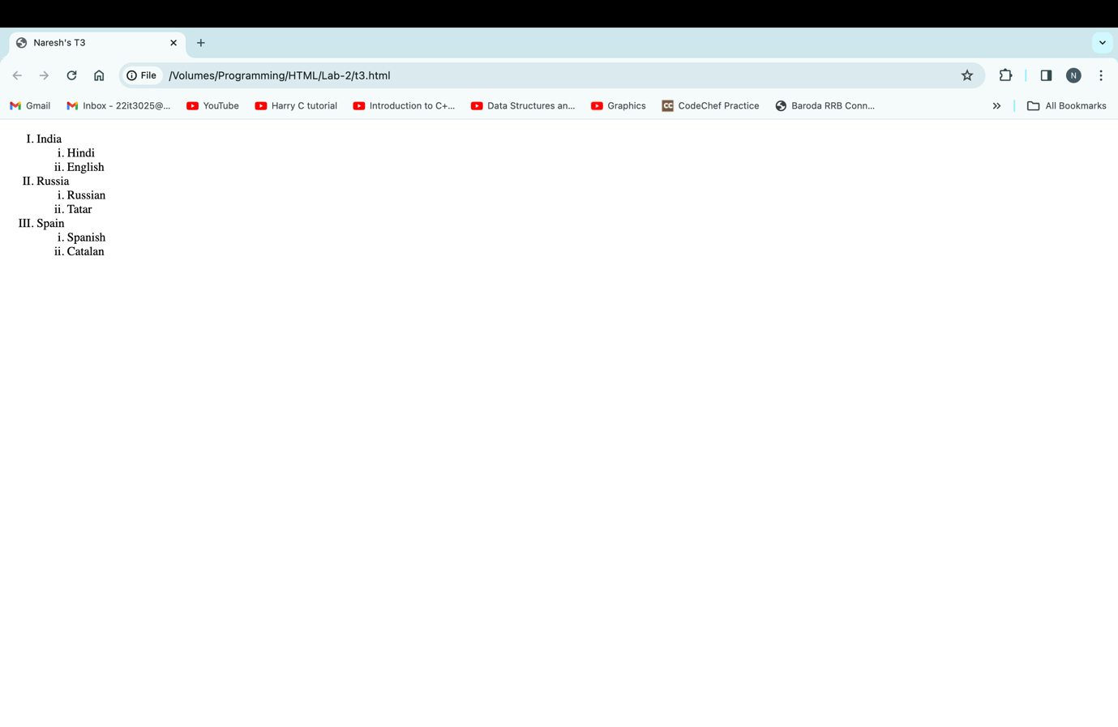

**T4 :**

<!DOCTYPE html>

<html>

<head>

<title>Naresh's T4</title>

</head>

<body>

<table>

<thead>

<tr>

<th>Country</th>

<th>Capital</th>

</tr>

</thead>

<tbody>

<tr>

<td>India</td>

<td>New Delhi</td>

</tr>

<tr>

<td>Pakistan</td>

<td>Islamabad</td>

</tr>

<tr>

<td>Spain</td>

<td>Madrid</td>

</tr>

<tr>

<td>France</td>

<td>Paris</td>

</tr>

<tr>

<td>Japan</td>

<td>Tokyo</td>

</tr>

</tbody>

<tfoot></tfoot>

</table>

</body>

</html>

**Output**

**T5 :**

<!DOCTYPE html>

<html>

<head>

<title>Naresh's T5</title>

<style>

table,

th,

td {

border: 1px solid black;

border-collapse: collapse;

}

</style>

</head>

<body>

<table>

<thead>

<tr>

<th>Countary</th>

<th colspan="2">Politicians</th>

</tr>

<tr>

<th rowspan="2">Turkmenistan</th>

<th>President</th>

<th>Gurbanguly Berdimuhamedow</th>

</tr>

<tr>

<th>Vice-President</th>

<th>Rasit Meredow</th>

</tr>

<tr>

<th rowspan="2">Eritrea</th>

<th>President</th>

<th>Isaias Afwerki</th>

</tr>

<tr>

<th>Vice-President</th>

<th>None</th>

</tr>

</thead>

</table>

</body>

</html>

**Output**

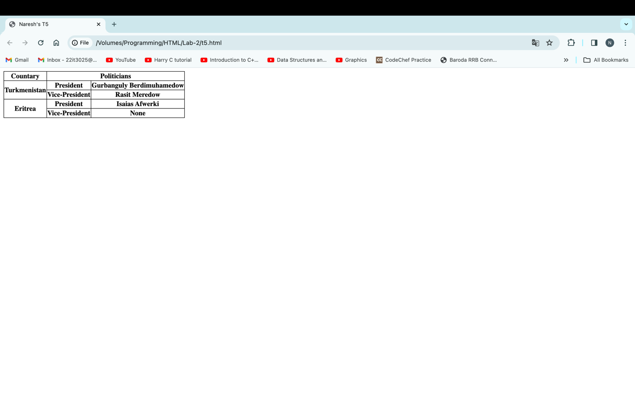

**T6 :**

<!DOCTYPE html>

<html>

<head>

<title>Naresh's T6</title>

</head>

<body>

<h1>LIST OF MY FAVOURITE WEBSITES</h1>

<ol type="A">

<li> <a href="https://www.google.com"> GOOGLE</a> </li>

<li><a href="https://www.youtube.com">YOUTUBE</a></li>

<li><a href="https://www.instagram.com">INSTAGRAM</a></li>

<li><a href="https://www.facebook.com">FACEBOOK </a></li>

</ol>

</body>

</html>

**Output**

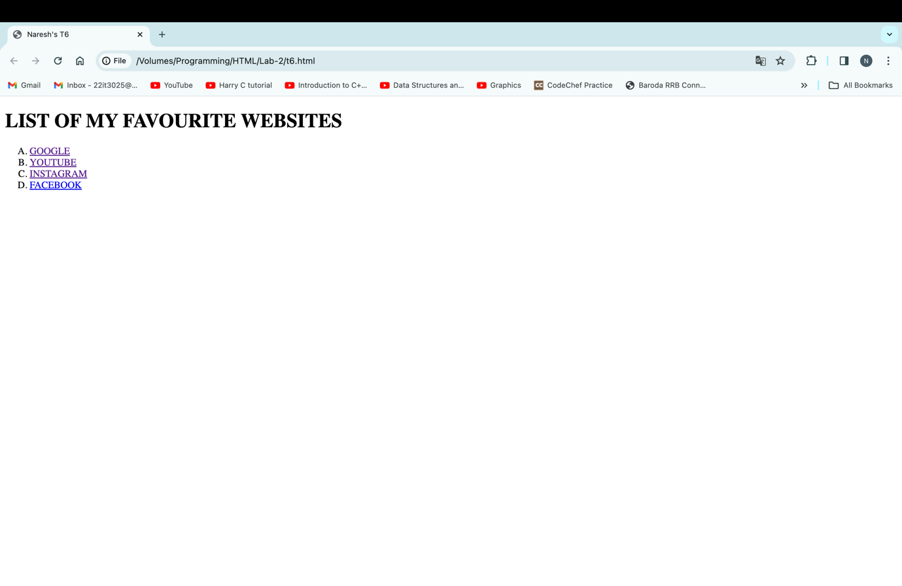

**T7 :**

<!DOCTYPE html>

<html>

<head>

<title>Naresh's T7</title>

</head>

<body>

<p>The importance of trees cannot be overstated. They provide us with the oxygen we need to breathe, the food we

need to eat, and the materials we need to build our homes and furniture. They also help to regulate the climate,

protect the soil, and provide homes for wildlife.</p>

<p>My school is a wonderful place where I learn new things every day. I have a great teacher who is always patient

and helpful. I also have lots of friends who make school fun. I love learning new things and I am always excited

to go to school.</p>

<p>I am so happy that I had the opportunity to go on vacation this year. I went to the beach with my family and we

had a great time. We swam in the ocean, built sandcastles, and collected seashells. We also went on a boat ride

and saw dolphins. It was an amazing experience and I will never forget it.</p>

<p>My hobby is playing video games. I love the challenge of trying to beat a new game or level. I also enjoy playing

with my friends online. Video games are a great way to relax and have fun.

</p>

<p>My favorite animal is the dog. Dogs are loyal, friendly, and always happy to see you. They make great companions

and I love spending time with them. My dog's name is Buddy and he is the best dog in the world.</p>

<p>I am so grateful for all of the good things in my life. I have a loving family, great friends, and a good

education. I am also healthy and happy. I know that I am lucky and I appreciate all that I have.</p>

<p>The importance of trees cannot be overstated. They provide us with the oxygen we need to breathe, the food we

need to eat, and the materials we need to build our homes and furniture. They also help to regulate the climate,

protect the soil, and provide homes for wildlife.</p>

<p>My school is a wonderful place where I learn new things every day. I have a great teacher who is always patient

and helpful. I also have lots of friends who make school fun. I love learning new things and I am always excited

to go to school.</p>

<p>I am so happy that I had the opportunity to go on vacation this year. I went to the beach with my family and we

had a great time. We swam in the ocean, built sandcastles, and collected seashells. We also went on a boat ride

and saw dolphins. It was an amazing experience and I will never forget it.</p>

<p>My hobby is playing video games. I love the challenge of trying to beat a new game or level. I also enjoy playing

with my friends online. Video games are a great way to relax and have fun.

</p>

<p>My favorite animal is the dog. Dogs are loyal, friendly, and always happy to see you. They make great companions

and I love spending time with them. My dog's name is Buddy and he is the best dog in the world.</p>

<p>I am so grateful for all of the good things in my life. I have a loving family, great friends, and a good

education. I am also healthy and happy. I know that I am lucky and I appreciate all that I have.</p>

<p>The importance of trees cannot be overstated. They provide us with the oxygen we need to breathe, the food we

need to eat, and the materials we need to build our homes and furniture. They also help to regulate the climate,

protect the soil, and provide homes for wildlife.</p>

<p>My school is a wonderful place where I learn new things every day. I have a great teacher who is always patient

and helpful. I also have lots of friends who make school fun. I love learning new things and I am always excited

to go to school.</p>

<p>

<a href="#top">go to top</a>

</body>

</html>

**Output**

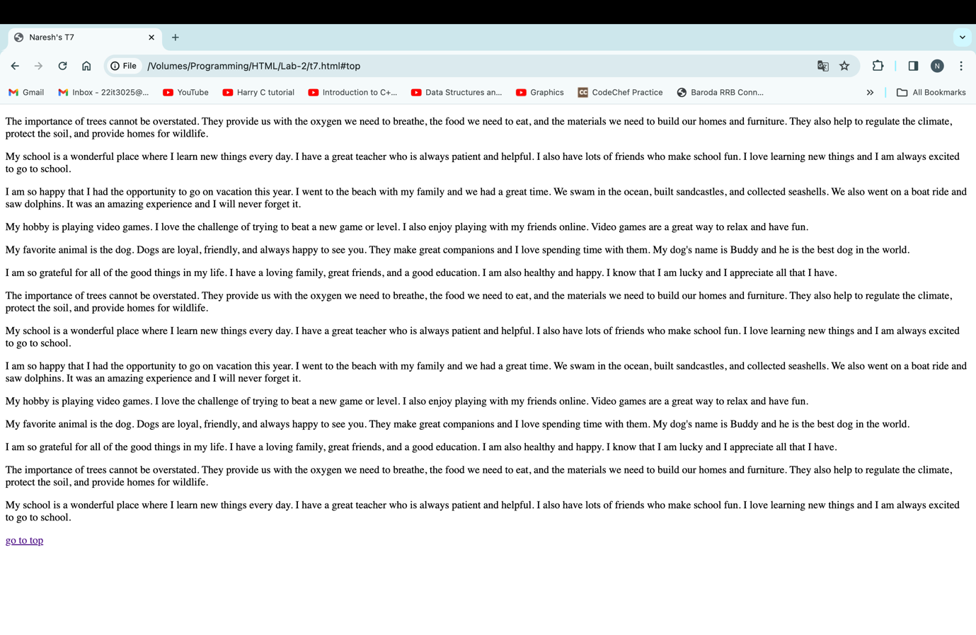

**T8 :**

<!DOCTYPE html>

<html>

<head>

<title>Naresh's T8</title>

</head>

<body>

<header id="top">

<a href="#bottom">go to bottom</a>

</header>

<p>The importance of trees cannot be overstated. They provide us with the oxygen we need to breathe, the food we

need to eat, and the materials we need to build our homes and furniture. They also help to regulate the climate,

protect the soil, and provide homes for wildlife.</p>

<p>My school is a wonderful place where I learn new things every day. I have a great teacher who is always patient

and helpful. I also have lots of friends who make school fun. I love learning new things and I am always excited

to go to school.</p>

<p>I am so happy that I had the opportunity to go on vacation this year. I went to the beach with my family and we

had a great time. We swam in the ocean, built sandcastles, and collected seashells. We also went on a boat ride

and saw dolphins. It was an amazing experience and I will never forget it.</p>

<p>My hobby is playing video games. I love the challenge of trying to beat a new game or level. I also enjoy playing

with my friends online. Video games are a great way to relax and have fun.

</p>

<p>My favorite animal is the dog. Dogs are loyal, friendly, and always happy to see you. They make great companions

and I love spending time with them. My dog's name is Buddy and he is the best dog in the world.</p>

<p>I am so grateful for all of the good things in my life. I have a loving family, great friends, and a good

education. I am also healthy and happy. I know that I am lucky and I appreciate all that I have.</p>

<p>The importance of trees cannot be overstated. They provide us with the oxygen we need to breathe, the food we

need to eat, and the materials we need to build our homes and furniture. They also help to regulate the climate,

protect the soil, and provide homes for wildlife.</p>

<p>My school is a wonderful place where I learn new things every day. I have a great teacher who is always patient

and helpful. I also have lots of friends who make school fun. I love learning new things and I am always excited

to go to school.</p>

<p>I am so happy that I had the opportunity to go on vacation this year. I went to the beach with my family and we

had a great time. We swam in the ocean, built sandcastles, and collected seashells. We also went on a boat ride

and saw dolphins. It was an amazing experience and I will never forget it.</p>

<p>My hobby is playing video games. I love the challenge of trying to beat a new game or level. I also enjoy playing

with my friends online. Video games are a great way to relax and have fun.

</p>

<p>My favorite animal is the dog. Dogs are loyal, friendly, and always happy to see you. They make great companions

and I love spending time with them. My dog's name is Buddy and he is the best dog in the world.</p>

<p>I am so grateful for all of the good things in my life. I have a loving family, great friends, and a good

education. I am also healthy and happy. I know that I am lucky and I appreciate all that I have.</p>

<p>The importance of trees cannot be overstated. They provide us with the oxygen we need to breathe, the food we

need to eat, and the materials we need to build our homes and furniture. They also help to regulate the climate,

protect the soil, and provide homes for wildlife.</p>

<p>My school is a wonderful place where I learn new things every day. I have a great teacher who is always patient

and helpful. I also have lots of friends who make school fun. I love learning new things and I am always excited

to go to school.</p>

<p>

<footer id="bottom"></footer>

<a href="#top">go to top</a>

</body>

</html>

**Output**

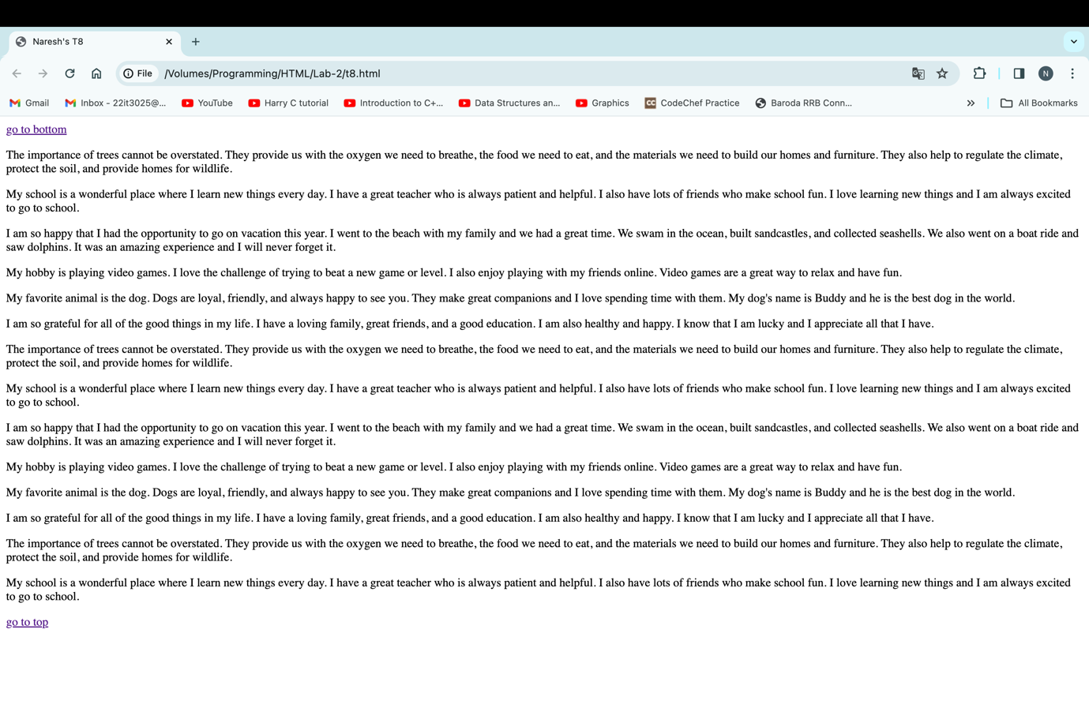

**T9 :**

<!DOCTYPE html>

<html>

<head>

<title>Naresh's T9</title>

</head>

<body>

<img src=" images.jpg " alt="Sunny image" width="200px" height="200px" border="2px">

</body>

</html>

**Output**

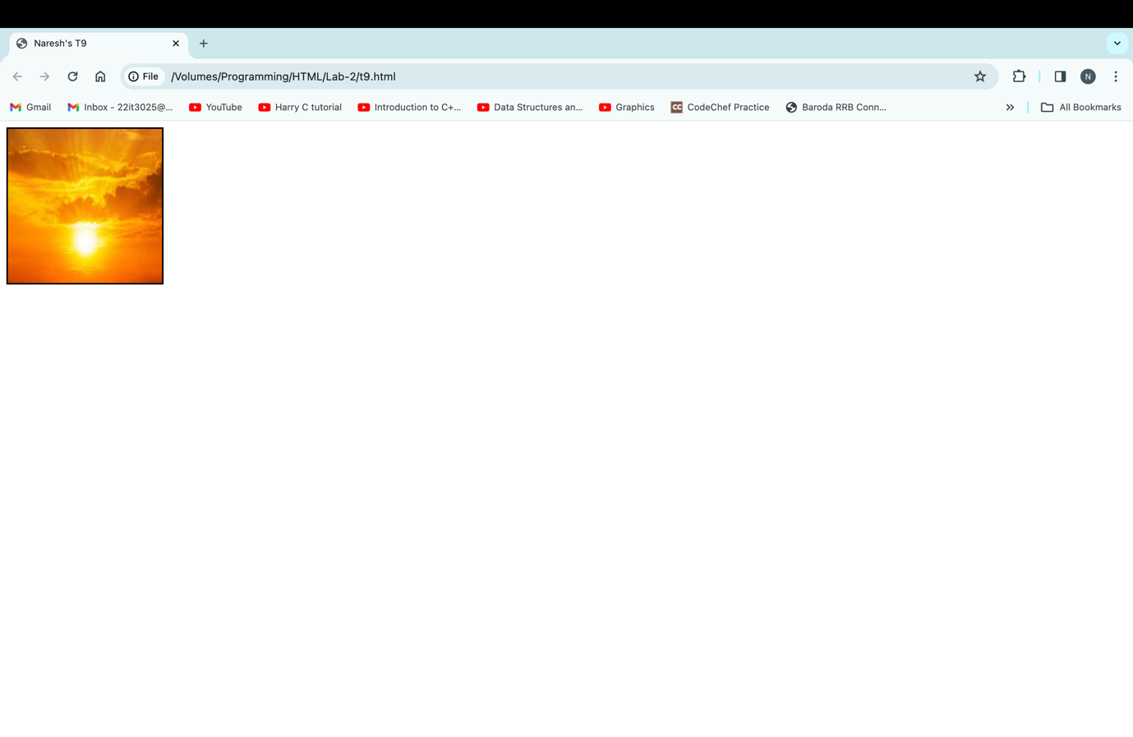

**T10 :**

<!DOCTYPE html>

<html>

<head>

<title>Naresh's T10</title>

</head>

<body>

<figure id="1">

<img src=" images.jpg " alt="sunny image" width="200px">

<figcaption>Fig.1 Sunny & Bright</figcaption>

</figure>

<br>

<br>

<figure id="2">

<img src=" download.jpg " alt="cosmos image" width="200px">

<figcaption>Fig.2 Cosmos</figcaption>

</figure>

<br>

<br>

<figure id="3">

<img src=" download1.jpg " alt="nature image" width="200px">

<figcaption>Fig.3 Nature</figcaption>

</figure>

<br>

<br>

<figure id="4">

<img src=" download2.jpg " alt="river image" width="200px">

<figcaption>Fig.4 River </figcaption>

</figure>

<br>

<br>

<figure id="5">

<img src=" download3.jpg " alt="waterfall image" width="200px">

<figcaption>Fig.5 A Small Waterfall </figcaption>

</figure>

</body>

</html>

**Output**

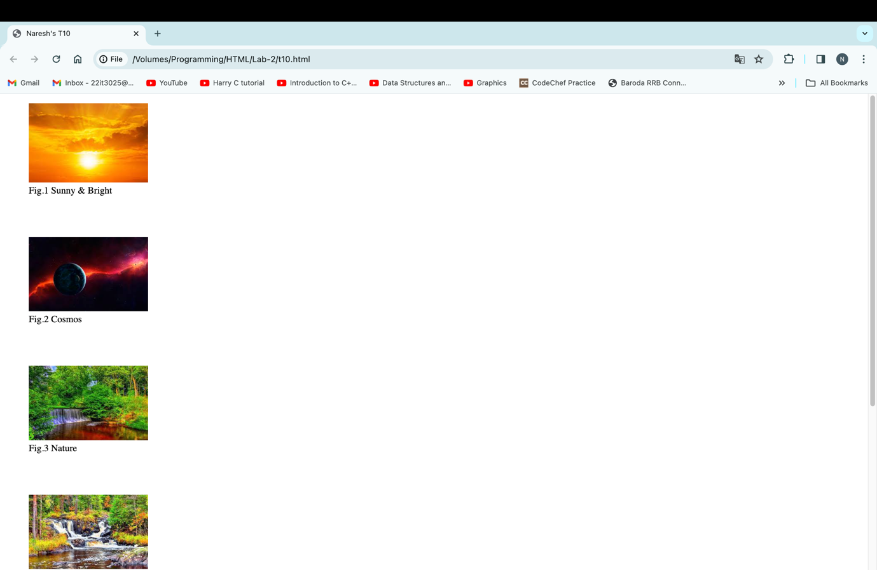

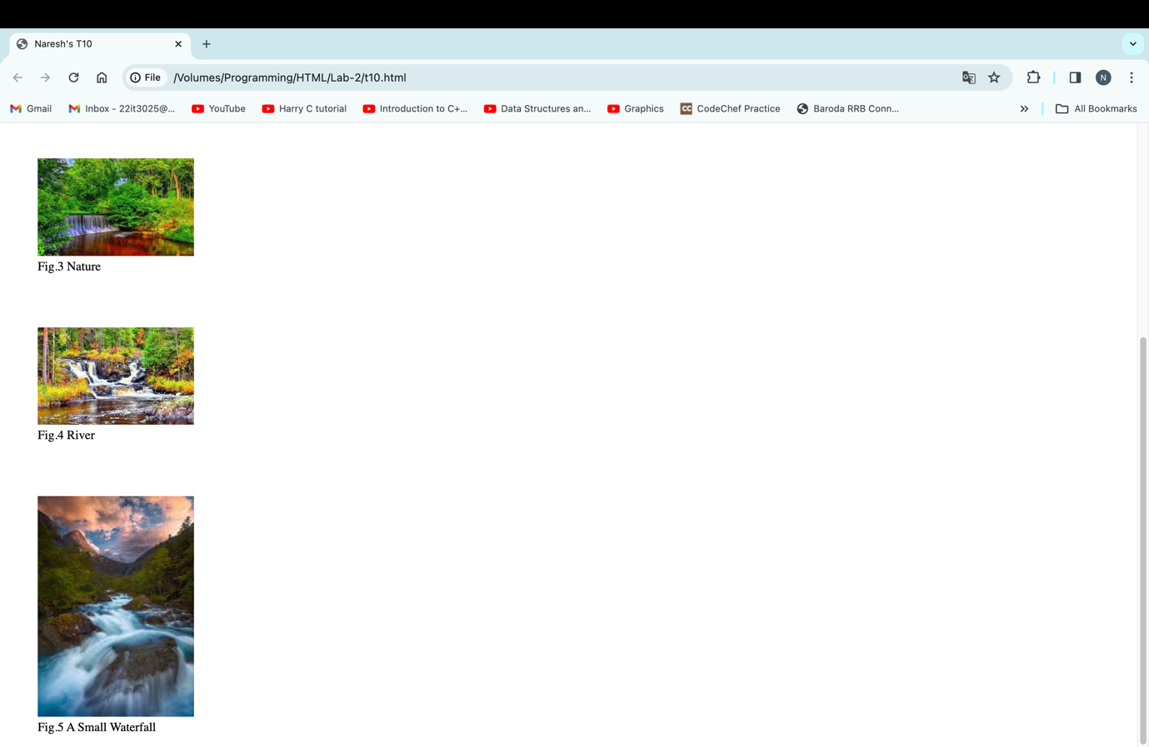

**T11 :**

<!DOCTYPE html>

<html>

<head>

<title>Naresh's T11</title>

</head>

<body>

<a href="https://www.google.com"> <img src=" images.jpg " alt="Sunny image" width="200px"> </a>

</body>

</html>

**Output**

