**WEB TECHNOLOGY**

**NARESH KUMAR**

**22IT3025**

**Lab – 3**

T1 : Add a CSS rule and appropriate html to style every other line of the unordered list with a light blue background color. Specify the background color using the rgb method.

● Eswatini

● Ecuador

● Tanzania

● Spain

● Slovakia

● Iraq

Solution :

<!DOCTYPE html>

<html>

<head>

<title>Naresh's T1</title>

<style>

li:nth-child(odd) {

background-color:rgb(173, 216, 230);

}

</style>

</head>

<body>

<h3>Creating a List With Light blue Color Background </h3>

<ul>

<li class ="Blue" > Eswatini </li>

<li > Ecuador</li>

<li class ="Blue" > Tanzania </li>

<li > Spain </li>

<li class ="Blue" > Slovakia </li>

<li > Iraq </li>

</ul>

</body>

</html>

OUTPUT :

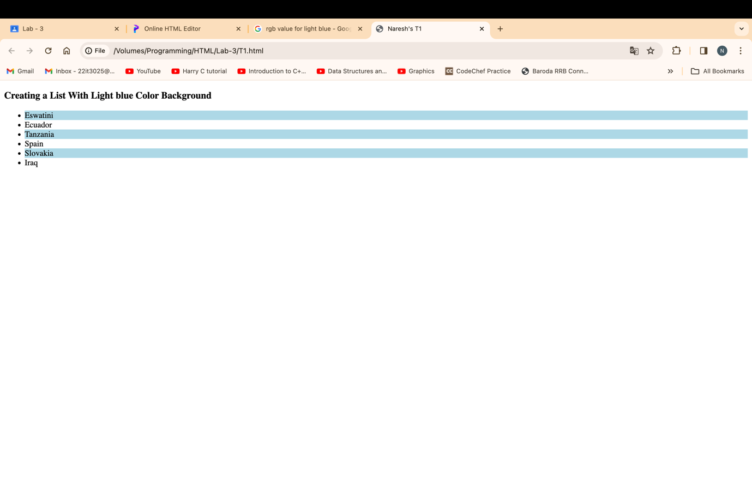

T2 : Given the table in the question style the table so that the odd rows have a light gray background. In addition add a header row to the table and style that row so it has white text and a black background color. Change the font so that they are all 14 point sans serif of some kind.

Albania Tirana Albanian

Papua New Guinea Port Moresby English

Latvia Riga Latvian

France Paris French

Solution :

<!DOCTYPE html>

<html>

<head>

<title>Naresh's T2</title>

<style>

table,

th,

td {

border: 1px solid black;

border-collapse: collapse;

font-family : sans-serif ;

}

tr:nth-child(even) {

background-color: rgb(211, 211, 211);

}

#head {

background-color: rgb(0, 0, 0);

color: rgb(255, 255, 255)

}

</style>

</head>

<body>

<h3>Creating a Table </h3>

<table>

<tr id="head">

<th>Country</th>

<th>Capital</th>

<th>Language</th>

</tr>

<tr>

<td>Albania</td>

<td>Tirana</td>

<td>Albanian</td>

</tr>

<tr>

<td>Papua New Guinea</td>

<td>Port Moresby</td>

<td>English</td>

</tr>

<tr>

<td>Latvia</td>

<td>Riga</td>

<td>Latvian</td>

</tr>

<tr>

<td>France</td>

<td>Paris</td>

<td>French</td>

</tr>

</table>

</body>

</html>

OUTPUT :

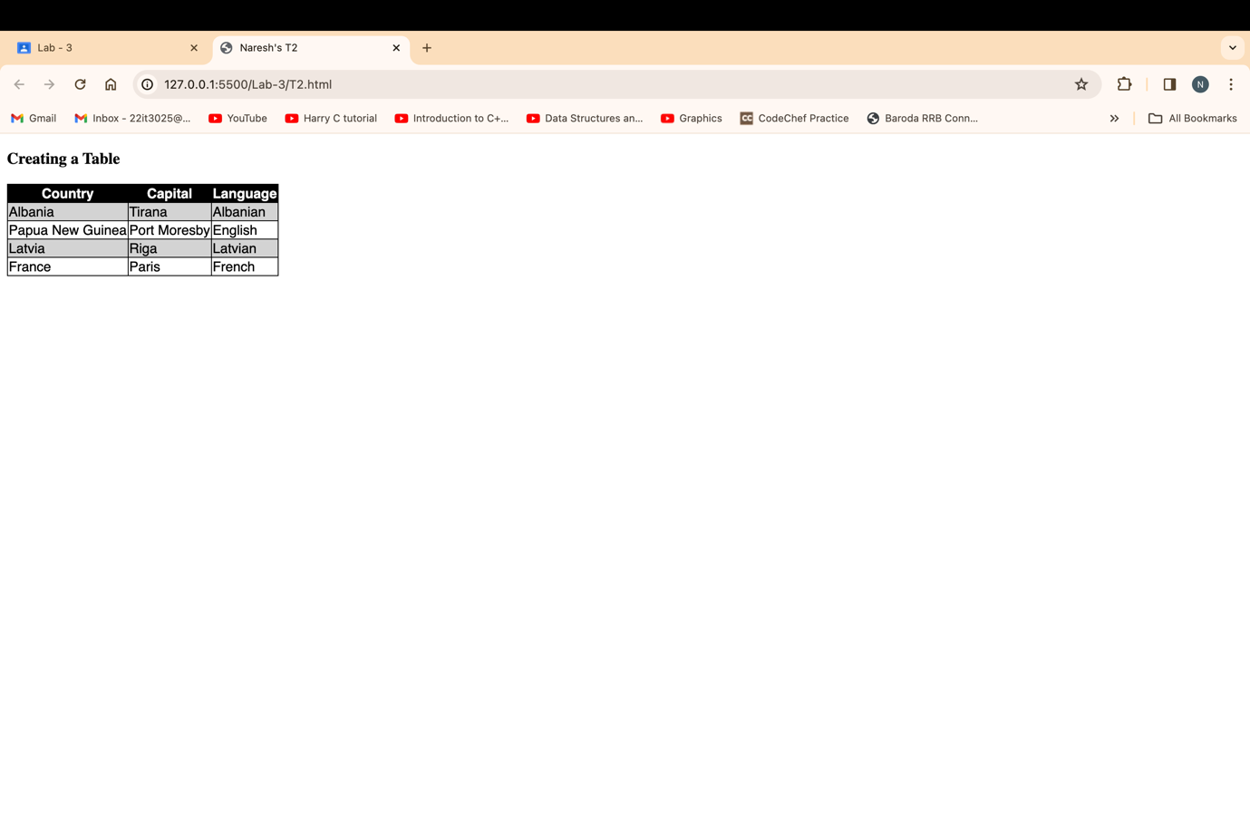

T3 : Suppose you are working on a recipe website. Recipes have a title, a list of ingredients, and an instructions section. Make a webpage that shows the recipe for grilled cheese sandwiches with bacon and tomato. The ingredients should be displayed as an unordered list, with no bullets. Meat ingredients should have a light red background color, vegetables should have a light green background, and dairy products should have light yellow. The title should be in a sans serif font of your choice, and the instructions should have a heading “Instructions” and the font for the instructions should be italic.

Solution :

<!DOCTYPE html>

<html lang="en">

<head>

<meta charset="UTF-8">

<meta name="viewport" content="width=device-width, initial-scale=1.0">

<title>Naresh's T3 </title>

<style>

body {

font-family: 'Arial', sans-serif;

}

h1 {

color: rgb(51, 51, 51);

}

ul {

list-style: none;

padding: 0;

}

li {

margin-bottom: 10px;

padding: 8px;

}

.meat {

background-color: rgb(255, 192, 192);

}

.vegetables {

background-color: rgb(192, 255, 192);

}

.dairy {

background-color: rgb(255, 255, 192);

}

.instructions {

font-style: italic;

}

</style>

</head>

<body>

<h1>Grilled Cheese Sandwich with Bacon and Tomato Recipe</h1>

<h2>Ingredients:</h2>

<ul>

<li class="meat">Bacon</li>

<li class="dairy">Cheese</li>

<li class="dairy">Butter</li>

<li class="vegetables">Tomato slices</li>

<li class="dairy">Bread slices</li>

</ul>

<h2 class="instructions">Instructions:</h2>

<ol class = "instructions">

<li>Cook bacon until crispy.</li>

<li>Butter one side of each bread slice.</li>

<li>Place a slice of cheese on the unbuttered side of half the bread slices</li>

<li>Add bacon and tomato slices on top of the cheese.</li>

<li>Top with the remaining bread slices, buttered side out.</li>

<li> Grill the sandwich on both sides until the bread is golden and the cheese is melted.</li>

<li>Serve hot and enjoy your grilled cheese sandwich with bacon and tomato !</li>

</ol>

</body>

</html>

OUTPUT :

T4 : Using CSS and HTML Make a webpage that has two columns. Each column should use half of the width of the page. The left half should have a light gray background and the right half should have a light green background. The left half should have a list of the 5 best selling books in Amazon’s kindle store, and the right should have a list of your five favorite celebrities or athletes.

Solution :

<!DOCTYPE html>

<html lang="en">

<head>

<meta charset="UTF-8">

<meta name="viewport" content="width=device-width, initial-scale=1.0">

<title>Naresh's T4</title>

<style>

body {

margin: 0;

font-family: Arial, sans-serif;

}

.container {

display: flex;

width: 100%;

}

.left-column, .right-column {

flex: 1;

padding: 20px;

box-sizing: border-box;

}

.left-column {

background-color: lightgray;

}

.right-column {

background-color: lightgreen;

}

li {

margin-bottom: 10px;

}

</style>

</head>

<body>

<div class="container">

<div class="left-column">

<h2>Best Selling Books on Amazon Kindle</h2>

<ol>

<li>R.D Sharma</li>

<li>H.C Verma</li>

<li>Arihant Maths</li>

<li>Paper Moon</li>

<li>Wings of Fire</li>

</ol>

</div>

<div class="right-column">

<h2>Favorite Celebrities/Athletes</h2>

<ol>

<li>ShahRukh Khan</li>

<li>Aamir Khan </li>

<li>Ajay Devgan</li>

<li>Sunil Chhetri</li>

<li>Neeraj Chopra</li>

</ol>

</div>

</div>

</body>

</html>

OUTPUT :

T5 : Using the nav element, make a navbar for at the top of a sample webpage. Add at least three links to the navbar using an unordered list that is displayed as inline rather than block. Make the navbar have a light blue background color, but change the background of the title to a darker blue when the mouse hovers over it.

Solution :

<!DOCTYPE html>

<html lang="en">

<head>

<meta charset="UTF-8">

<meta name="viewport" content="width=device-width, initial-scale=1.0">

<title>Naresh's T5</title>

<style>

body {

margin: 0;

font-family: sans-serif;

}

nav {

background-color: lightblue;

padding: 10px;

}

ul {

margin: 0;

padding: 0;

}

li {

display: inline;

margin-right: 15px;

}

a {

color: darkblue;

}

h1 {

margin: 0;

padding: 0;

display: inline-block;

transition: background-color 0.3s;

}

h1:hover {

background-color: navy;

}

</style>

</head>

<body>

<nav>

<ul>

<li><a href="https://google.com">Google</a></li>

<li><a href="https://youtube.com">Youtube</a></li>

<li><a href="https://instagram.com">Instagram</a></li>

</ul>

<h1>Hover to change Color</h1>

</nav>

</body>

</html>

OUTPUT :

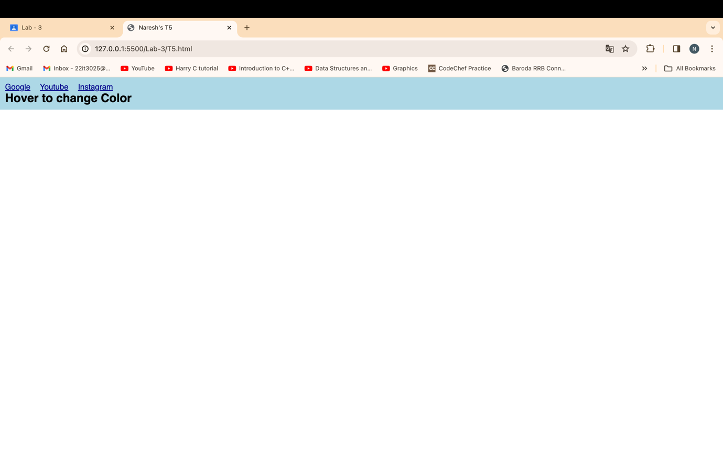

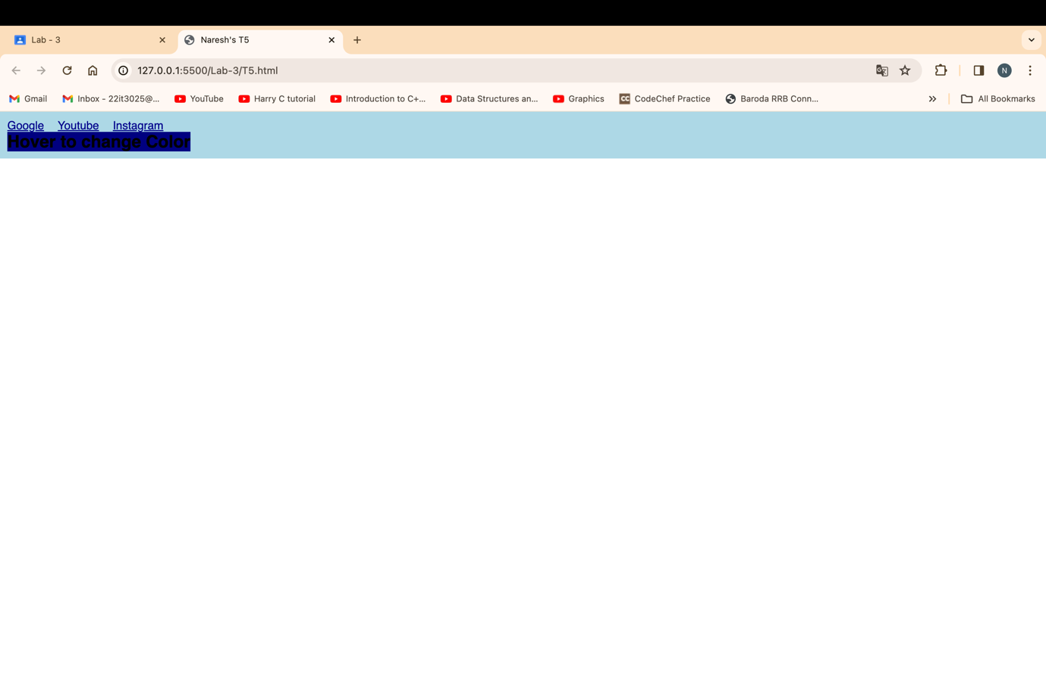

T6 : Using the image of the playing card, use transformations and animations to make the playing card spin around endlessly.

Solution :

<!DOCTYPE html>

<html lang="en">

<head>

<meta charset="UTF-8">

<meta name="viewport" content="width=device-width, initial-scale=1.0">

<title>Naresh's T6</title>

<style>

@keyframes spin {

0% { transform: rotate(0deg); }

100% { transform: rotate(360deg); }

}

.card {

margin-top: 25%;

margin-left: 50%;

margin-bottom: 40% ;

width: 100px;

height: 150px;

background-size: cover;

animation: spin 5s linear infinite;

}

</style>

</head>

<body>

<h1>Playing card spinning arround </h1>

<div class="card">

<img src="https://encrypted-tbn0.gstatic.com/images?q=tbn:ANd9GcRbUMz6jY_agvw-bNX_zeXpwNw7deRZNox-wQ&usqp=CAU" alt="Playing_card image">

</div>

</body>

</html>

OUTPUT :

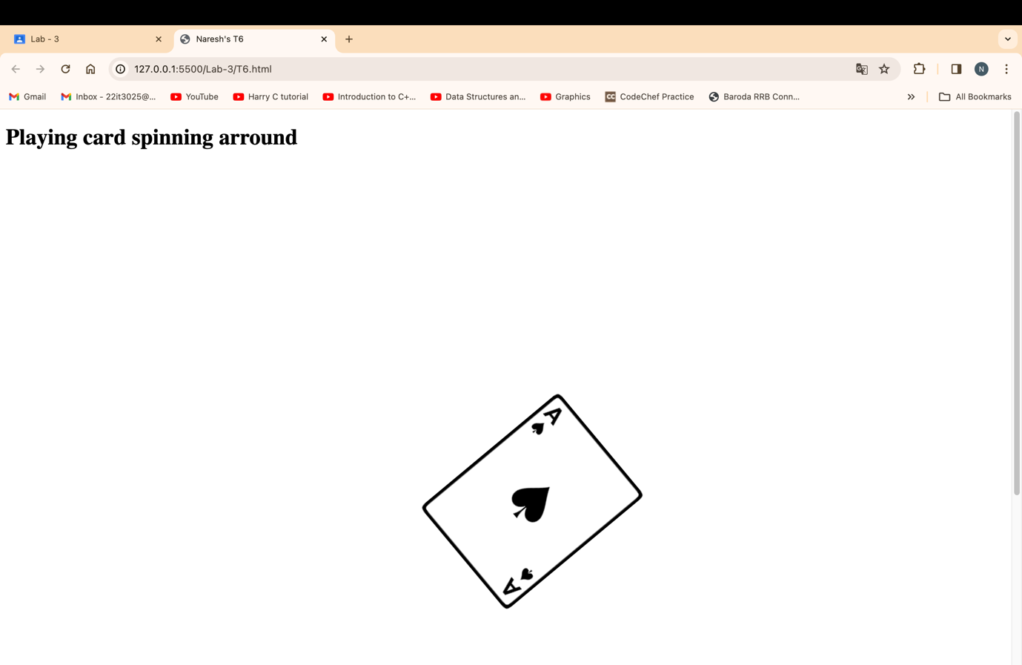

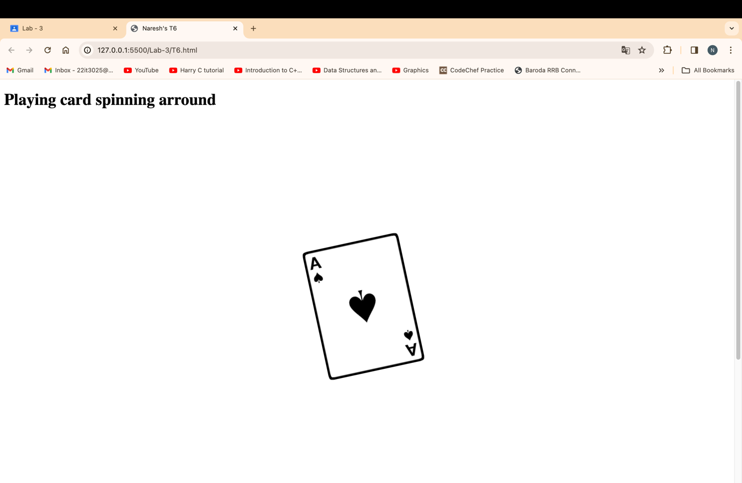

T7 : Develop a homepage for yourself, published on github pages, that employs a two column layout with a fixed navbar (always on screen), and a footer. The navbar should link to at least two additional pages used to describe your hobbies or favorite teams. The CSS for this website should be contained in its own CSS file, and all three pages should use this CSS file.

Solution :

https://naresh6184.github.io/MyHomepage/  
  
OUTPUT : 