Encrypting an existing file with content:

*ansible-vault encrypt aws_creds*

*ansible-vault decrypt aws_creds*

Create encrypted a file on-demand:

#This will create a file which is empty and we need to provide creds.

*ansible-vault create aws_creds*

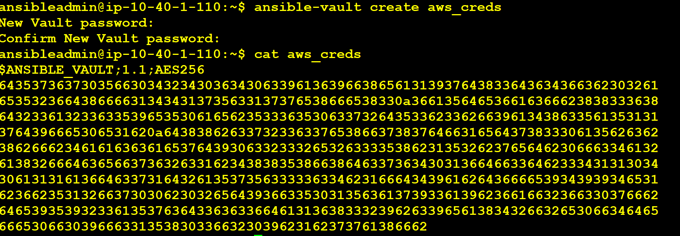

*ansible-vault decrypt aws_creds*

*cat aws_creds*

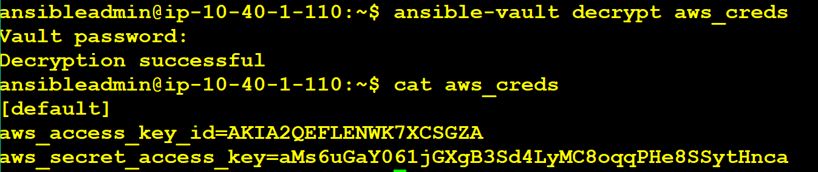

ansible-vault encrypt_string 'India@123456' --name 'user_password'

Once provided the vault password, copy the encrypted data which is shown below screenshot.

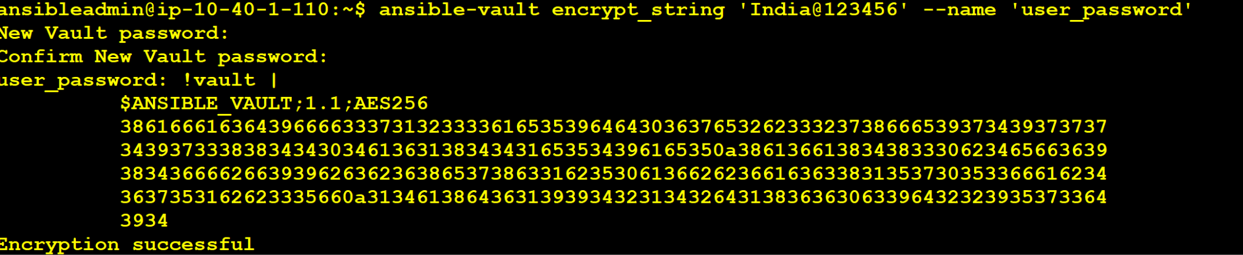

To Decrypt the string:

Make sure you delete the spaces before the lines.

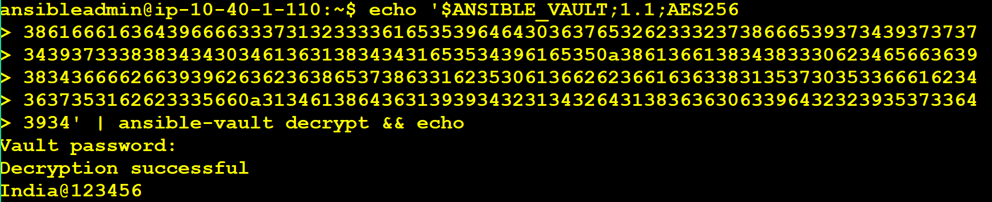

ansible-playbook -i testservers vault-testing.yml --check --ask-vault-pass

ansible-playbook -i testservers vault-testing.yml --ask-vault-pass